Use Apollo to Do Collaborative Genome Annotation

Wilson Leung
06/2018

Introduction
Apollo is a real-time genome annotation editor that allows multiple users to collaborate on the annotation of eukaryotic genomes. In this walkthrough, we will examine the key features of Apollo and illustrate how we can use this tool to annotate a gene in the D. miranda genome.
See the Apollo User Guide for a detailed overview of the key functionalities and user interface provided by Apollo (http://genomearchitect.org/users-guide/).

Navigate to the feature of interests in Apollo
For this walkthrough, we have constructed an Apollo instance which contains only the Drosophila miranda Muller F element (scaffold_6). Open a new web browser window and navigate to the Apollo instance for the Drosophila miranda MSH22 (scaffold_6) assembly. Log into the Apollo instance using your Apollo account credentials.

Enter “scaffold_6:799,000..804,000” into the position text box at the top left panel and then click on the “Go” button (Figure 1).

Figure 1. Navigate to the scaffold_6:799,000..804,000 region of D. miranda scaffold_6.

We will first examine the gene predictions in this region. Select the “Track” tab in the right panel, and then click on the “Gene Predictions” header to expand this section. Select the checkboxes next to Augustus Gene Prediction, GlimmerHMM Gene Prediction, and SNAP Gene Prediction to add these evidence tracks to the genome browser view (Figure 2).

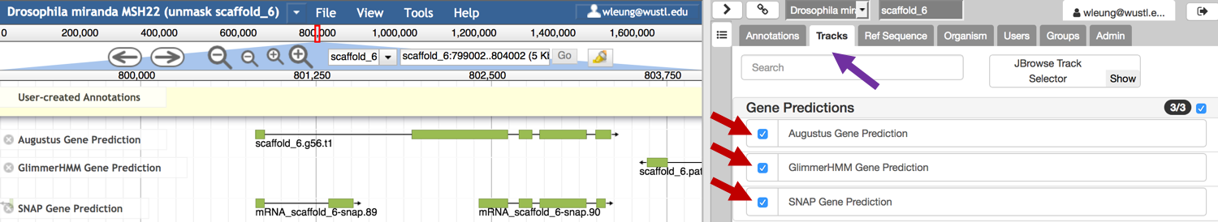
Figure 2. Select the “Tracks” tab in the right panel (purple arrow) to access the list of evidence tracks available for the D. miranda assembly. Click on the checkbox next to an evidence track to add it to the genome browser display on the left panel (red arrows).
The genome browser view shows one Augustus gene prediction (scaffold_6.g56.t1), and two SNAP gene predictions (mRNA_scaffold_6-snap.89 and mRNA_scaffold_6-snap.90) in this region. Each gene prediction consists of green rectangles that are connected by lines, where the rectangles demarcate the locations of the predicted coding exons and the lines correspond to introns (Figure 3). The arrow at the end of the gene prediction points to right, which indicates that the feature is on the plus strand with respect to scaffold_6.

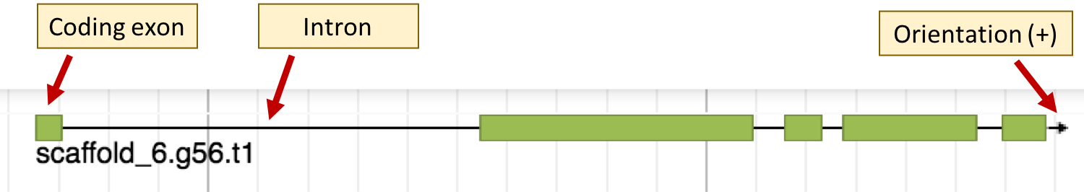
Figure 3. The D. miranda Augustus gene prediction scaffold_6.g56.t1 consists of five coding exons and it is on the plus strand with respect to scaffold_6.

The region also includes the end of the GlimmerHMM prediction scaffold_6.path1.gene81. Because the arrow associated with this gene prediction is pointing to the right, this gene prediction is in the minus strand with respect to the scaffold_6 sequence.

Click on the “scaffold_6.g56.t1” feature in the Augustus Gene Prediction track to further investigate this feature. A transcript dialog will appear which provides additional details about this gene prediction. The “Primary Data” section shows that the predicted transcript is located at scaffold_6:800821..803354. The “Subfeatures” section shows the location and the sequence associated with each coding exon (Figure 4).

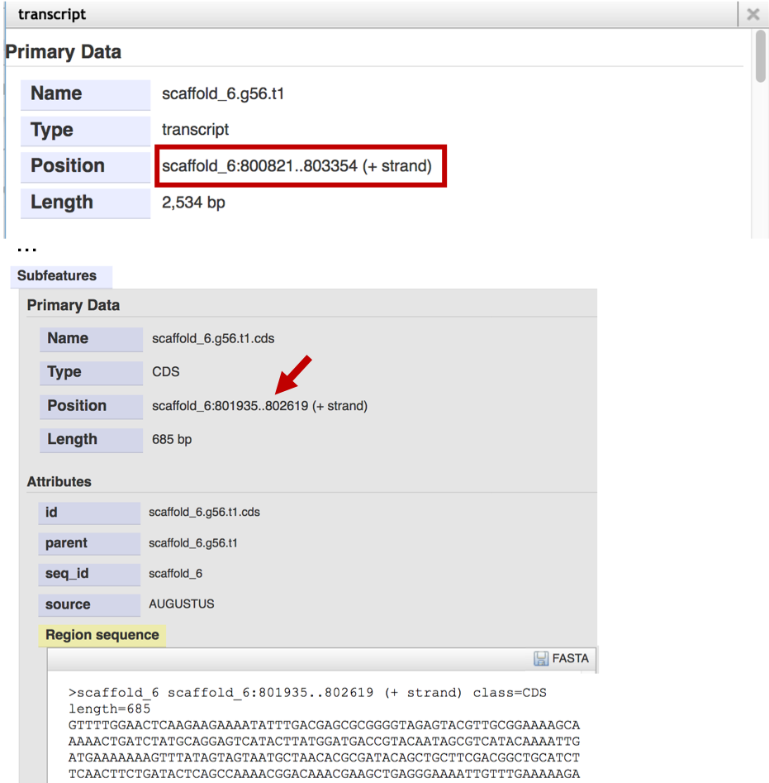
Figure 4. The transcript dialog shows the extent of the scaffold_6.g56.t1 feature on scaffold_6 (red box). The “Subfeatures” section list the location (red arrow) and the sequences associated with each coding exon.
Click on the “X” icon at the top right corner of the “transcript” window to close the window. To see if the scaffold_6.g56.t1 feature is similar to transcripts in Drosophila melanogaster, click on the “Sequence Similarity” header in the “Tracks” panel and then select the “BLAT Alignment” track (Figure 5).

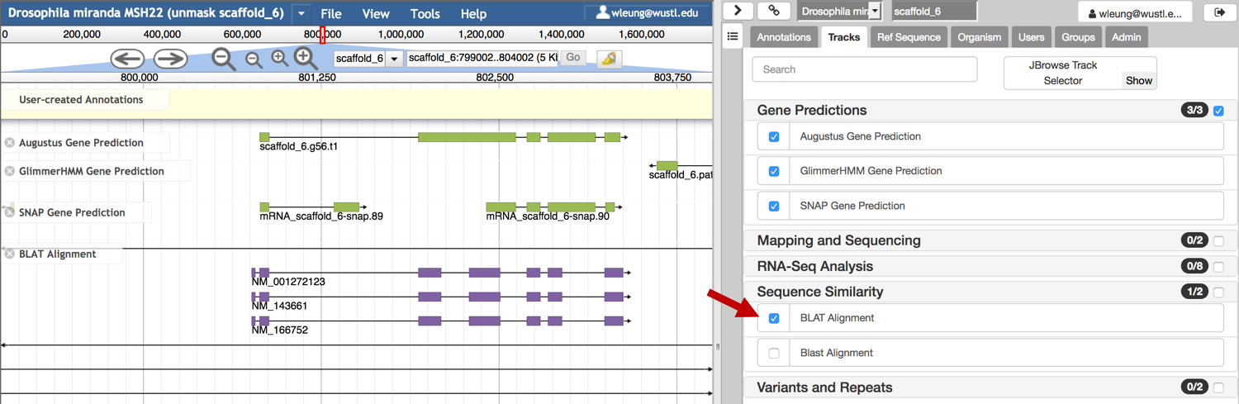
Figure 5. Select the “BLAT Alignment” track under the “Tracks” section to identify regions in the D. miranda scaffold with sequence similarity to transcripts from D. melanogaster.

The BLAT Alignment track shows three transcripts from D. melanogaster that overlap with the scaffold_6.g56.t1 gene prediction (i.e., NM_001272123, NM_143661, and NM_166752). The purple boxes indicate regions of similarity between the D. melanogaster transcript and the D. miranda genomic sequence, while the lines which connect the purple boxes correspond to gaps in the alignment.

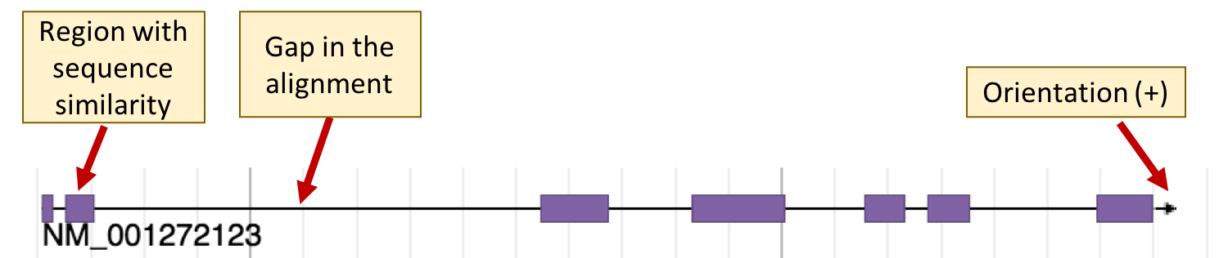
Figure 6. The alignment between the D. melanogaster transcript NM_001272123 against D. miranda scaffold_6 consists of seven alignment blocks, and the alignment is in the plus strand.

Obtain the predicted protein sequence for scaffold_6.g56.t1
Our investigation thus far has identified a potential protein-coding gene at scaffold_6:800821..803354 based on the Augustus gene prediction scaffold_6.g56.t1. Because this feature overlaps with alignment blocks from the BLAT Alignment tracks, the feature has some sequence similarity to three transcripts in D. melanogaster (i.e., NM_001272123, NM_143661, and NM_166752).

To further characterize this feature, we will compare the scaffold_6.g56.t1 feature against a database of known proteins in D. melanogaster. The first step of this analysis would require us to obtain the predicted peptide sequence for the scaffold_6.g56.t1 feature.

Right click (control-click macOS) on the scaffold_6.g56.t1 feature and then select the “Create new annotation” → “gene” option. A new gene model will appear in the “User-created Annotations” section (scaffold_6.g56.t1-00001; Figure 7).

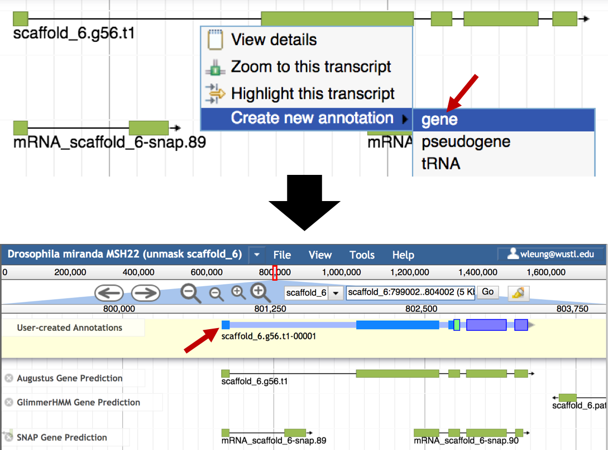
Figure 7. Use the Augustus prediction scaffold_6.g56.t1-00001 to construct a new gene model.

The thickest boxes in scaffold_6.g56.t1-00001 correspond to coding exons. By default, the “Color by CDS frame” option is enabled, and the color of the box corresponds to the reading frame (red = frame 1, green = frame 2, purple = frame 3). The thinner blue boxes correspond to untranslated exons, and the thinnest light blue boxes correspond to introns (Figure 8).

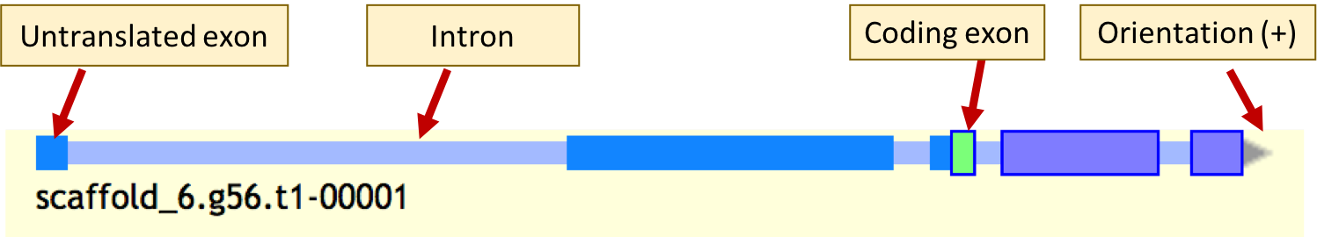
Figure 8. The key components of a gene model in the User-created Annotations track.

The exons in the Augustus gene prediction scaffold_6.g56.t1 should all be part of the coding region of the gene. However, Apollo designated the first two exons and the beginning of the third exon as part of the 5’ untranslated region (UTR) of the gene (as demarcated by the thinner blue boxes in scaffold_6.g56.t1-00001). To expand the coding region, right click (control-click on macOS) on the scaffold_6.g56.t1-00001 and then select the “Set Longest ORF” option in the drop-down menu. Apollo will then convert all the exons in the scaffold_6.g56.t1-00001 to coding exons (Figure 9).

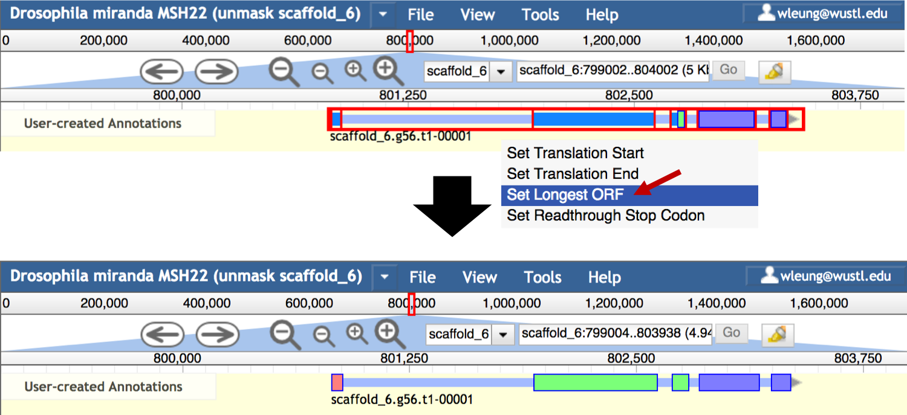
Figure 9. Use the “Set Longest ORF” option to expand the coding region of a user-created gene annotation to the largest coding region possible.

To obtain the protein sequence for the revised gene model (which correspond to the Augustus gene prediction scaffold_6.g56.t1), right click (control-click on macOS) on the gene model and then select the “Get Sequence” option from the drop-down menu. Verify that the “Peptide sequence” option is selected in the “Sequence” window. Select and copy the protein sequence onto the clipboard.

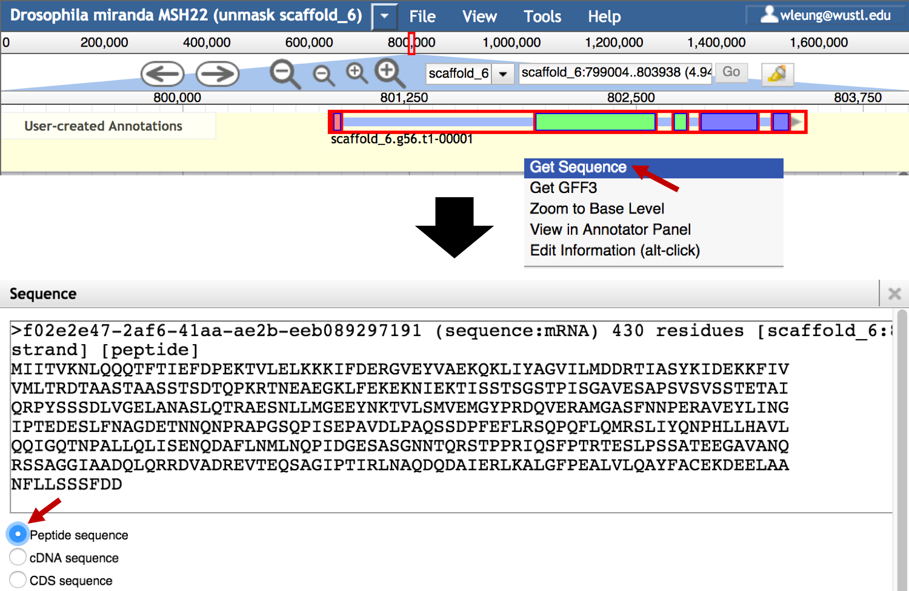
Figure 10. Use the "Get Sequence" option to obtain the peptide sequence for a gene model.

Identify the putative D. melanogaster ortholog
We can compare the predicted peptide sequence for scaffold_6.g56.t1-00001 against a database of annotated proteins in D. melanogaster (i.e., the reference genome) to further characterize this feature.

Open a new web browser tab and navigate to the FlyBase BLAST web page at http://flybase.org/blast/. Paste the predicted protein sequence into the “Sequence” text box. The sequence header begins with the “>” symbol, followed by the unique identifier for the feature in Apollo (i.e., f02e2e47-2af6-41aa-ae2b-eeb089297191). The description after this identifier provides additional information for the feature, such as the feature type, the size of the feature, and its location in the genome assembly.

To simplify the description of the BLAST result, we will change the sequence header to “>scaffold_6.g56.t1-00001”. In addition, we will change the “Database” field to “Annotated proteins (AA)”, the “Program” field to “blastp: AA -> AA”, and verify that the “D. melanogaster” option is selected under the “Species (optional)” section. Click on the “BLAST” button to run the search (Figure 11).

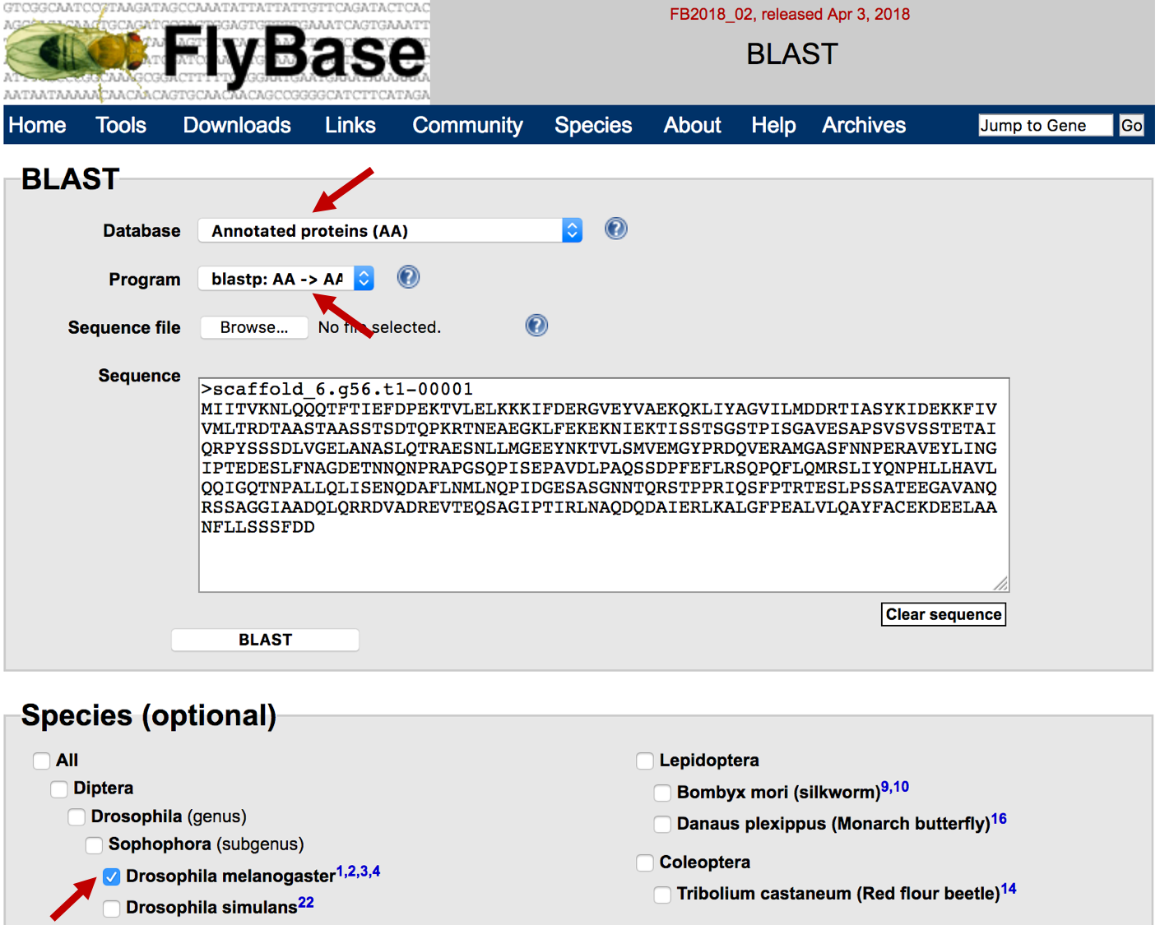
Figure 11. Compare the D. miranda predicted peptide sequence scaffold_6.g56.t1-00001 against the D. melanogaster Annotated proteins database using FlyBase BLAST.

The blastp search results show that the matches to the C, A, and B isoforms of Rad23 have much lower E-values (ranges from 9.48e-144 to 2.81e-104) than the next best match (A isoform of CG10694 with an E-value of 1.35e-19). For the A and C isoforms of Rad23 (i.e., Rad23-PA and Rad23-PC), the blastp alignment covers the entire length of the gene prediction (Figure 12).

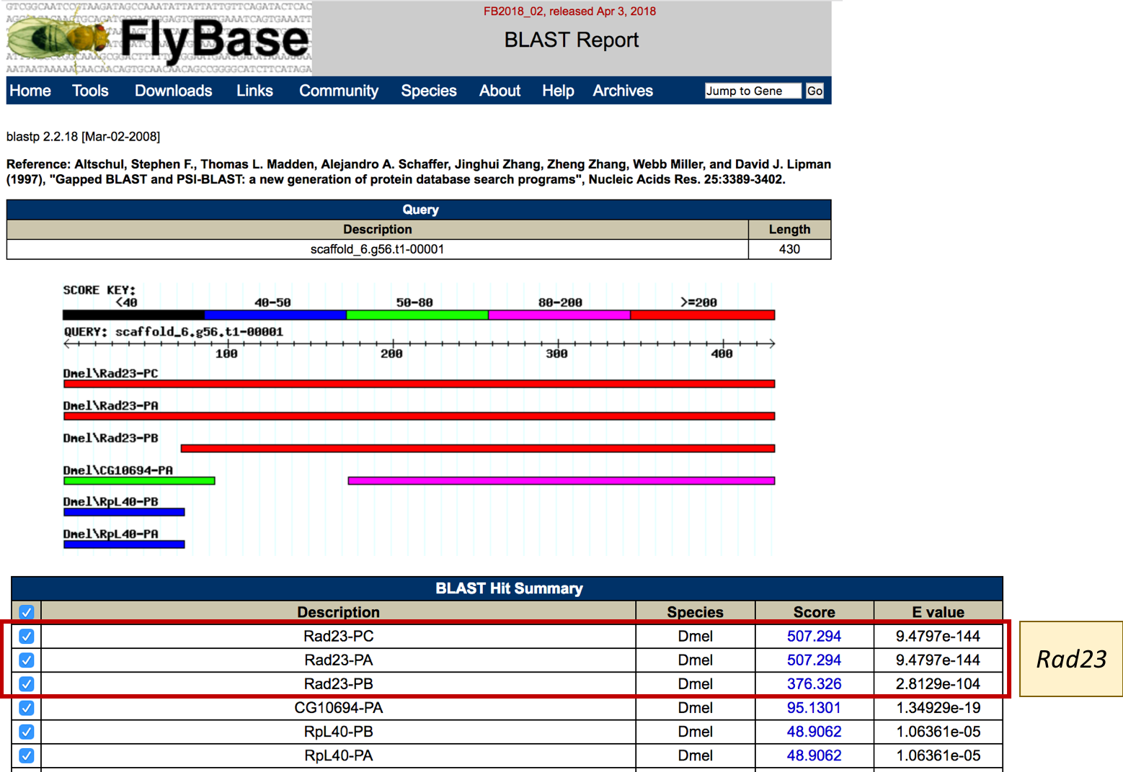
Figure 12. The FlyBase blastp search results for scaffold_6.g56.t1-00001 (query) against the D. melanogaster Annotated proteins database (subject).

Based on the FlyBase blastp search result, the scaffold_6.g56.t1-00001 feature is likely to be a putative ortholog of the D. melanogaster gene Rad23.

Determine the gene structure of the D. melanogaster ortholog
In order to construct the gene models for the Rad23 ortholog in D. miranda, we need to first determine the gene structure of Rad23 in D. melanogaster (i.e., number of isoforms, unique coding exons). Open a new web browser tab and navigate to the Gene Record Finder for D. melanogaster at http://gander.wustl.edu/~wilson/dmelgenerecord/index.html. Enter “Rad23” into the “Search D. melanogaster Gene Records” field, and then click on the “Find Record” button (Figure 13).

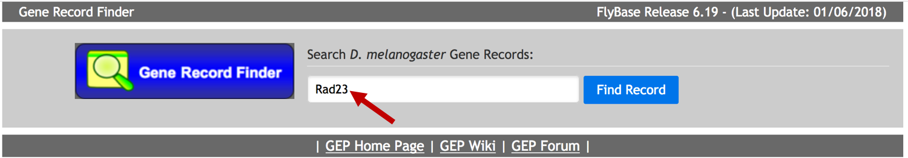
Figure 13. Retrieve the D. melanogaster record for Rad23 from the Gene Record Finder.
Consistent with the FlyBase blastp search results, the “mRNA Details” section of the Gene Record Finder record indicates that there are three isoforms (A, B, and C) of Rad23 (Figure 14).
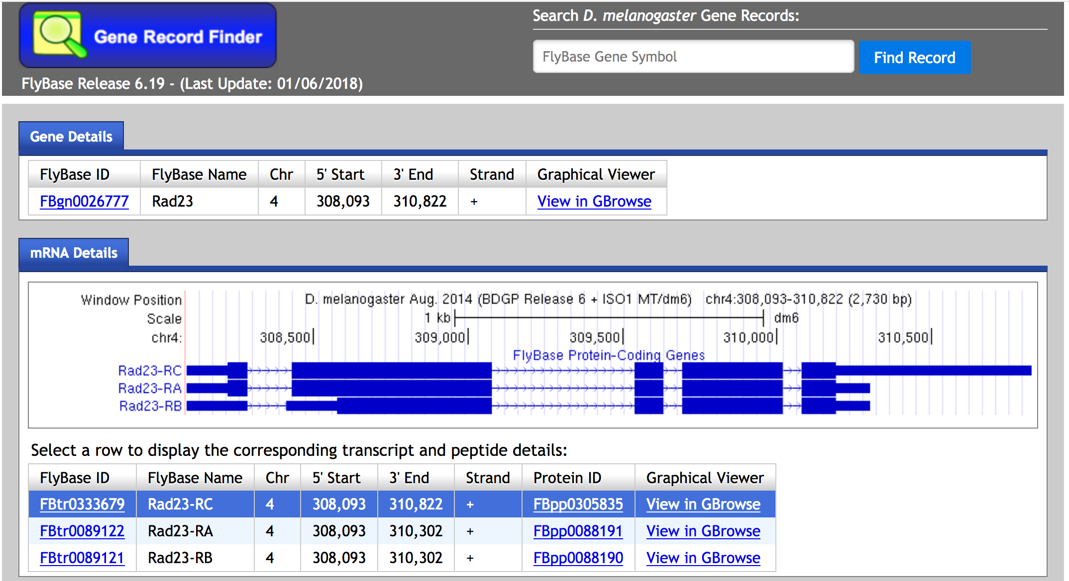
Figure 14. The “mRNA Details” section of the Gene Record Finder provides a graphical overview of the isoforms associated with the gene in D. melanogaster. The thick boxes correspond to coding exons, the thinner boxes correspond to untranslated regions, and the lines correspond to introns.
In Drosophila, the part of the isoform name before the last hyphen corresponds to the gene symbol, and the part of the name after the last hyphen corresponds to the isoform (e.g., A, B, and C). The isoform letter is preceded by either “-R” (mRNA) or “-P” (protein). Hence Rad23-RA is the mRNA for the A isoform of Rad23 while Rad23-PA is the protein for the A isoform of Rad23.

The “CDS usage map” in the “Polypeptides Details” section shows the set of coding exons (CDS) used by each isoform (Figure 15). The coding exons are listed from 5’ to 3’ end of the gene from left to right. The CDS usage map shows that the C and A isoforms of Rad23 have five coding exons, and the coding regions for these two isoforms are identical. The B isoform of Rad23 only has four coding exons, and it differs from C and A isoforms at the N-terminus of the protein (it uses the CDS 3_2320_0 instead of CDS 1_2320_0 and 2_2320_0.

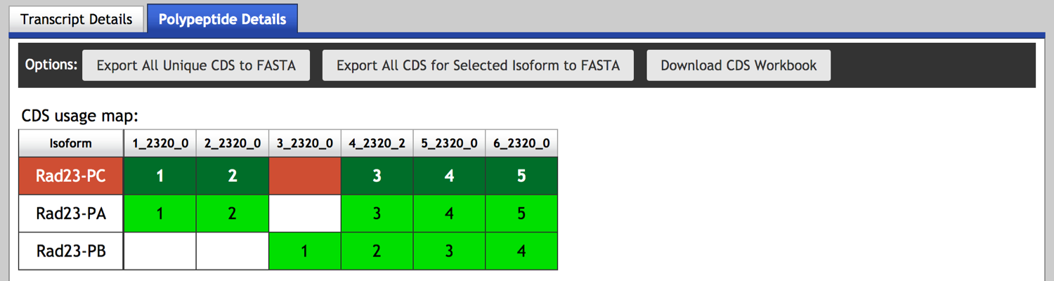
Figure 15. The Gene Record Finder CDS usage map shows the set of coding exons used by each isoform of Rad23. Each column of the CDS usage map corresponds to an unique coding exon.

Determine the approximate locations of each coding exon
We will use the gene structure information for Rad23 in D. melanogaster to facilitate the annotation of the Rad23 ortholog in D. miranda. The annotation strategy is based on parsimony, which seeks to minimize the number of changes between the D. melanogaster Rad23 gene and the D. miranda ortholog.

We will first construct the orthologous gene model for Rad23-PC. To begin the analysis, we will determine the approximate placements of the five coding exons of Rad23-PC using blastx searches. We will then examine the regions near the ends of the blastx alignments to identify the start codon, stop codon, and the splice donor and acceptor sites.

By default, the Rad23-PC isoform should be selected in the CDS usage map (highlighted in red). (If another isoform is selected, click on the Rad23-PC row in the CDS usage map to switch to this isoform.) The CDS 2_2320_0 is the largest (216 aa) among the five coding exons of Rad23-PC. Click on the “2_2320_0” row in the CDS Sequence table obtain the amino acid sequence for this CDS (Figure 16). Select the sequence in the “Sequence viewer” and copy it onto the clipboard.

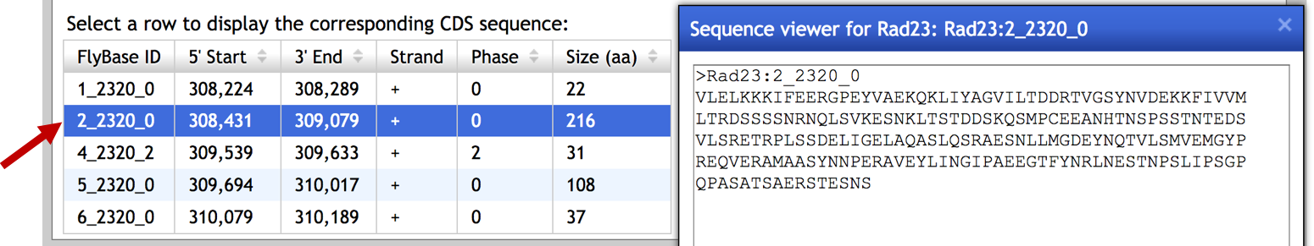
Figure 16. Click on a row in the CDS Sequence table of the Gene Record Finder to obtain the amino acid sequence for the CDS.

To determine the placement of this coding exon in D. miranda scaffold_6, open a new web browser tab and navigate to the NCBI BLAST home page. Click on the blastx image (Figure 17).

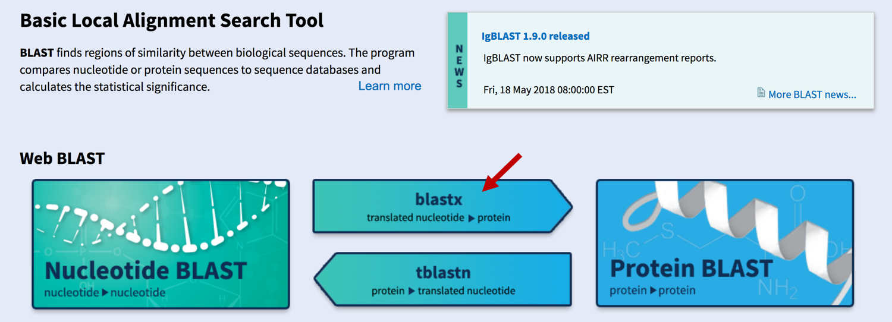
Figure 17. Access the blastx search program from the NCBI BLAST home page.
Select the “Align two or more sequences” checkbox. Paste the sequence for CDS 2_2320_0 into the “Enter Subject Sequence” textbox. The scaffold_6 sequence is identical to the sequence record CM001521 in GenBank (it was relabeled by the “rename the scaffolds” tool). Hence we can enter the accession number “CM001521” into the “Enter Query Sequence” textbox instead of the sequence for the entire scaffold. In addition, we can limit the search region to 799,000..804,000 by entering “799000” in the “from” field and “804000” in the “to” field under the Query subrange section (Figure 18).

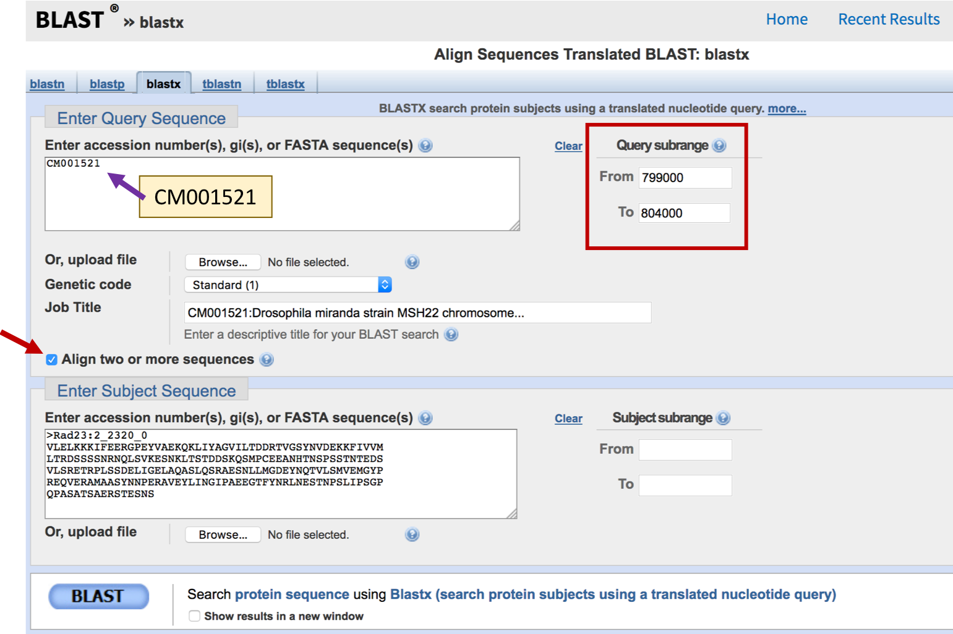
Figure 18. Select the “Align two or more sequences” option in the blastx interface to compare CM001521 (i.e. scaffold_6; query) against the D. melanogaster CDS 2_2320_0 (subject). Use the Query subrange fields to limit the search region to 799,000–804,000.

In addition, we will adjust two additional BLAST parameters to increase the sensitivity of the blastx search. Click on the “Algorithm parameters” header to expand this section. Change the “Compositional adjustments” field to “No adjustment” and uncheck “Low complexity regions” under the “Filter” field (Figure 19). Click on the “BLAST” button to run the search.

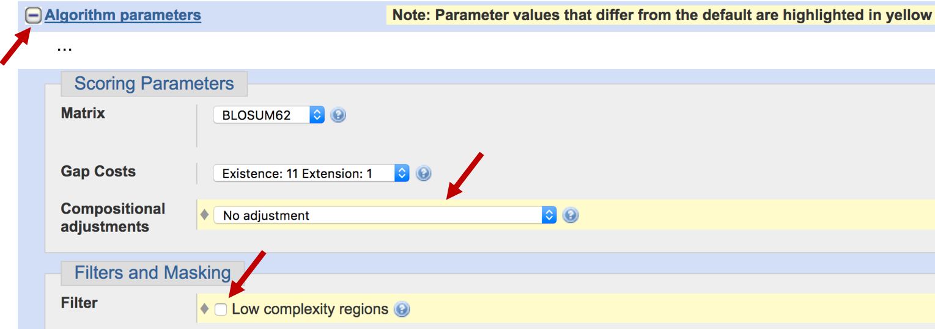
Figure 19. Turn off the compositional adjustments and the low complexity regions filter under the “Algorithm parameters” section.
The blastx search result placed CDS 2_2320_0 at 801,935–802,618 in frame +2 (with an E-value of 9e-73). The blastx alignment covers 215 out of 216aa of the CDS (Figure 20).

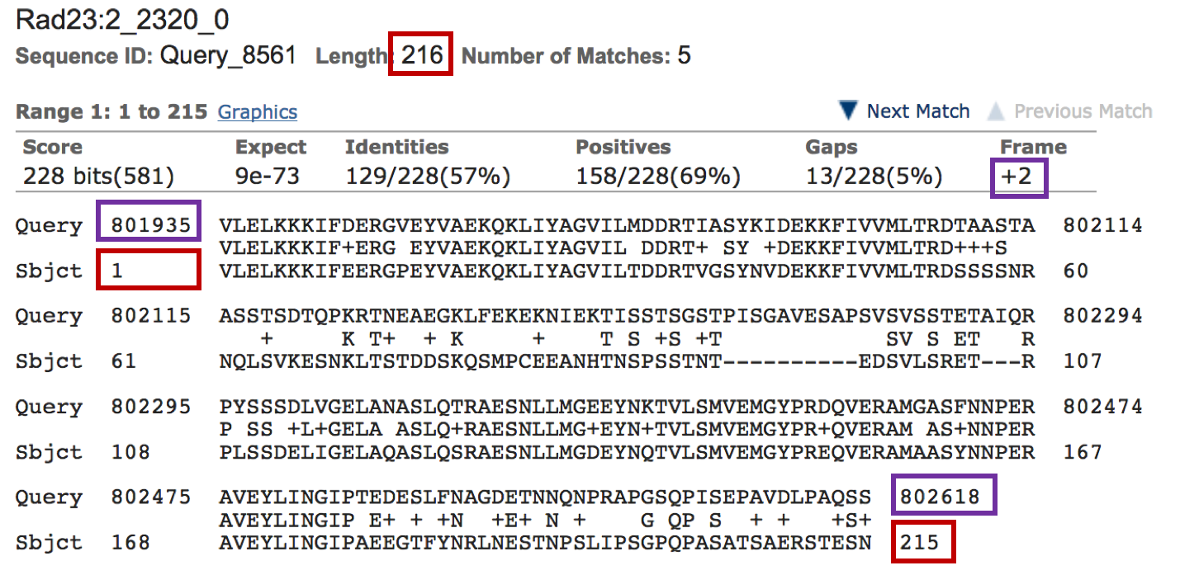
Figure 20. The blastx of D. melanogaster CDS 2_2320_0 (subject) against D. miranda scaffold_6 (query) placed this CDS at 801,935-802,618 in frame +2. The alignment covers the entire CDS except for the last amino acid.

We can apply the same procedure to place the rest of the coding exons onto scaffold_6. The results of all the blastx searches of the Rad23 CDSs (subject) against scaffold_6 (query) are summarized below:

FlyBase ID | Query start | Query end | Frame | Coverage
1_2320_0 | 800821 | 800886 | +1 | 22/22
2_2320_0 | 801935 | 802618 | +2 | 215/216
4_2320_2 | 802700 | 802792 | +2 | 31/31
5_2320_0 | 802845 | 803180 | +3 | 108/108
6_2320_0 | 803244 | 803354 | +3 | 37/37

Use the Annotator Panel to determine exon coordinates
We can use the CDS blastx search results to construct the D. miranda Rad23-PC gene model in Apollo. Go back to the web browser tab with Apollo. Right click (control-click on macOS) on the scaffold_6.g56.t1-00001 gene model and then select the “View in Annotator Panel” option (Figure 21). The right panel will switch to the “Annotations” tab, and the entry “scaffold_6.g56.t1-00001” will appear in green next to the “mRNA” type. (If the entry is missing but the blue “scaffold_6.g56.t1” gene name is listed in the Annotations panel, click on the left arrow at the end of the row to expand the section and view the list of transcripts associated with the gene.)
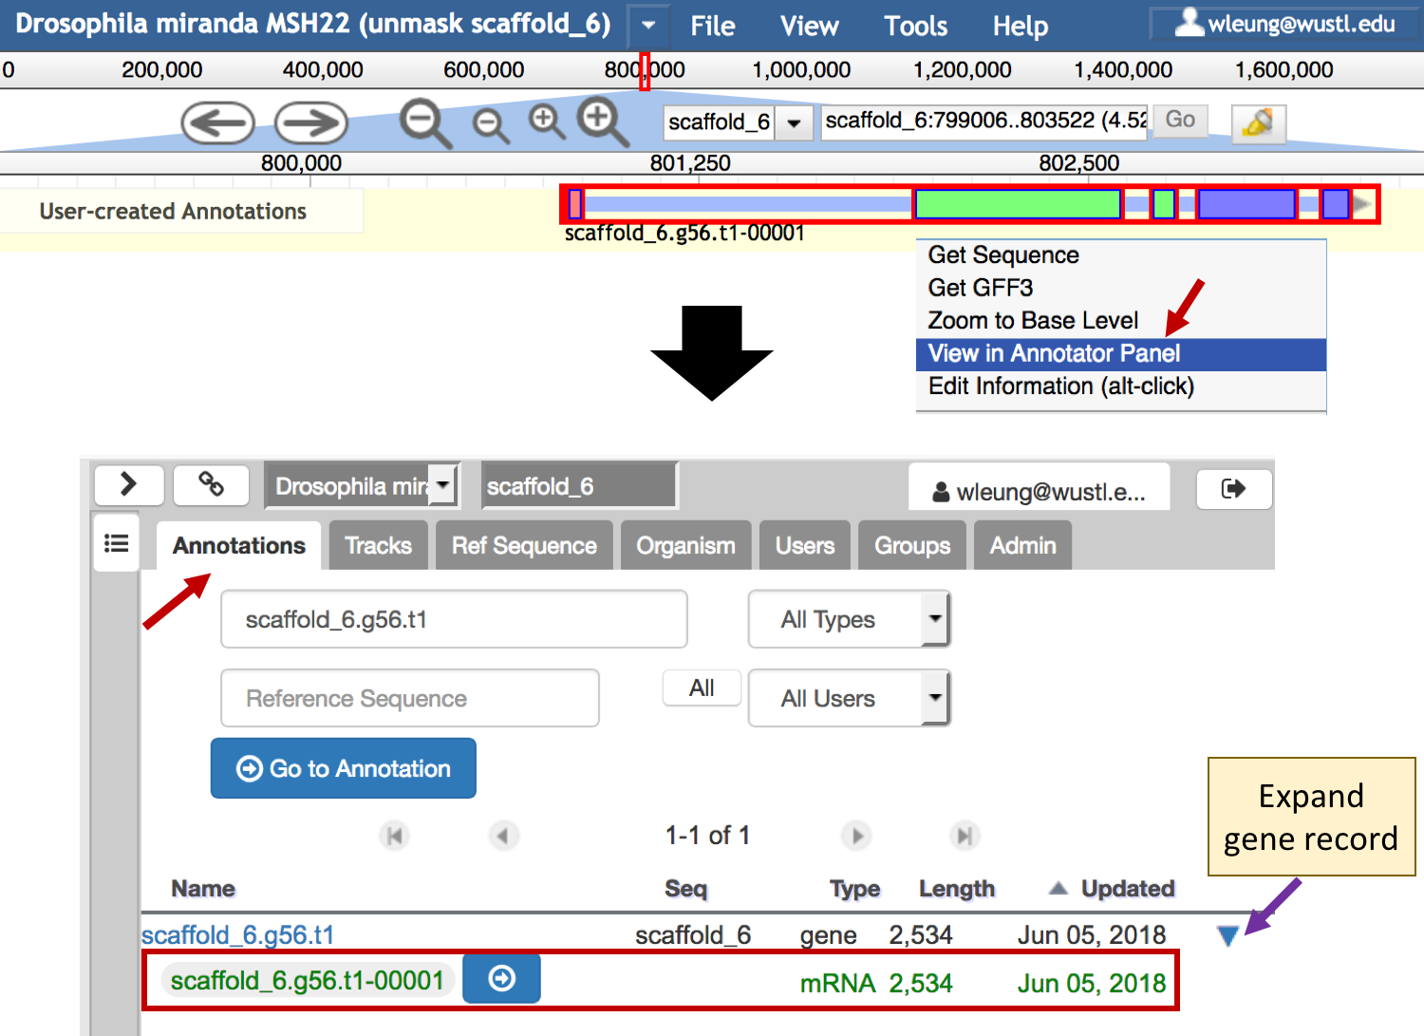
Figure 21. View the scaffold_6.g56.t1-00001 mRNA record in the Annotator Panel.

Click on the green “scaffold_6.g56.t1-00001” button under the “Name” column. The “Details” panel will appear at the bottom right corner which shows the name, description, location, reference sequence, and owner associated with this feature (Figure 22).

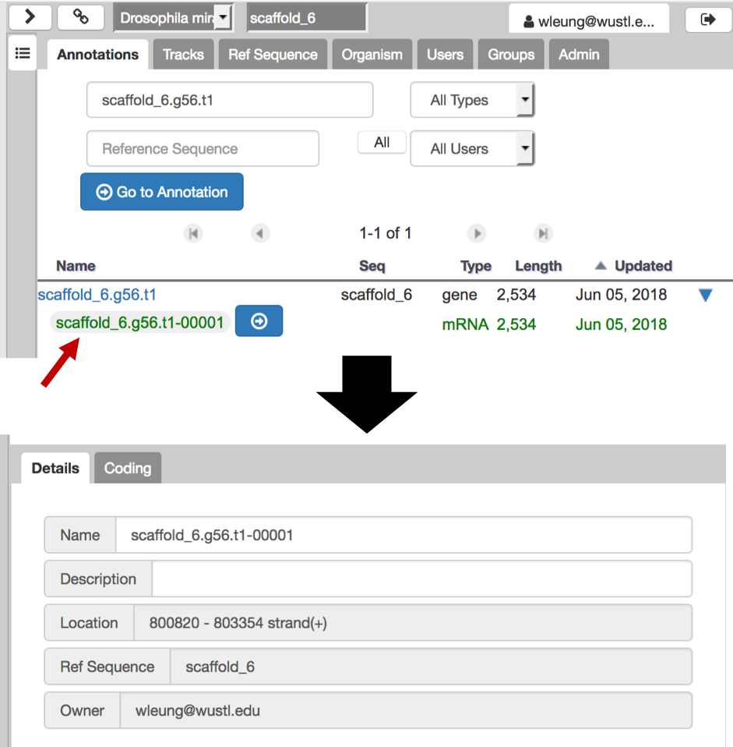
Figure 22. Click on the green “scaffold_6.g56.t1-00001” button to view the transcript details.
Click on the “Coding” tab to switch to the list of exon coordinates. To facilitate interpretation of these exon coordinates, click on the “Start” column header to sort the exons by their minimum coordinates (i.e., the 5’ end of the exon for a gene on the plus strand; the 3’ end of the exon for a gene on the minus strand). Select the first row to view the “5’ End” and the “3’ End” coordinates of the first exon (Figure 23).

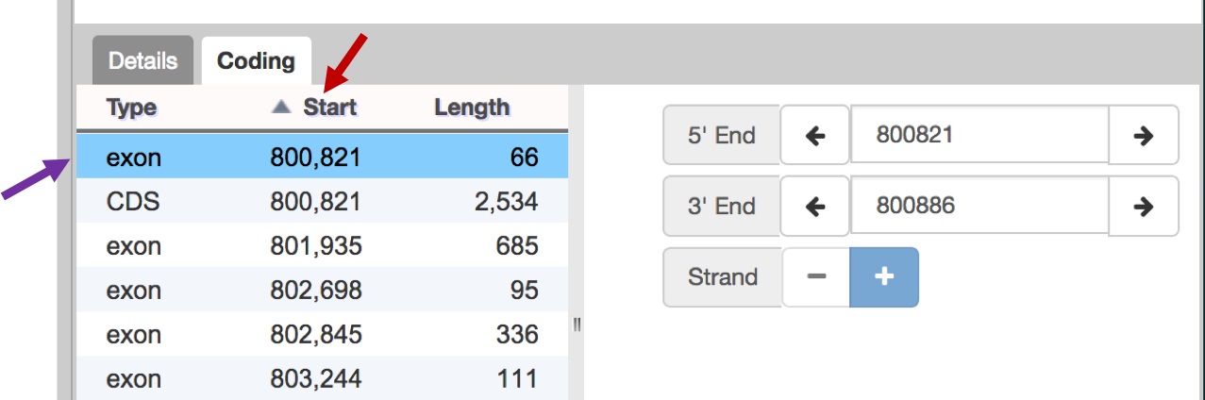
Figure 23. Click on the “Start” column header (red arrow) to sort the exons by their minimum coordinates in ascending order. Click on a row in the “Coding” table to view the coordinates for the exons. The controls on the right panel (left and right arrows, text box) can be used to modify the exon coordinates.
Note that the “CDS” entry in this table corresponds to the coding span (i.e., region from start codon to stop codon, including introns). In this example, the coding span for scaffold_6.g56.t1-00001 range from 800,821– 803,354.

Annotate the donor site for the first coding exon in Apollo
Examination of the coordinates for the “exon” features in the “Coding” table shows that the coordinates are similar to the coordinates that we have obtained via the blastx searches of the CDSs from Rad23-PC. We will navigate to the ends of each coding exon of Rad23-PC in Apollo to verify the locations of the splice acceptor and donor sites.

The full-length blastx alignment for CDS 1_2320_0 begins with a methionine at 800,821 and ends at 800,886 in frame +1 (Figure 24).

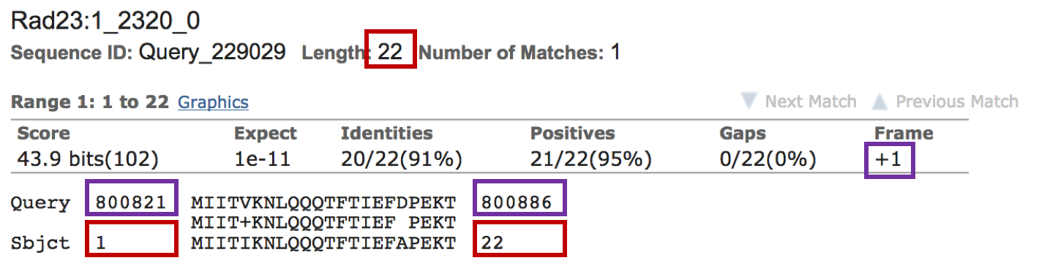
Figure 24. The blastx alignment of CDS 1_2320_0 (subject) against scaffold_6 (query).

To identify the splice donor site for this CDS, enter “scaffold_6:800875..800900” into the position text box and then click “Go”. A “Reference Sequence” track will appear which shows the nucleotide sequences and the corresponding amino acid translations in the three reading frames for the plus and minus strands.

Because the Rad23 gene is on the plus strand, we will hide the minus strand sequence and amino acid translations from the genome browser. Right click (control-click on macOS) on base 800,886 in the nucleotide sequence of the “Reference sequence” track. Select the “Toggle Reverse Strand” option (Figure 25).

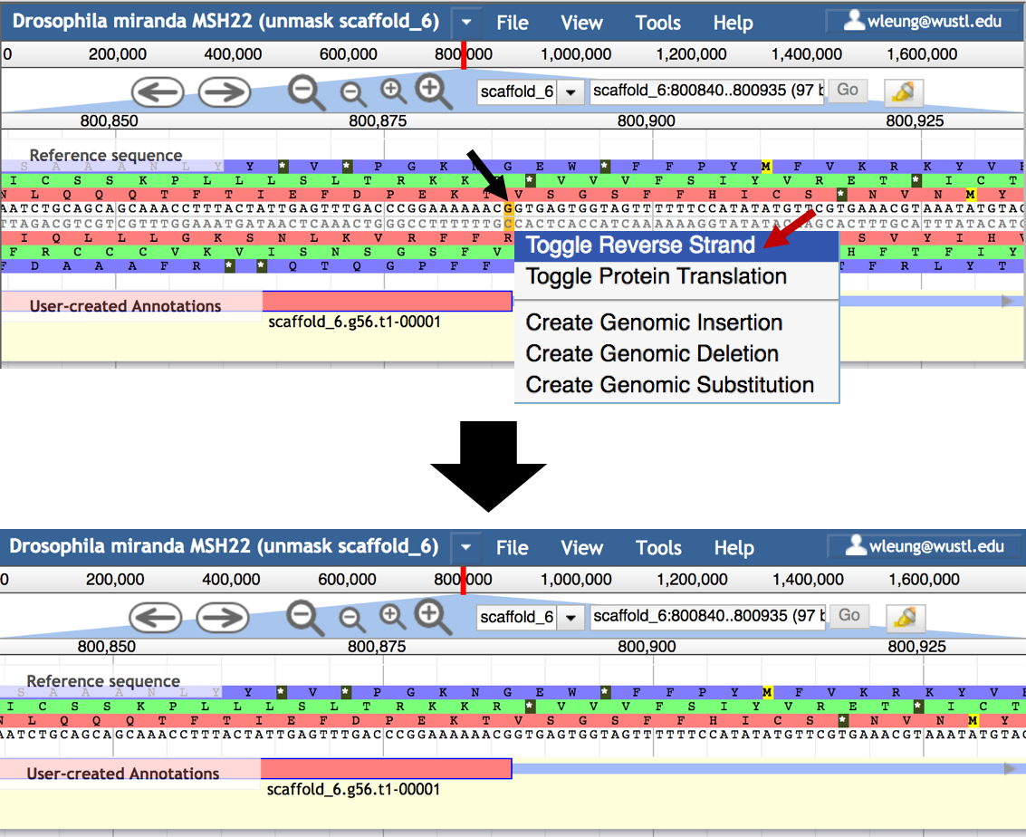
Figure 25. Hide the minus strand sequence and amino acid translations from the “Reference sequence” track.

When the “Color by CDS frame” option is enabled (available under the “View” menu; enabled by default), the three reading frames are represented by different colors (red = frame 1, green = frame 2, blue = frame 3). In addition, methionines are highlighted in yellow, and stop codons (*) are in gray. Selecting an exon in the User-created Annotations track will add the nucleotide sequence to the exon. When the mouse hovers in the base position row, a red line will appear along with a tooltip which shows the base position (Figure 26).

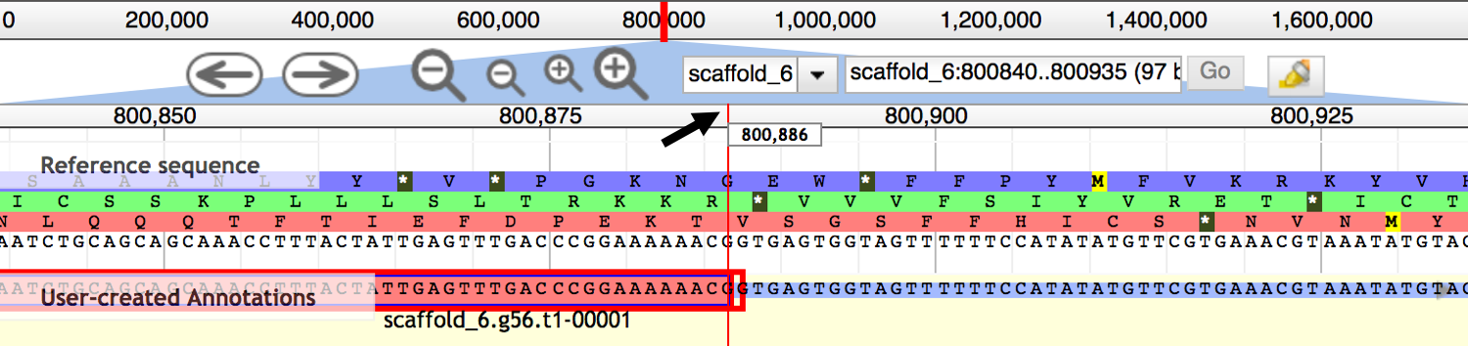
Figure 26. Hover the mouse over the ruler to show the scaffold position.

An intron begins with a splice donor site and ends with a splice acceptor site. The splice donor site has the consensus sequence GT and the splice acceptor site has the consensus sequence AG. The GC non-canonical splice donor site appears at approximately 1% of the unique introns in D. melanogaster (FlyBase release 6.19).

In addition to the canonical sequences for the splice donor and acceptor sites, we must also take the phases of the splice donor and acceptor sites of adjacent exons into account in order to maintain an open reading frame after the intron is removed. A codon could form by combining the nucleotides from adjacent exons after splicing. The number of nucleotides between the last complete codon and the splice donor site is called the donor phase. The number of nucleotides between the splice acceptor site and the first complete codon is the acceptor phase. Hence the phases of the donor and acceptor sites are predicated on the reading frame of the coding exons.

The sum of the donor phase and acceptor phase must be 0 (no additional codon) or 3 (an additional codon). Hence a phase 0 donor site is compatible with a phase 0 acceptor site, a phase 1 donor is compatible with a phase 2 acceptor site, and a phase 2 donor is compatible with a phase 1 acceptor site. Incompatible splice donor and acceptor sites will result in a frame shift in the downstream coding exons.

The blastx alignment to CDS 1_2320_0 ends at 800,886 on scaffold_6, and the coding exon is in the +1 frame. Examination of the “Reference sequence” track shows that there are no extra nucleotides between the end of the last complete codon at 800,886, and the splice donor site at 800,887–800,888. Hence this GT splice donor site is in phase 0 (Figure 27).

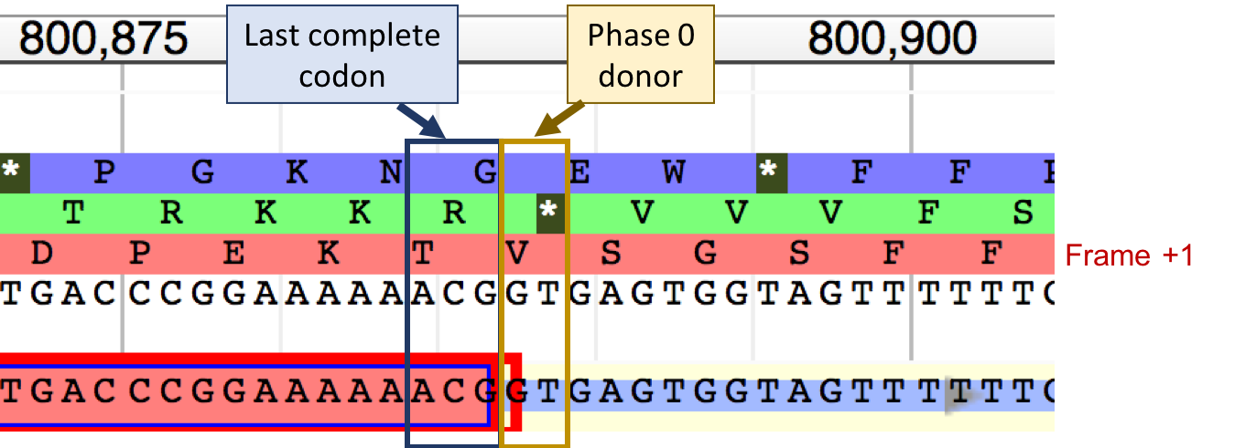
Figure 27. The splice donor site at 800,887–800,888 is in phase 0 relative to frame +1.
By contrast, the GT at 800,891–800,892 is a phase 1 donor site relative to frame + 1 because there is an A between the last complete codon GTG, and the GT donor site (Figure 28).

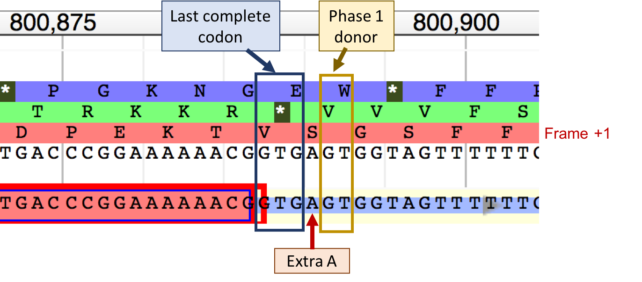
Figure 28. The GT at 800,891–800,892 is a phase 1 donor site relative to frame +1.

We can modify the exon coordinates by dragging the end of the exon to a different position. Move the mouse to the end of the exon in the “User-created Annotations” section. The mouse icon will change to a vertical bar with an arrow pointing to the right ( ). For demonstration purposes, we will extend the exon by two nucleotides so that the exon ends at 800,888. Press and hold the mouse button and then drag the mouse to position 800,888. Release the mouse button and the exon will be extended to 800,888. Apollo will automatically validate the new gene model, and an exclamation point will appear next to the end of the exon because the next two nucleotides (GA) is a non-canonical splice donor site (Figure 29).

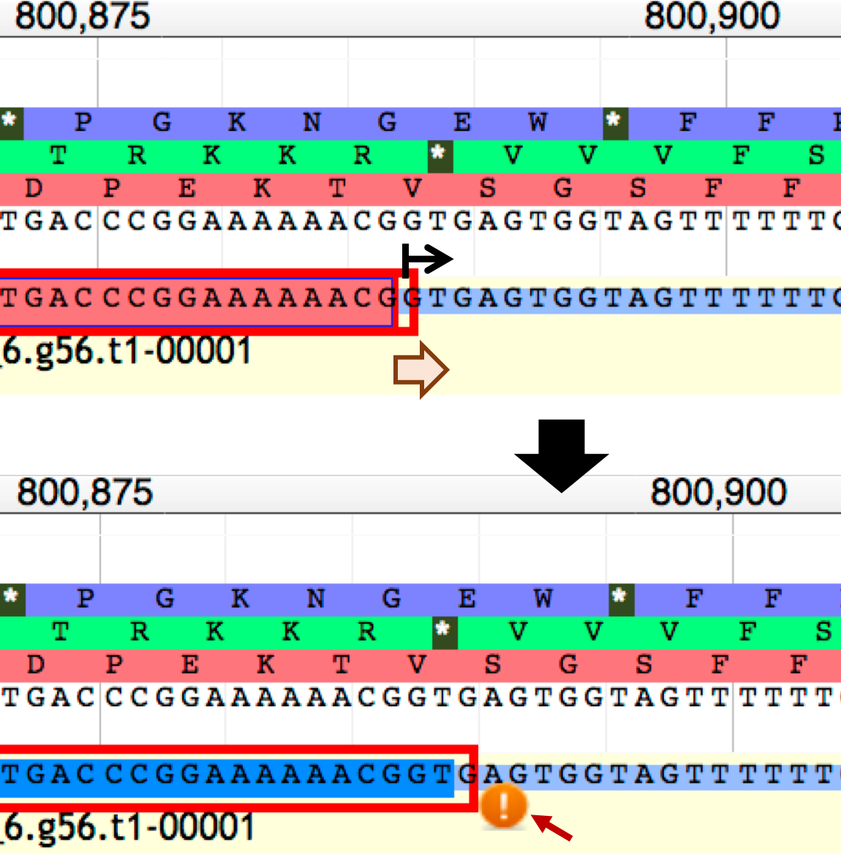
Figure 29. Extend the end of the first coding exon from 800,886 to 800,888.
In addition to validating splice sites, Apollo will also automatically re-calculate the coding span in order to maximize the size of the coding region.

To undo the change that we have just made, right click on the scaffold_6.g56.t1-00001 gene model and then select the “Undo” option (Figure 30).

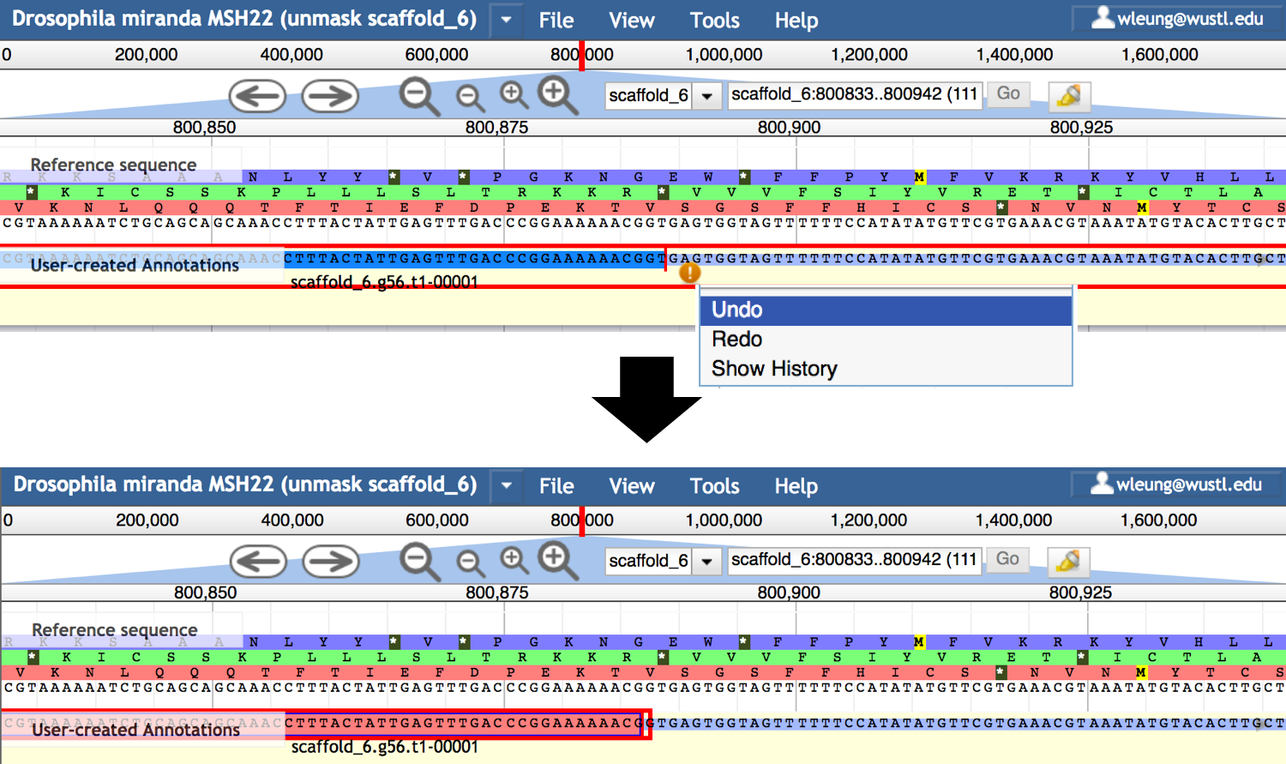
Figure 30. Select “Undo” from the context menu to revert the end position of the first coding exon to 800,886.
Apollo will automatically keep track of all the changes that we have made to the gene model. Right click (control-click on macOS) on the gene model and select the “Show History” option to review the history of changes. The “Show History” panel also allow us to revert to the past versions of the gene model.

Annotate the acceptor site for the second coding exon in Apollo
Our analysis of CDS 1_2320_0 has placed the end of this coding exon at 800,886 with a phase 0 donor site. In order for the next CDS (2_2320_0) to be compatible with this splice donor site, its splice acceptor site must be in phase 0. The blastx alignment for CDS 2_2320_0 begins at 801,935. Hence we will search for a phase 0 acceptor site surrounding this region.

Enter “scaffold_6:801920..801950” into the position text box and then click “Go”. Examination of the region surrounding 801,935 shows a splice acceptor site at 801,933–801,934. Because the blastx search result for CDS 2_2320_0 indicates that the coding exon is in frame +2, this splice acceptor site is in phase 0 (Figure 31). Hence this splice acceptor site is compatible with the phase 0 donor site for CDS 1_2320_0. Because there is an in-frame stop codon at 801,932–801,934, there are no alternative splice acceptor site candidates available. Consequently, we will place the start of CDS 2_2320_0 at 801,935.

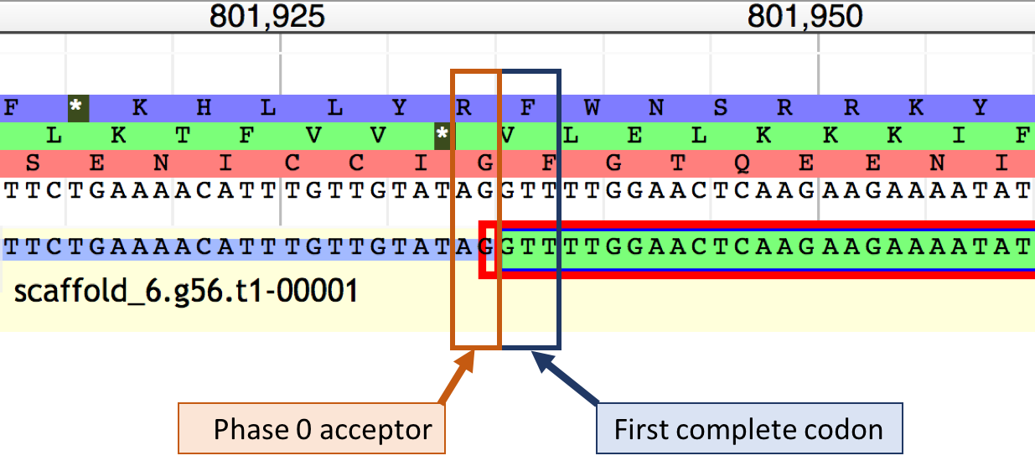
Figure 31. Phase 0 acceptor site for CDS 2_2320_0 at 801933–801934.

Exercise:
Using the strategy described above, analyze the remaining splice donor acceptor sites for the Rad23-PC ortholog in D. miranda. What are the set of coding exon coordinates for your final gene model?

Add metadata to the gene annotation
In addition to recording the exon coordinates, we can also add metadata to the gene annotation. Right click on your final gene model for the Rad23-PC ortholog, and then select the “Edit Information (alt-click)” option (Figure 32).

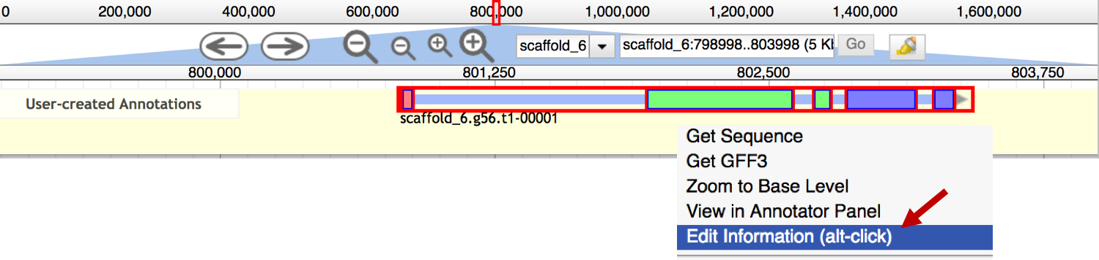
Figure 32. Edit the metadata associated with the gene model.
The Information Editor window is divided into two sections. The left panel contains the information associated with the gene, while the right panel contains the information for a specific isoform. For example, we can change the “Name” field for the gene to “Dmir_Rad23”, and change the “Name” field for the mRNA to “Dmir_Rad23-RC”. When you close the Information Editor, the new isoform name will appear underneath the gene model (Figure 33).

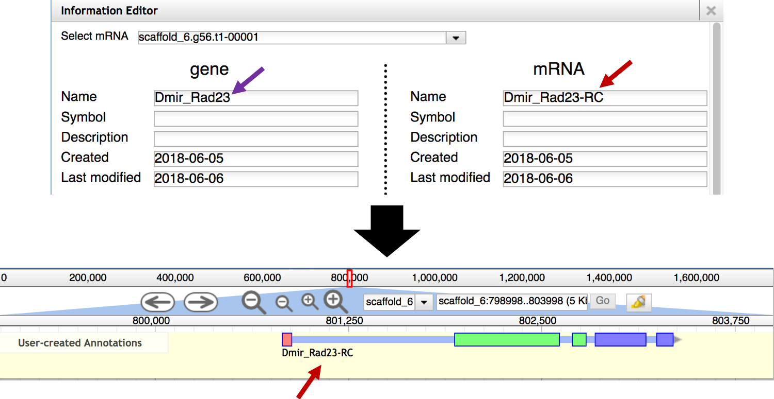
Figure 33. Change the gene and mRNA names associated with a user-created annotation.

In addition to changing the gene and mRNA names, we can use the Information Editor to add external database references (DBXRefs), attributes, PubMed IDs, Gene Ontology IDs, and Comments to the gene annotation.

Conclusion
This walkthrough uses the annotation of the putative ortholog of Rad23-PC in D. miranda to illustrate some of the key features of Apollo. We constructed an initial gene model based on the Augustus gene prediction scaffold_6.g56.t1. We then compare the protein sequence for this gene model against the Annotated proteins database at FlyBase with blastp to identify the putative ortholog (i.e., Rad23).

Using the Gene Record Finder, we determined the gene structure of Rad23 and the set of unique coding exons for Rad23-PC. We then performed CDS-by-CDS blastx searches to estimate the locations of the five CDSs of Rad23-PC. Using Apollo, we examined the regions near the ends of the blastx alignments to identify compatible splice donor and acceptor sites. These analyses enable us to construct the final gene model for the Rad23-PC ortholog in D. miranda.

