Set up a collaborative annotation environment on Apollo for Drosophila biarmipes

Yating Liu
07/2018

Table of Contents
1. Log into Apollo 2
2. Use the Apollo User Manager to create an annotation user group 3
3. Run the G-OnRamp workflow for JBrowse to create a D. biarmipes JBrowse Archive 4
4. Use the “Create or Update Organism” tool to create a D. biarmipes Apollo workspace 7
5. Create user accounts for the collaborative annotators 8
6. Add the annotators to the user group 10
7. Go to Apollo to check the settings and start genome annotation 11
Appendix A: Create an instructor account on Apollo with the “Apollo User Manager” tool 13

Introduction
The Apollo genome annotation editor provides a platform for real-time collaborative annotation of eukaryotic genomes. G-OnRamp provides the tools for instructors and researchers to create Apollo workspaces for genome annotation, and to manage the Apollo user accounts of other annotators (e.g., collaborators and students). In this walkthrough, we will set up an Apollo instance to facilitate the collaborative annotation of the Muller F element of Drosophila biarmipes.

In order to use the G-OnRamp tools to interact with Apollo, the system administrator of the G-OnRamp instance must first create Apollo accounts with instructor privileges (see Appendix A for details). For the G-OnRamp workshop, we have already created the instructor account for you on Apollo.

1. Log into Apollo
Open a new web browser window and navigate to the G-OnRamp Apollo instance at http://cloud5.galaxyproject.org/apollo. Log into Apollo with the Email address you used for your G-OnRamp Galaxy account, and the (default) password “1234” (Figure 1).

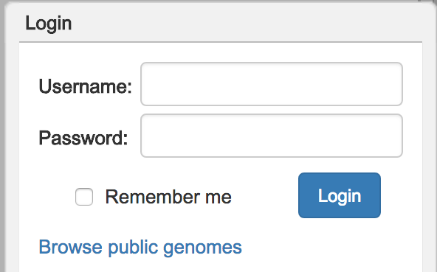
Figure 1: Enter the Email address for your G-OnRamp Galaxy account in the “Username” field, the default password “1234” in the “Password” field, and then click on "Login".
To change your password, click on the user icon ( ) at the top right corner of the “Annotation Panel” (Figure 2), and then enter your new password in the “Edit password” window (Figure 3).

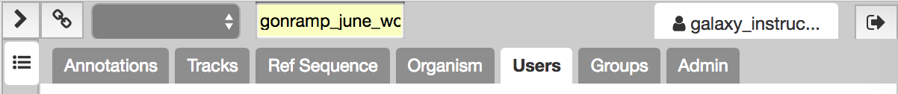
Figure 2: Click on the user icon (red arrow) to open the password editing window

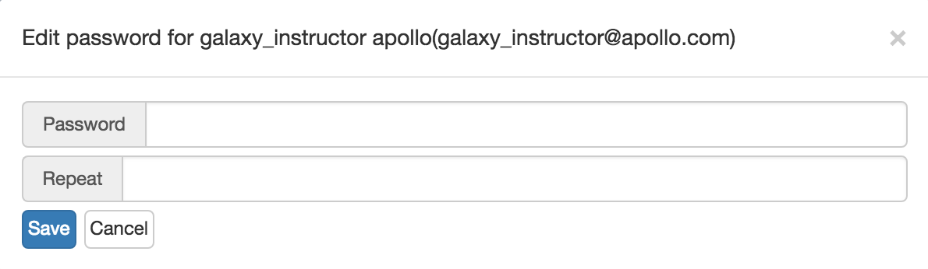
Figure 3: In the password editing window, enter a new password in the “Password” field, and then enter the same password in the “Repeat” field. Click on the “Save” button to change your password.

2. Use the Apollo User Manager to create an annotation user group
To control access to multiple genome databases hosted in a single Apollo instance, the administrator or instructor can set the permissions to administer, read, write, and export the data for each genome database. Instead of managing the permissions for each Apollo user separately, user permissions can be controlled at the group level where all members of a user group have the same set of permissions. Each Apollo user can belong to one or more groups.

G-OnRamp provides the Apollo User Manager tool to manage the Apollo user accounts of collaborators in a genome annotation project. In this walkthrough, we will put the annotators for the D. biarmipes Muller F element project into a new user group so that we can manage the permissions for all of these users together.

Open a new web browser window. Go back to the G-OnRamp Galaxy instance at http://cloud5.galaxyproject.org and log in. Search for the “Apollo User Manager” tool on the left “Tools” panel and then click on the link to open the tool (Figure 4).

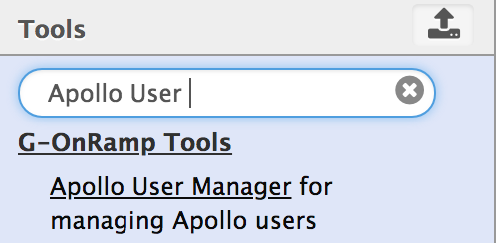
Figure 4: Enter “Apollo User Manager” into the search box of the Tools panel, and then click on the “Apollo User Manager” link (red arrow) to open the tool.
Click on the “Insert New operation” button to open an operation configuration block (Figure 5). Select the “Create a user group” option followed by the “Single user group” option to create one user group. Enter “D. biarmipes annotation” into the “Group name” field. Because this operation will fail if the user group already exists in Apollo, we will make the group name unique by appending your last name and first name to the group name. For example, if your name is Jane Smith, then the group name should be changed to “D. biarmipes annotation (Smith, Jane)”. Click on the “Execute” button to create a new user group (Figure 6).

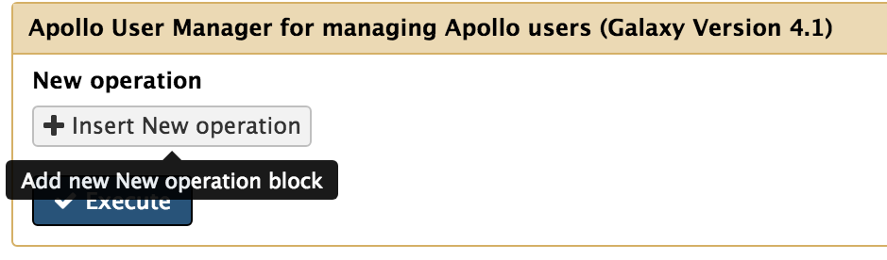
Figure 5: Click on the "Insert New operation" button to open an operation configuration block.

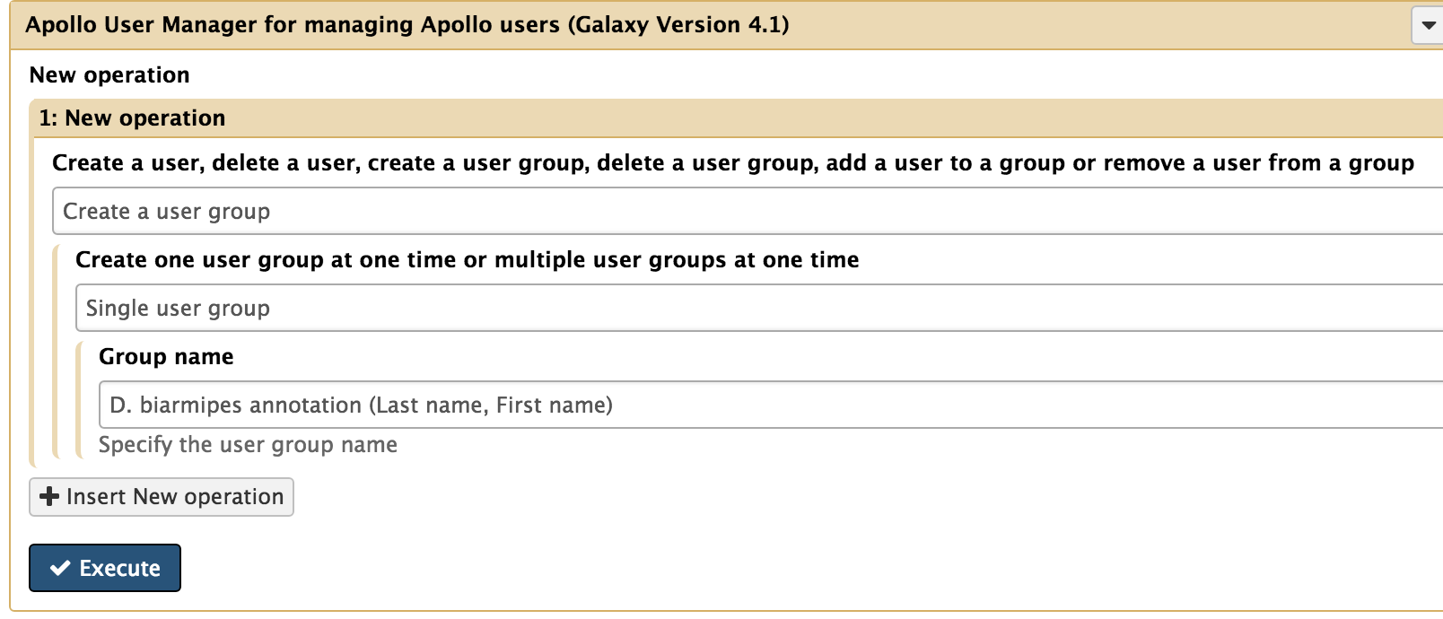
Figure 6: Choose "Create a user group" from the first drop-down menu and then select “Single user group” from the second drop-down menu to create one user group. Enter the group name into the “Group name” field. (Replace “Last name” and “First name” in the “Group name” field with your last name and first name.) Click on the “Execute” button.

3. Run the G-OnRamp workflow for JBrowse to create a D. biarmipes JBrowse Archive
Because Apollo is a JBrowse plug-in, we will need to create the JBrowse Archive for the D. biarmipes Muller F element region before we can create the Apollo workspace. First, we will create a new History by clicking on the “History options” ( ) button at the top right corner of the History panel and choose “Create New” from the drop-down menu.

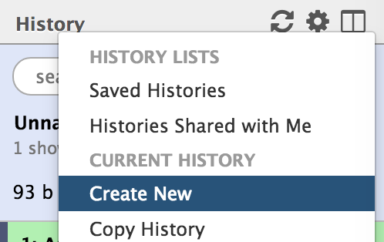
Figure 7: Create a new History by clicking on the "History options” button (red arrow) and then select “Create New”.

The G-OnRamp workflow for JBrowse has been shared with you in the “Shared Data”. Click on “Shared Data” in the menu bar and select “Workflows” in the drop-down menu to access the published workflows available on the G-OnRamp instance. Find the “G-OnRamp workflow for JBrowse” entry and click on the down arrow to open the drop-down menu. Click on the “Import” option to import this workflow into your Galaxy account (Figure 8).

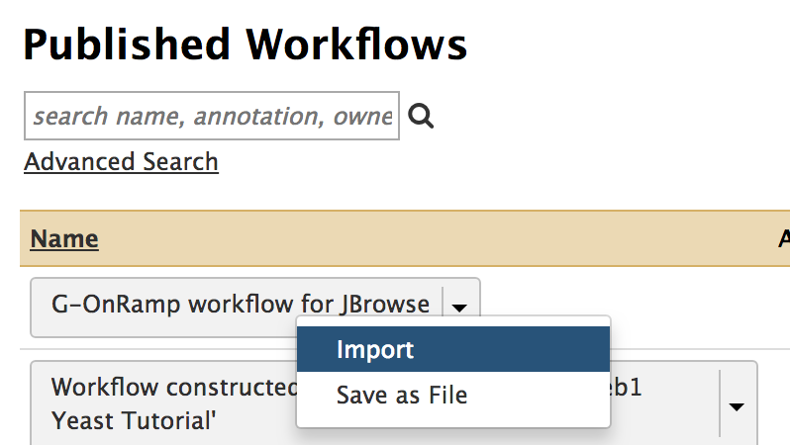
Figure 8: Click on the down arrow next to the "G-OnRamp workflow for JBrowse” entry, and then click on “Import” from the drop-down menu to import the workflow.
The test datasets that we will use in this walkthrough are available in the “Data Libraries”. Click on the “Shared Data” menu item on the menu bar and then select “Data Libraries” in the drop-down menu. Click on the “Intro_G-OnRamp” link. You will see five datasets in the folder. Select all the datasets by selecting the checkbox before the “name” column header. Click on the “To History” button, select “as Datasets”, and then click on the “Import” button to copy all the files to the current History.

Click on the “Workflow” menu item on the menu bar to access all your workflows. Click on the “imported: G-OnRamp workflow for JBrowse” button and select “Run” from the drop-down menu to run the workflow.

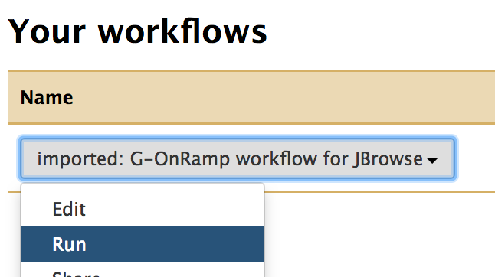
Figure 9: Click on the drop-down menu of the “imported: G-OnRamp workflow for JBrowse” workflow, and then select the “Run” option to run the workflow.
In order to run the workflow, you need to specify the input datasets that should be used for the “Reference genome”, “mRNA GenBank records”, “Protein Query Sequence”, “RNA-Seq: Forward reads” and “RNA-Seq: reverse reads”. You should also specify the model organism for each gene prediction tool [Augustus, GlimmerHMM and SNAP]. (See section 4.2 of the “Introduction to G-OnRamp Walkthrough” for details on the tool parameters and input datasets.) Scroll down to the JBrowse Archive Creator step and change the “JBrowse Hub Name” field from “Unknown” to “D.biarmipes” (Figure 10). Finally, click on the “Run workflow” button at the top right corner of the page.

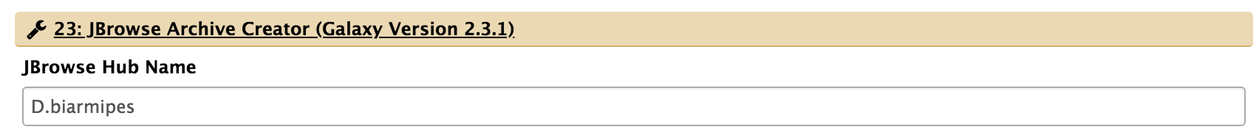
Figure 10: Scroll down to the JBrowse Archive Creator step and enter “D.biarmipes” in the “JBrowse Hub Name” field to change the name of the JBrowse Archive.
This workflow will take several minutes to complete. After all the steps in the G-OnRamp workflow have been completed (i.e., turned green), we get the D. biarmipes JBrowse Archive created by JBrowse Archive Creator in the last step (step 28). If you want to view the assembly on JBrowse, click on “28: JBrowse Archive Creator” to expand the History item and click on the “Display with JBrowse” link (Figure 11).

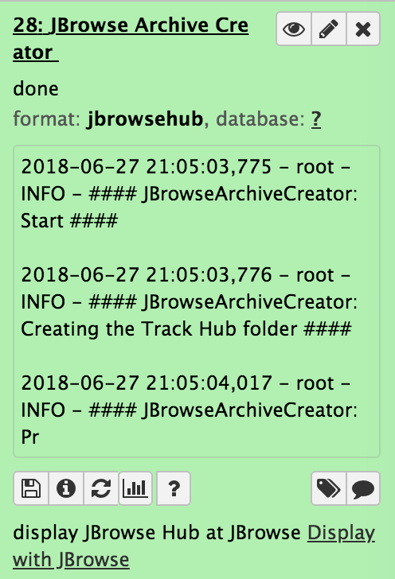
Figure 11: A JBrowse Archive for D. biarmipes is created by JBrowse Archive Creator in the last step of the “imported: G-OnRamp workflow for JBrowse” workflow. Click on the link for the “JBrowse Archive Creator” item and then click on “Display with JBrowse” (red arrow) to visualize the JBrowse Archive on JBrowse.

4. Use the “Create or Update Organism” tool to create a D. biarmipes Apollo workspace
We will use the “Create or Update Organism” tool to create a new Apollo workspace from the D. biarmipes JBrowse Archive. Search for the “Create or Update Organism” tool in the Tools panel and open the tool.

Select the History item named “JBrowse Archive Creator” as the input to the “JBrowse HTML Output” field. Select “Direct Entry” for the “Organism Common Name Source” field so that we can specify the name of the Apollo workspace in the “Organism Common Name” text box. (Apollo uses the term “Organism” to refer to the workspace associated with the organism.)

Because Apollo requires the “Organism Common Name” to be unique, we will append your first and last name to this field. For example, if your name is Jane Smith, then the “Organism Common Name” field should be changed to “D. biarmipes (Smith, Jane)”. Click on “Insert Group” to open a group permission configuration block (Figure 12).

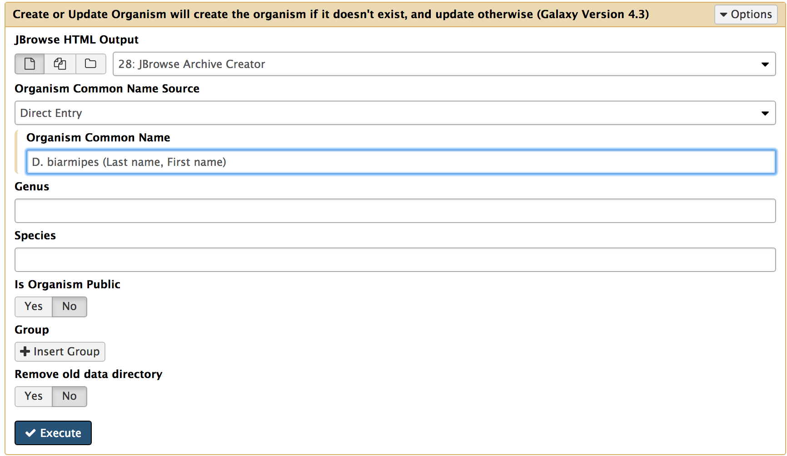
Figure 12: Specify the JBrowse Archive as the input for “JBrowse HTML Output”, then select “Direct Entry” and type the name you like for the Apollo workspace (organism). (Replace the “Last name” and “First name” in the “Organism Common Name” field with your last name and first name.) Click on the “Insert Group” button to configure the group permissions for this Apollo workspace.
Select the user group you have previously created in Step 2 from the drop-down menu for the “Grant access to a user group” field. Under the “Permissions to the organism” section, select the checkboxes next to “Write”, “Read”, and “Export” in order to give all users in this user group permission to create, view, and export gene annotations from this workspace (Figure 13). Click on the “Execute” button to create the workspace and grant permissions to the user group.

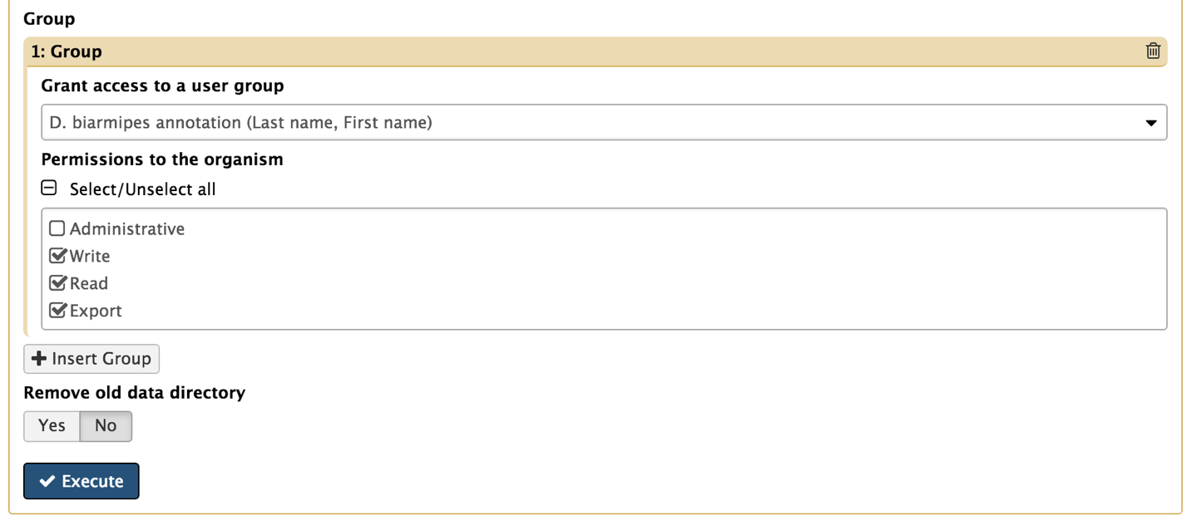
Figure 13: Select the user group and then check the “Write”, “Read”, and “Export” checkboxes to grant all users in the group permission to write, read, and export gene annotations for this Apollo workspace.

5. Create user accounts for the collaborative annotators
Now that we have created the workspace (organism) on Apollo and added a user group which can access the workspace, the next step is to create user accounts for our collaborators and add them to this user group.

When we need to create a large number of user accounts (e.g., create accounts for students in a class), we can upload a comma-separated values (CSV) file that contains the user information and use “Apollo User Manager” to create multiple user accounts at once.

For training purposes, a sample CSV file called “new_annotators.csv” is in the “data” subfolder of the “G-OnRamp July workshop” folder on the Desktop. Click on “Upload File” under the “Get Data” group of the Tools panel to open the file upload window (Figure 14). Choose the CSV file and click on the “Start” button to upload the file to Galaxy (Figure 15).

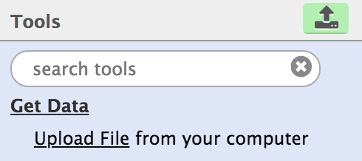
Figure 14: Find the "Upload File" tool in the “Get Data” group of the Tools panel and click on the link to open the file upload window.

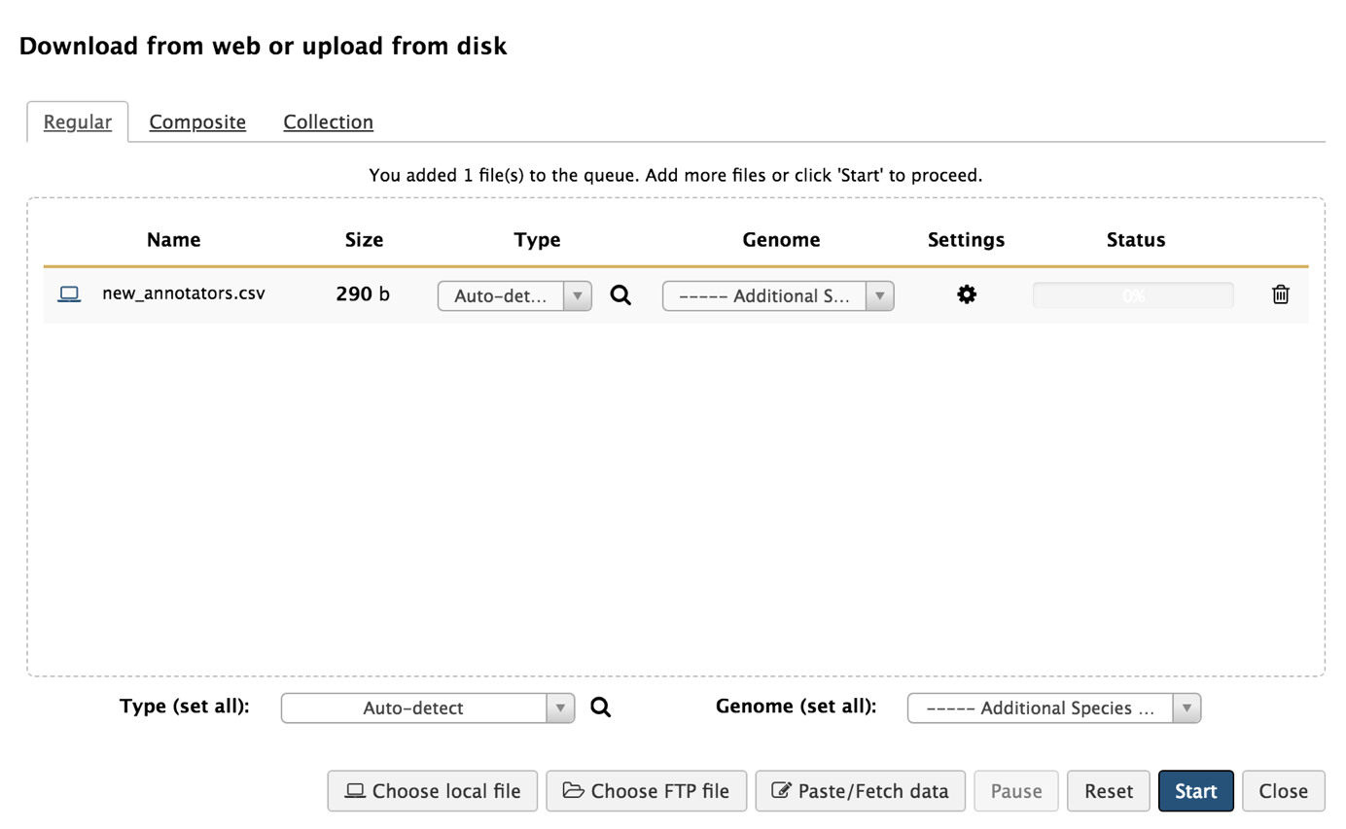
Figure 15: Drag and drop the CSV file to the upload file window or click on the “Choose local file” button to select the file from the disk, then click on the “Start” button.
Open the “Apollo User Manager” tool and click on “Insert New operation”. Choose “Create a user” and “Multiple users” to create multiple user accounts at once. Specify the file format as “CSV” and use “new_annotators.csv” as the input. Click on “Execute” (Figure 16).

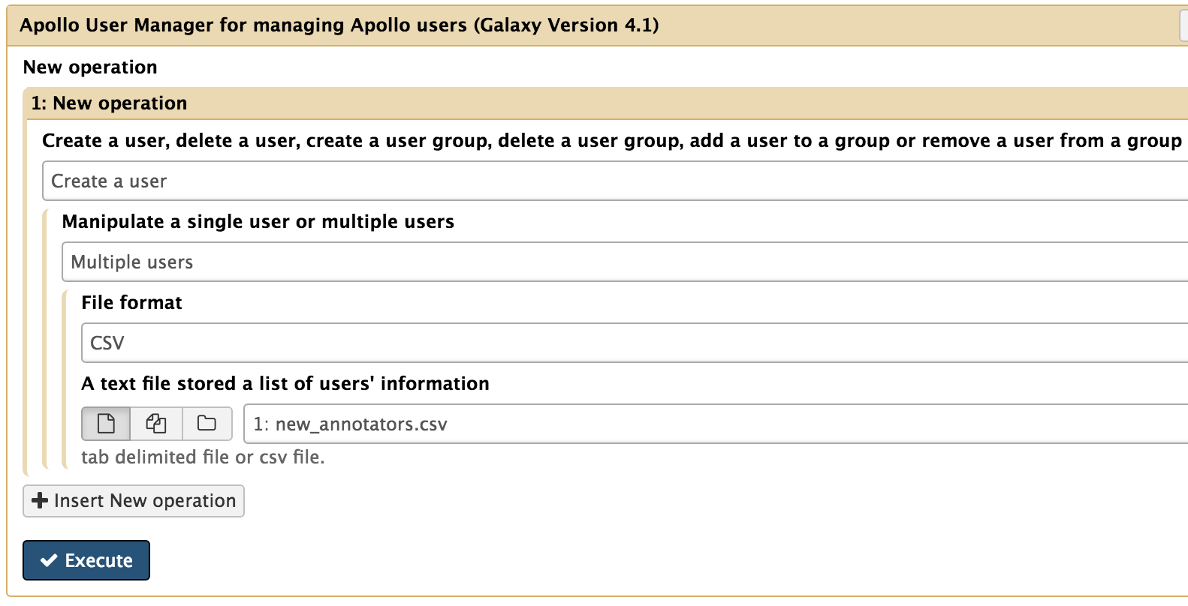
Figure 16: Use the "Multiple users” option to create multiple user accounts at once. Specify the file format as “CSV” and choose “new_annotators.csv” as the input dataset.
After the tool finished running, you can download the output file by clicking on the “Download” icon (Figure 17). This output file contains the information for the new Apollo user accounts, including the auto-generated initial passwords for each user account (Figure 18).

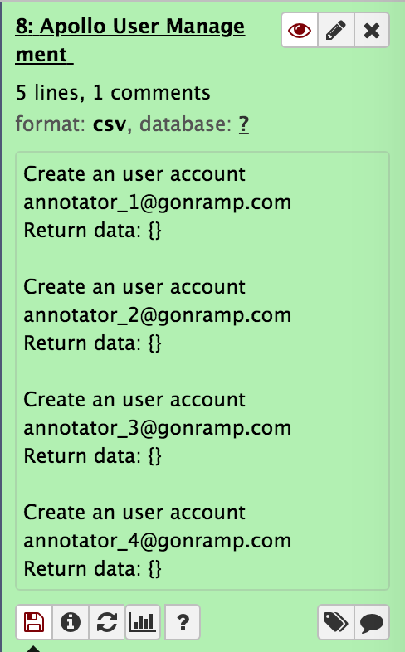
Figure 17: Click on "Apollo User Manager" History item and then click on the “Download” icon (red arrow) to download the output table.
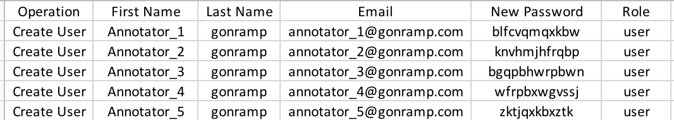
Figure 18: The output table from "Apollo User Manager" lists all the new users and their initial passwords (red rectangle).

6. Add the annotators to the user group
After we have created user accounts for our collaborators, we would want to give them access to the Apollo workspace. As we have already set up a user group and members of this group have read, write, and export permissions to the D. biarmipes workspace, the simplest way for the collaborators to access the workspace would be to add them to this user group.

We can use the “Apollo User Manager” tool to add annotators to the user group. Since we want to add multiple users to the group at once, we need to provide a CSV file that contains the list of user accounts and group. For training purposes, a sample CSV file called “add_users_to_group.csv” is in the “data” subfolder of the “G-OnRamp July workshop” folder on the Desktop. Note that you need to change the values in the “group” column to the name of the group you have created in Step 2 (Figure 19). (You can double click on the CSV file to view and edit the file in Microsoft Excel.) Save the modified file and upload the file to the G-OnRamp Galaxy instance.

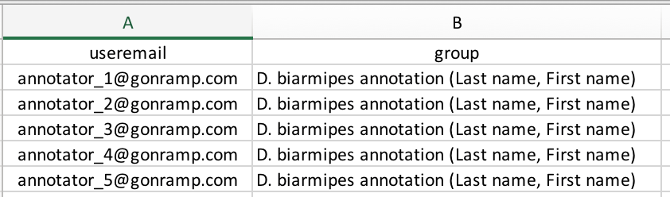
Figure 19: Open the “add_users_to_group.csv” file, and change the values in the “group” column to the name of the annotation user group you have created earlier [e.g., D. biarmipes annotation (Last name, First name)]. (Replace “Last name” and “First name” with your last name and first name.)
Open the “Apollo User Manager” tool and click on “Insert New operation”. Choose “Add a user to a group” and “Multiple users” to add multiple users to a group at once. Specify the file format as “CSV” and use “add_users_to_group.csv” as the input dataset. Click on “Execute” to add the users to the group.

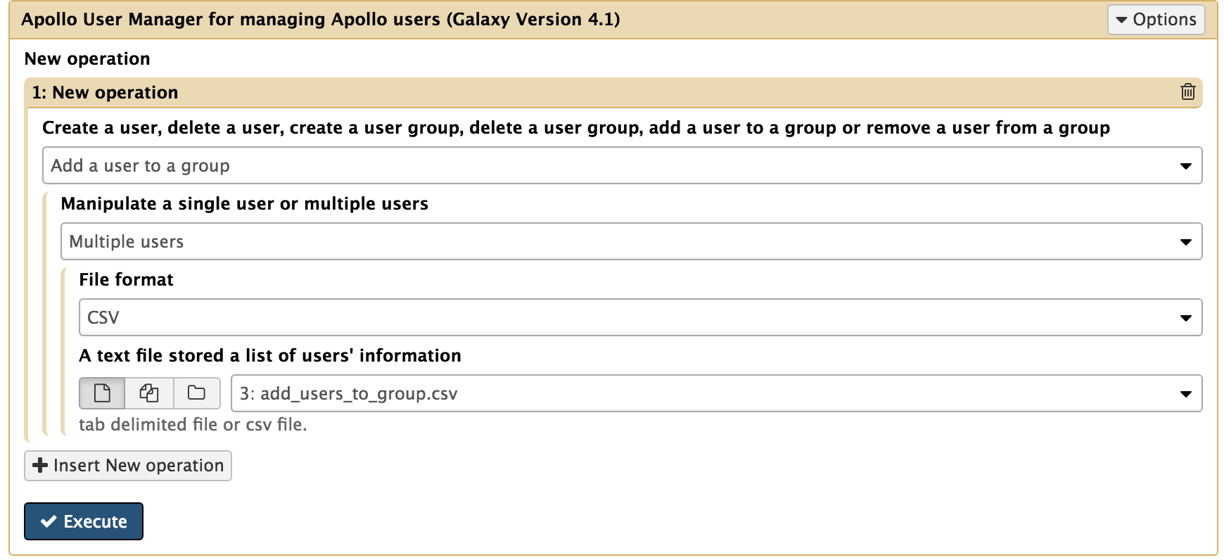
Figure 20: Select the “Add a user to a group” and the "Multiple users” options to assign multiple users to groups at once. Specify the file format as “CSV” and choose “add_users_to_group.csv” as the input dataset.

7. Go to Apollo to check the settings and start genome annotation
Go back to the G-OnRamp Apollo instance (http://cloud5.galaxyproject.org/apollo). You can see the user group that you have created under the “Group” tag in the “Annotation Panel” (Figure 21). The table in this tab shows the group names and the number of users in each group.

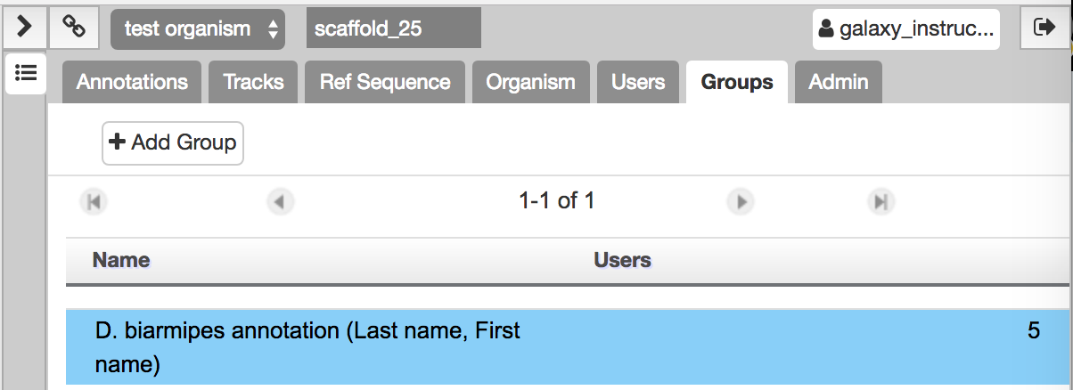
Figure 21: Click on "Groups" tab in the "Annotation Panel". This section shows all your user groups and the number of users in each group.
Select the user group you have created in Step 2 by clicking on the group name [e.g., “D.biarmipes annotation (Last name, First name)”]. The group will be highlighted in blue when it is selected. Additional information about the group are available through the four tabs (“Details”, “Organisms”, “Users”, and “Group Admin”) underneath the group table. For example, you can examine the group permissions under the “Organisms” section (Figure 22). The panel shows that the group has write, export, and read permissions to the workspace “D.biarmipes (Last name, First name)”.

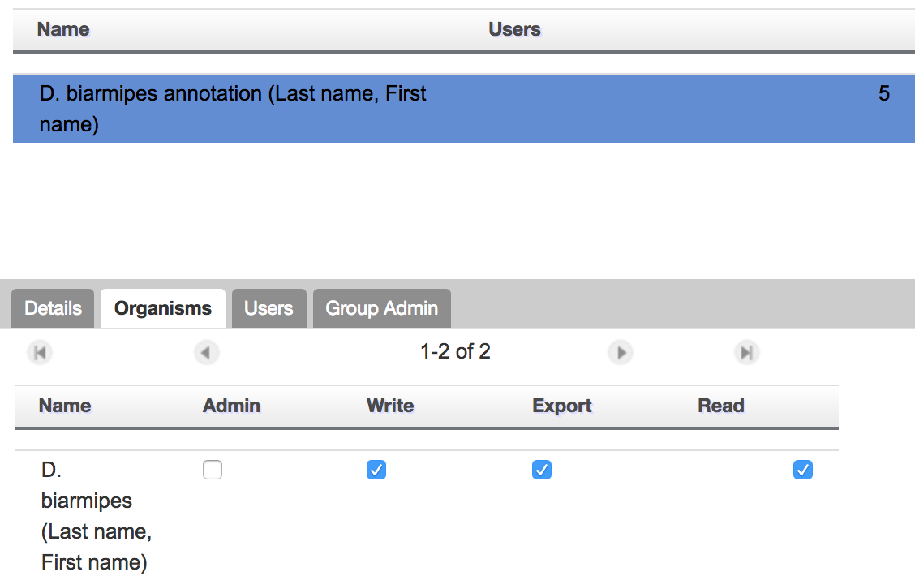
Figure 22: Select the user group by clicking on the group name in the groups table. The group will be highlighted in blue and detailed information for this group will appear in the panel below. Click on the “Organisms” tab to review the group permissions for the different Apollo workspaces (organisms).

Appendix A: Create an instructor account on Apollo with the “Apollo User Manager” tool
This section describes how the Apollo administrator can use the Apollo User Manager tool to create an instructor account.

The steps for creating an instructor account are similar to the steps for creating a regular user account (see Section 5). Open the Apollo User Manager tool and click on “Insert New operation” to open an operation configuration block. Then choose the “Create a user” and “Single user” options. Enter the user email, first name, and last name into the corresponding text boxes. Select the “instructor” option for the “Role” field and click on the “Execute” button (Figure 23).

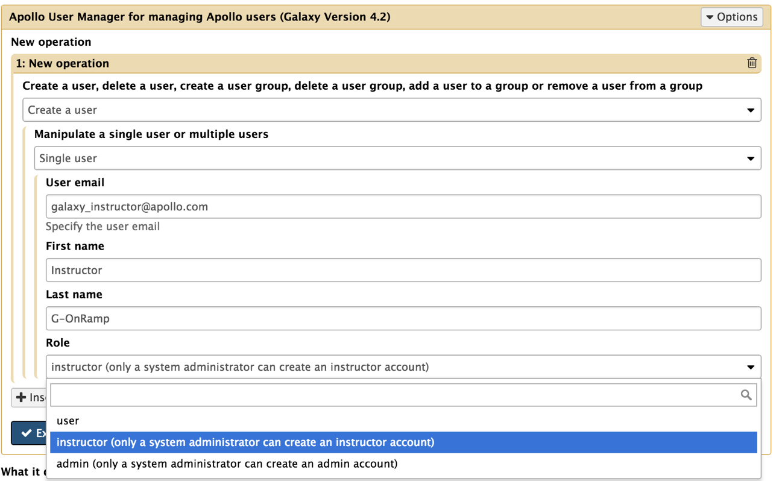
Figure 23: Select “instructor” from the drop-down menu for the “Role” field to create an instructor account.
The steps for creating multiple instructor accounts at once are the same as the steps for creating multiple user accounts (as discussed in Section 5). The only difference is that the role column of the user information file should be changed from “user” to “instructor” (Figure 24).

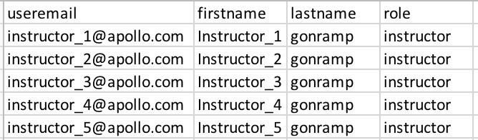
Figure 24: Change the “role” column of the user information CSV file to “instructor” to create multiple instructor accounts.

