Explore the Genome Browsers created by G-OnRamp

(Answer key)

Yating Liu
07/2018

1. Introduction
This exercise will explore the Drosophila miranda UCSC Assembly Hub created by G-OnRamp in order to illustrate how you can use the Genome Browsers to address interesting biological questions.

2. Use Galaxy to explore the genome assembly

Open a new web browser window and navigate to the G-OnRamp server at http://cloud5.galaxyproject.org/ and log into your account. (Note that this instance will only be available during the G-OnRamp workshop.) Click on “Shared Data” in the top menu bar and select “Histories” from the drop-down menu to see the list of shared Histories. Click on the link of the “Drosophila miranda MSH22 UCSC Genome Browser” History and then click on “Import history” on the top right corner to import the History to your Galaxy.

Q1. Which dataset in the History contains the sequences of the D. miranda whole genome assembly? Download the dataset “9: rename the scaffolds on data 1: name mapping”. How many scaffolds are in the D. miranda whole genome assembly? What are the original sequence names and what are their corresponding sequence names after renaming step?

The dataset “3: GCF_000269505.1_DroMir_2.2_genomic.fna” contains the genomic sequences for the D. miranda assembly. There are six scaffolds in the D. miranda assembly. The original sequence names and their renamed sequence names are listed in the Table 1.

Table 1: Name mapping tables
Original sequence name | Renamed sequence name
NC_030302.1 Drosophila miranda strain MSH22 chromosome XL, DroMir_2.2, whole genome shotgun sequence | scaffold_1
NC_030303.1 Drosophila miranda strain MSH22 chromosome XR, DroMir_2.2, whole genome shotgun sequence | scaffold_2
NC_030304.1 Drosophila miranda strain MSH22 chromosome 2, DroMir_2.2, whole genome shotgun sequence | scaffold_3
NC_030305.1 Drosophila miranda strain MSH22 chromosome 3, DroMir_2.2, whole genome shotgun sequence | scaffold_4
NC_030306.1 Drosophila miranda strain MSH22 chromosome 4, DroMir_2.2, whole genome shotgun sequence | scaffold_5
NC_030307.1 Drosophila miranda strain MSH22 chromosome 5, DroMir_2.2, whole genome shotgun sequence | scaffold_6

Q2. Which scaffold is the largest in the D. miranda assembly? How long is the largest scaffold?

The largest scaffold is scaffold_3. It consists of 33,007,066 bases.

Solution 1: run the twoBitInfo tool on the dataset “15: faToTwoBit on data 8”. Select the “Sequence lengths” option for the “Type of output file” field.

Solution 2: Click on “Display at Track Hub UCSC main” link, then click on “view sequences” button on UCSC Genome Browser Gateway page (Figure 1, Figure 2).

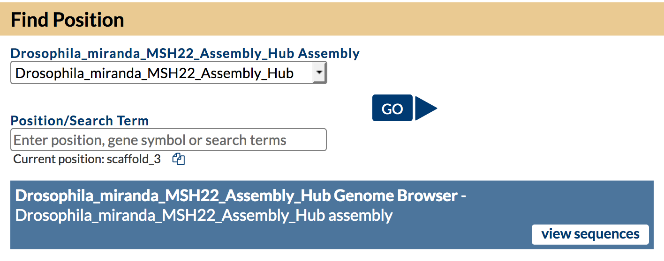
Figure 1: Click on "view sequences" button to get the information of each sequence
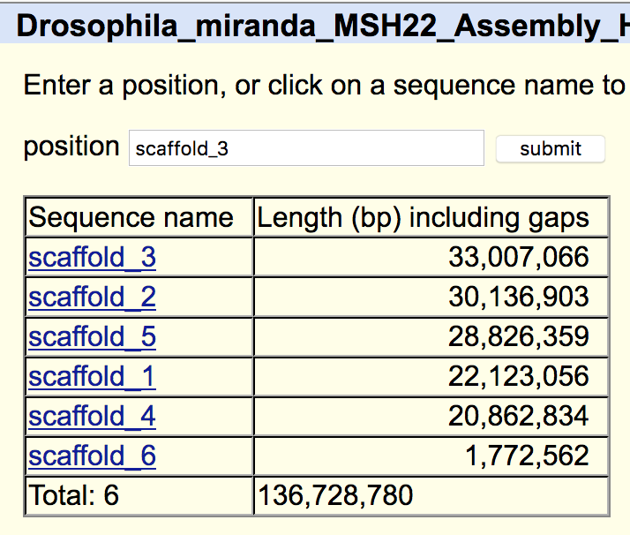
Figure 2: The table for each sequence, including the total number of sequences, sequence name, length and link for each sequence

Q3. How many gaps are in the assembly? How many gaps are in each scaffold?

There are 7,148 gaps in the assembly.

Table 2: The number of gaps on each scaffold
Scaffold | # Gaps
scaffold_1 | 1253
scaffold_2 | 1583
scaffold_3 | 1313
scaffold_4 | 1118
scaffold_5 | 1643
scaffold_6 | 238

3. Use the UCSC Assembly Hub to explore a genomic region

Open the D. miranda UCSC Genome Browser Assembly Hub. Navigate to position scaffold_6:789,800-806,800. Scroll down to the track configuration section and hide the HISAT RNA-Seq alignment tracks (i.e., “SRR364798 HISAT S” and “SRR364800 HISAT S”) in order to simplify the display.

Q4. How many Augustus gene predictions are in this region? How many of these Augustus gene predictions overlap with features in either the BLAST or BLAT alignment tracks?

There are three Augustus gene predictions (scaffold_6.g14314.t1, scaffold_6.g14315.t1, and scaffold_6.g14316.t1) in this region. Only the Augustus gene prediction scaffold_6.g14316.t1 overlaps with the BLAST and BLAT alignments.

Q5. For the Augustus gene predictions that do not overlap with features in the TBLASTN or BLAT alignment tracks, perform a NCBI BLASTP search of the translated protein sequence against the “Reference proteins (refseq_proteins)” database. Based on the BLASTP search results, do these predictions correspond to protein-coding genes in Drosophila?
(Hint: To obtain the protein sequence of a predicted gene, click on the feature in the Genome Browser image, and then click on the “Translated Protein” link. The NCBI BLAST web server is available at https://blast.ncbi.nlm.nih.gov/Blast.cgi.)

Most of the significant matches to the Augustus predictions scaffold_6.g14314.t1 and scaffold_6.g14315.t1 are to retrotransposons. The scaffold_6.g14314.t1 prediction contains two conserved domains (R1-I-EN) and (RT_nLTR_like) that are often found in LINE retrotransposons (Figure 3). The scaffold_6.g14315.t1 prediction also contains a RT_nLTR_like conserved domain, and it shows significant matches to Jockey retrotransposons in many different insects (Figure 4). Hence these gene predictions are unlikely to correspond to protein-coding genes in D. miranda.

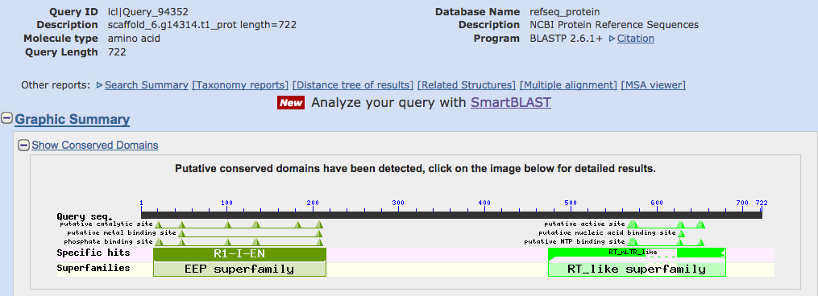
Figure 3. The Augustus gene prediction scaffold_6.g14314.t1 contains the R1-I-EN (endonuclease domain encoded by R1 and I-element retrotransposons) and the RT_nLTR_like (non-LTR reverse transcriptase) conserved domains.
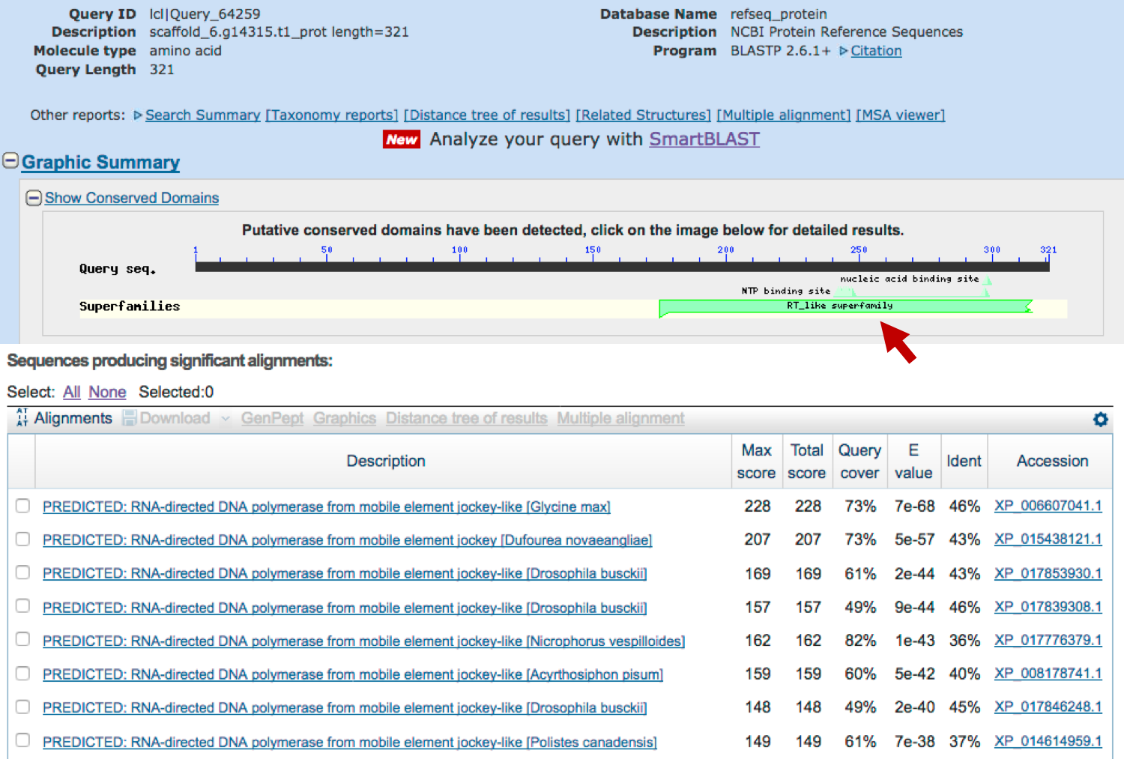
Figure 4. A BLASTP search of the Augustus gene prediction scaffold_6.g14315.t1 against the Reference proteins database shows that the end of the predicted protein contains a RT_nLTR_like conserved domain (red arrow), and the prediction shows significant similarity to the Jockey LINE retrotransposons in other insects.
Change the display mode of the “BLAT Alignment” track to “pack”. When you click on a feature in the “BLAT Alignment” track, a details page will appear where you can view the GenBank record and the transcript alignment.

Q6. Change the display mode of the BLAT alignment track to “full”. Click on the BLAT alignment to the transcript NM_143661. What is the name of this transcript? How long is this transcript? Scroll down to the “FEATURES” section of the GenBank report for NM_143661. Where is the coding region within this transcript? (Hint: see the CDS section of the FEATURES table.)

The name of this transcript is “Drosophila melanogaster Rad23, transcript variant A (Rad23), mRNA”. This transcript has a total length of 1489 bp. The coding region is located at positions 132–1376 of the transcript (Figure 5).

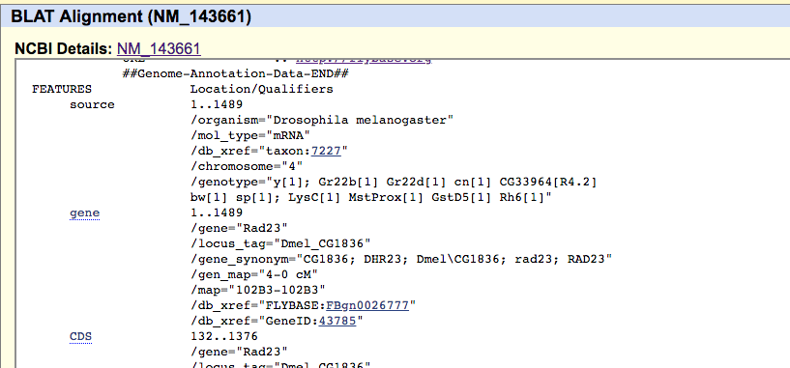
Figure 5: Scroll down to the “FEATURES” section of the GenBank report for NM_143661 to get the CDS region
Q7. Scroll down to the “Genomic Alignments” section of the BLAT Alignment details page. What is the percent identity between the NM_143661 and scaffold_6? What is the orientation of the transcript alignment? Does the alignment include the entire length of the NM_143661 transcript?

The alignment between the NM_143661 and scaffold_6 has 78.2% percent identity. The transcript and scaffold_6 are in the same orientation (i.e., plus strand). The alignment only covers part of the transcript (positions 198–1397).

Q8. Click on the alignment statistics link (next to the “browser” link) under the “Genomic Alignments” section to view the transcript alignment. What do the capital blue and red letters within the cDNA and genomic sequences symbolize?

The capital blue letters correspond to matching bases between the coding regions of the NM_143661 transcript and the scaffold_6 sequence. The capital red letters correspond to matching bases between the untranslated regions of the NM_143661 transcript and the scaffold_6 sequence.

Q9. Go back to the Genome Browser view of the region at scaffold_6:789,800-806,800. There is another set of BLAT and TBLASTN alignments at 804,000–805,500 that is also supported by the RNA-Seq data from the virgin males (SRR364798) and virgin females (SRR264800) samples. Based on the RNA-Seq read coverage tracks (“SRR364798 Sequence Coverage” and “SRR364800 Sequence Coverage”) and the regtools splice junction tracks (“SRR364798 Splice Junctions” and “SRR364800 Splice Junctions”), how many introns does this feature have?

The feature in this region likely has two introns (three transcribed exons).

Q10. Using the BLAT alignments and the procedure described above, characterize the feature located at 804,000-805,500 of scaffold_6.

The GenBank records for the BLAT alignments NM_205872, NM_001144383, NM_143662, and NM_001297784 show that they correspond to the B, D, E and F isoforms of the Zip102B gene in D. melanogaster, respectively.

In D. melanogaster, the gene CG32850 is located next to Zip102B. To determine the location of the putative ortholog of CG32850 in the D. miranda assembly, we can enter the accession numbers of the transcripts of CG32850 into the “enter position or search terms” text box of the Genome Browser.

Q11. The RefSeq accession number for the A isoform of CG32850 is NM_166753, and the RefSeq accession number for the B isoform of CG32850 is NM_001272124. Can you find the BLAT alignments to these transcripts in the D. miranda assembly? Are the genes Rad23, Zip102B, and CG32850 syntenic between D. melanogaster and D. miranda?

There are no BLAT alignments to the A isoform of CG32850. The BLAT alignment to the B isoform of CG32850 is located at 809,689-816,907, which is next to the Zip102B ortholog in D. miranda. Comparison of the gene order and the relative orientations of Rad23, Zip102B, and CG32850 shows that this region is syntenic between D. melanogaster and D. miranda.

