Customize the Genome Browsers produced by G-OnRamp

Yating Liu
07/2018

Table of Contents
1. Introduction 2
2. Modify G-OnRamp workflow 2
2.1 Big picture 3
2.2 Modify tool parameters 4
2.3 Add an evidence track to the Hub Archive Creator 5
2.4 Show or hide an output dataset 11
2.6 Save the changes to the workflow 12
3. Exercise: edit the workflow to run RNA-Seq analysis on two different RNA-Seq samples 13
3.1 Make a copy of the current workflow 13
3.2 Edit the “G-OnRamp:Dbia3_RNA-Seq” workflow 13
3.3 Upload your datasets and run the workflow 19
4. Remove an evidence track from the Hub Archive Creator 22
5. Add custom tracks to the Genome Browser 23
5.1 Upload the custom track file to the “G-OnRamp:Dbia3_RNA-Seq” History 24
5.2 Rename the scaffold names of the track file 25
5.3 Run Hub Archive Creator to create a new UCSC Genome Browser including the custom track 26

1. Introduction
In addition to running the G-OnRamp workflow with default settings, one of the key features of Galaxy is the ability to modify an existing workflow (e.g., change tool parameters, add or remove tools) using the Workflow Canvas. From this tutorial, you will learn how to:
- Modify tool parameters
- Modify the workflow by adding and removing tools
- Add or remove evidence tracks from the Hub Archive Creator
- Customize the workflow to run RNA-Seq analysis on two samples
Note that this tutorial assumes that the reader is already familiar with the basic concepts of Galaxy and of G-OnRamp. It will modify the “G-OnRamp: D. biarmipes F element” workflow that we have previously created in the “Introduction to G-OnRamp Walkthrough”.

2. Modify G-OnRamp workflow
Log into your account on the G-OnRamp Galaxy instance at http://cloud5.galaxyproject.org/. (Note that this instance will only be available during the G-OnRamp workshop.) Click on the “Workflow” menu item in the menu bar to access the list of available workflows. Click on the down arrow for the “G-OnRamp: D. biarmipes F element” workflow and click on “Copy” to create a copy the G-OnRamp workflow for editing (Figure 1).

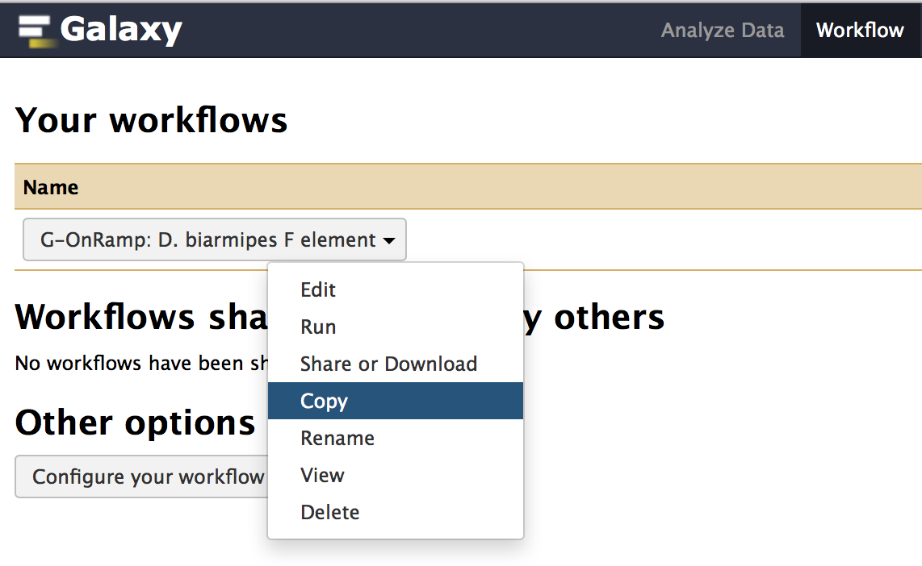
Figure 1: Click on the "Copy" option to create a new copy of the G-OnRamp workflow.
Rename the new copy of the workflow (i.e. Copy of ‘G-OnRamp: D. biarmipes F element’) to “Customized G-OnRamp” using the “Rename” option in the drop-down menu. Click on the down arrow for the “Customized G-OnRamp” workflow and click on “Edit” to open the Workflow Canvas (Figure 2).
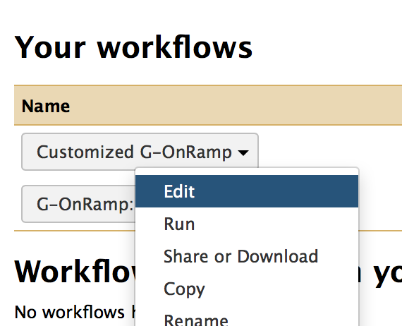
Figure 2: Click on the "Edit" option to open the “Customized G-OnRamp” workflow in the Workflow Canvas.

2.1 Big picture
The entire workflow is shown in Figure 3. Each box represents a tool. The “>” symbol on the left side of the box denotes an input dataset for the tool. The “>” symbol on the right side of the box denotes the output dataset produced by the tool. A tool could have multiple input datasets (e.g., HISAT) and output datasets (e.g., Augustus). The “noodles” between the tools correspond to how data are processed by the different tools within the workflow. Each noodle shows how the output dataset from one tool is used as the input dataset for another tool. For example, Figure 4 shows the connection between the “Input dataset” and the Augustus gene predictor. The output from the “Input dataset” tool serves as the “Genome Sequence” input for Augustus.

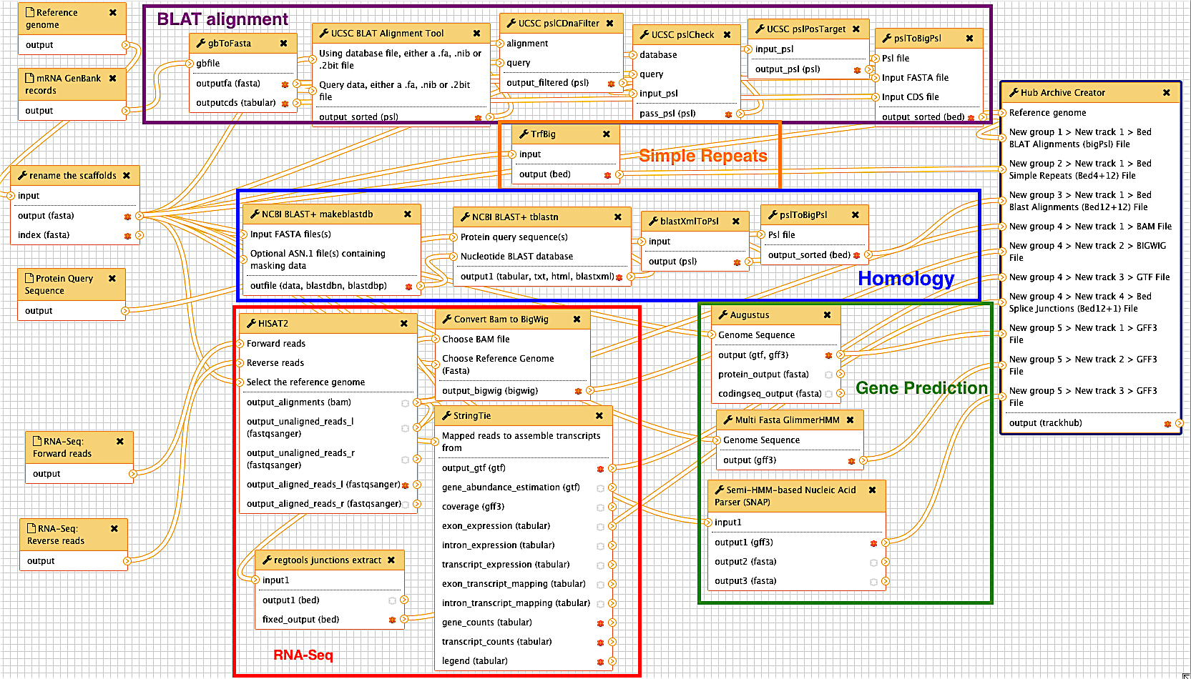
Figure 3: The entire G-OnRamp workflow shown in the Workflow Canvas
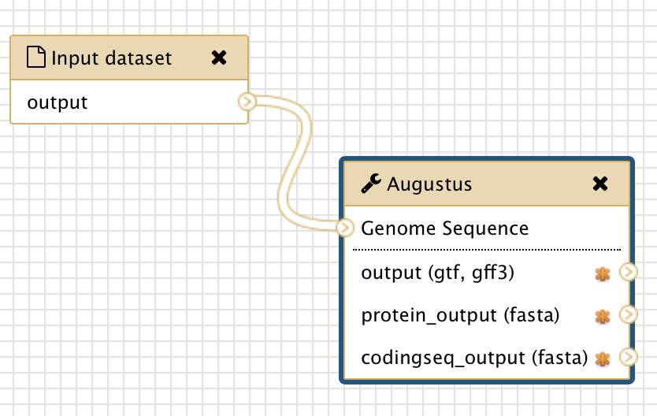
Figure 4: The connection between the “Input dataset” tool and the Augustus tool (red arrow)

2.2 Modify tool parameters
You can click on each tool in the Workflow Canvas to learn more about the tool (i.e. what it does and how to use it). You can use the “Details” panel on the right to examine and change the tool parameters (Figure 5). If the analysis workflow was originally derived from a History, then the settings of each tool within the workflow will reflect the parameters used in that analysis. For example, because we used paired-end RNA-Seq data in the “Introduction to G-OnRamp Walkthrough”, the “Individual paired reads” option is selected. If you have unpaired RNA-Seq data, you need to click on the down arrow and select the “Individual unpaired reads” option under the “Single end or paired reads” field. (Note that you do not need to change the parameter here because we will use paired-end RNA-Seq data in this walkthrough.)

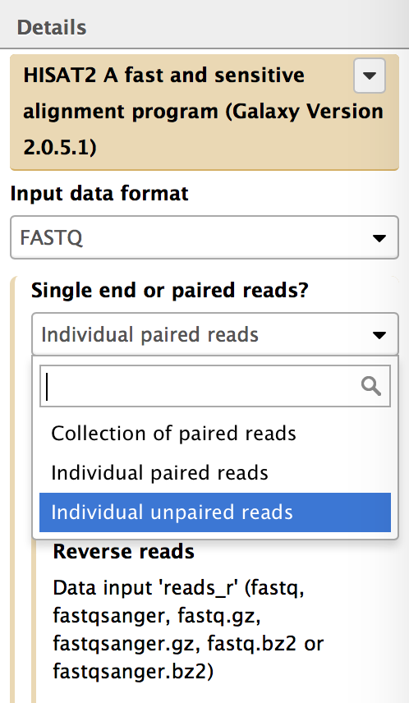
Figure 5: Click on HISAT and use the Details panel to edit the parameter settings for the HISAT.
If there is an arrow on the left side of a parameter, then the parameter could be set when you run the workflow (i.e., set at Runtime). For instance, if you open the Details panel of the Augustus tool, you will see that the “Model Organism” parameter is hidden. This is because we designed the workflow so that you must specify the model organism to use at runtime. If you click on the down arrow on the left side of the “Model Organism” field, a drop-down menu will appear where you can set the “Model Organism” parameter in advance. If you would like to set this parameter at runtime, click on the up arrow to hide the field (Figure 6).

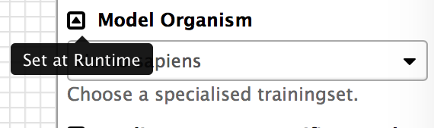
Figure 6: Click on the up arrow icon on the left side of the "Model Organism" field to set this parameter at runtime (red arrow).

2.3 Add an evidence track to the Hub Archive Creator
You can also use the Workflow Canvas to add or delete a tool. For example, if you want to add the results from WindowMasker (which identifies simple repeats and low complexity sequences) to the G-OnRamp workflow, you can use the search field in the “Tools” panel to search for “WindowMasker”. The tools WindowMasker_ustat and WindowMasker_mkcounts will appear in the Tools panel (Figure 7). These tools correspond to the two stages (ustat and mk_counts, respectively) used by WindowMasker to identify repeats in DNA sequences. Click on both links to add the WindowMasker_ustat and WindowMasker_mkcounts tools to the Workflow Canvas (Figure 8).

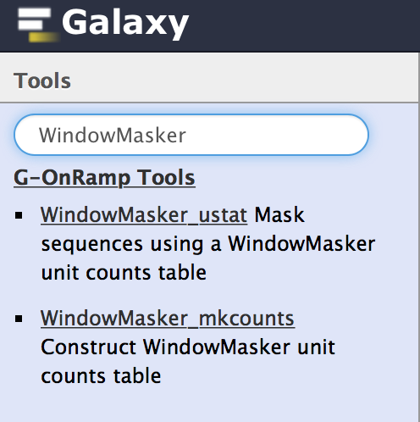
Figure 7: Use the search field in the Tools panel to search for the WindowMasker tools.
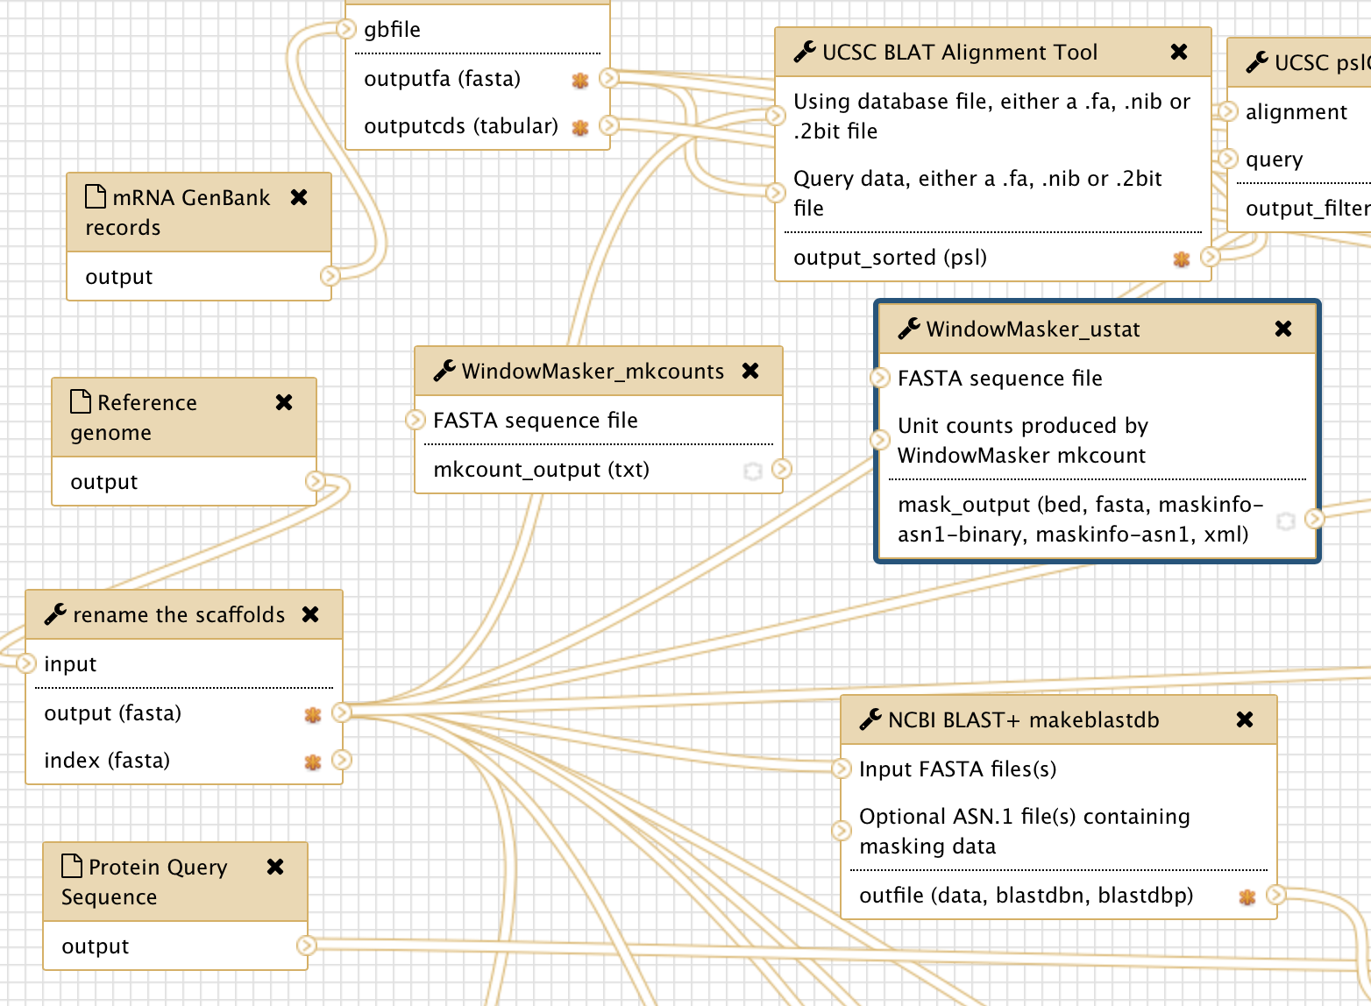
Figure 8: WindowMasker_ustat and WindowMasker_mkcounts are added to the Workflow Canvas (red arrows).
The next step would be to incorporate the WindowMasker_ustat and WindowMasker_mkcounts tools with the rest of the G-OnRamp workflow. This is accomplished by specifying the input and output datasets for these WindowMasker tools.

The first stage of the WindowMasker analysis is mk_counts (WindowMasker_mkcounts), which constructs a unit counts table for a genome assembly. The unit counts correspond to the frequency of short sequences with length k (k-mers) in the genome assembly. There is a “>” symbol on the left side of the “FASTA sequence file” field in WindowMasker_mkcounts, which indicates that it requires the genome sequences in FASTA format. Here we will use the genome sequences that have been renamed by “rename the scaffolds” tool, which shortens the scaffold names to less than 32 characters. (Older versions of the UCSC Genome Browser impose a 31-character limit on the scaffold names.)

To establish a new connection between the “rename the scaffolds” and the WindowMasker_mkcounts tools, click on the “>” symbol on the right side of “output (fasta)” in the “rename the scaffolds” tool and drag it to the “>” symbol on the left side of “FASTA sequence file” in the WindowMasker_mkcounts tool. As you drag the connection, the connection will appear as a green “noodle” (Figure 9).

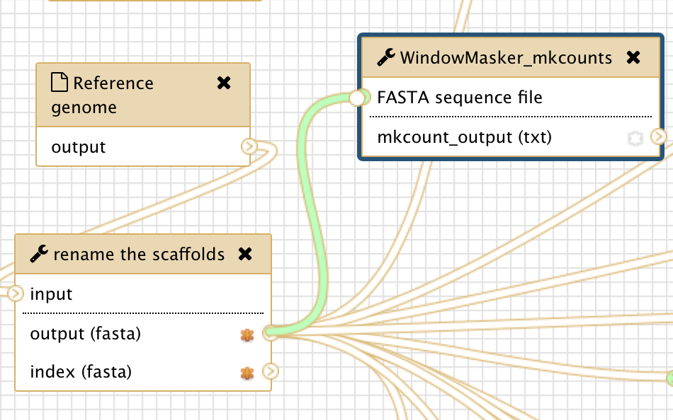
Figure 9: Connect the output from the “rename the scaffolds” tool to the input for the WindowMasker_mkcounts tool.
When you release the mouse next to the “Genome Sequence” field on the left side of the WindowMasker_mkcounts box, it will establish the connection between these two tools.

The second stage of the WindowMasker analysis is ustat (WindowMasker_ustat), which uses the unit counts produced by WindowMasker_mkcounts to mask repetitive regions within a DNA sequence. The WindowMasker_ustat tool requires a FASTA sequence file as an input dataset. Repeat the steps above to create a connection between “output (fasta)” of the “rename the scaffolds” tool with the “FASTA sequence file” input for the WindowMasker_ustat tool (red arrow in Figure 10).

WindowMasker_ustat also needs the unit counts table produced by WindowMasker_mkcounts as an input. Connect the “mkcount_output” in WindowMasker_mkcounts with the “Unit counts produced by WindowMasker mkcount” in WindowMasker_ustat (blue arrow in Figure 10).

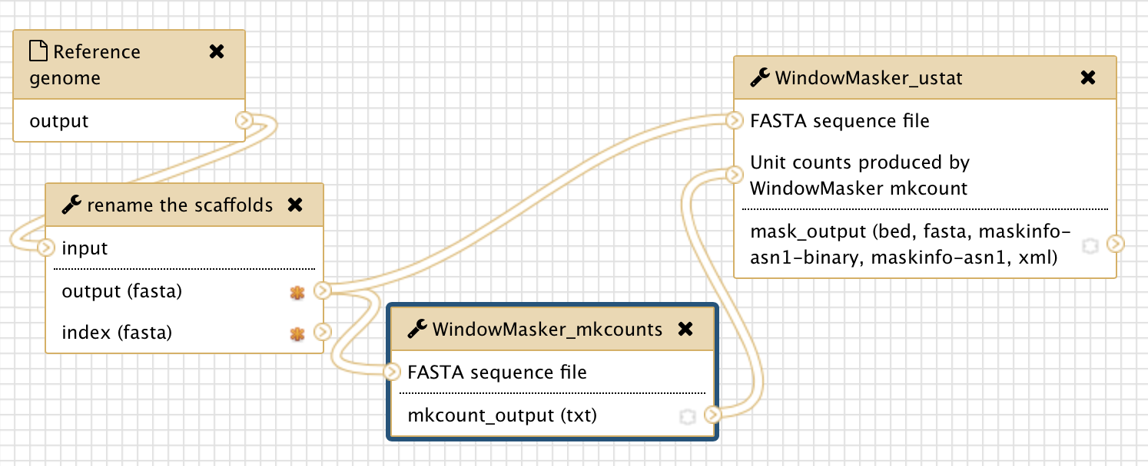
Figure 10: Connect the “output (fasta)” from the “rename the scaffolds” tool to the “FASTA sequence file” inputs for the WindowMasker_mkcounts and WindowMasker_ustat tools (red arrow). In addition, connect the “mkcount_output (txt)” from the WindowMasker_mkcounts tool to the “Unit counts produced by WindowMasker mkcount” input for the WindowMasker_ustat tool (blue arrow).
Using the same approach, you can connect the output of WindowMasker to the Hub Archive Creator. However, because all the input connections to the Hub Archive Creator are already connected to the output connections from the other tools, we need to add another input connection to the Hub Archive Creator before we can create the connection with the output from the WindowMasker_ustat tool.

Click on the Hub Archive Creator box in the Workflow Canvas and then examine the Details panel on the right. Scroll down to the end of the first group “Repeats” and click on “Insert New track” to create the WindowMasker track (Figure 11).

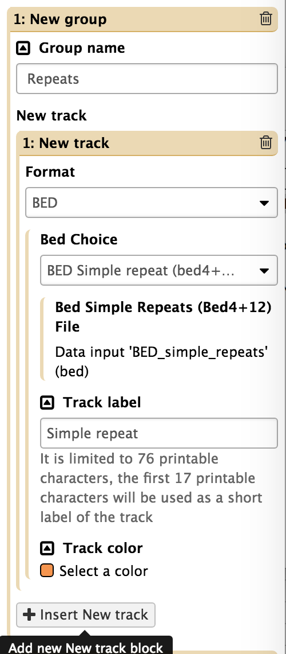
Figure 11: Click on the "Insert New Track" button in the Details panel to create a new input connection for the Hub Archive Creator.
In order to establish a connection between two tools, the datatype of the output dataset from the first tool must be the same as the datatype of the input dataset for the second tool. You can see the output format of WindowMasker by clicking on WindowMasker_ustat and open the Details panel (Figure 12). In this case, the output format for WindowMasker_ustat is BED.
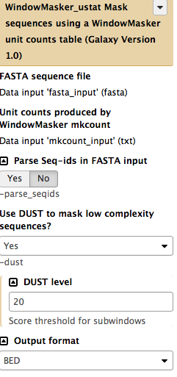
Figure 12: Open the Details panel of the WindowMasker_ustat tool and verify that the output format is set to BED.
Consequently, we need to select the “BED” format for the new input connection in the Hub Archive Creator (Figure 13, red arrow). We will use “BED Generic (bed4)” as the BED Choice (Figure 13, blue arrow). You can specify the name of the track as “WindowMasker” and select a color (e.g., light blue) for that track (Figure 13, purple arrows).

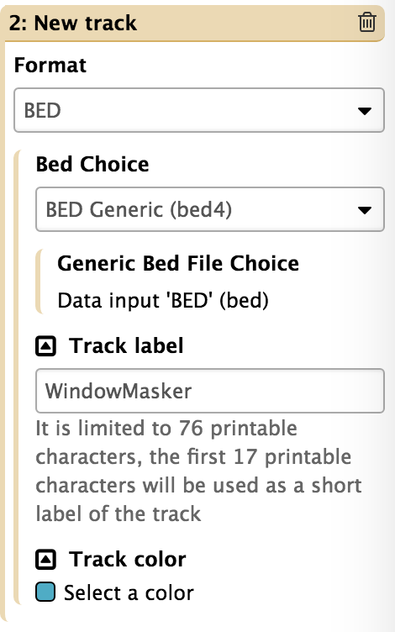
Figure 13: Select the BED format in the drop-down menu, then change the “Track label” to “WindowMasker” and the “Track color” to “light blue”.

A “New group 1 > New track 2 > Generic Bed File Choice” entry will appear in the Hub Archive Creator tool (Figure 14).

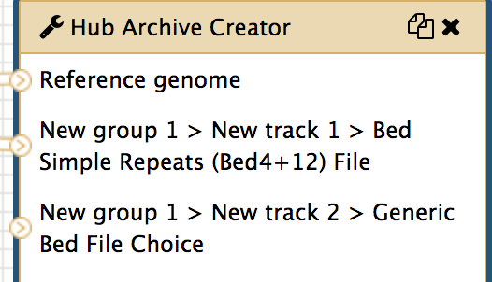
Figure 14: The Hub Archive Creator with a new BED input connection (red rectangle)
After you have created the new BED input connection, you can connect the output of the WindowMasker_ustat tool to the input of the Hub Archive Creator. Click on the “>” symbol next to the “mask_output” field in the WindowMasker_ustat tool, drag it to the “>” symbol next to the “New group 1 > New track 2 > Generic Bed File Choice” field in the Hub Archive Creator tool and then release the mouse (Figure 15).

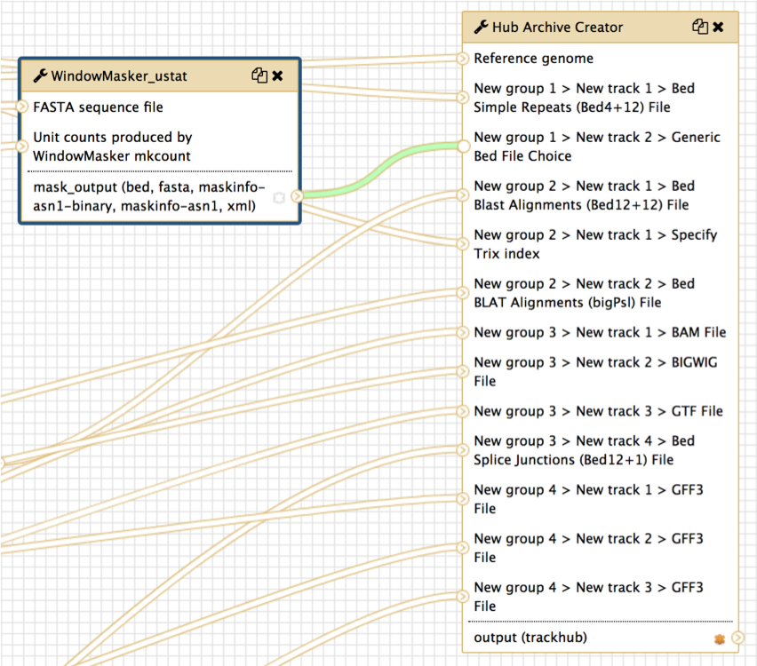
Figure 15: Connect the output of WindowMasker_ustat to the Hub Archive Creator

2.4 Show or hide an output dataset
To simplify the display in the History panel, the output of each tool is hidden from your History by default. To show a dataset in the History, you can mark the dataset as a workflow output by clicking on the “*” symbol. All unmarked datasets will be hidden from your History. For example, StringTie will produce eight output files. However, because only the “output_gtf (gtf)” output is marked (“*” symbol in dark orange) in the workflow, only the GTF file will appear in your History after you run the workflow (Figure 16). The other seven output datasets will be hidden from the History. This feature is particularly useful when you are working with large workflows that produce many temporary datasets.

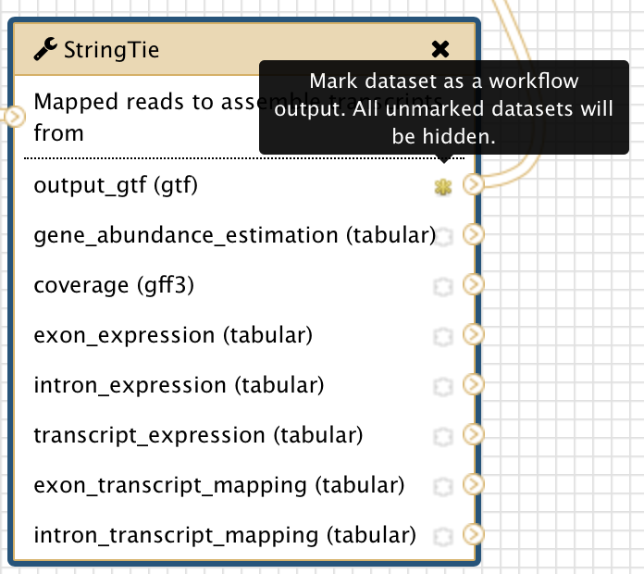
Figure 16: The yellow star next to “output_gtf (gtf)” output for the StringTie tool indicates that this dataset has been marked as a workflow output
You can show the outputs from WindowMasker_mkcounts and WindowMasker_ustat tools in the History by clicking on the “*” symbol next to “mkcount_output(txt)” and “mask_output” (Figure 17).

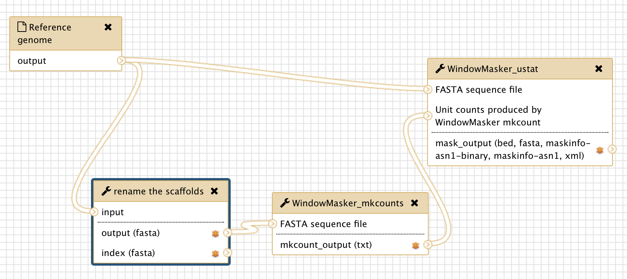
Figure 17: Show the outputs from WindowMasker tools in the History by clicking on the "*" symbols (red arrows) next to the output files.

2.6 Save the changes to the workflow
Remember to save your changes before you leave the Workflow Canvas page. Click on the settings icon at the top right corner of Workflow Canvas and then click on “Save” (Figure 18).

Figure 18: Save the changes that you have made to the workflow

3. Exercise: edit the workflow to run RNA-Seq analysis on two different RNA-Seq samples

3.1 Make a copy of the current workflow
Make a copy of “Customized G-OnRamp” workflow and rename the new workflow as “G-OnRamp:Dbia3_RNA-Seq” (Figure 19). Right click on the new workflow and click on “Edit” to go to the Workflow Canvas.

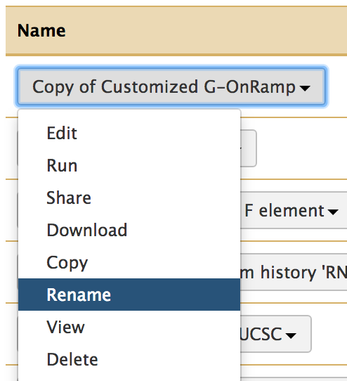
Figure 19: Copy the current workflow and rename it as “G-OnRamp:Dbia3_RNA-Seq”

3.2 Edit the “G-OnRamp:Dbia3_RNA-Seq” workflow
Given that there are two RNA-Seq samples (D. biarmipes RNA-Seq paired-end reads for female shallow and D. biarmipes RNA-Seq paired-end reads for male shallow), you can run the RNA-Seq analysis tools on each sample within a single workflow and then view the evidence tracks for both samples on the UCSC genome browser.

Below are some hints on how to construct this workflow:

First, you need to add an additional set of tools, including HISAT, StringTie, Convert Bam to BigWig, and regtools junctions extract, in order to perform the RNA-Seq analysis for the two samples.

Second, you need to modify the parameter settings for HISAT. Select the “Individual paired reads” option under the “Single end or paired reads?” field (Figure 20). Select the “Use a genome from history” option under the “Source for the reference genome to align against” field (Figure 21).

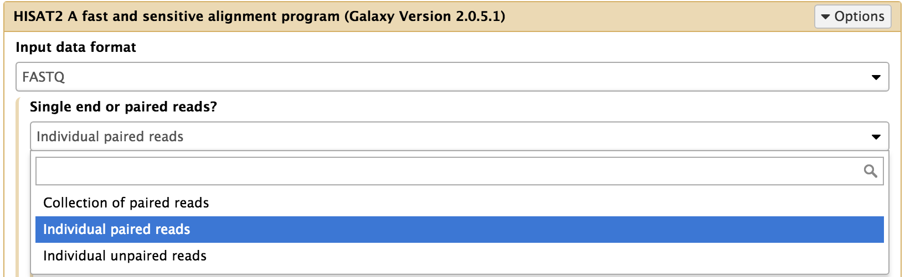
Figure 20: Choose the “Individual paired reads” option under the “Single end or paired reads” field
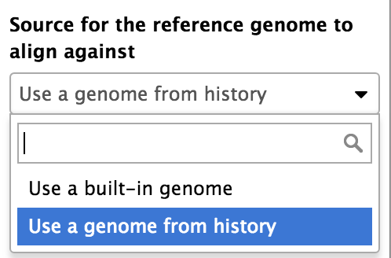
Figure 21: Choose “Use a genome from history” for “Source for the reference genome to align against”
Third, you need to add two “Input dataset”, which represent the second RNA-Seq datasets (forward reads file and reverse reads file). Click on “Inputs” at “Tools” panel to collapse the input dataset items, then click on “Input dataset” twice to add two input datasets to the workflow (Figure 22, Figure 23).

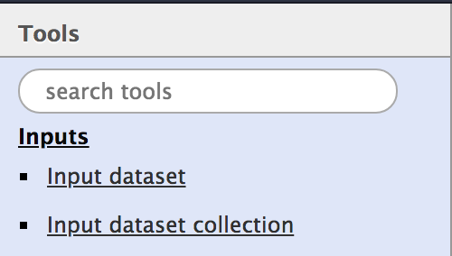
Figure 22: Click on "Inputs" in "Tools" panel and then click on "Input dataset" to add an “Input dataset” into workflow
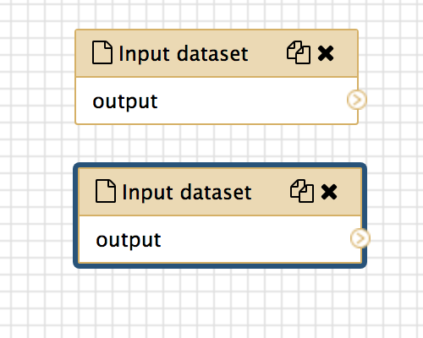
Figure 23: Add two "Input dataset" into the workflow since we have two individual paired reads
In order to differentiate the forward reads and reverse reads of two RNA-Seq samples, you need to label the four “Input dataset” differently. Click on the each Input dataset (you should have four input dataset for RNA-Seq analysis in total) and edit their label on the “Details” panel (Figure 24). Here let’s label the input datasets existed in original workflow as “Male shallow: forward reads” and “Male shallow: reverse reads”. And label the input datasets we added as “Female shallow: forward reads” and “Female shallow: reverse reads” (Figure 25).

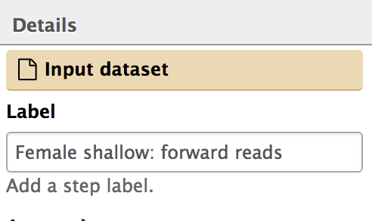
Figure 24: Label each Input dataset for RNA-Seq analysis. For example, you can label the forward reads of female shallow file as “Female shallow: forward reads”
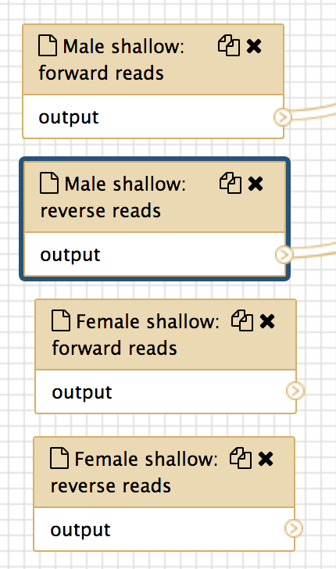
Figure 25: Label four RNA-Seq datasets as “Male shallow: forward reads”, “Male shallow: reverse reads”, “Female shallow: forward reads”, and “Female shallow: reverse reads”
Connect the output female shallow input datasets to the “Forward reads” and “Reverse reads” of the new HISAT tool respectively. And also use the output from “rename the scaffolds” tool as the “Select the reference genome” of the HISAT tool (Figure 26).

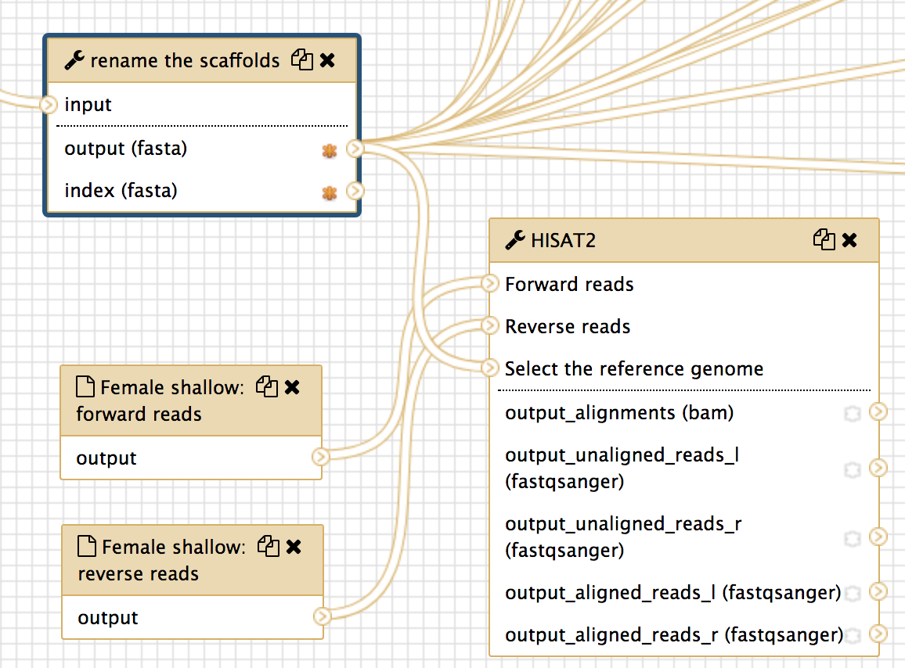
Figure 26: Connect the output of "Female shallow: forward reads” with input of “Forward reads”, connect the output of "Female shallow: reverse reads” with input of “Reverse reads”, and connect the output (fasta) of “rename the scaffolds” tool to “Select the reference genome”
Connect the output alignments (bam) from HISAT with the other three tools (StringTie, Convert Bam to BigWig, regtools junction extract). You also want to mark the output datasets, which would be used to create evidence tracks by Hub Archive Creator, as a workflow output by clicking on the “*” symbol (Figure 27).

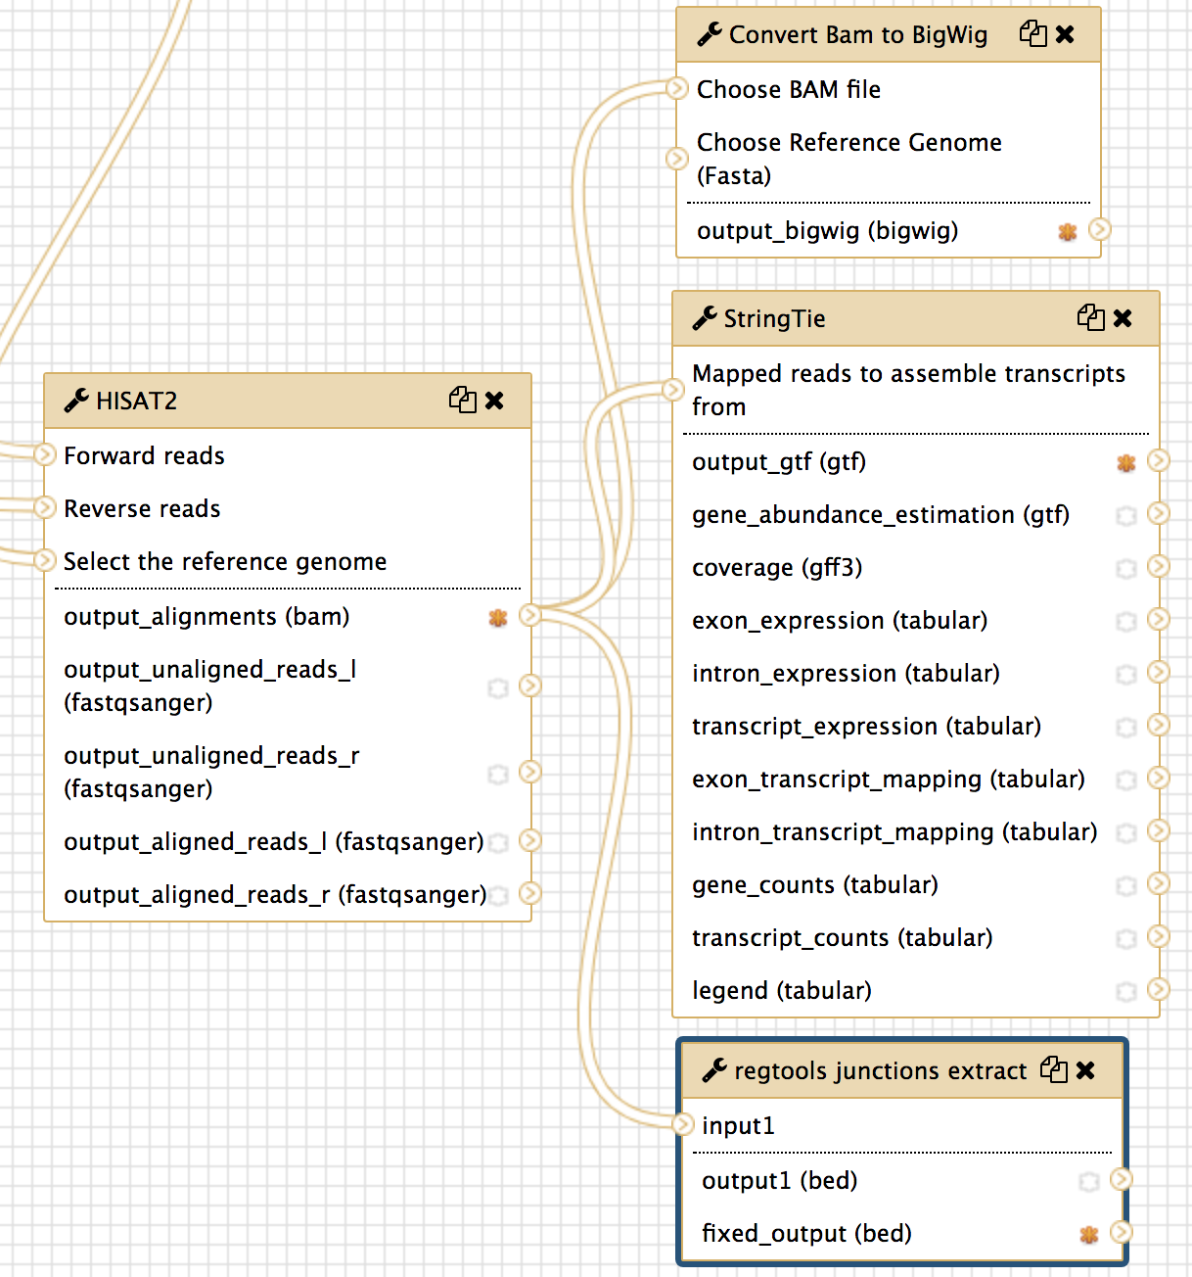
Figure 27: Connect output alignments from HISAT to the input of StringTie, Convert Bam to BigWig, regtools junction extract. Mark output_alignment (bam), output_bigwig (bigwig), output_gtf, and fixed_output (bed) by clicking on the “*” symbols
Convert Bam to BigWig tool also needs reference genome as its input. Here we connect the “output (fasta)” from “rename the scaffolds” tool to the “Choose Reference Genome” of the “Convert Bam to BigWig” tool (Figure 28).

Figure 28: Use output (fasta) from the "renamed the scaffold" tool as the input “Choose Reference Genome” of the “Convert Bam to BigWig” tool
In the end, you will need to add input connections to the Hub Archive Creator in order to connect the outputs from the HISAT, StringTie, Convert Bam to BigWig, and regtools junctions extract to the Hub Archive Creator. You can click on the Hub Archive Creator box in the Workflow Canvas and then examine the Details panel on the right. Scroll down to end of the third group “RNA-Seq Analysis” and click on “Insert New track” to create the connects for each new track.

Specify Format to “BAM” for “output_alignments (bam)” track from HISAT, specify Format to “BIGWIG” for output “output_bigwig (bigwig)” track from “Convert BAM to BigWig”, specify Format to “BED” and Bed Choice to “BED Splice junctions (bed12+1 / spliceJunctions.as)” for “fixed_output (bed)” track from “regtools junctions extract”, and specify Format to “GTF” for “output_gtf (gtf)” track from StringTie. Edit the “Track label” of each track. For example, “Female shallow Sequence Alignment”, “Female shallow Sequence Coverage”, “Female shallow Splice Junctions”, and “Female shallow StringTie Transcripts”. You may also want to customize the labels of previous RNA-Seq analysis tracks by adding “Male shallow” to the beginning of the labels. You can also customize the color of each track by clicking on “select a color” (Figure 29). You may also want to label the tracks of two samples differently.

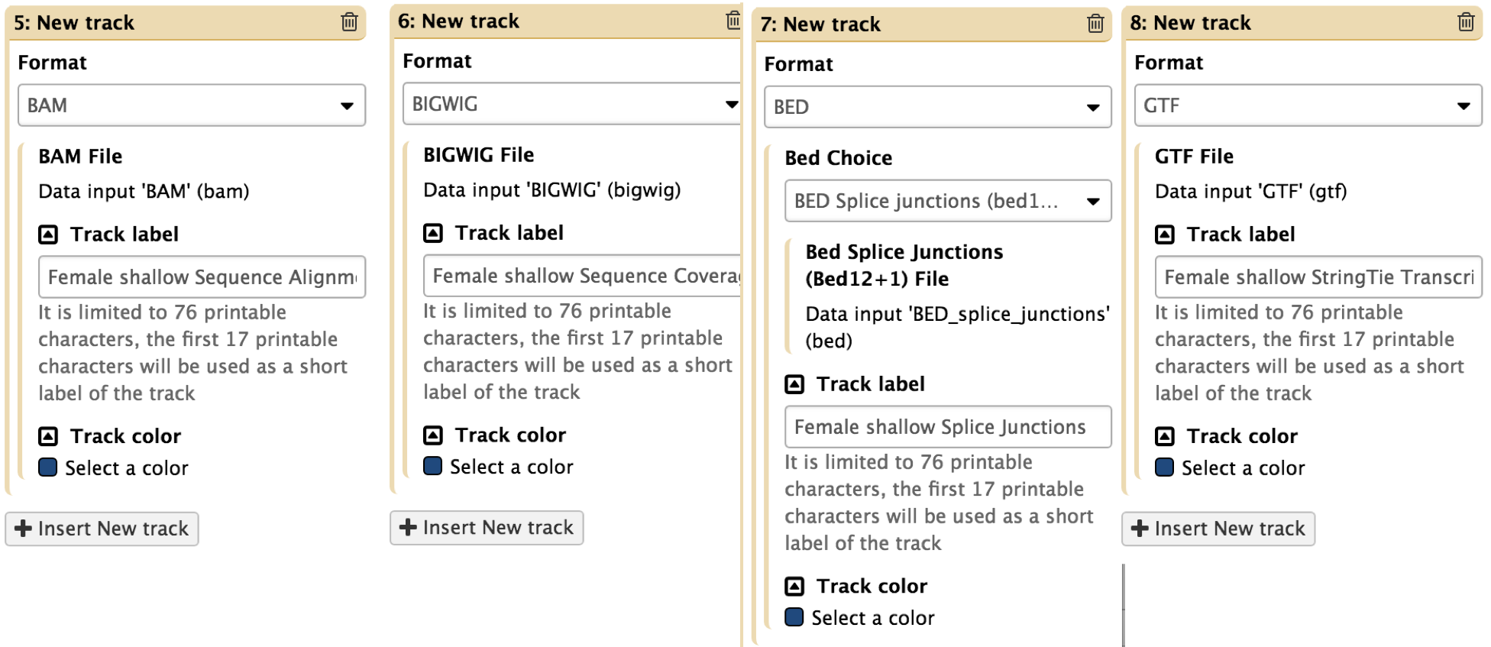
Figure 29: Insert new tracks in “RNA-Seq Analysis” group to add input connections for the outputs from the HISAT, StringTie, Convert Bam to BigWig, and regtools junctions extract. Specify the corresponding format for each track (red arrow) and edit the track label for each track (red rectangle). You can change the track color by clicking on “Select a color”.
Connect the marked output from each tool with its correspond connection in Hub Archive Creator (Figure 30).
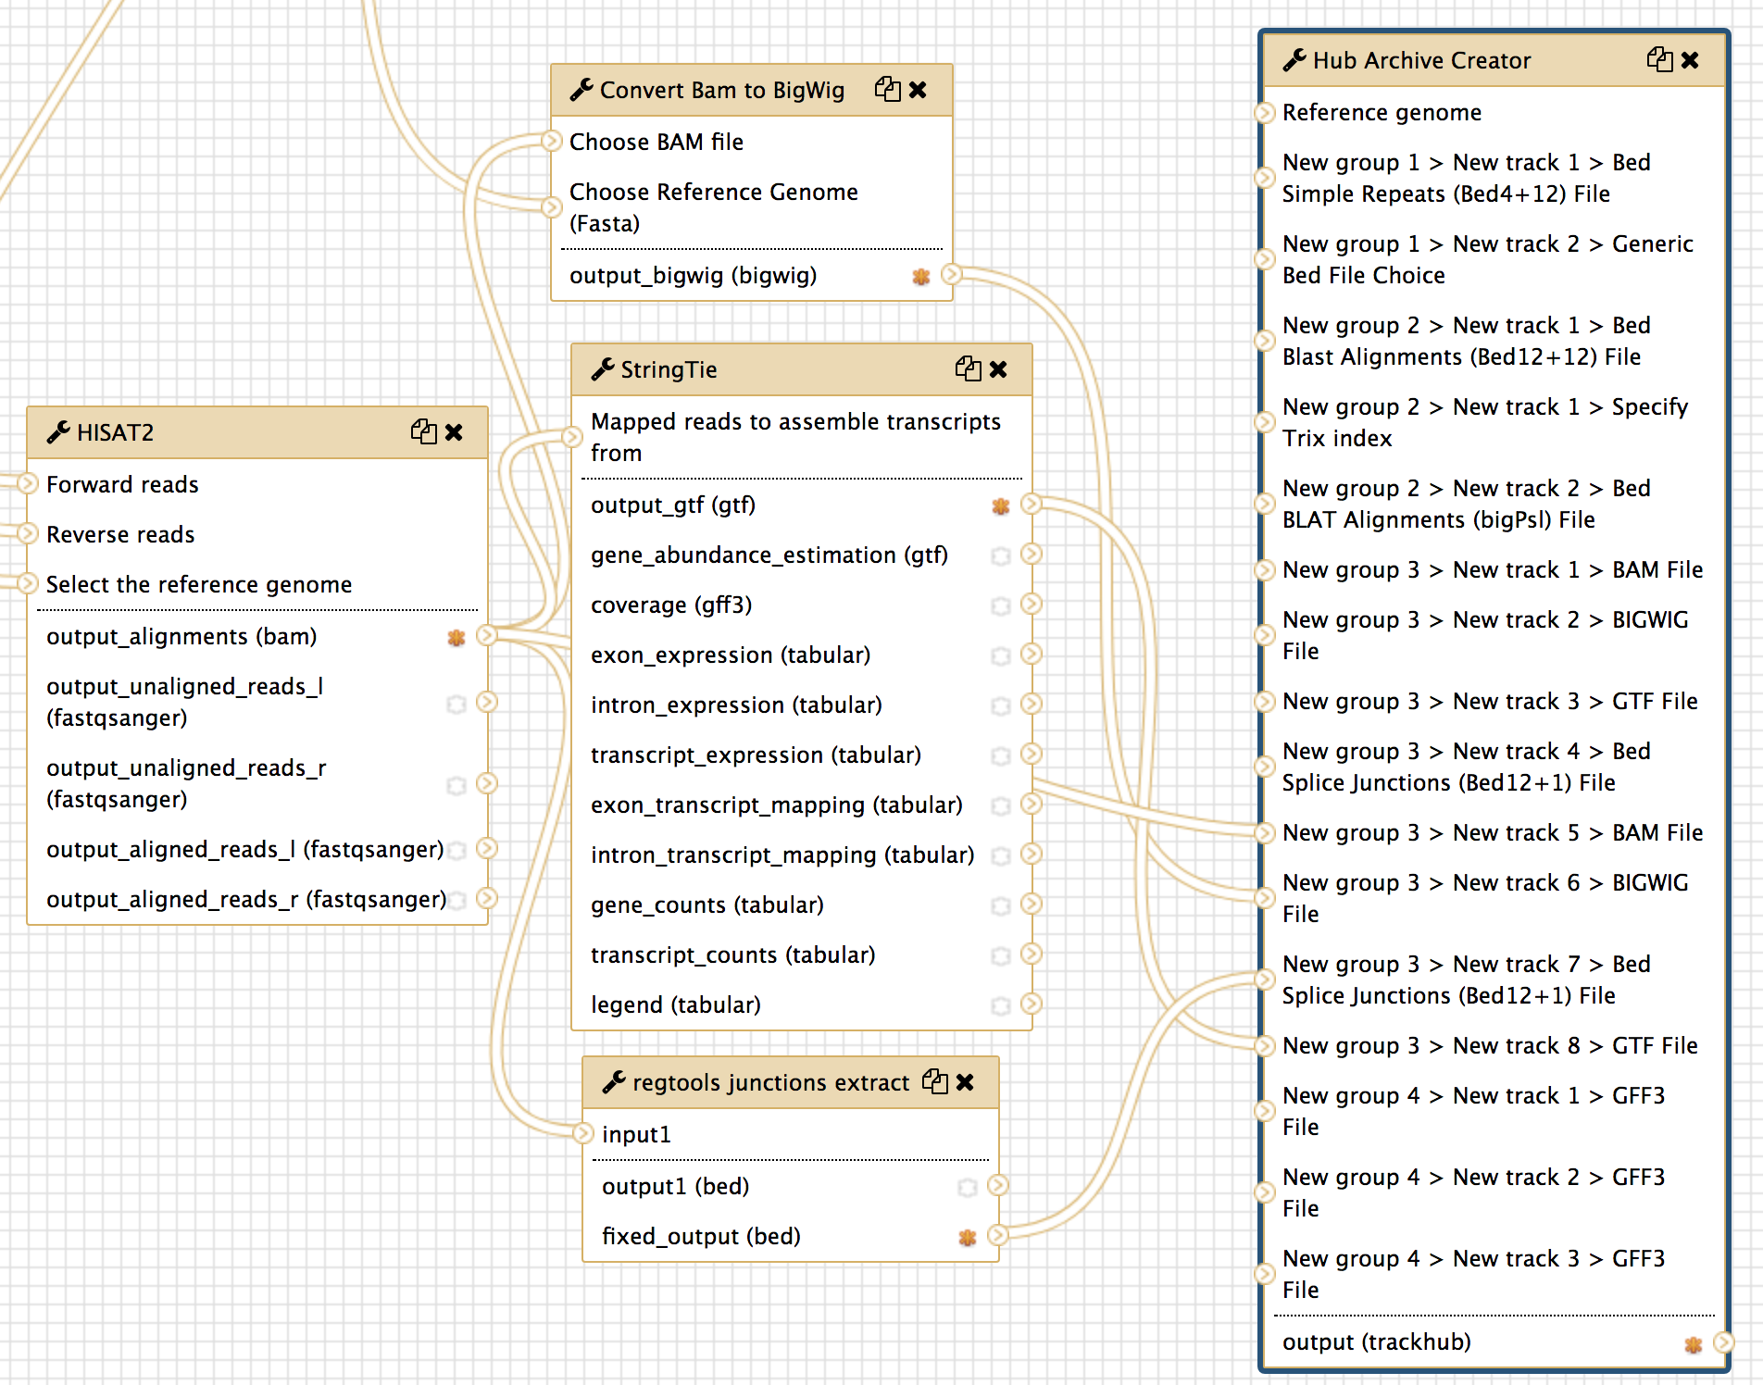
Figure 30: Connect the marked output from each tool (colored rectangles) to the corresponding new connections (rectangles with the same colors as their corresponding input) at Hub Archive Creator

Don’t forget to save the changes before you leave the Workflow Canvas.

3.3 Upload your datasets and run the workflow
To help us keep track of the different Histories, we will create a new History for this walkthrough and change the name of the History to “G-OnRamp:Dbia3_RNA-Seq”.

The test datasets that we will use in this exercise are available in the Data Libraries. Click on the “Shared Data” menu item on the menu bar and then select “Data Libraries” in the drop-down menu. Click on the “G-OnRamp:Dbia3_RNA-Seq” link. You will see seven datasets in the folder: the genome sequences from the Drosophila biarmipes Muller F element (dbia3.fa), a collection of Drosophila melanogaster protein sequences (dmel-hits-translation-r6.11.fa), a collection of D. melanogaster RNA GenBank records (dmel-mrna-chrom4.gb.txt), the D. biarmipes RNA-Seq paired-end reads for female shallow (forward reads file: “Dbia3_adult_females_shallow_1.fastq.gz” and reverse reads file: “Dbia3_adult_females_shallow_2.fastq.gz”), and the D. biarmipes RNA-Seq paired-end reads for male shallow (forward reads file: “Dbia3_adult_males_shallow_1.fastq.gz” and reverse reads file: “Dbia3_adult_males_shallow_2.fastq.gz”).

Import the datasets in the “G-OnRamp:Dbia3_RNA-Seq” folder to the “G-OnRamp:Dbia3_RNA-Seq” History. Run the “G-OnRamp:Dbia3_RNA-Seq” workflow. Make sure to select the correct input datasets (Figure 31). Don’t forget to change the model organisms for the gene prediction tools (Figure 32) and change the name of your new Assembly Hub.

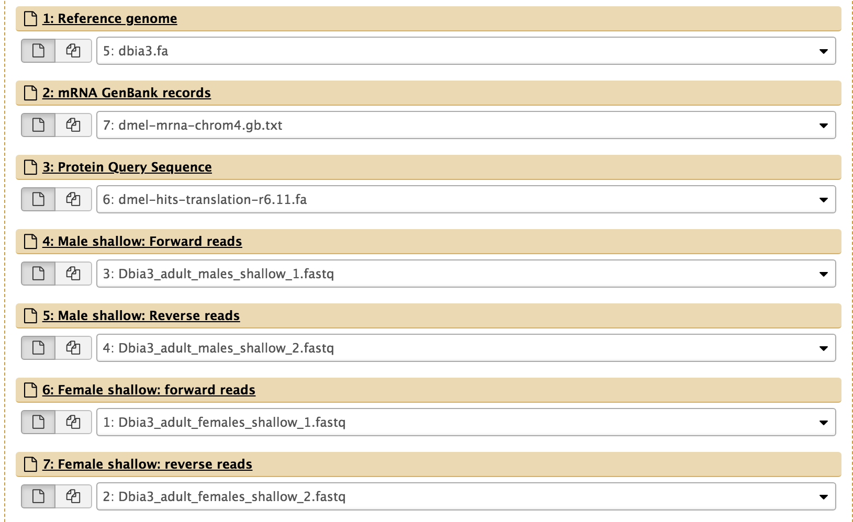
Figure 31: Make sure the input datasets that you have specified are the same as those shown in this Figure.
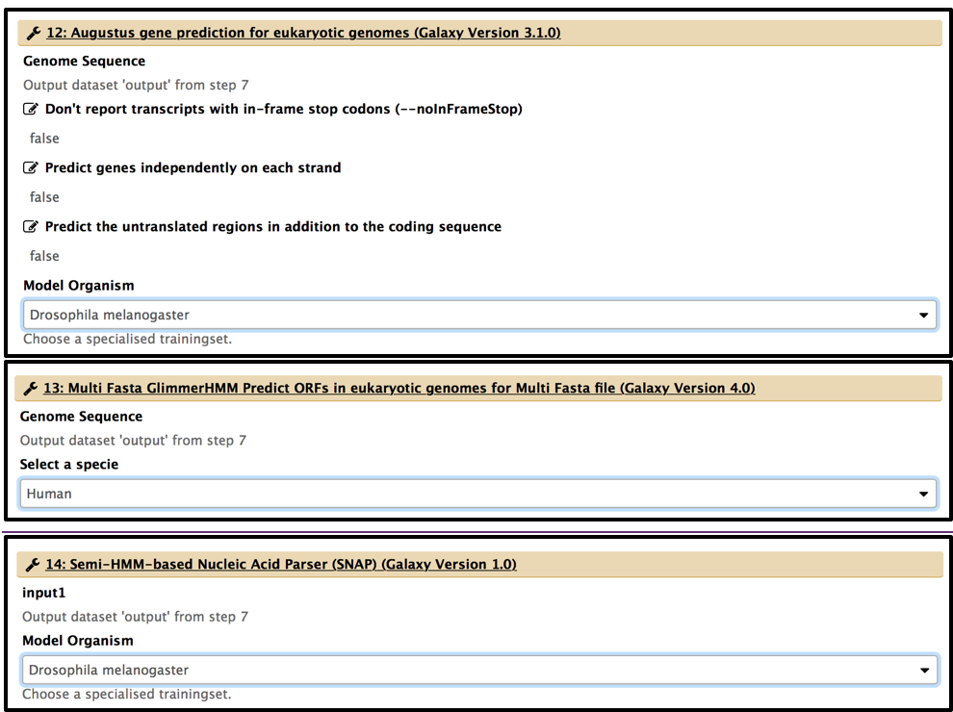
Figure 32: Change the model organisms for the gene prediction tools (i.e. Augustus, GlimmerHMM, and SNAP).
Finally, you can then view the RNA-Seq results produced by the modified G-OnRamp workflow as different evidence tracks on the UCSC genome browser (Figure 33).

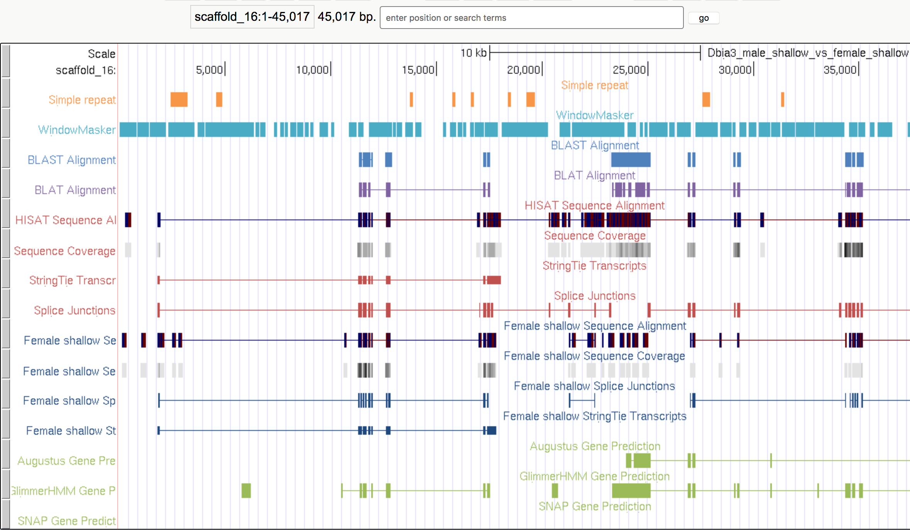
Figure 33: View the Dbia3 genome assembly and the evidence tracks produced by the Hub Archive Creator on the UCSC genome browser

4. Remove an evidence track from the Hub Archive Creator
Make a copy of “Customized G-OnRamp” workflow and rename the new workflow as “G-OnRamp: Remove WindowMasker track”. Click on the down arrow next on the new workflow and then select the Edit option to go to the Workflow Canvas.

To delete a tool from the workflow, click on the “x” at the top right corner of that tool. The tool and its connections will be removed from the workflow. For example, click on the “x” at the top right corner of the two WindowMasker tools to remove them from the workflow (Figure 34).

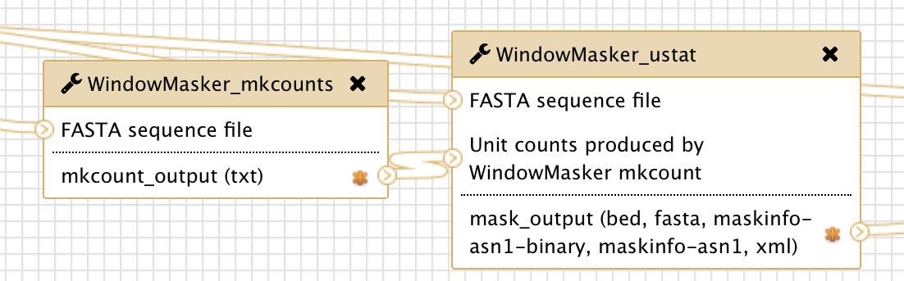
Figure 34: Click on the “x” at the top right corner to delete the WindowMasker_mkcounts and the WindowMasker_ustat tools from the workflow
When you delete the WindowMasker tools, the connections between WindowMasker_ustat and the Hub Archive Creator will also be removed. However, the “New group 1 > New track 2 > Generic Bed File Choice” entry in Hub Archive Creator will need to be removed manually.

Click on the Hub Archive Creator tool and scroll down to the “Repeats” group in the Details panel. Click on the “Trash” icon at the top right corner of the WindowMasker track to delete the track (Figure 35). Remember to save the changes to the workflow before you leave the Workflow Canvas.

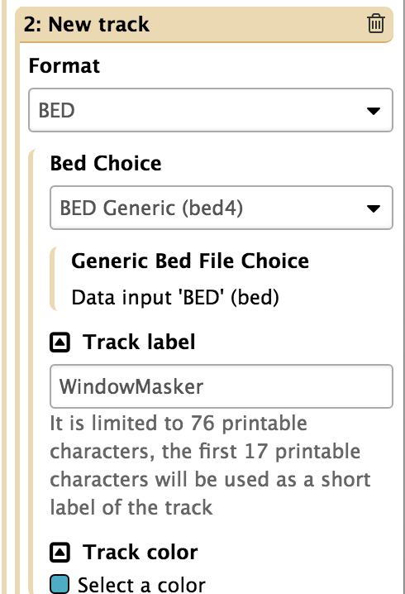
Figure 35: Click on the trash icon to remove the “Variation and Repeats” group from the Hub Archive Creator

5. Add custom tracks to the Genome Browser
The default G-OnRamp workflow performs analysis on genome assembly and RNA-Seq reads to produce multiple complementary evidence tracks on UCSC Genome Browser or JBrowse, including sequence similarity, tandem repeats, RNA-Seq analysis, and gene predictions.

We learnt how to add WindowMasker tools and RNA-Seq analysis tools to the G-OnRamp workflow in order to run additional analysis and add the evidence track files (output files from those analysis) to the genome browser. In addition to customizing the G-OnRamp workflow, you can also customize the genome browser produced by G-OnRamp by adding custom track files directly (output from other pipelines, e.g. MAKER). The steps for adding a custom track are 1) upload the custom track file to the Galaxy; 2) rename the scaffold names of the track file; 3) run the browser generator tool (Hub Archive Creator for generating UCSC Genome Browser or JBrowse Archive Creator for generating JBrowse) to create a new genome browser containing the existing evidence tracks plus the custom track. Here we will practice on adding a sequence coverage track of D. biarmipes egg shallow (BigWig format file) to the UCSC Genome Browser.

5.1 Upload the custom track file to the “G-OnRamp:Dbia3_RNA-Seq” History
The sequence coverage track file named “D.biarmipes_egg_shallow_sequence_coverage.bigwig” is in the “data” subfolder of the G-OnRamp workshop materials folder on your desktop. The file is a BigWig file that showing the sequence coverage of the RNA-Seq reads from D. biarmipes egg shallow.

To upload the file, click on “Get Data” and then click on “Upload File” in the Tools panel to open the uploading window (Figure 36). Then drag and drop the file to the uploading box, and click on the “Start” button to upload the file (Figure 37). Click on the “Close” button to go back to the Analysis page. The new History item will turn green after the file is uploaded.

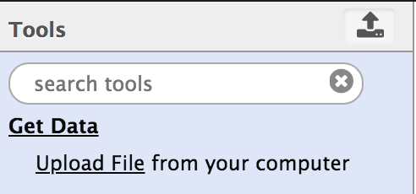
Figure 36: Click on "Get Data" and then click on "Upload File” to open the uploading window
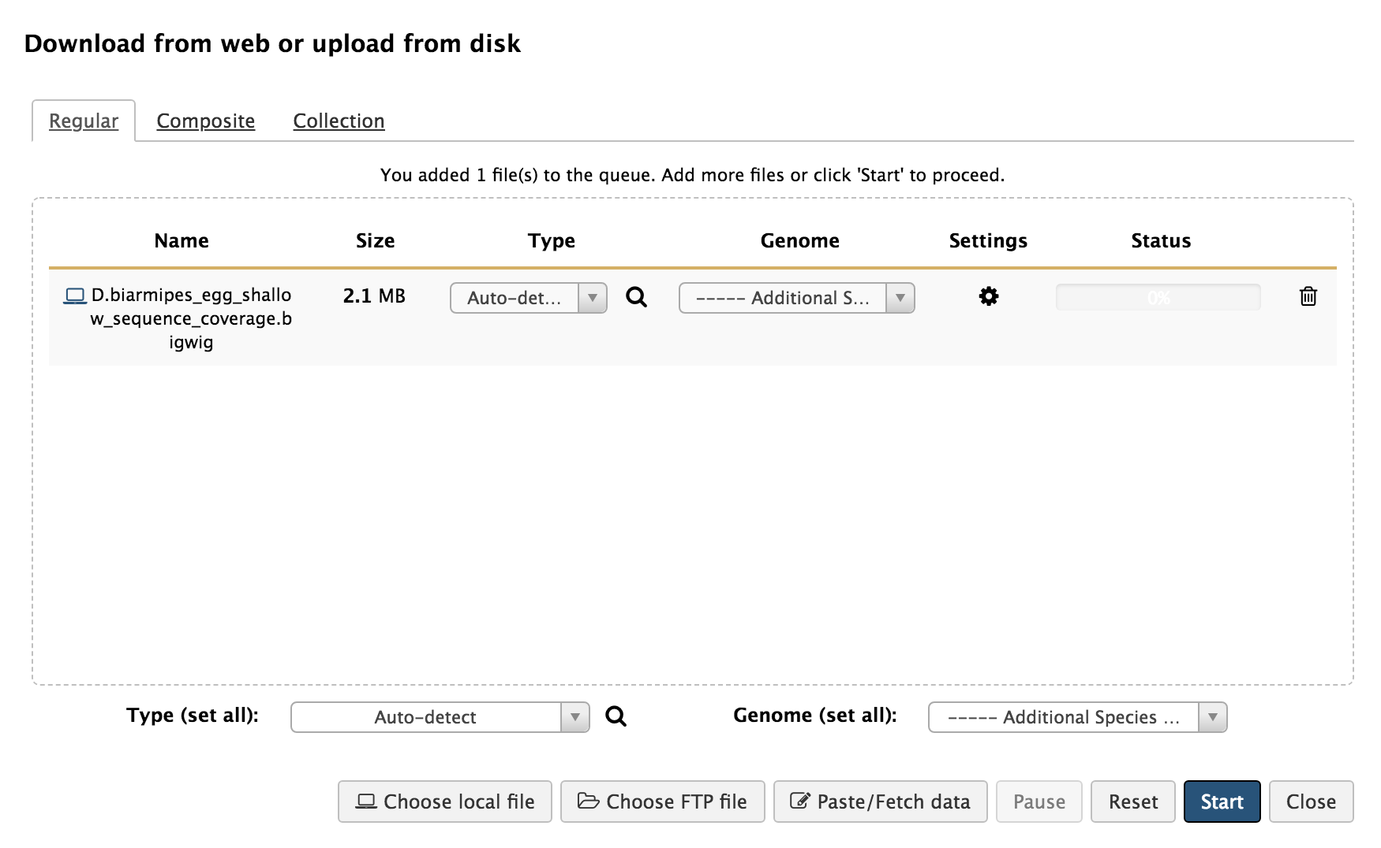
Figure 37: Drag and drop the file to the box and then click on the “Start” button to start uploading

5.2 Rename the scaffold names of the track file
We renamed the scaffolds of the reference genome with “rename the scaffolds” tool in our G-OnRamp workflow. The “renamed the scaffolds” tool shortens the scaffold names to less than 32 characters, otherwise, the UCSC Genome Browse will fail to display the Assembly Hub. The tool outputs two datasets: 1) “9: rename the scaffolds on data 1: name mapping”, which contains the original sequence names and the sequence names after renaming; 2) “8: rename the scaffolds on data 1: renamed_reference, which is the renamed reference genome. We use the renamed reference genome for the following analysis and generating the genome browser.

However, the custom sequence coverage file is mapped to the original reference sequence, so the scaffold names of the file are different from the scaffold names in the renamed reference. This will cause the track fail to display in the genome browser. Therefore, we need to rename the scaffolds in the track file to make them consistent with the renamed reference genome.

Here we can use the tool “rename the tracks” to rename the scaffolds in the custom track file. Search the tool in the Tools panel and click on the “rename the tracks” to open the tool configuration form (Figure 38).

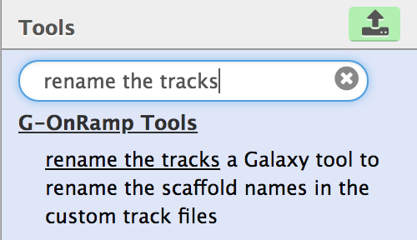
Figure 38: Search "rename the tracks" in the search box in the Tools panel and then click on the link “rename the tracks” to open the tool
Specify the format of your custom track file as “BigWig”, select the BigWig file you just uploaded as the input to the “Custom track file” field, select the renamed reference file and the name mapping file output from “rename the scaffolds” tool. Then execute the tool to rename the custom track file accordingly. You will get a new History item (e.g. 44: rename the tracks on data 9, data 8, and data 43: renamed_track) for the renamed custom track file.

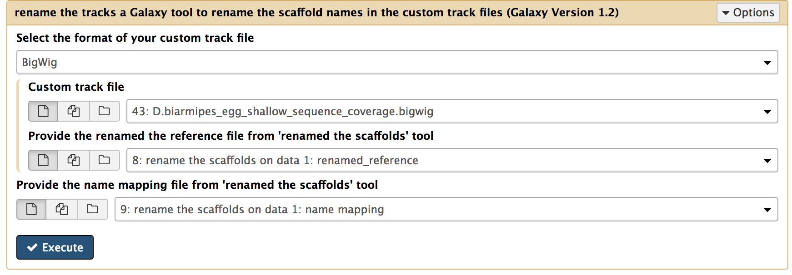
Figure 39: Select "BigWig" for the format, specify the track file, renamed reference file and name mapping file. Then click on “Execute”

5.3 Run Hub Archive Creator to create a new UCSC Genome Browser including the custom track
Hub Archive Creator is a Galaxy tool that is used to prepare your files to be ready for Assembly Hub visualization. Find the Hub Archive Creator from the Tools panel and open the tool. Here you can specify the name of your Assembly Hub in the “UCSC Genome Browser assembly ID” field. The default name is “unknown”. You have to select your reference genome file for the “Reference genome” field. Here we use the renamed reference genome. To add evidence tracks, you can either add the track to an existing group by click on “Insert New track” within the group, or add the track to a new group: first create a new group by click on “Insert New group”, then click on “Insert New track” within the group. A group is used to put the related evidence tracks together. Multiple evidence tracks can belong to one group.

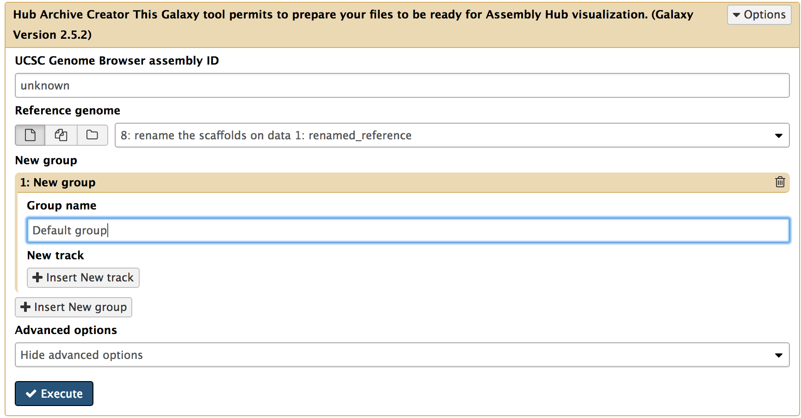
Figure 40: This is the configuration page of Hub Archive Creator. If no group exist, you have to create a new group first by clicking on “Insert New group”, then add an evidence track within the group by clicking on “Insert New track”. You can change the group name (default name is “Default group”) to a meaningful name
Since we want to include all evidence tracks in the previous Assembly Hub, we can modify the previous configuration of Hub Archive Creator instead of adding all evidence tracks one by one from the scratch. First, click on the History item that produced by Hub Archive Creator (e.g. 42: Hub Archive Creator on data 24, data 23, and others), then click on the “rerun” icon to open the configuration page which contains the input files and parameters we used before (Figure 41). (It may take a few seconds to load.)

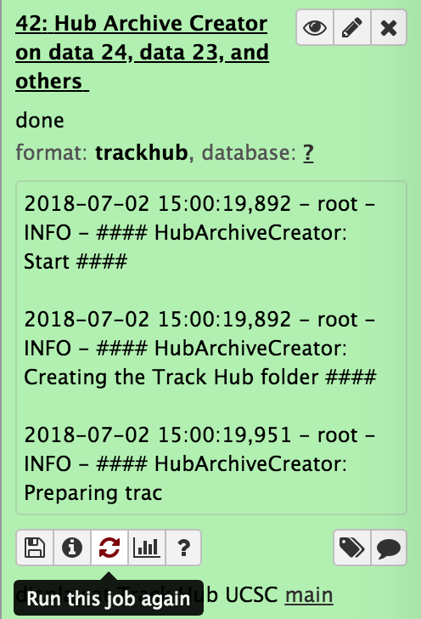
Figure 41: Click on the icon which indicates “Run this job again” to open the configuration page
The next step is to add the sequence coverage of D. biarmipes egg shallow to the Hub Archive Creator. Let’s add this new track to the “RNA-Seq Analysis” group. First, find the group named “RNA-Seq Analysis” then scroll down to the end of this group and click on “Insert New track” to add a new track configuration block (Figure 42).

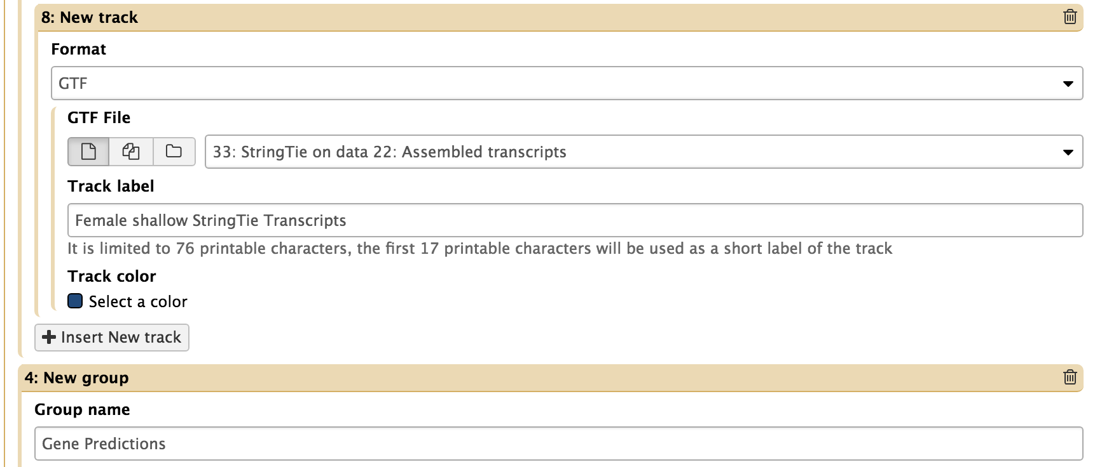
Figure 42: Scroll down to the end of the "RNA-Seq Analysis” group and then click on “Insert New track”
Select “BIGWIG” from the drop-down menu for the “Format” and select the renamed custom track file for the “BIGWIG File”. You can label the track as “Egg shallow sequence coverage” and select a color for the track (Figure 43).

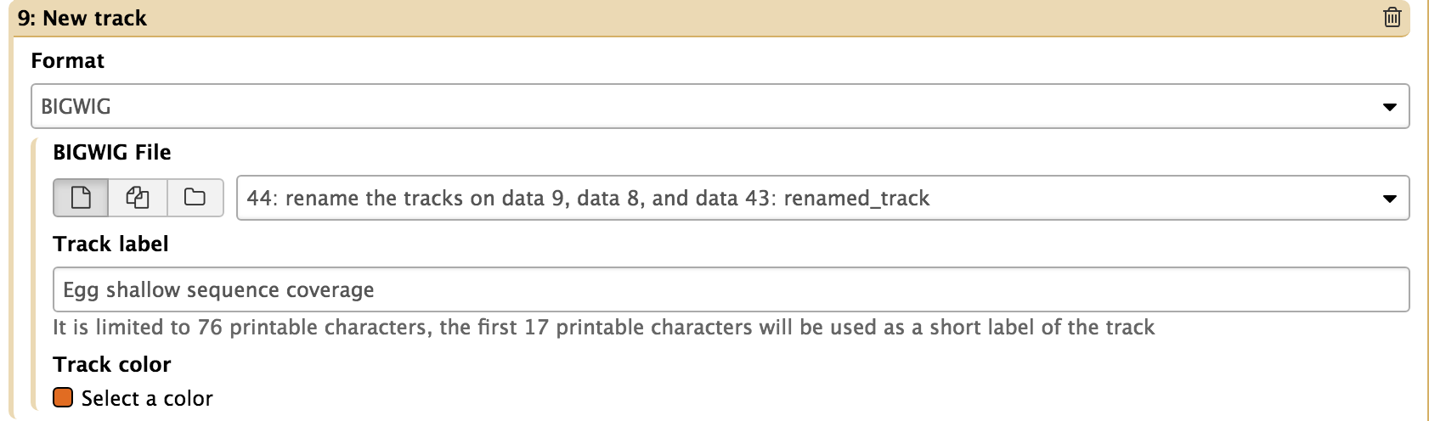
Figure 43: In the new track block, select “BIGWIG” for the track file format and select the renamed track file as the input file. You can customize the track label and track color
Finally, scroll down to the end of the configuration blocks and click on the “Execute” button to run the Hub Archive Creator to create a new UCSC Assembly Hub which will contain the sequence coverage track of D.biarmipes egg shallow.

