Comparative Gene Annotation with Galaxy / G-OnRamp

Wilson Leung
07/2018

Introduction
As part of the gene annotation process, we can use the putative orthologs from multiple species to characterize a feature within a genomic scaffold. This walkthrough will illustrate how we can use comparative genomics to characterize a protein-coding gene in the Drosophila miranda Muller F element that does not have a corresponding ortholog in Drosophila melanogaster. As part of analysis, we will use multiple web databases and tools (e.g., FlyBase, NCBI blastp, SmartBLAST, Gene2Function) to facilitate the annotation of this feature.
This walkthrough assumes that the reader is already familiar with using Apollo for genome annotation. (See the “Use Apollo to Do Collaborative Genome Annotation” walkthrough for an overview of Apollo.)

Navigate to the feature of interests in Apollo
For this walkthrough, we have constructed an Apollo instance which contains only the Drosophila miranda Muller F element (scaffold_6). Open a new web browser tab and navigate to the Apollo instance for the “Drosophila miranda MSH22 (unmask scaffold_6)” assembly at http://cloud5.galaxyproject.org:8080/apollo/annotator/index. Log into the Apollo instance using your Apollo account credentials.

Enter “scaffold_6:715000..732000” into the position text box at the top left panel and then click on the “Go” button (Figure 1).

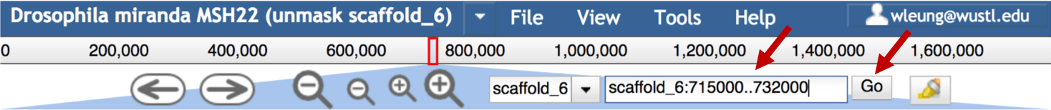
Figure 1. Navigate to the 715000–732000 region in scaffold_6 of the D. miranda assembly.

Select the “Tracks” tab in the right panel, click on the “Gene Predictions”, “RNA-Seq Analysis”, and “Sequence Similarity” headers to expand these sections. Select the checkboxes next to the following tracks (Figure 2):

- Under “Gene Predictions”: Augustus Gene Prediction
- Under “RNA-Seq Analysis”:
  - SRR364798 Sequence Coverage
  - SRR364800 Sequence Coverage
- Under “Sequence Similarity”: BLAT Alignment
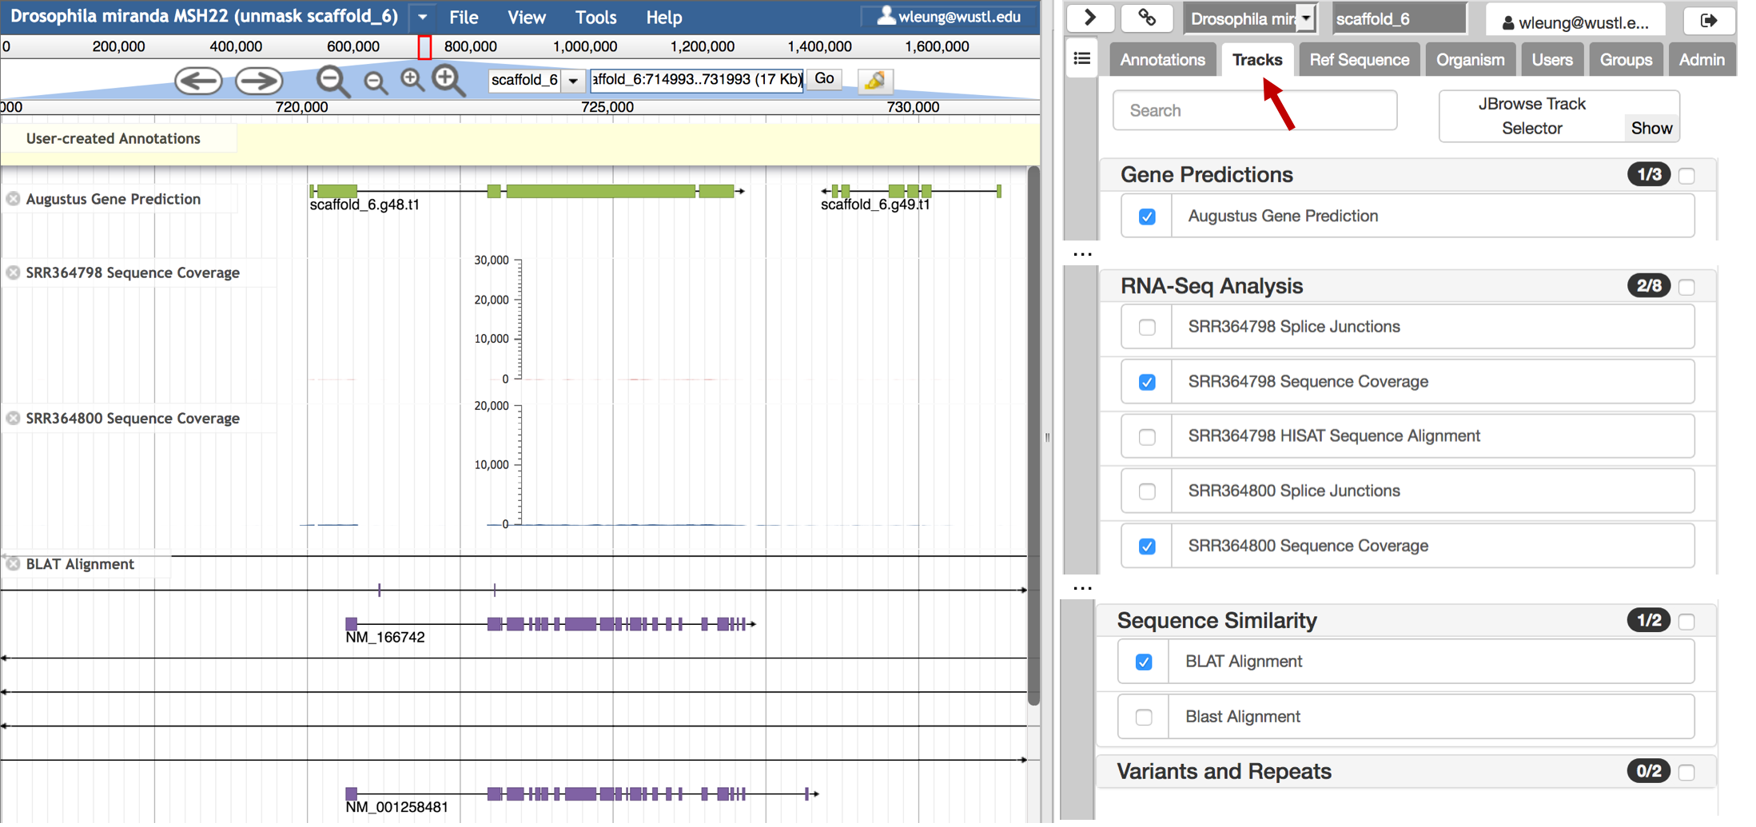
Figure 2. Select the “Tracks” tab in the right panel (red arrow) and then select the checkboxes next to the evidence tracks to examine the computational and experimental data available for this region.

The D. miranda SRR364798 and SRR364800 RNA-Seq data are derived from whole virgin males and whole virgin females, respectively. By default, the y-axis of the RNA-Seq coverage tracks ranges from the minimum to the maximum read coverage of the entire RNA-Seq dataset (i.e., “autoscale”: “global”). To facilitate the interpretation of the RNA-Seq data, we will change the display options so that it will automatically adjust the scale based on the minimum and maximum values within the viewing range (i.e., “autoscale”: “local”).

Click on the drop-down menu next to the “SRR364798 Sequence Coverage” track title and then select the “Edit config” option. Change the second line from “autoscale”: “global” to “autoscale”: “local”, and then click on the “Apply” button (Figure 3). Repeat the procedure to change the display of the “SRR364800 Sequence Coverage” track to “autoscale”: “local”.

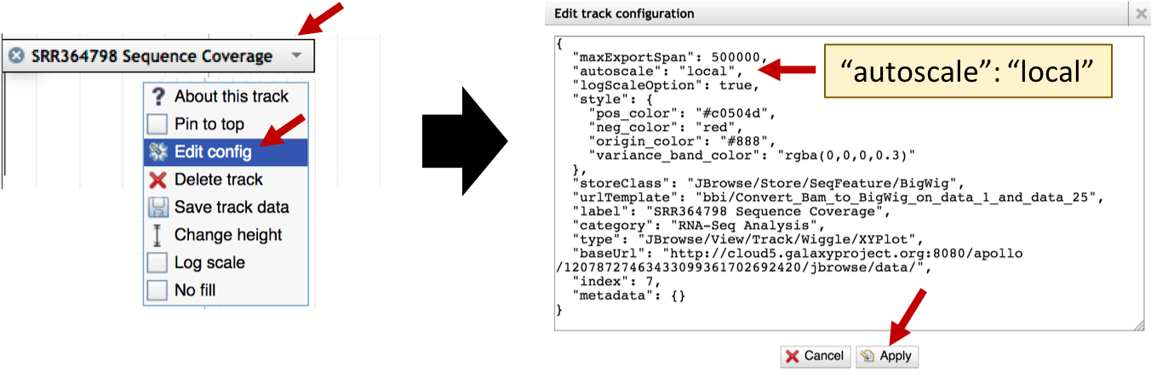
Figure 3. Configure the “SRR364798 Sequence Coverage” track so that the scale for the y-axis will change based on the minimum and maximum values of the viewing range.
The Apollo view shows two Augustus gene predictions in this region. The BLAT Alignment track indicates that the Augustus gene prediction scaffold_6.g48.t1 overlaps with the BLAT alignments to the Drosophila melanogaster transcripts NM_166742 and NM_001258481 (i.e., isoforms A and B of CG31998). By contrast, there are no BLAT alignments that overlap with the Augustus gene prediction scaffold_6.g49.t1. (The lines that span this region correspond to gaps in the BLAT alignments.) However, this feature overlaps with RNA-Seq read coverage from the whole virgin male (SRR364798) and whole virgin female (SRR364800) samples, which indicates that this region is being transcribed in the D. miranda genome (Figure 4).

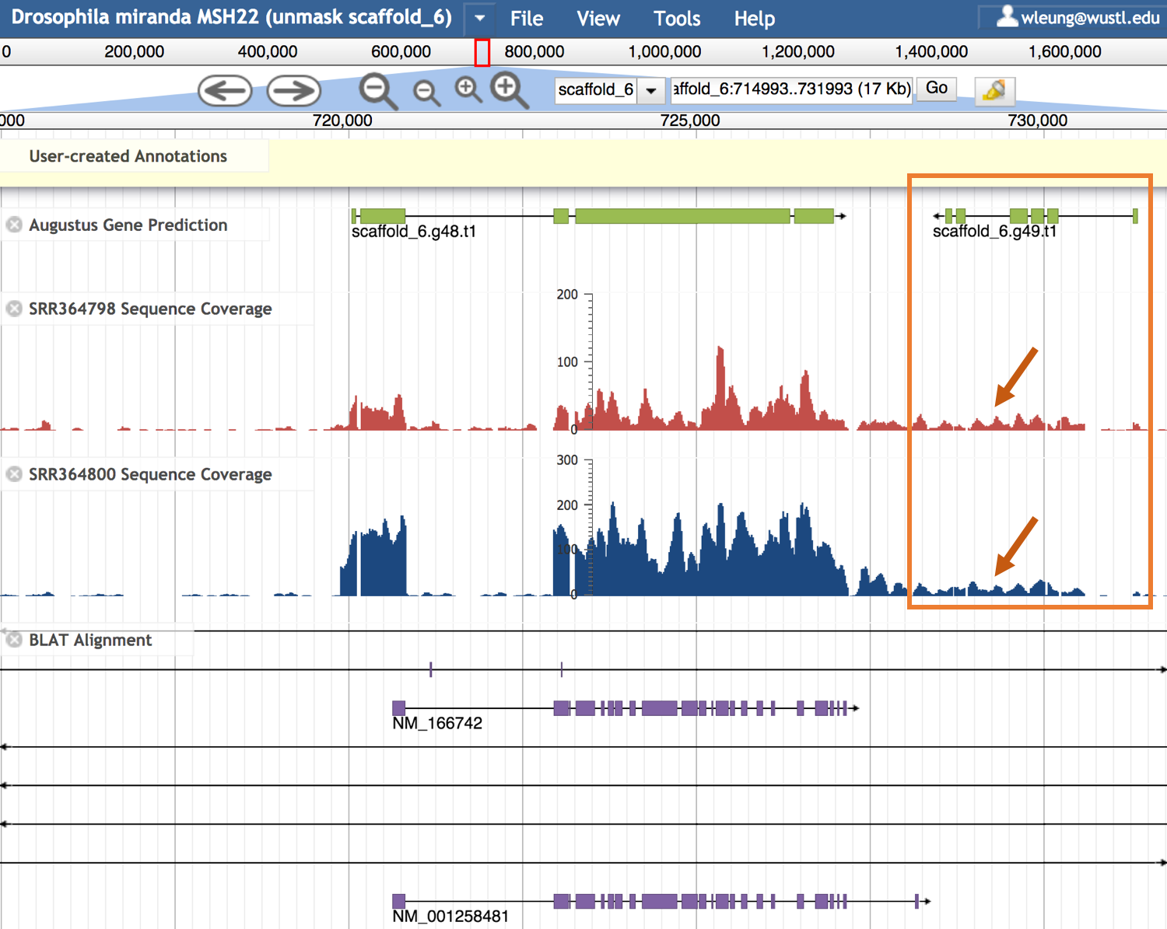
Figure 4. The Augustus gene prediction scaffold_6.g49.t1 is supported by RNA-Seq read coverage in the SRR364798 and SRR364800 samples (orange box and arrows). However, this feature does not overlap with the BLAT alignments to D. melanogaster transcripts.

Compare scaffold_6.g49.t1 to D. melanogaster annotated proteins
To verify that the Augustus gene prediction scaffold_6.g49.t1 does not correspond to any of the known protein-coding genes in D. melanogaster, we will compare the predicted protein sequence for D. miranda scaffold_6.g49.t1 against the collection of D. melanogaster proteins annotated by FlyBase.

In order to obtain the protein sequence for the Augustus gene prediction, we will construct a new gene model in Apollo. Right click (control-click on macOS) on the Augustus gene prediction scaffold_6.g49.t1 and select the “Create new annotation” → “gene” option. A new gene model will appear in the “User-created Annotations” section (Figure 5).
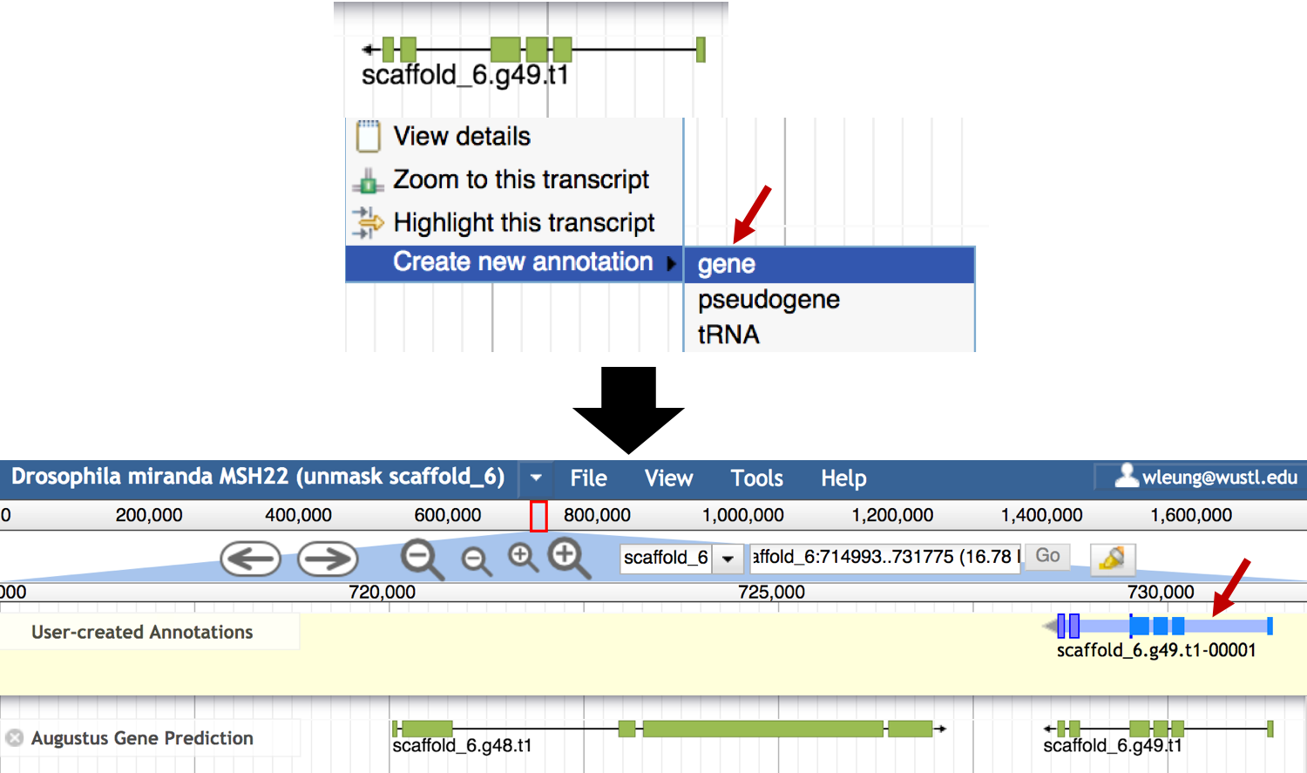
Figure 5. Create a new gene model (scaffold_6.g49.t1-00001) based on the Augustus gene prediction scaffold_6.g49.t1.

Enter “scaffold_6:727000..732000” into the position text box at the left panel and then click on the “Go” button to zoom into the region surrounding the new gene model. The thin boxes in the first four exons of the gene model correspond to the 5’ untranslated regions. However, because all the exons of the Augustus gene prediction should be part of the coding region, we will revise the gene model to expand the coding region. Right click (control-click on macOS) on one of the introns of the scaffold_6.g49.t1-0001 gene model to select the entire gene model, and then select the “Set Longest ORF” option (Figure 6).

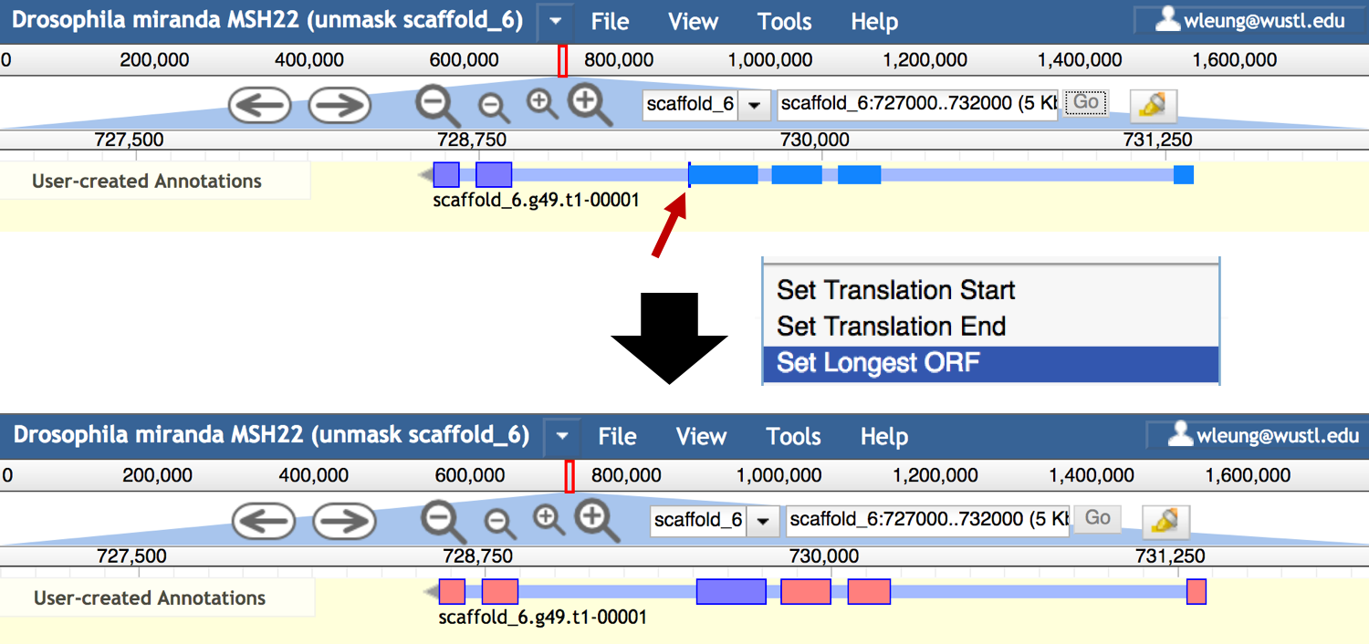
Figure 6. The original gene model constructed by Apollo designated the start of the coding region at the fourth transcribed exon (red arrow). Use the “Set Longest ORF” option to expand the coding region.

To obtain the protein sequence associated with the revised gene model, right click (control-click on macOS) on the scaffold_6.g49.t1-00001 feature in the User-created Annotations track and then select the “Get Sequence” option (Figure 7). Verify that the “Peptide sequence” option is selected in the “Sequence” dialog box.
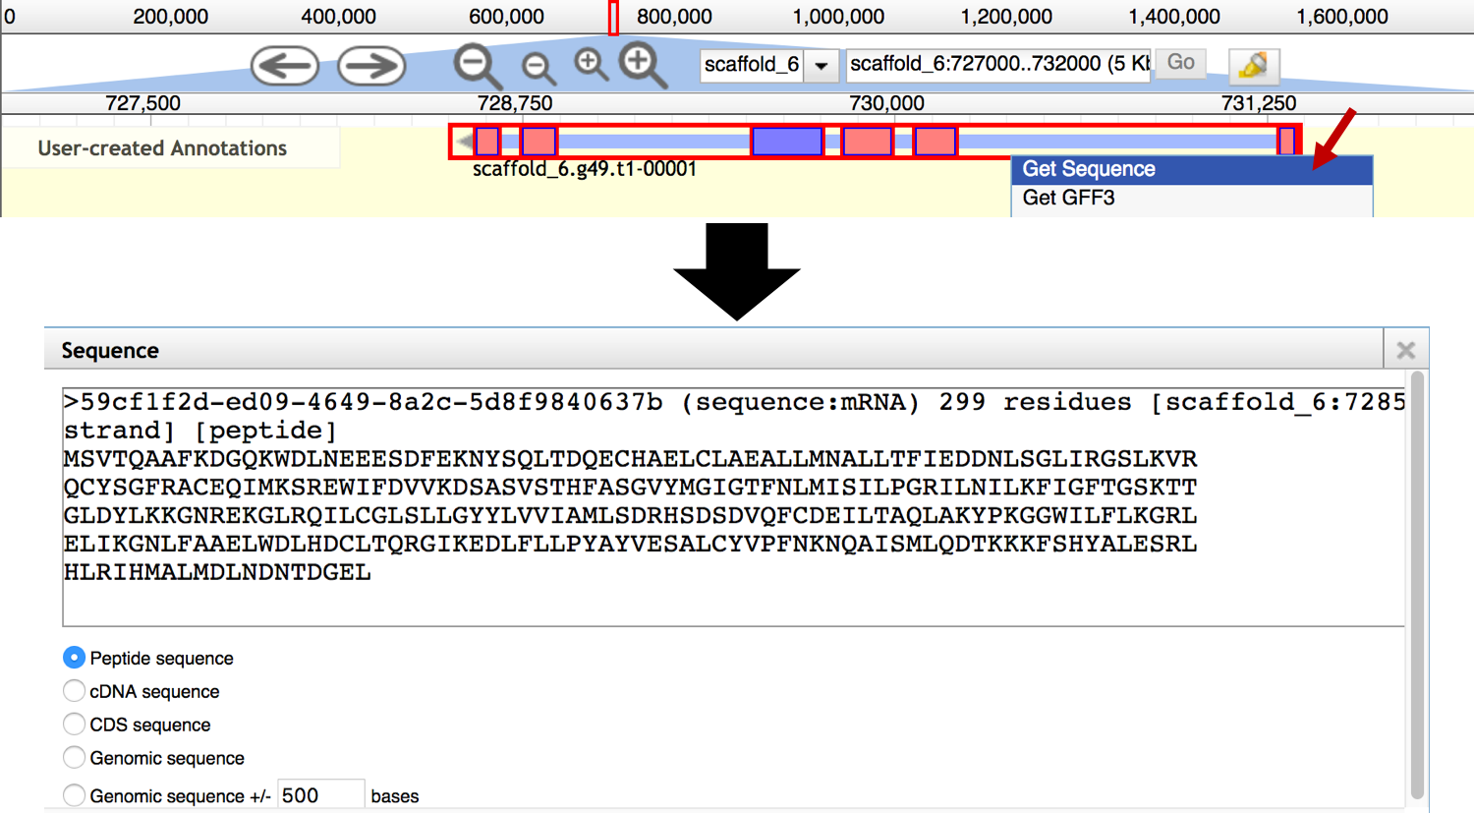
Figure 7. Retrieve the peptide sequence for the scaffold_6.g49.t1-00001 feature.

Select the peptide sequence in the “Sequence” window and copy it onto the clipboard. Open a new web browser tab and navigate to the FlyBase BLAST page at http://flybase.org/blast/. Paste the predicted protein sequence into the “Sequence” text box. Change the sequence header (i.e., the line which begins with “>”) to “>scaffold_6.g49.t1”, and then change the BLAST search settings to the following (Figure 8):

- Database: Annotated proteins (AA)
- Program: blastp: AA -> AA
- Species (optional): Drosophila melanogaster
- Click on the “BLAST” button

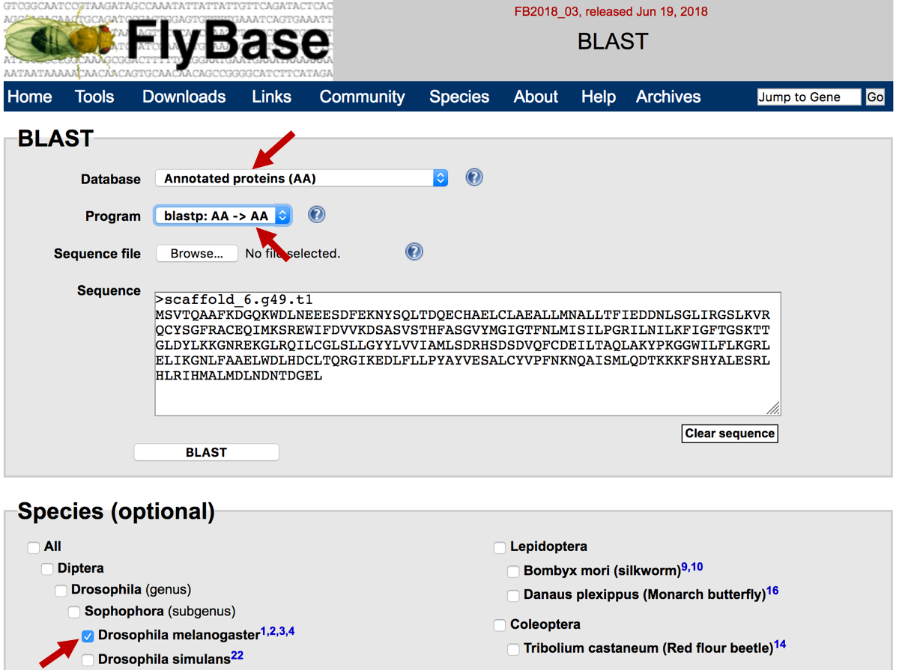
Figure 8. Configure the FlyBase blastp search of the Augustus gene prediction scaffold_6.g49.t1 against the D. melanogaster “Annotated proteins” database.
Consistent with the results from the BLAT Alignment track in Apollo, there are no significant matches between the Augustus gene prediction and the D. melanogaster annotated proteins in FlyBase (Figure 9).

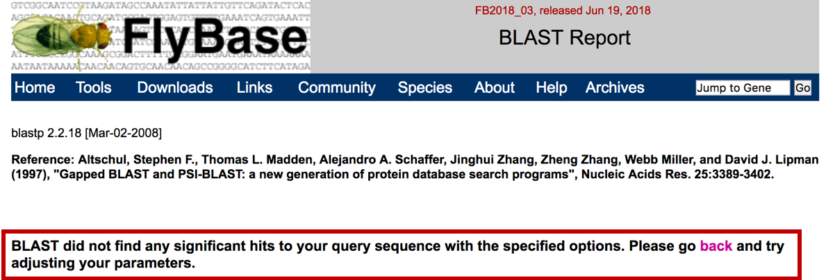
Figure 9. No significant matches (E-value < 10) between the Augustus gene prediction scaffold_6.g49.t1 and the annotated proteins in D. melanogaster.

Compare scaffold_6.g49.t1 to the RefSeq protein database
To ascertain if scaffold_6.g49.t1 is similar to proteins in other species, we will perform an NCBI blastp search against the NCBI Reference Protein database (refseq_protein).

Open a new web browser tab, and navigate to the NCBI BLAST home page at https://blast.ncbi.nlm.nih.gov/Blast.cgi. Click on the “Protein BLAST” image (Figure 10).

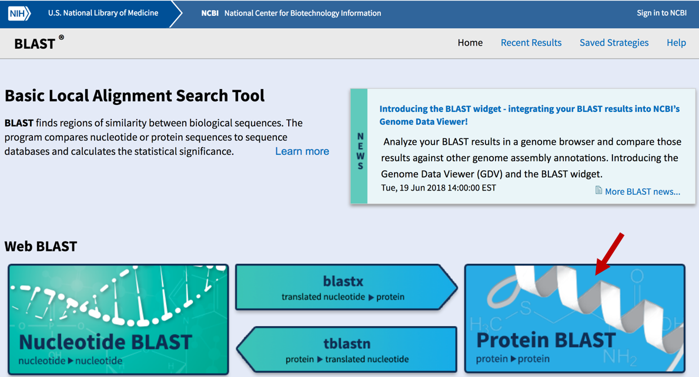
Figure 10. Access blastp from the NCBI BLAST home page.

Paste the protein sequence for the Augustus gene prediction into the “Enter Query Sequence” text box. Change the sequence header to ““>scaffold_6.g49.t1”. Select the “Reference proteins (refseq_protein)” option under the “Database” field. Click on the “BLAST” button (Figure 11).

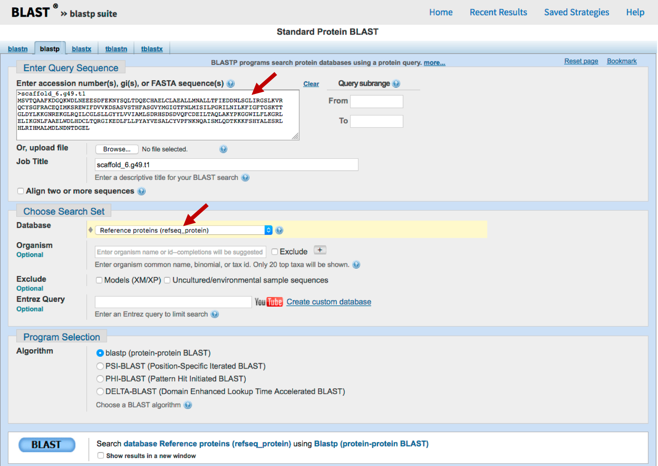
Figure 11. Configure a blastp search of the Augustus gene prediction scaffold_6.g49.t1 against the NCBI refseq_protein database.
The blastp search against the refseq_protein database may take several minutes to complete.

The “Graphic Summary” section of the blastp search results show that the Augustus gene prediction contains a conserved domain DUF3808 (Figure 12). The Graphical Overview of the matches show that there are 190 BLAST hits to this gene prediction, many of which cover almost the entire length of the gene prediction and have high alignment scores (≥ 200; red boxes). Hence the blastp search results suggest that scaffold_6.g49.t1 could correspond to a protein-coding gene whose orthologs are found in other species but not in D. melanogaster.

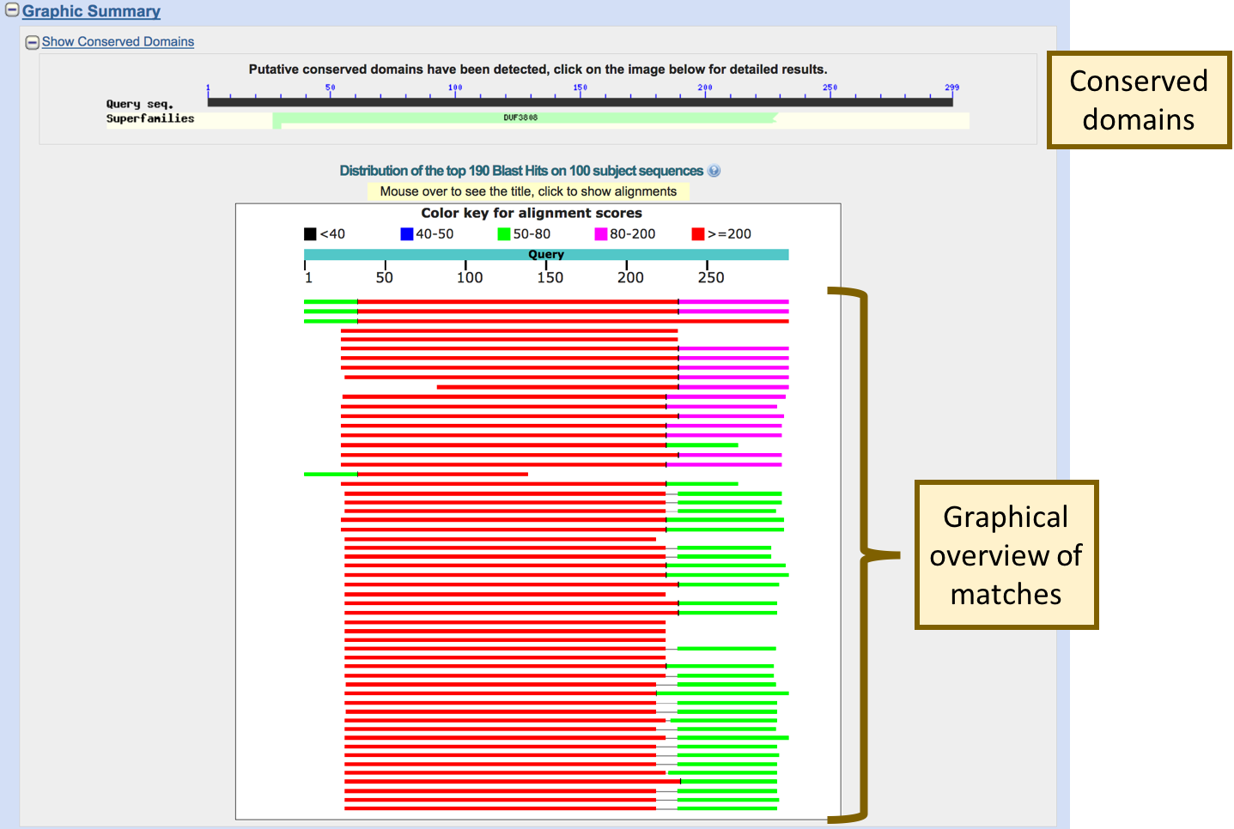
Figure 12. Graphical overview of the blastp search results indicate that the Augustus gene prediction contains a conserved domain (DUF3808), and there are multiple highly significant matches to the gene prediction in the refseq_protein database.

Use the NCBI Taxonomy reports to investigate protein matches
To further investigate the taxonomic distributions of the protein matches, click on the “Taxonomy reports” link at the top of the blastp search results (Figure 13). The Tax BLAST report is divided into three sections:

- Lineage Report: summarizes the blastp matches by lineage, the indentation levels and the number of dots in the “Organism” column correspond to the taxonomic level.

- Organism Report: groups the blastp matches by species. This report can be used to quickly identify the best blastp match in each species.

- Taxonomy Report: provides a more interactive view of the Lineage Report. Toggle the “+/-” button next to the non-leaf node to show or hide a section (e.g., clade).

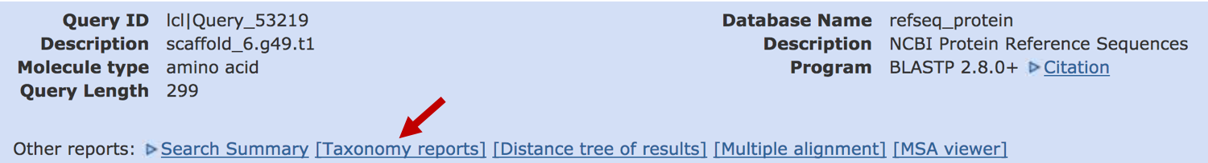
Figure 13. Click on the "Taxonomy reports" link (red arrow) to view a summary of the species with significant blastp matches to scaffold_6.g49.t1.
Examination of the Lineage Report shows that there are 264 matches to different winged insects (infraclass: Neoptera; Figure 14). The “Blast Name” column indicates that these matches are found in flies, mosquitos, beetles, hymenopterans, and wasps. There are 28 matches among 10 Drosophila species. The score column indicates that the best matches are found within the obscura group (i.e., Drosophila miranda matches have a maximum score of 414, and the Drosophila obscura matches have a maximum score of 376).

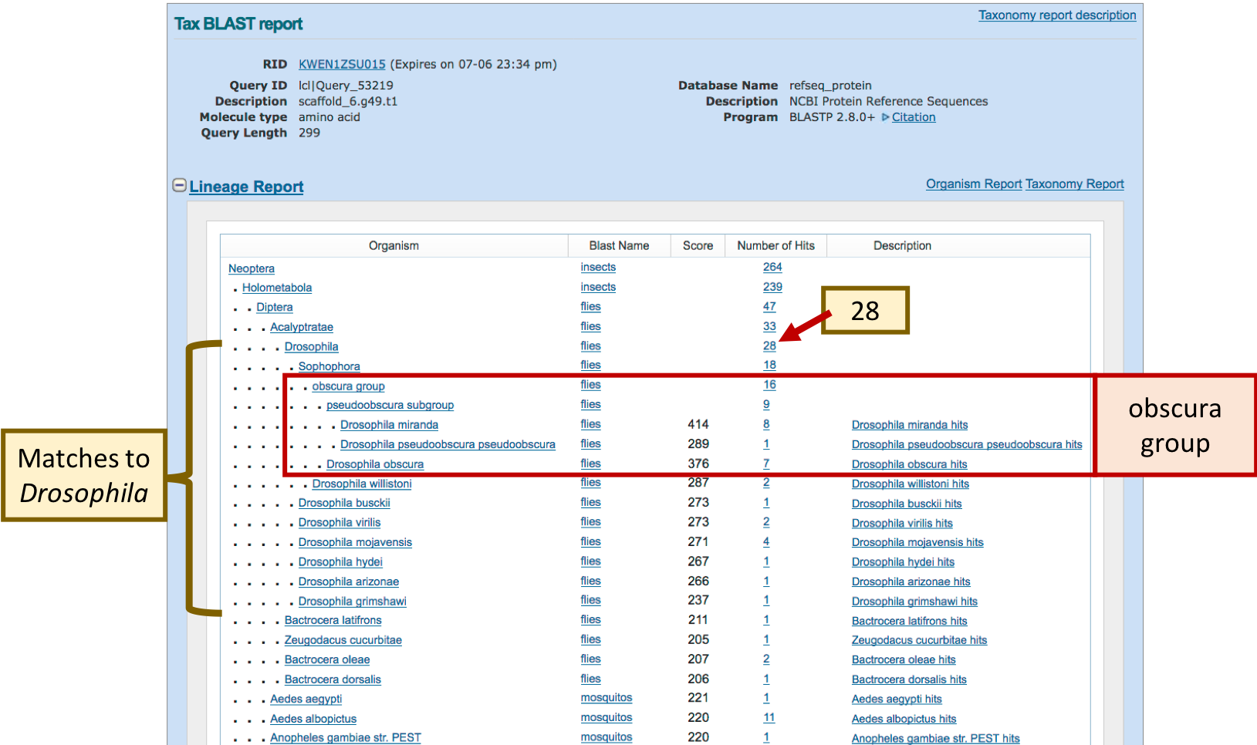
Figure 14. The Lineage Report shows that there are 28 blastp matches to the Augustus gene prediction in 10 Drosophila species. The best matches are found in the obscura group.

Click on the “Drosophila miranda hits” link under the “Description” column to navigate to the list of D. miranda matches in the Organism Report. The entries under “Drosophila miranda [flies]” shows eight matches to the different isoforms of the predicted tetratricopeptide repeat protein 39B-like gene, with E-values that range from 6e-139 to 7e-75. Similarly, there are seven matches to the different isoforms of the tetratricopeptide repeat protein 39B-like gene in D. obscura, with E-values that range from 9e-127 to 3e-121 (Figure 15).
Some of the matches in the “Organism Report” have the same title (e.g., tetratricopeptide repeat protein 39B-like isoform X2 [Drosophila miranda]). However, because the “Accession” column indicates that these matches have different RefSeq accession numbers (e.g., XP_017155608, XP_017155609), they correspond to distinct records in the RefSeq database.
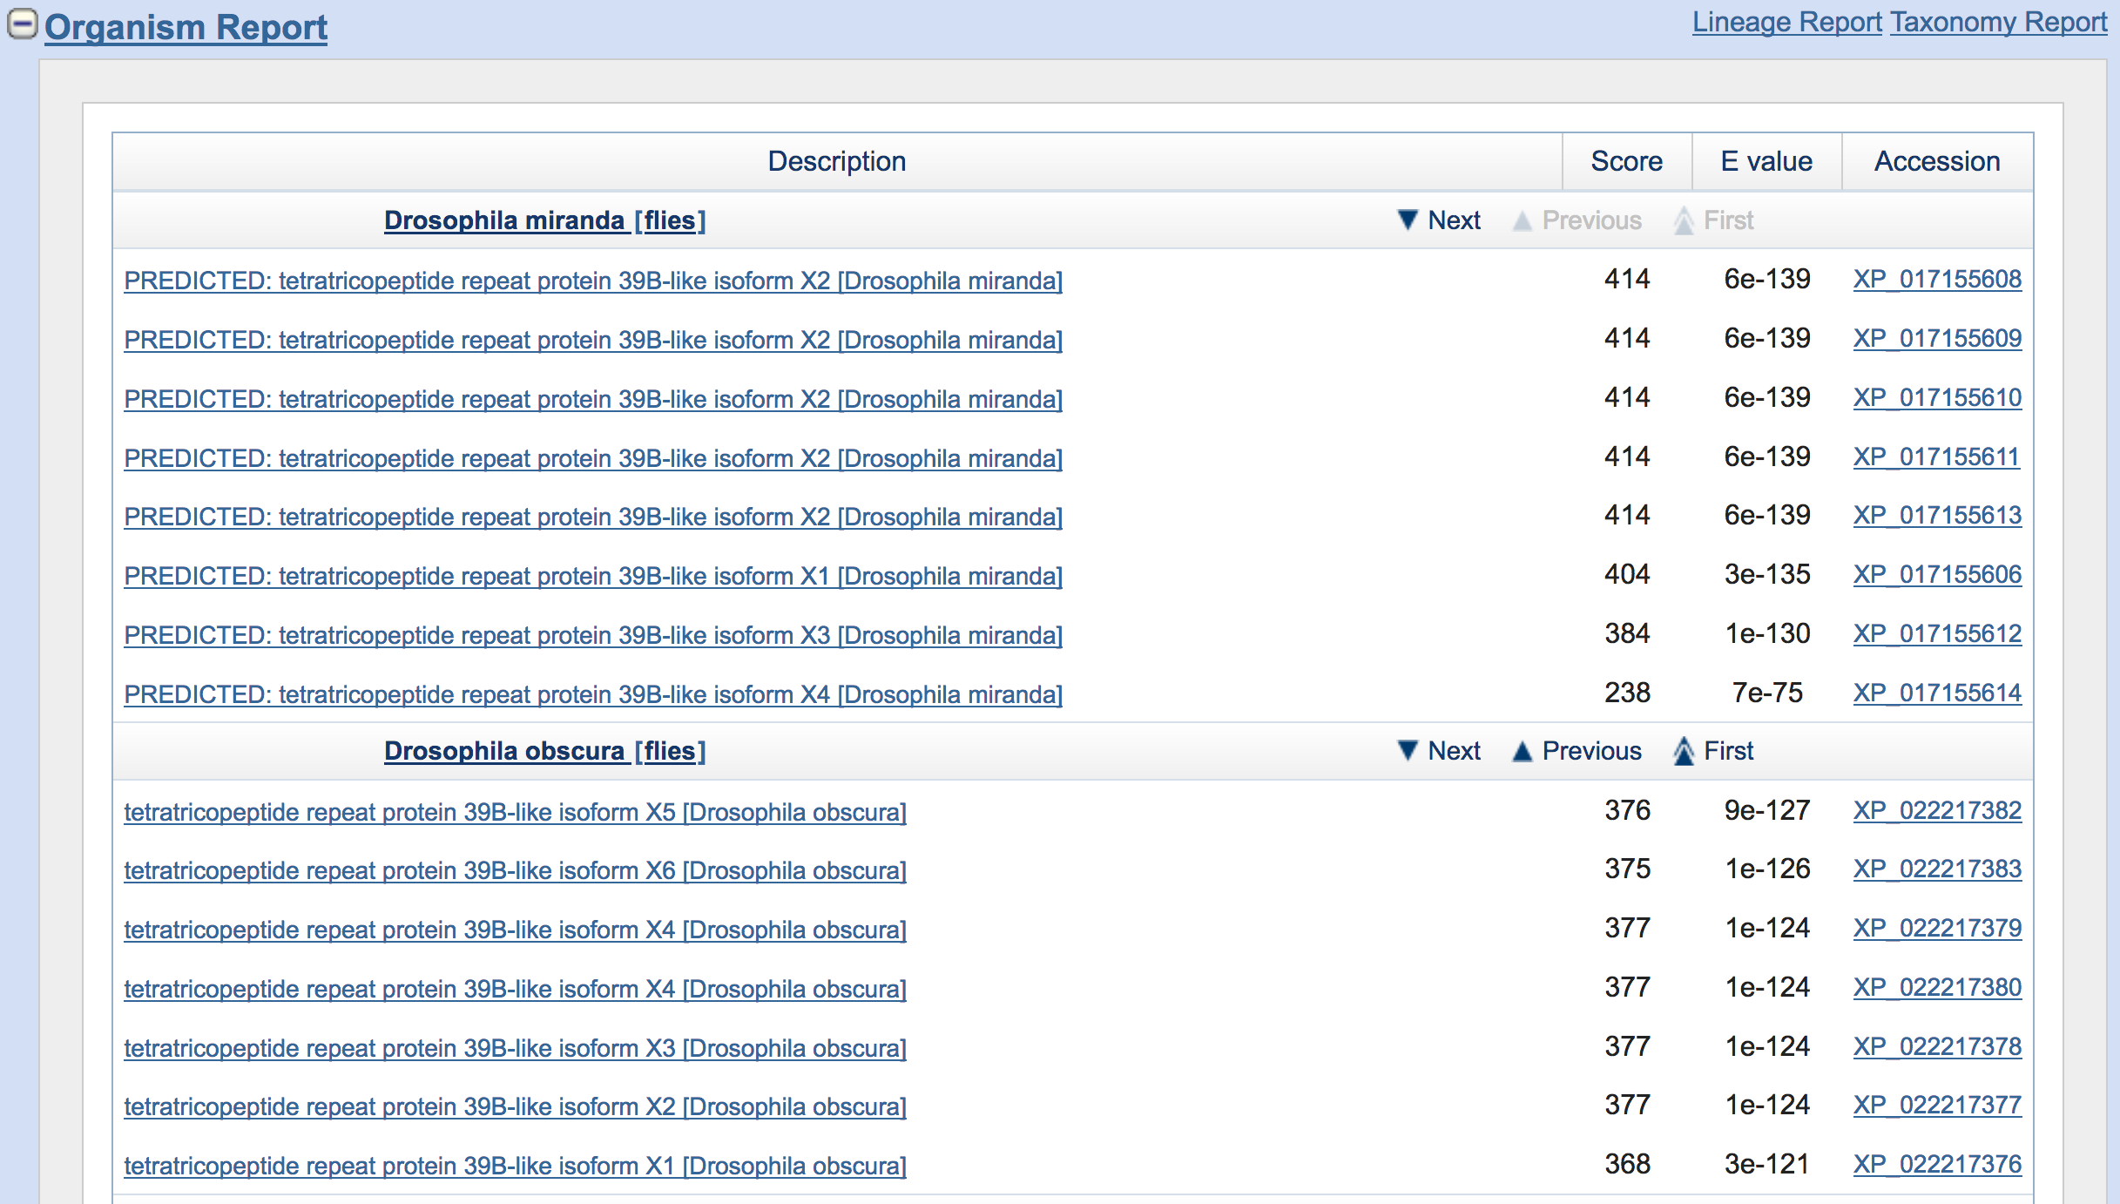
Figure 15. The Organism Report groups the blastp matches by organism.

Scroll down in the Organism Report section in order to examine the best match in the other species beside Drosophila. The results show that the most significant blastp matches to scaffold_6.g49.t1 in many species contain the description “tetratricopeptide repeat protein 39B-like” (Figure 16). Hence the blastp search result indicates that the scaffold_6.g49.t1 could be an ortholog of the tetratricopeptide repeat protein 39B-like gene.

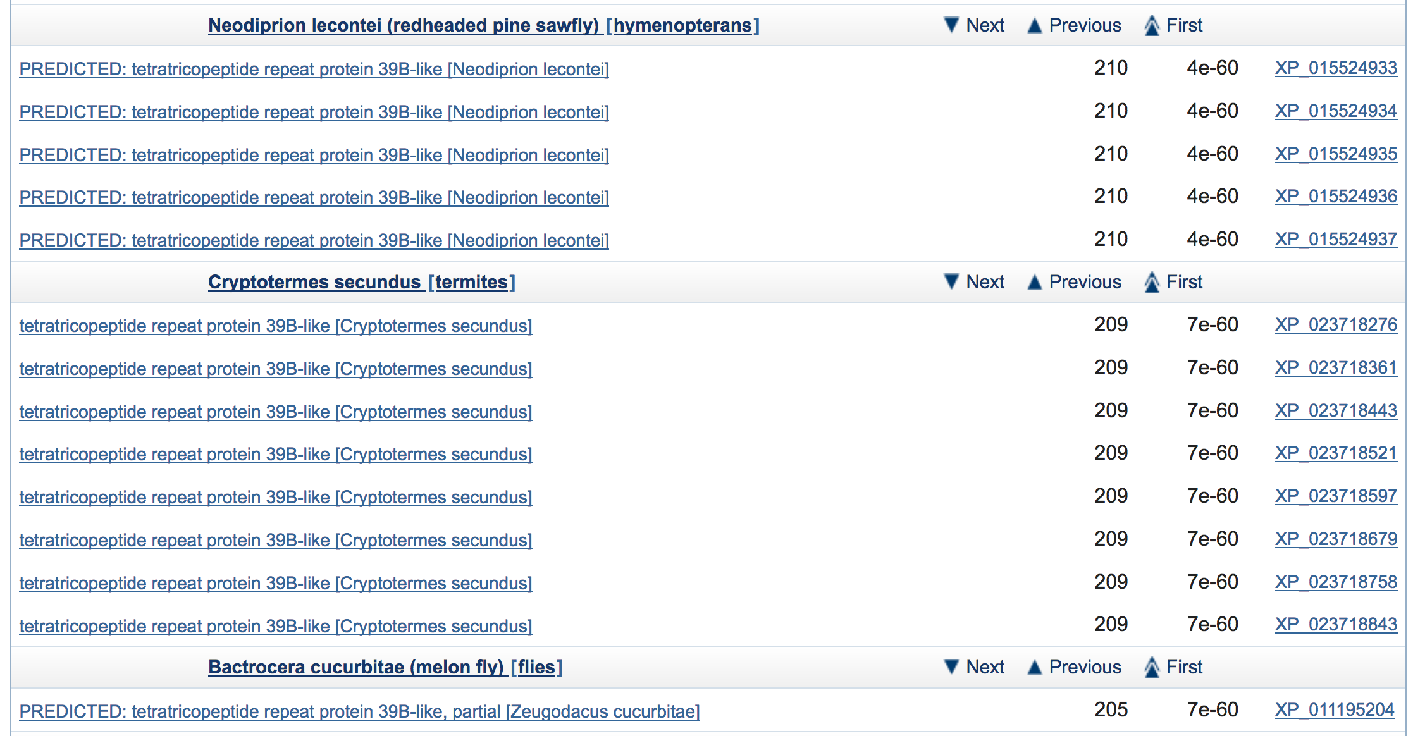
Figure 16. The Organism Report shows that the best blastp matches to the D. miranda gene prediction scaffold_6.g49.t1 in redheaded pine sawfly, termites, and melon fly correspond to the tetratricopeptide repeat protein 39B-like gene.

In order to infer the evolutionary history of the Drosophila tetratricopeptide repeat protein 39B-like gene, we need to interpret the Tax BLAST report within the context of the known phylogenetic relationships of the different Drosophila species. A phylogenetic tree of 12 Drosophila species is available through the Synteny Table page on FlyBase (http://flybase.org/maps/synteny).

Comparison of the phylogenetic tree with the species in the Lineage Report indicates that the putative orthologs of scaffold_6.g49.t1 in D. miranda are found in the Drosophila subgenus, as well as the species in the obscura and willistoni groups of the Sophophora subgenus (Figure 17). Because the putative ortholog of the tetratricopeptide repeat protein 39B-like gene is also found in other insects (e.g., mosquitos, ants, beetles), the most parsimonious hypothesis is that the tetratricopeptide repeat protein 39B-like gene is found in the common ancestors of Drosophila, and that this gene was lost in the melanogaster group.

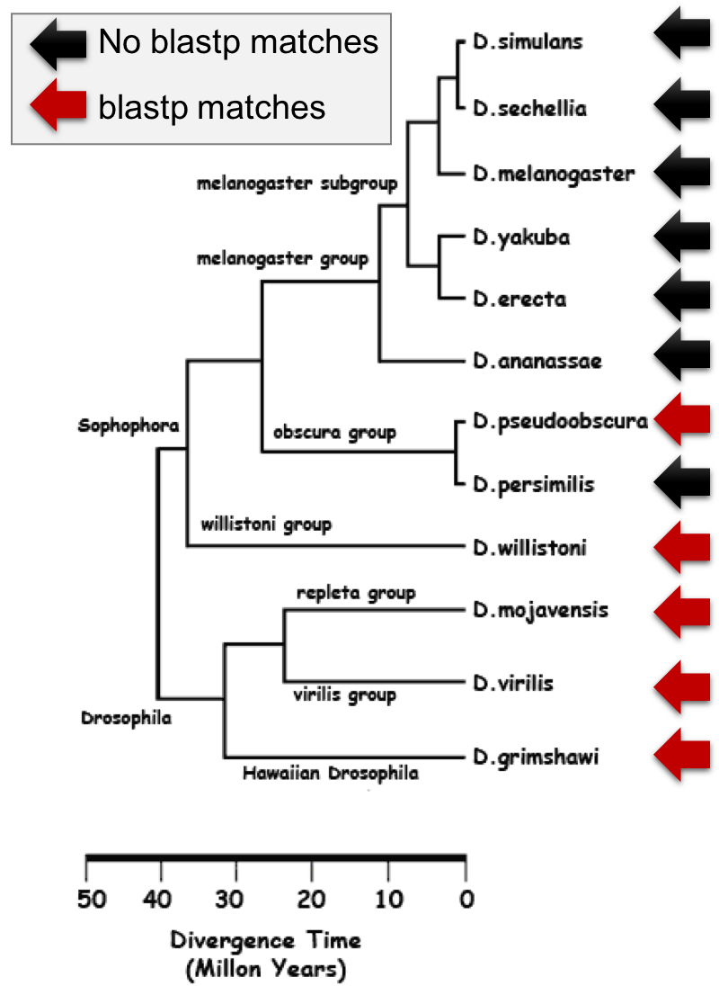
Figure 17. Distribution of species with blastp matches to the D. miranda gene prediction scaffold_6.g49.t1 compared to the phylogenetic relationships of 12 Drosophila species. The phylogenetic tree was obtained from the Synteny Table page at FlyBase (http://flybase.org/maps/synteny).

Investigate the conserved domain DUF3808
Our investigation of the taxonomy reports shows that the scaffold_6.g49.t1 gene prediction has significant sequence similarity to the tetratricopeptide repeat protein 39B-like gene in many insects. To further investigate the potential function of this feature, we will examine the conserved domain DUF3808 that covers most of the scaffold_6.g49.t1 gene prediction.

Go back to the blastp search results and then click on the image under the “Show Conserved Domains” section (Figure 18).

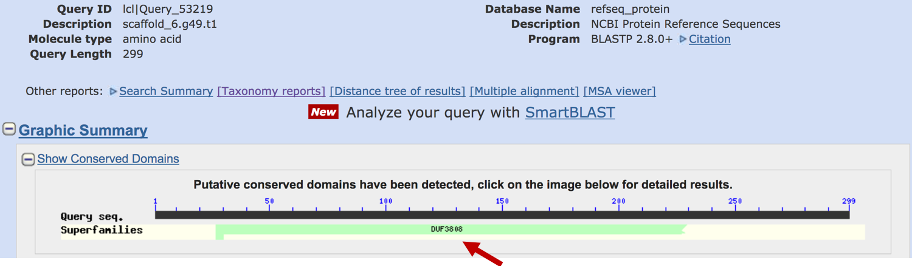
Figure 18. Click on the image in the “Show Conserved Domains” section to navigate to the conserved domain search results which compares scaffold_6.g49.t1 against the NCBI Conserved Domains Database.

The “List of domain hits” section of the conserved domain search (CD-search) results show a single match to the domain DUF3808 (accession number pfam10300). The match spans residues 27–229 of scaffold_6.g49.t1 (query), and it has an E-value of 1.25e-46 (Figure 19).

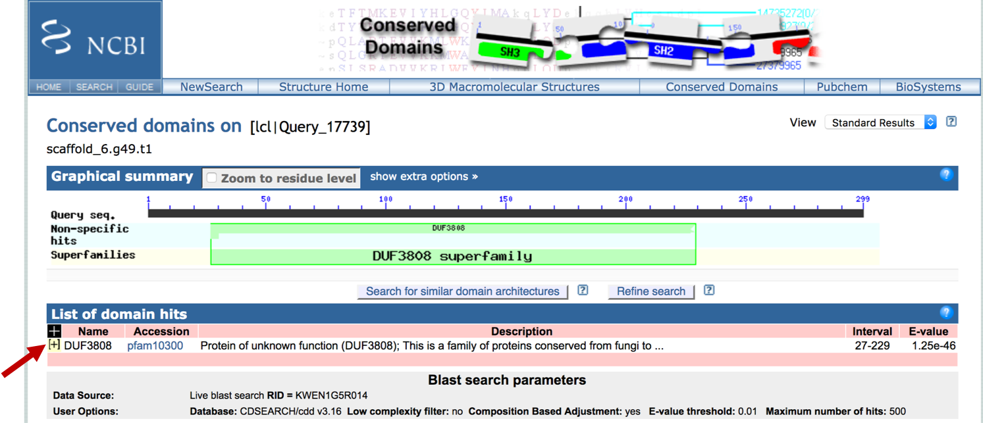
Figure 19. CD-search results for the scaffold_6.g49.t1 gene prediction. Click on the “+” icon (red arrow) to view the detailed description of the domain hit.

Click on the yellow “+” icon next to the DUF3808 entry to view the detailed description of the domain and the alignment of scaffold_6.g49.t1 against the consensus sequence for the conserved domain. The description for DUF3808 indicates that “DUF” is an abbreviation for Domain of Unknown Function, and this domain is found in species that range from yeasts to humans (Figure 20).

The alignment section indicates that the domain DUF3808 consists of 467 amino acids (the “Cd Length” field), and that the alignment covers residues 79–291 of the conserved domain. The red color in the alignment denotes identical residues between scaffold_6.g49.t1 and DUF3808.

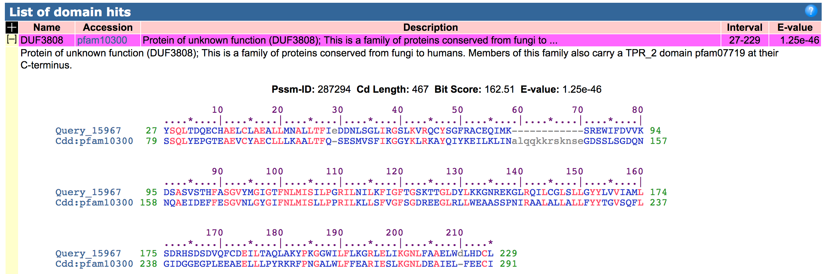
Figure 20. Expand the “DUF3808” entry in the “List of domain hits” table to see a more detailed description of DUF3808, and the alignment between scaffold_6.g49.t1 and DUF3808.

To further investigate this domain, click on the green box in the “Graphical summary” section to navigate to the DUF3808 record in the Conserved Domains Database (CDD; Figure 21).

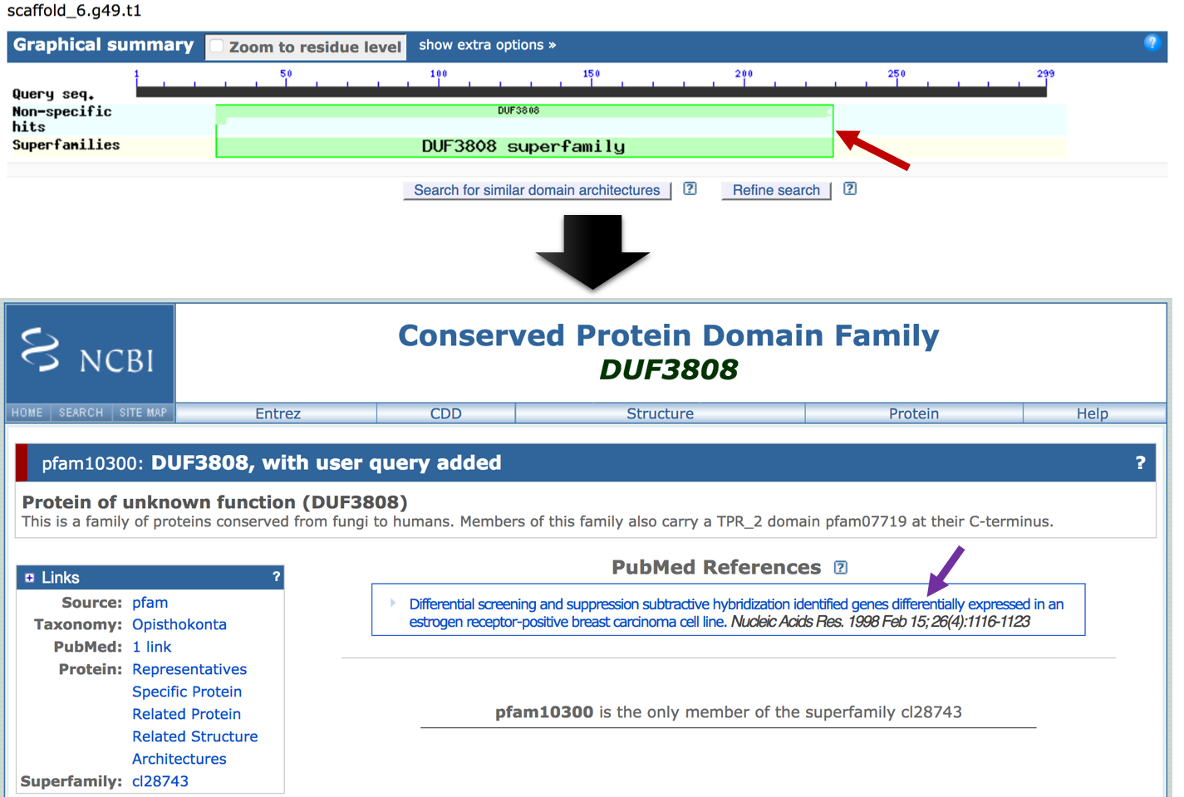
Figure 21. Click on the DUF3808 conserved domain (red arrow) in the “Graphical summary” section to navigate to the corresponding CDD record. Click on the link under the “PubMed References” section to review the literature associated with this conserved domain (purple arrow).

The CDD record indicates that the domain is a member of the superfamily cl28743. There is one PubMed record associated with this domain (Kuang et al. 1998). This manuscript describes the characterization of the human DEME-6 gene, which is expressed in six out of twelve primary breast tumors, but it is not expressed in normal breast tissues.

The “Sequence Alignment” section of the CDD record shows the multiple sequence alignment of the sequences used to construct the conserved domain. By default, ten members of the conserved domains are shown along with the query sequence (Figure 22). The blue links on the left correspond to the GenBank accession numbers of the sequences used to construct the multiple sequence alignment. By default, the alignment columns that have information content of at least 2.0 bits are in red.

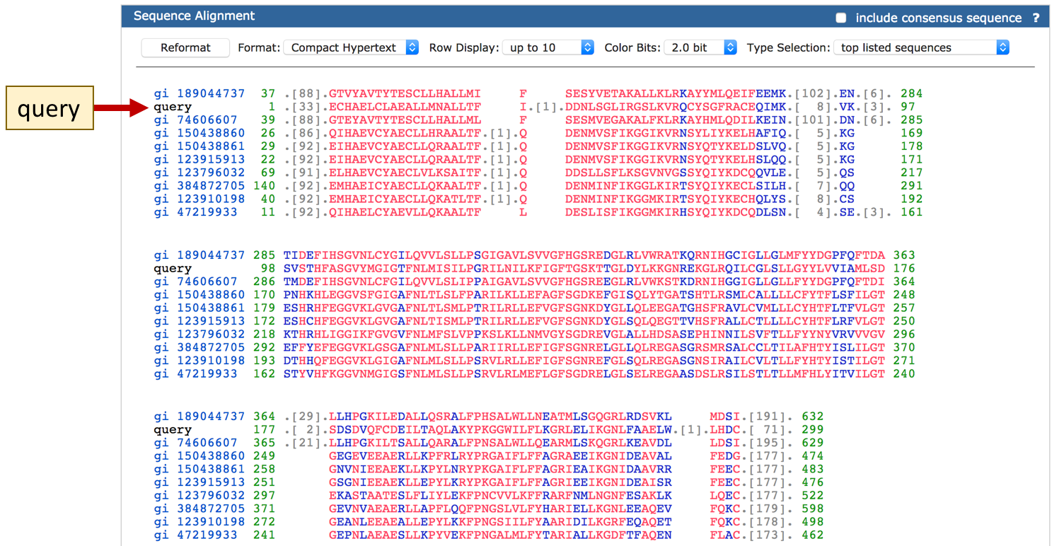
Figure 22. The default display of the CDD Sequence Alignment section shows the multiple sequence alignment of the first 10 sequences that were used to construct the consensus sequence for the conserved domain (i.e., Type Selection = “top listed sequences”). The query sequence (scaffold_6.g49.t1) is also added to the multiple sequence alignment (red arrow).

We can alter the display settings for the Sequence Alignment section in order to identify the most highly conserved positions within the DUF3808 domain. Change the “Row Display” field to “All 20 rows”, the “Color Bits” field to “4.0 bit”, and then click on the “Reformat” button. The updated alignment shows that the residues at positions 122 (P) and 134 (F or Y) of the query are highly conserved (Figure 23).

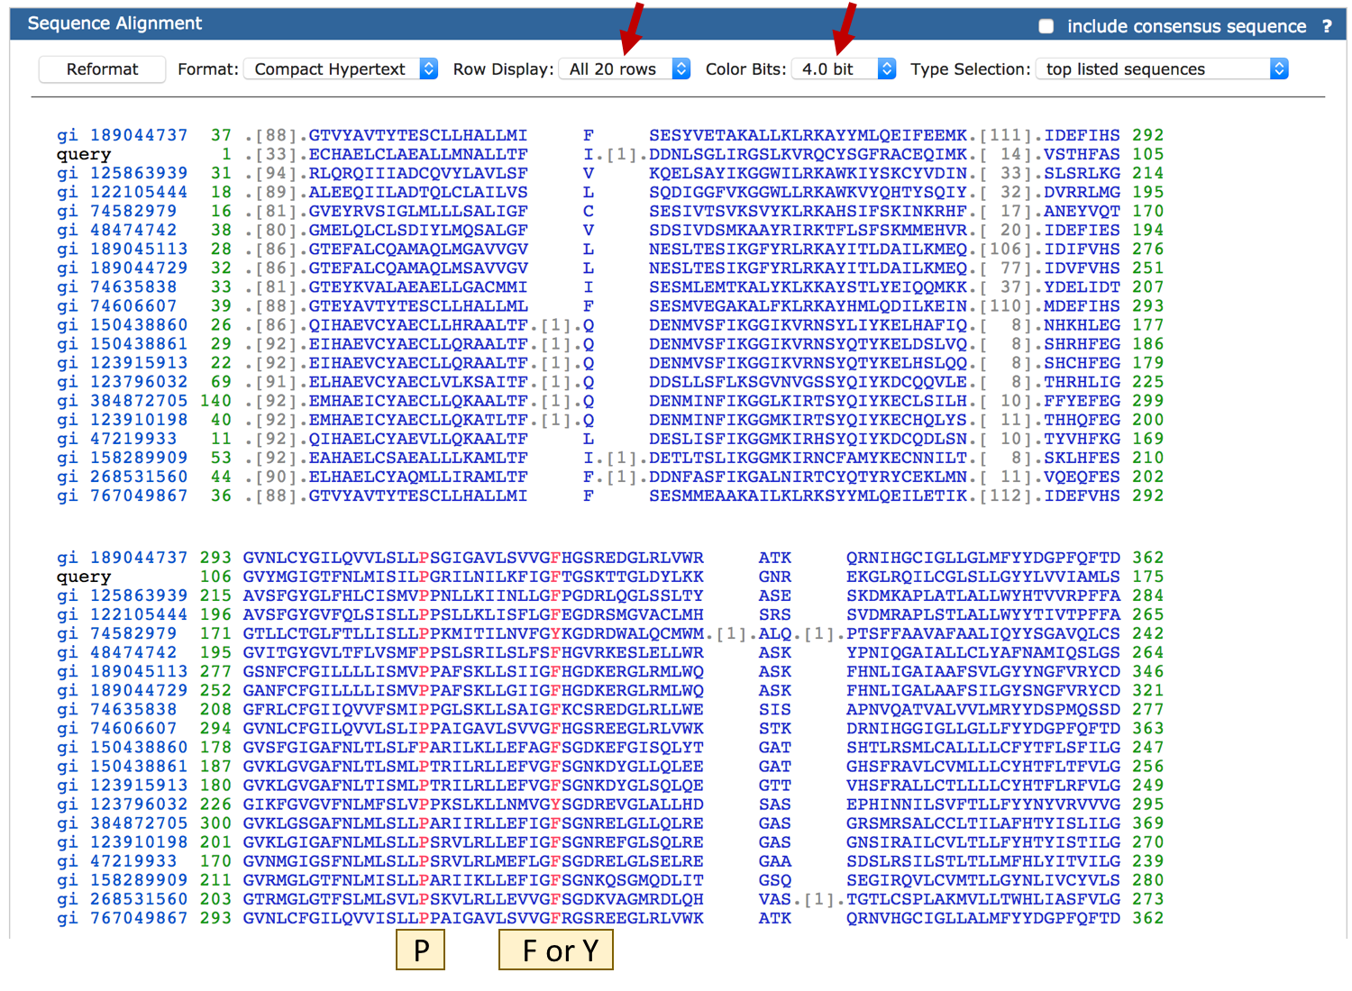
Figure 23. Adjust the display settings for the multiple sequence alignment to demarcate the highly conserved residues within the conserved domain DUF3808.

The description for DUF3808 mentions that the C-terminus of some members of this gene family contains the TPR_2 domain (pfam07719). To learn more about this domain, open a web browser tab and navigate to the NCBI home page (https://www.ncbi.nlm.nih.gov/). Select “Conserved Domain” in the drop down menu of the top search bar, enter “pfam07719” into the text box, and then click on the “Search” button. Click on the “TPR_2: Tetratricopeptide repeat” link to access the CDD record (Figure 24).

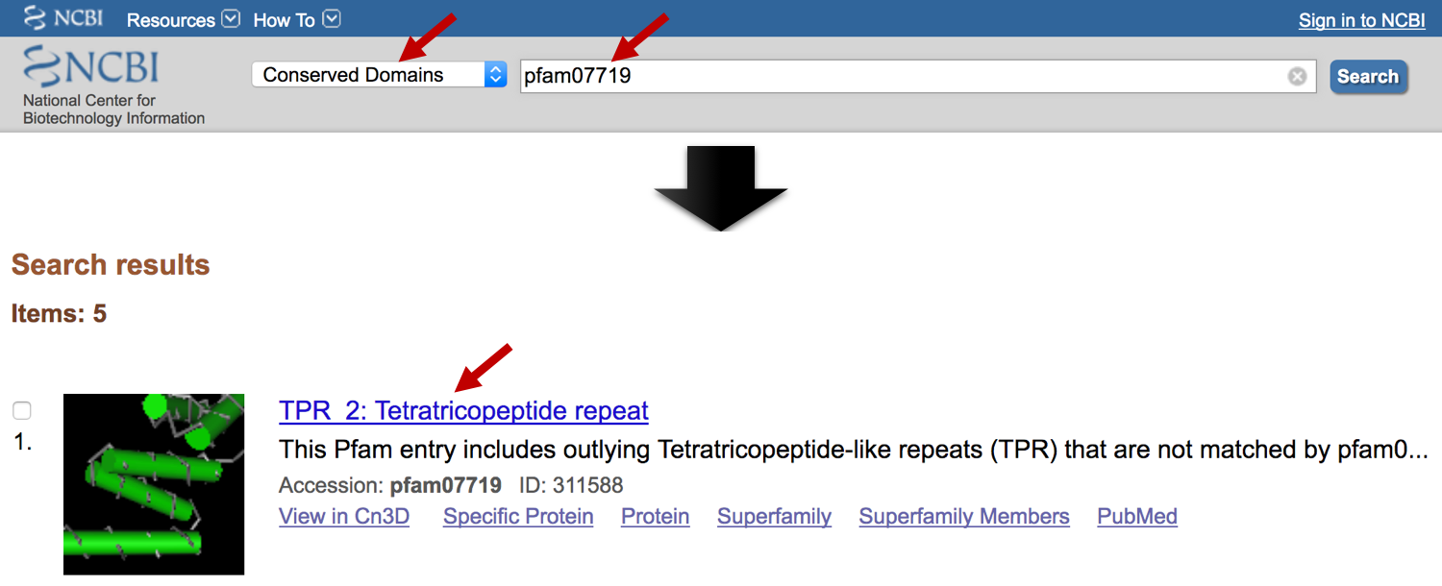
Figure 24. Navigate to the pfam07719 record in the CDD.

The description of the pfam07719 record indicates that this entry corresponds to Tetratricopeptide-like repeats (TPR), which is the same as the names of the genes that we have investigated earlier in the NCBI taxonomy reports. Click on the “Tetratrico peptide repeat interactions: to TPR or not to TPR?” link in the “PubMed References” section to learn more about this conserved domain (Figure 25).

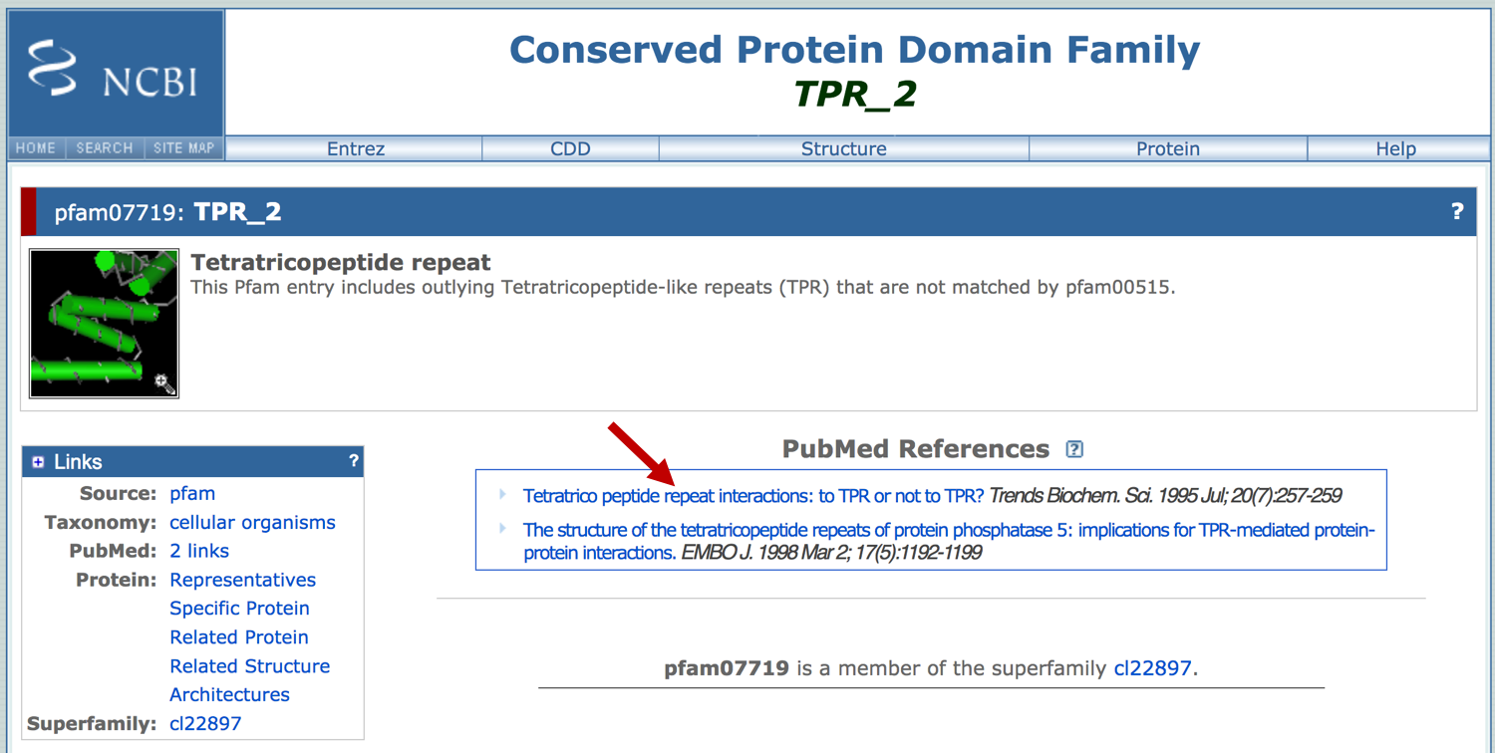
Figure 25. Click on the first link under the “PubMed References” section to learn more about the conserved domain TPR_2 (pfam07719).

This review article indicates that the TPR_2 domain is found in species that range from bacteria to human. The domain consists of a 34-amino acid repeated motif that have eight conserved residues. Genes that contain this conserved domain are involved in a variety of biological processes, including cell cycle control, stress response, and mitochondrial and peroxisomal protein transport (Lamb et al. 1995).

Collectively, the investigation of the DUF3808 conserved domain within the D. miranda gene prediction scaffold_6.g49.t1 enable us to infer the potential functions of this feature (i.e., based on the functions of the conserved domain in human). However, our analysis also indicates that the scaffold_6.g49.t1 prediction might only correspond to part of the gene in D. miranda. There are two lines of evidence which support this hypothesis. First, the alignment between DUF3808 and scaffold_6.g49.t1 only covers part of the conserved domain (i.e., residues 79–291 out of 467 residues; Figure 20). Second, while the best blastp matches to scaffold_6.g49.t1 in a variety of insects are to the “tetratricopeptide repeat protein 39B-like” gene, the predicted gene did not show any significant sequence similarity to the tetratricopeptide repeat (TPR_2) conserved domain (Figure 18).

7. Use RNA-Seq data to improve the gene model
To ascertain if we could improve the gene model, go back to the Apollo web browser tab and examine the RNA-Seq read coverage tracks from whole virgin males (SRR364798) and whole virgin females (SRR364800). These read coverage tracks show that there are additional regions within the coding span of scaffold_6.g49.t1 that are being actively transcribed (Figure 26).

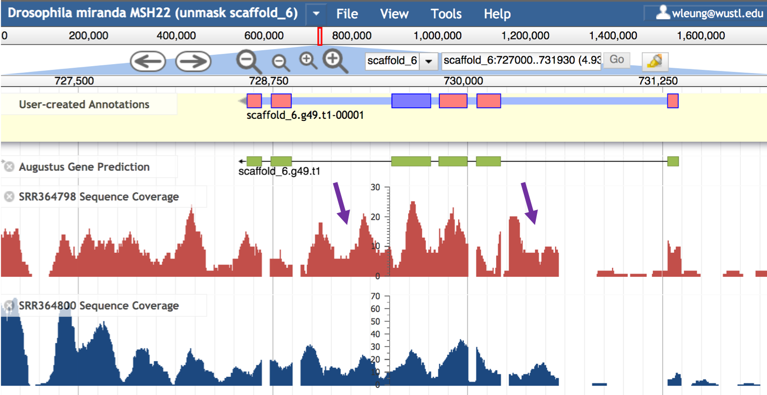
Figure 26. The regions between the first and second coding exons, and between the fourth and fifth coding exons of scaffold_6.g49.t1 show high RNA-Seq read coverage (purple arrows).

We can leverage the transcripts assembled from RNA-Seq data to improve the scaffold_6.g49.t1 gene model. Select the “SRR364798 StringTie Transcripts” track under the “RNA-Seq Analysis” section of the “Tracks” panel. We will also unselect the “BLAT Alignment” track under the “Sequence Similarity” section since this region does not have any informative BLAT alignments. Enter “scaffold_6:726000..734000” into the position text box and then click “Go” (Figure 27).

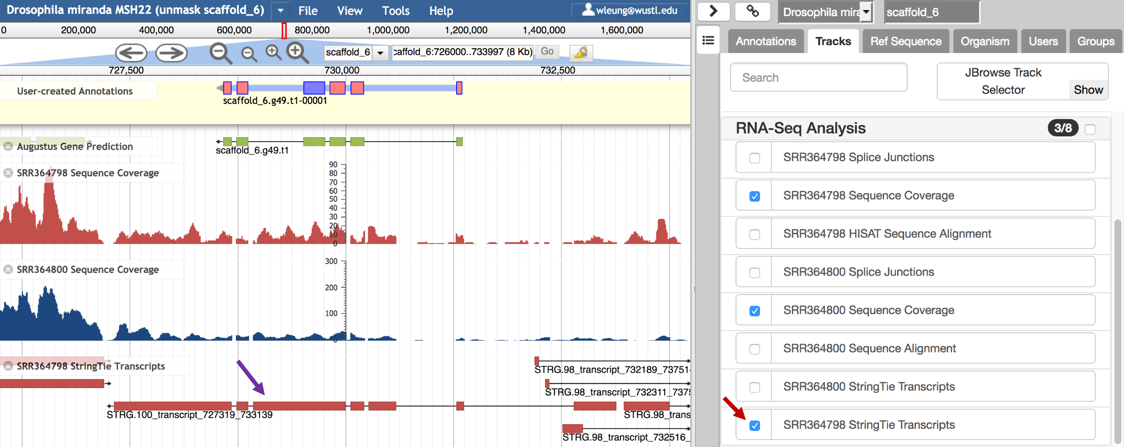
Figure 27. Select the checkbox next to “SRR364798 StringTie Transcript” track to view the transcripts assembled by StringTie based on the RNA-Seq data from whole virgin males.
The StringTie transcript STRG.100_transcript_727319_733139 overlaps with, but extends beyond the Augustus gene model. To incorporate this StringTie transcript into the gene model, right click (control-click on macOS) on the STRG.100_transcript_727319_733139 feature and then select the “Create new annotation” → “gene” option. A new gene model will appear in the “User-created Annotations” section (Figure 28).

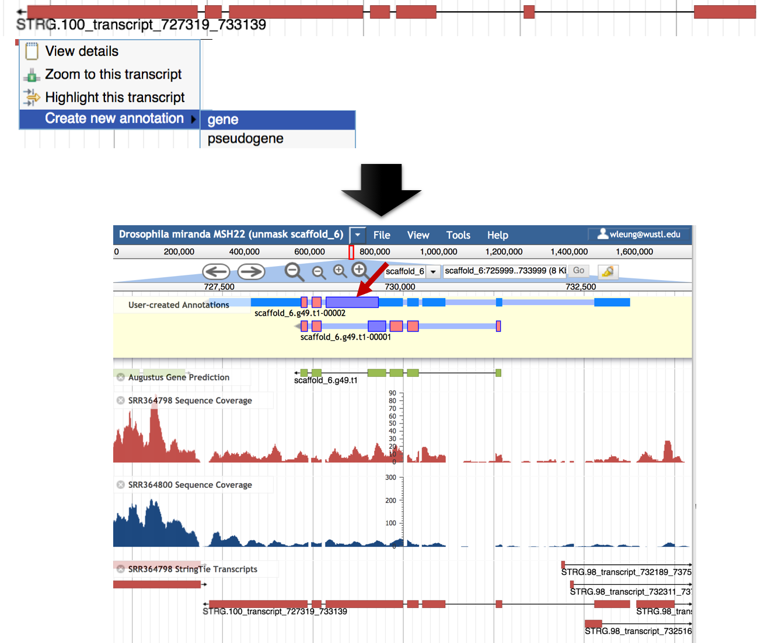
Figure 28. Create a new gene model scaffold_6.g49.t1-00002 based on the StringTie transcript STRG.100_transcript_727319_733139. The initial coding exon for scaffold_6.g49.t1-00002 partially overlaps with the fourth coding exon of scaffold_6.g49.t1-00001 (red arrow).

The thinner boxes in the scaffold_6.g49.t1-00002 gene model correspond to the untranslated regions (UTRs) and the thicker boxes correspond to the coding regions. Enter “scaffold_6:728000..730000” into the position text box and then click “Go” to navigate to the region surrounding the initial coding exon of scaffold_6.g49.t1-00002 (Figure 29).

By default, the color of the coding exons correspond to the reading frame. Because the initial coding exon of scaffold_6.g49.t1-00002 and the fourth coding exon of scaffold_6.g49.t1-00001 are in the same color, these coding exons are in the same reading frame (i.e., frame -3). Consequently, we can extend the fourth coding exon of scaffold_6.g49.t1-00001 to the end of the first coding exon of scaffold_6.g49.t1-00002.
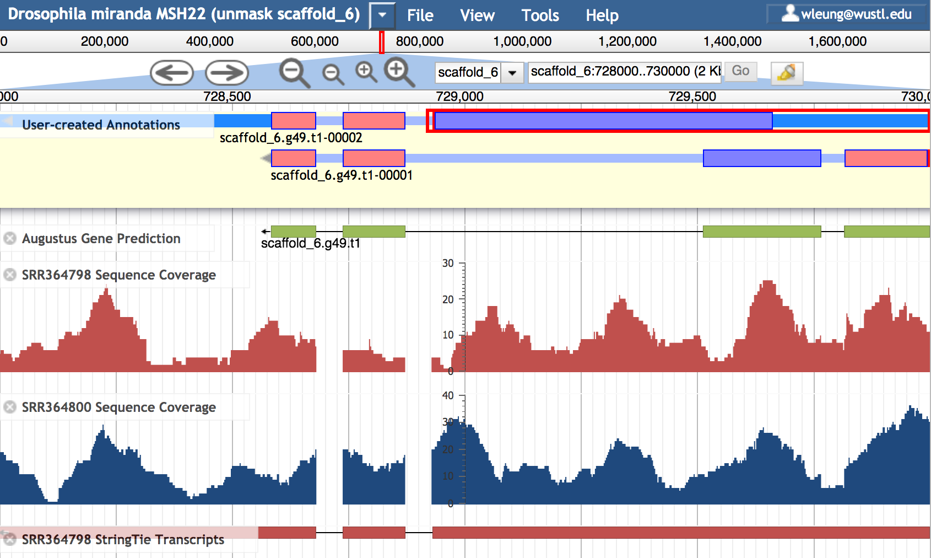
Figure 29. The purple color of the first coding exon of scaffold_6.g49.t1-00002 and the fourth coding exon of scaffold_6.g49.t1-00001 indicate that they are in the same reading frame (-3).

Click on the fourth coding exon of scaffold_6.g49.t1-00001. Move the mouse to the 3’ end of the coding exon (at 729,513). The mouse cursor will change to a resize icon ( ) with the arrow pointing to the left. Press the mouse button and then drag to the left until you reach the 3’ end of the first coding exon for scaffold_6.g49.t1-00002 at 728,931 (Figure 30). (Note that we will need to zoom in to place the end of the exon at position 728,931.)

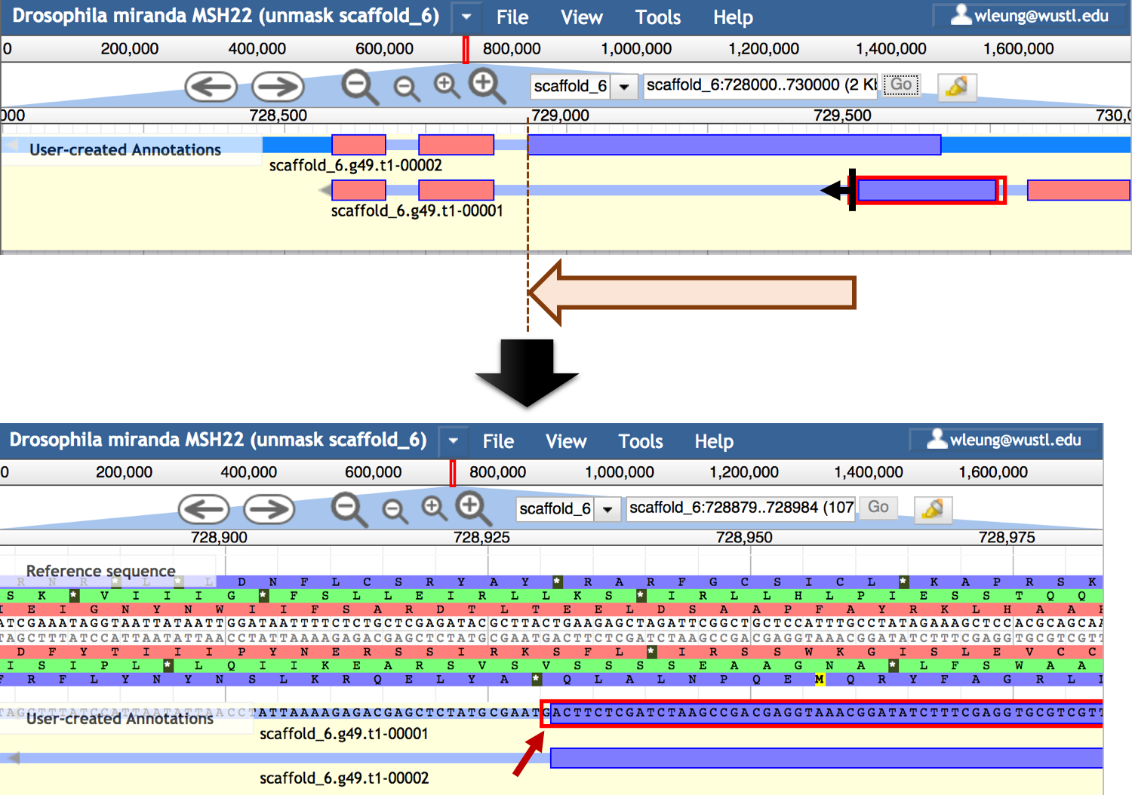
Figure 30. Extend the fourth coding exon of scaffold_6.g49.t1-00001 to 728,931.
Enter “scaffold_6:726000..734000” into the position text box and then click “Go” to view the revised gene model. There is an extra exon at 730266-730586 in the scaffold_6.g49.t1-00002 gene model that we could incorporate into the scaffold_6.g49.t1-00001 gene model (Figure 31).

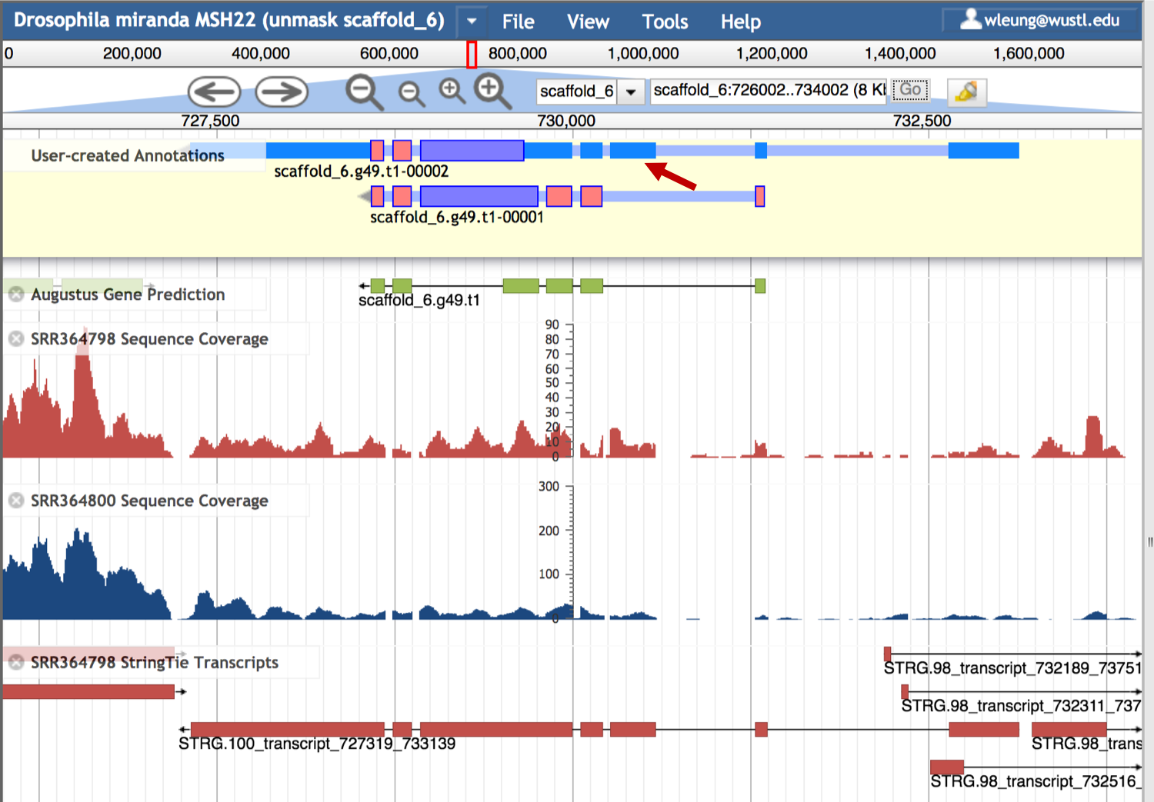
Figure 31. The extra exon in the scaffold_6.g49.t1-00002 gene model (red arrow) is supported by the SRR364800 and SRR364798 Sequence Coverage tracks.

We will delete the other exons in the scaffold_6.g49.t1-00002 gene model and then merge the exon at 730,266–730,586 with the scaffold_6.g49.t1-00001 gene model. Hold onto the shift key and then select all the exons of scaffold_6.g49.t1-00002 except for the third exon. Right click (control-click on macOS) and then select the “Delete” option (Figure 32).

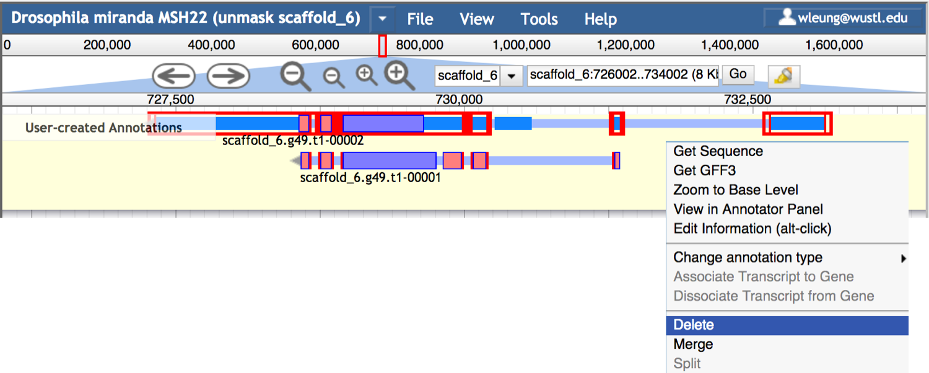
Figure 32. Delete all the coding exons of scaffold_6.g49.t1-00002 except the third coding exon.
Hold onto the shift key, click on one of the introns of scaffold_6.g49.t1-00001 to select the entire gene model, and then select the remaining exon from scaffold_6.g49.t1-00002 (now with the label scaffold_6.g49.t1a-00001). Right click (control-click on macOS) and then select the “Merge” option (Figure 33).

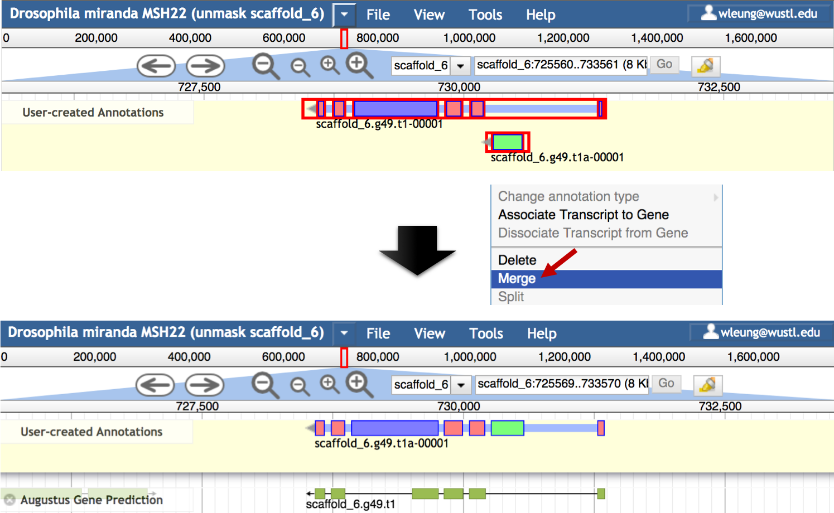
Figure 33. Use the “Merge” option to incorporate the third exon from scaffold_6.g49.t1-00002 into the scaffold_6.g49.t1-00001 gene model.

Right click on the revised scaffold_6.g49.t1-00001 gene model and then select the “Get Sequence” option. Verify that the “Peptide sequence” option is selected, and the protein sequence for the revised gene model will appear in the “Sequence” window (Figure 34). For the rest of this walkthrough, we will refer to the revised scaffold_6.g49.t1-00001 gene model as “Dmir_novel_gene1_mRNA1”.

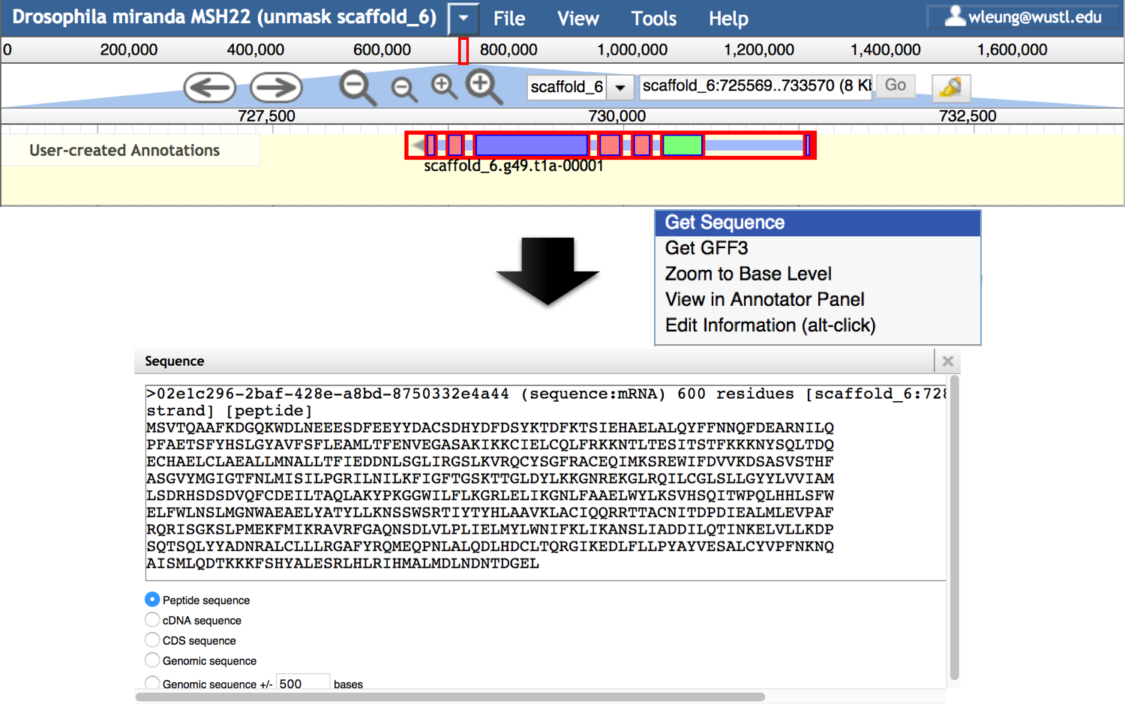
Figure 34. Retrieve the peptide sequence for the revised gene model.

Exercise: characterize the revised D. miranda gene model using blastp
Perform a NCBI blastp search of the predicted protein sequence Dmir_novel_gene1_mRNA1 against the refseq_protein database. Compare the blastp results with the results obtained previously using scaffold_6.g49.t1 as the query, and answer the following questions:

- Which protein sequence in the refseq_protein database is the best match to Dmir_novel_gene1_mRNA1?
- Are the best matches in the blastp results for Dmir_novel_gene1_mRNA1 similar to those for scaffold_6.g49.t1?
- How do the E-values and alignment scores of the RefSeq protein matches differ between the two blastp searches?
- Where is the DUF3808 conserved domain in the Dmir_novel_gene1_mRNA1 sequence? How does it compare to the location and extent of the DUF3808 conserved domain in scaffold_6.g49.t1?
- Based on the multiple sequence alignment of the DUF3808 conserved domain, how many positions within the domain have an information content of at least 4.0 bits?

8. Investigate putative orthologs in model organisms with SmartBLAST
Most of the blastp matches for Dmir_novel_gene1_mRNA1 in the refseq_protein database are to computational gene predictions produced by the NCBI Eukaryotic Genome Annotation Pipeline (https://www.ncbi.nlm.nih.gov/genome/annotation_euk/process/). However, the conserved domain investigations (i.e., presence of the DUF3808 domain) suggest that this gene might also exist in human.

We can use the SmartBLAST tool to quickly identify the putative orthologs to this feature in human and in other model organisms. Click on the “SmartBLAST” link at the top of the blastp search results page for Dmir_novel_gene1_mRNA1 to perform this search (Figure 35).

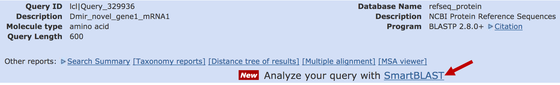
Figure 35. Click on the SmartBLAST link at the top of the blastp search results to perform a SmartBLAST search using the query sequence.
SmartBLAST is also available under the “Specialized searches” section of the NCBI BLAST home page (https://blast.ncbi.nlm.nih.gov/Blast.cgi).
SmartBLAST will compare the Dmir_novel_gene1_mRNA1 protein sequence against the protein sequences from the landmark database and the non-redundant protein database (nr). The landmark database consists of protein sequences from 27 well-studied reference species, such as Caenorhabditis elegans, Danio rerio, D. melanogaster, Mus musculus, and human.
See the “Landmark Database” section of the SmartBLAST help page for details (https://blast.ncbi.nlm.nih.gov/smartblast/smartBlast.cgi?CMD=Web&PAGE_TYPE=BlastDocs).

The SmartBLAST output consists of three sections: Summary, Descriptions, and Alignments. The Summary section shows the query sequence in conjunction with the five best matches from the landmark database. If there are fewer than five matches to sequences in the landmark database, the remaining slots are filled by the best matches to the nr database. If the query sequence is identical to a sequence in the landmark database or the nr database, then the GenBank information for the sequence will be incorporated into the SmartBLAST Summary (e.g., XP_017155608.1 in this example).

This section includes a phylogenetic tree which shows the relationships among the six protein sequences, and a Graphical Overview of the BLAST alignments. Move the mouse over the “Legend” link at the bottom right corner of the Summary section to see an explanation of the color scheme used in the Graphical Overview (Figure 36).

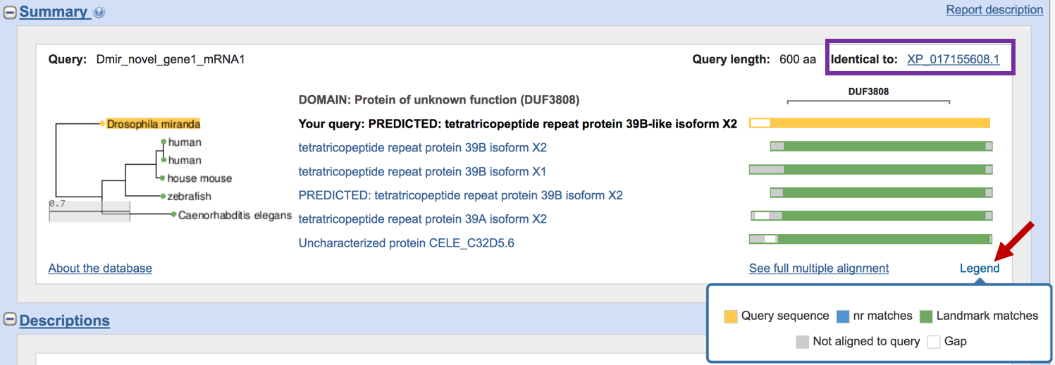
Figure 36. Hover over the "Legend" link (red arrow) to see an explanation of the color scheme used in the Summary section. For example, the yellow color denotes the query sequence, while the green color denotes matches to sequences in the landmark database. The “identical to” field at the top right corner indicates the query sequence is identical to the D. miranda protein XP_017155608.1 in the refseq_protein database (purple box).

The phylogenetic tree in the SmartBLAST Summary section shows that the D. miranda Dmir_novel_gene1_mRNA1 gene model has significant sequence similarity to proteins from human, house mouse, zebrafish, and C. elegans. Consistent with the results of the blastp search against the refseq_protein database, four of these matches (from human, mouse, and zebrafish) have the term “tetratricopeptide repeat protein” as part of their description. However, the matches to human and mouse correspond to tetratricopeptide repeat protein 39B, while the match to zebrafish is to tetratricopeptide repeat protein 39A.

The Graphical Overview provides a visual summary of the multiple sequence alignment for these six sequences. The portions of the sequence that are in gray correspond to unaligned regions of the protein, while the yellow, blue, and green boxes correspond to the aligned region of the query, nr matches, and landmark matches, respectively. The white boxes correspond to gaps within the multiple sequence alignment. The Graphical Overview suggests that most of the differences among these proteins are located at the beginning and at the end of the protein. The Graphical Overview also demarcates the location of the DUF3808 conserved domain with respect to the multiple sequence alignment.

The Descriptions section are divided into two subsections. The “Best hits” subsection shows the blastp alignment details for the sequences shown in the Summary section. The “Additional BLAST Hits” subsection shows the rest of the matches from the nr database. Similar to the standard blastp output, the alignments for these matches are available under the “Alignments” section of the SmartBLAST output.

Generate multiple sequence alignments with COBALT
NCBI provides the COBALT program (Papadopoulos and Agarwala 2007) which generates a constraint-based multiple sequence alignment of protein sequences. Click on the “See full multiple alignment” link beneath the Graphical Overview to access the COBALT alignment of the protein sequences in the Summary section of the SmartBLAST output (Figure 37).

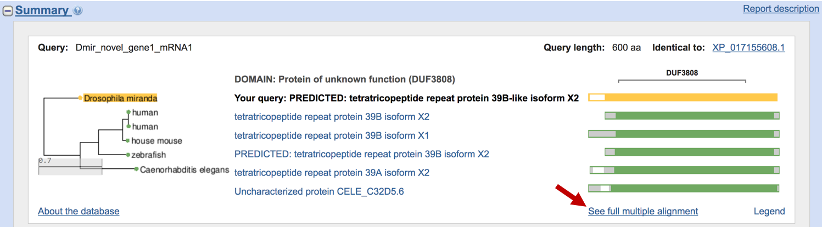
Figure 37. Click on the “See full multiple alignment” link to view the COBLAT alignment of the query sequence against the five best matches in the landmark / nr databases.
Clicking on the “See full multiple alignment” link will occasionally result in an error indicating that SmartBLAST was “Unable to submit search at this time.” To mitigate this error, click on the refresh button on your web browser to reload the page and run the COBALT search again.
The COBALT output consists of three sections: Graphical Overview, Descriptions, and Alignments. The Graphical Overview section includes the NCBI Multiple Sequence Alignment (MSA) viewer which enables the interactive exploration of the multiple sequence alignment (Figure 38). For example we can use the controls in the top toolbar to zoom, navigate along the alignment, and change the coloration method (available under the “Tools” drop-down menu).

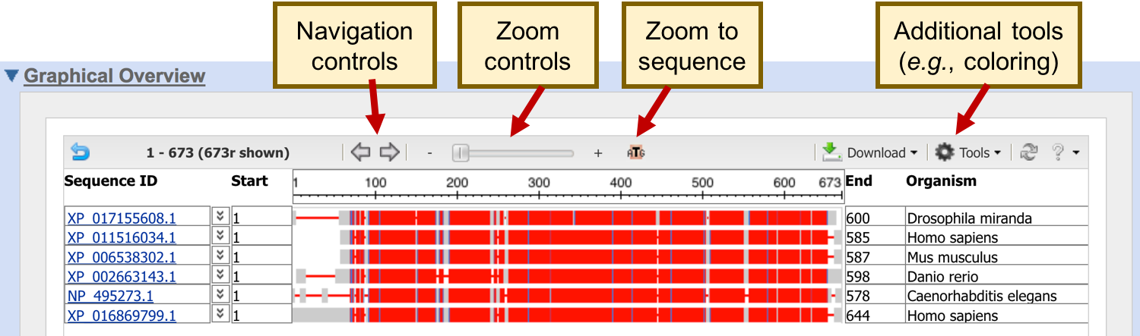
Figure 38. An interactive overview of the multiple sequence alignment produced by COBALT. Use the navigation controls at the main toolbar of the NCBI MSA viewer to manipulate the display of the multiple sequence alignment. Note that the query sequence has been replaced by the identical D. miranda sequence from the RefSeq database (i.e., XP_017155608.1).

Each row corresponds to one of the sequences in the Summary section of the SmartBLAST output (identified by the values in the “Sequence ID” column). The species from which the sequence was derived is specified in the “Organism” column.

By default, the “Conservation” coloring is applied to the alignment. Alignment columns that contain gaps are in gray, columns at or above the relative entropy threshold (i.e., highly conserved positions) are in red, and columns below the relative entropy threshold are in blue. The Graphical Overview indicates that almost the entire Dmir_novel_gene1_mRNA1 protein is conserved compared to the five best matches identified by SmartBLAST.

For sequences where domain annotations are available (e.g., sequences with GenBank accession numbers), the locations of the conserved domains could be displayed in conjunction with the multiple sequence alignment. Click on the down arrow next to the sequence ID XP_011516034.1 to expand the section. The expanded section shows that this sequence corresponds to the human “tetratricopeptide repeat protein 39B isoform X2”, and the sequence contains the DUF3808 and TPR_12 conserved domains (Figure 39).

Move the mouse over the DUF3808 domain. A tooltip will appear which shows that the domain is located at positions 45–501 of the XP_011516034.1 sequence. Move the mouse over the TPR_12 domain. The tooltip associated with the TPR_12 domain shows that this feature corresponds to the tetratricopeptide repeat, and the domain is located at positions 497–561 of the XP_011516034.1 sequence (Figure 40). Similarly, expanding the row for the XP_006538302.1 match in house mouse shows that the DUF3808 and TPR_12 domains are located at approximately the same locations with respect to the multiple sequence alignment.

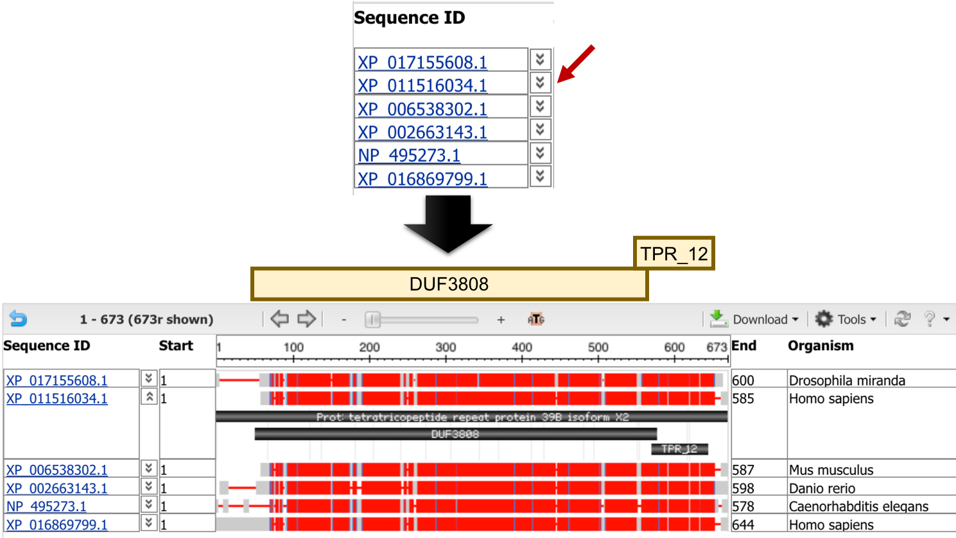
Figure 39. Click on the down arrow next to the Sequence ID (red arrow) to view the locations of the conserved domains with respect to the multiple sequence alignment.

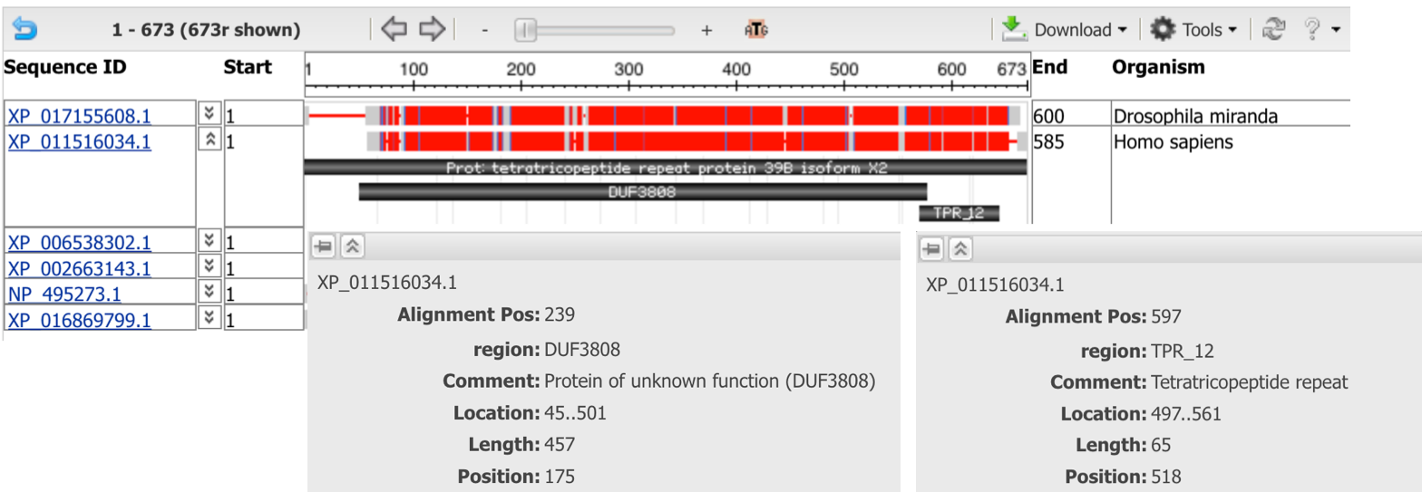
Figure 40. Hover over the conserved domains in the MSA viewer to learn more about the locations of the DUF3808 and TPR_12 conserved domains.

The TPR_12 domain in the human XP_011516034.1 sequence overlaps with the portion of the multiple sequence alignment that are highly conserved (as indicated by the mostly red region at approximately 570–670 of the multiple sequence alignment). To examine this region more closely, right click on the ruler at around position 570 of the multiple sequence alignment, and then select the “Zoom to Sequence” option. Depending on the exact location of the mouse click, we may need to use the controls on the main toolbar (or drag the alignment to the left or right) to navigate to the region surrounding the start of the TPR_12 domain (i.e., at position 576; Figure 41).
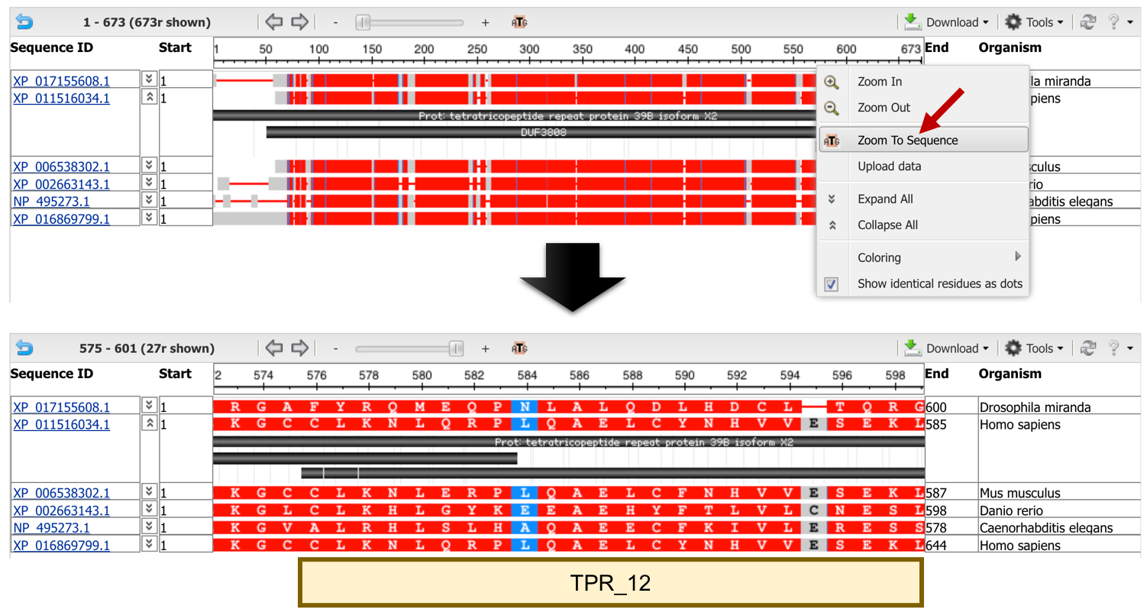
Figure 41. Right click on the ruler and then select the “Zoom to Sequence” option (red arrow) to zoom into a specific region of the multiple sequence alignment.

An alignment statistics tooltip will appear when the mouse hovers over a base in the MSA viewer. This tooltip shows the alignment position, sequence position, and the alignment statistics with respect to the sequence that overlaps with the position of the mouse. For example, hovering the blue base (i.e., Asparagine) in the XP_017155608.1 sequence (i.e., Dmir_novel_gene1_mRNA1) shows that the residue is at column 584 relative to the multiple sequence alignment, and position 520 relative to XP_017155608.1 (Figure 42).

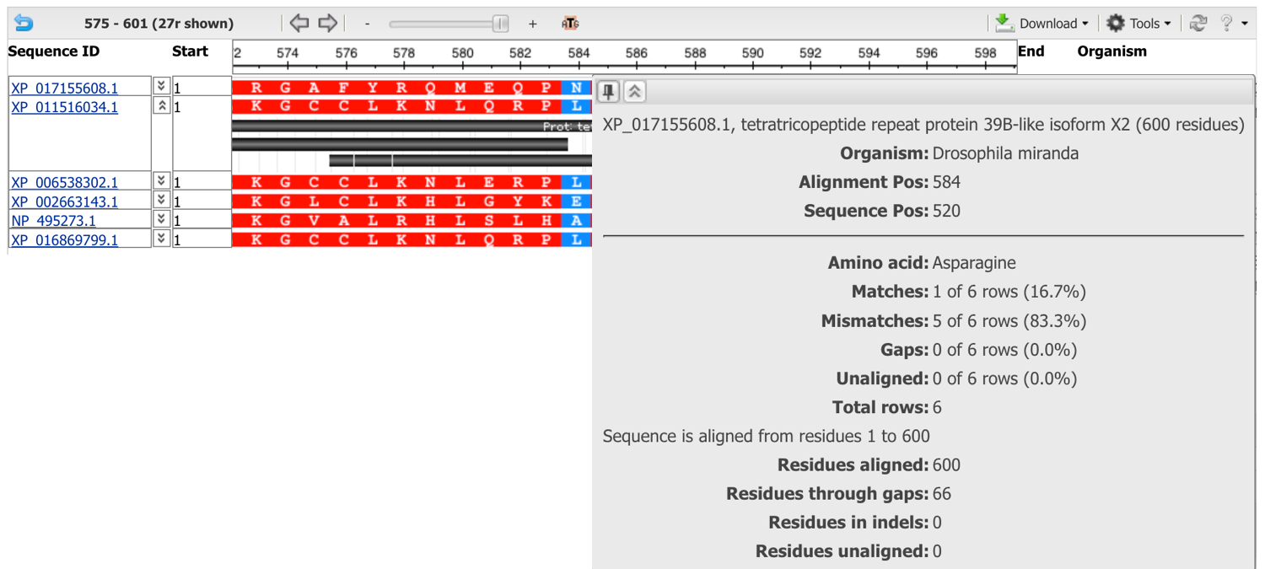
Figure 42. Hover over a base in the MSA viewer to view the multiple sequence alignment statistics for that position (e.g., position 520 of XP_017155608.1).
The MSA viewer also showed gray bases at column 595 of the multiple sequence alignment due to a gap in the alignment to the XP_017155608.1 sequence (Figure 43).

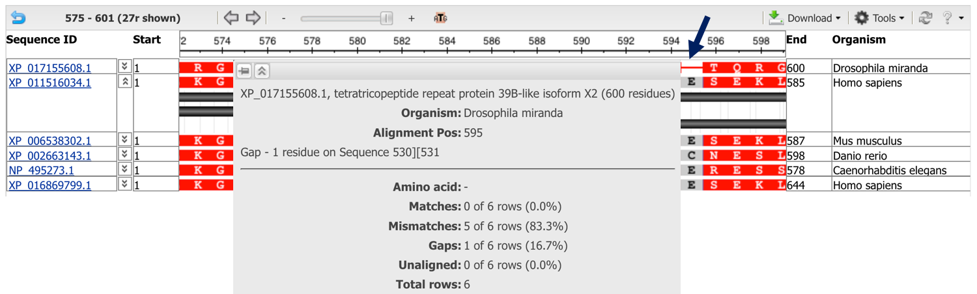
Figure 43. The bases at column 595 of the multiple sequence alignment are in gray due to the gap between residues 530–531 in the alignment to XP_017155608.1.
See the “Getting Started” tutorial for the MSA viewer on the NCBI web site for an overview of the additional features available in the MSA viewer (https://www.ncbi.nlm.nih.gov/tools/msaviewer/tutorial1/).

The “Descriptions” section of the COBALT output provides a longer description of the sequences used in the multiple sequence alignments, and “Related information” from other NCBI databases and web services (e.g., Gene, Genome Data Viewer). If the original set of sequences selected by SmartBLAST were too diverged from each other to produce a reliable multiple sequence alignment, we can select the checkboxes next to a subset of more closely-related sequences and then click on the “Re-align” button to re-run COBALT (Figure 44).

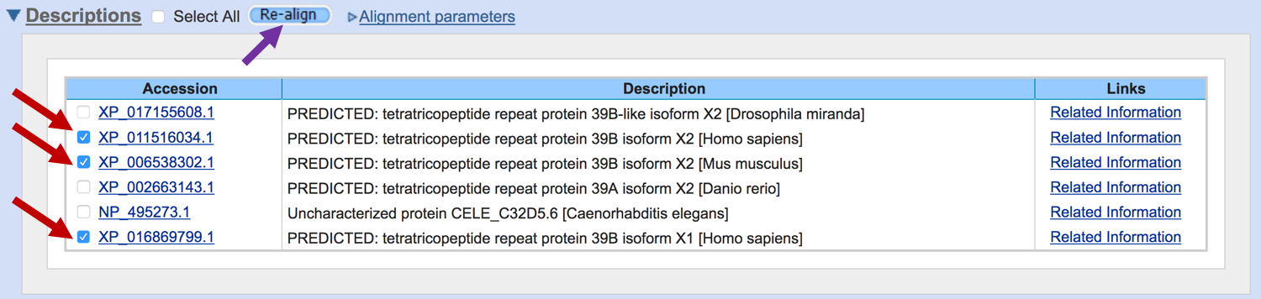
Figure 44. Select the checkboxes next to XP_011516034.1, XP_006538302.1, and XP_016869799.1 (red arrows), and then click on the “Re-align” button (purple arrow) to generate a new COBALT alignment for tetratricopeptide repeat protein 39B in human and house mouse.

The “Alignments” section shows the entire multiple sequence alignment for the sequences in the “Descriptions” section. By default, the alignment is displayed in the “Compact” View Format, where unaligned regions of the sequences are demarcated by a number surrounded by square brackets. The number denotes the number of unaligned residues (for example, “[5]” indicates that there are five unaligned residues). Select the “Expanded” option in the “View Format” field to view the entire unaligned region (Figure 45).

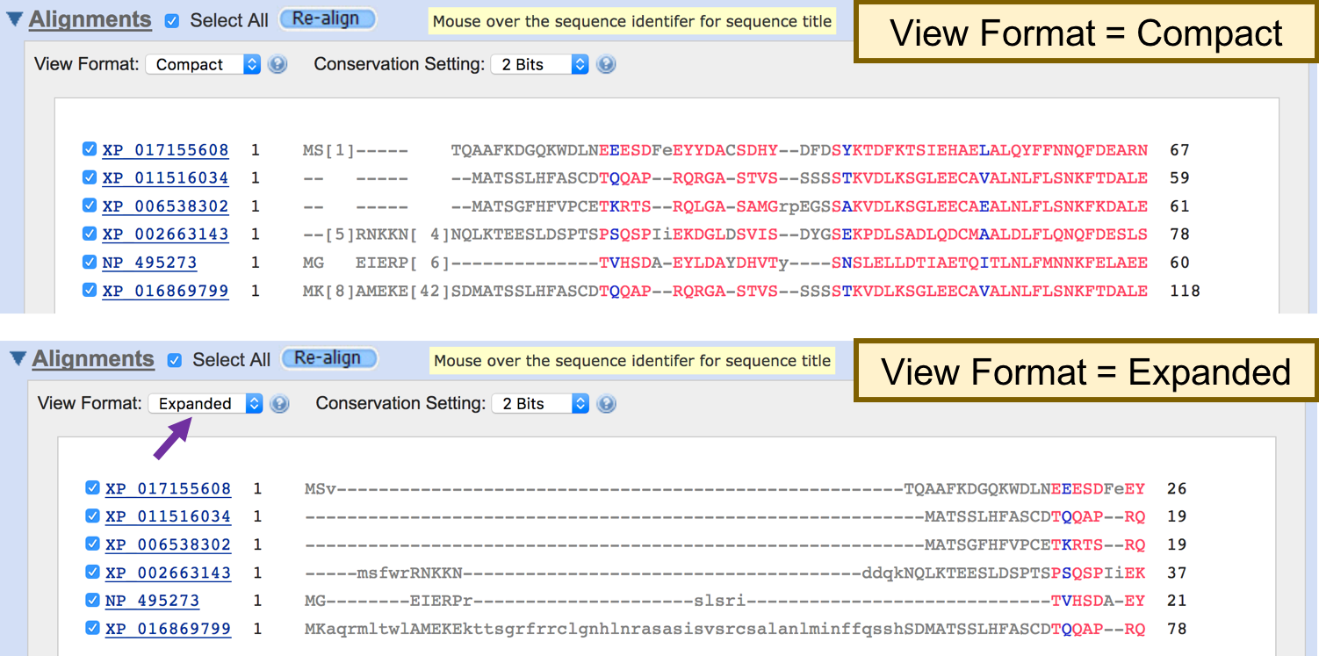
Figure 45. Change the View Format from “Compact” to “Expanded” to view the unaligned regions of the multiple sequence alignment.

Similar to the “Sequence Alignment” display for the conserved domain, we can use the “Conservation Setting” field to control the coloring of the multiple sequence alignment. By default, aligned columns with at least 2.0 bits of information are highlighted in red. We can increase the value of the “Conservation Setting” (e.g., 4.0 bits) to highlight the positions within the multiple sequence alignment that are highly conserved. In addition, we can use the “Identity” option to highlight the columns with identical residues (Figure 46).

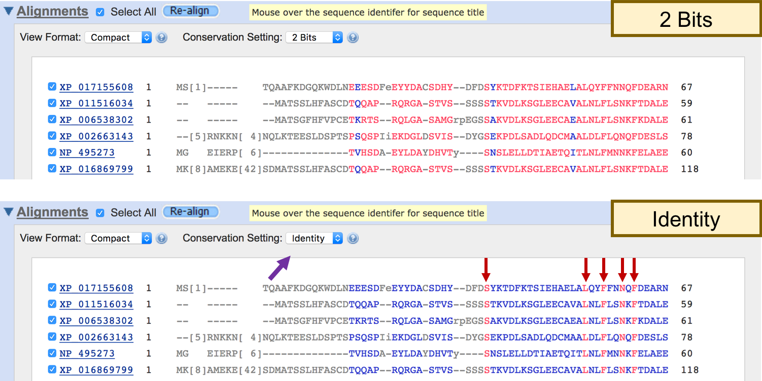
Figure 46. Change the "Conservation Setting" to “Identity” to highlight columns with identical residues in the multiple sequence alignment (red arrows).

Investigate function of Dmir_novel_gene1_mRNA1 using Gene2Function
Our investigation thus far suggests that the Dmir_novel_gene1_mRNA1 gene is likely to be a putative ortholog of tetratricopeptide repeat protein 39B in human. We can leverage the information from human and other model organisms to further characterize the potential functions of this gene.

To learn more about the human tetratricopeptide repeat protein 39B, scroll up to the “Descriptions” section of the COBALT output and then move the mouse over the “Related Information” link next to the XP_011516034.1 entry. Click on the “Gene” link in the tooltip to access the Entrez Gene record associated with this human protein (Figure 47).

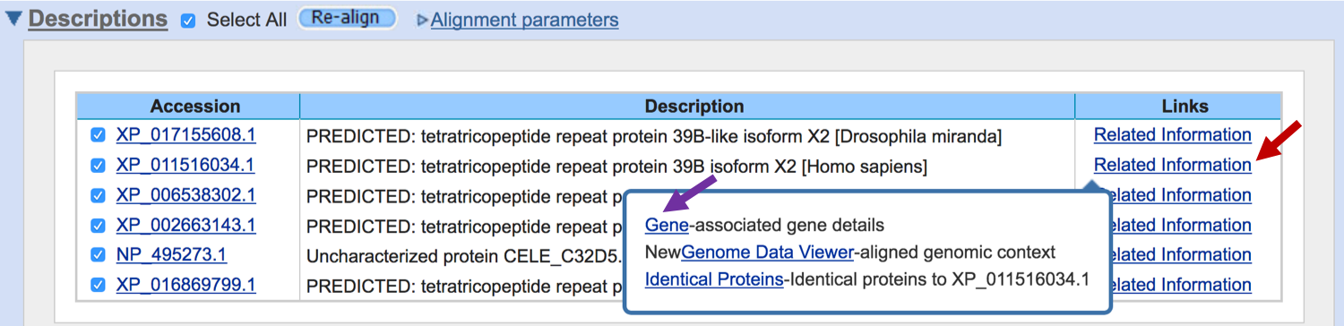
Figure 47. Click on the "Gene" link in the "Related Information" tooltip for XP_011516034.1 (purple arrow) to access the Entrez Gene record for tetratricopeptide repeat protein 39B isoform X2 in human.

The summary section of the Entrez Gene record indicates that the official symbol for this gene is TTC39B, and the primary source for this gene is the HUGO Gene Nomenclature Committee (HGNC; Figure 48). The “Genomic context” section indicates that TTC39B is located on human chromosome 9 at 15,167,204–15,307,360 in the current human assembly (GRCh38.p12).

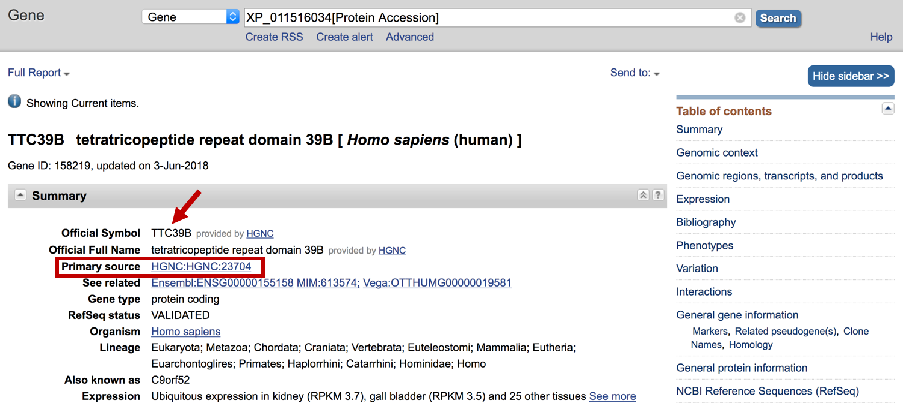
Figure 48. Entrez Gene record for the human TTC39B gene is derived from the data provided by the HGNC. Use the links the right sidebar to quickly navigate to the different sections of the Entrez Gene report (e.g., Genomic context).
The titles of the articles in the "Related articles in PubMed” subsection (under the “Bibliography” section) suggest that this gene might be related to gallbladder disease, susceptibility for bipolar disorder, and coronary artery disease (Figure 49).

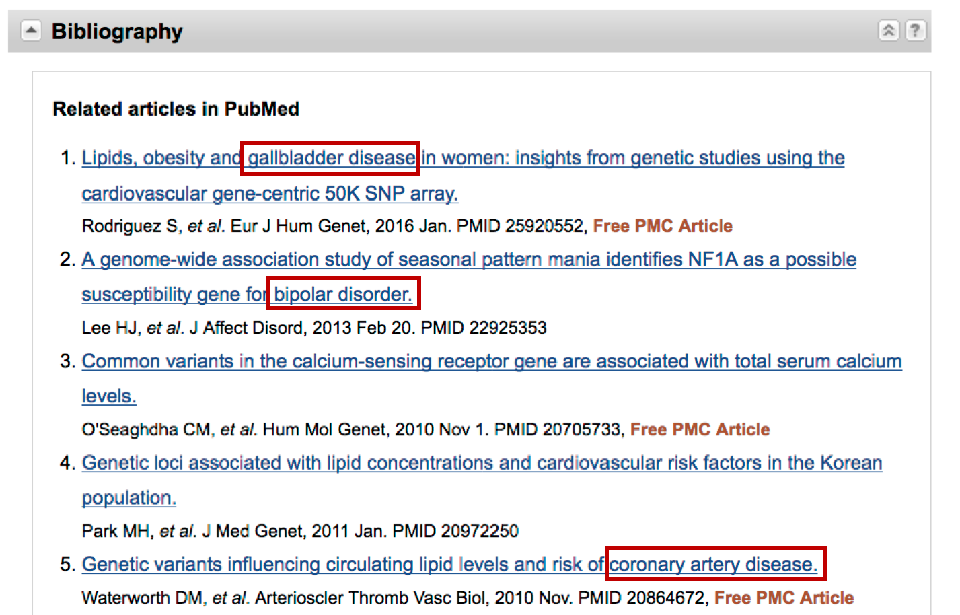
Figure 49. The articles in the “Related articles in PubMed” section indicates that the TTC39B gene might be associated with several human diseases.

We can use the Gene2Function web site to investigate the list of diseases that are associated with the human TTC39B gene, and to determine if there are experimental data available for the orthologs in other model organisms (Hu et al. 2017). Open a new web browser tab and navigate to the Gene2Function web site (http://www.gene2function.org/search/). Under the “Search by Gene” panel, select “Human” under the “Species” field, and enter “TTC39B” into the “Gene” field. Click on the “Search by Gene” button (Figure 50).

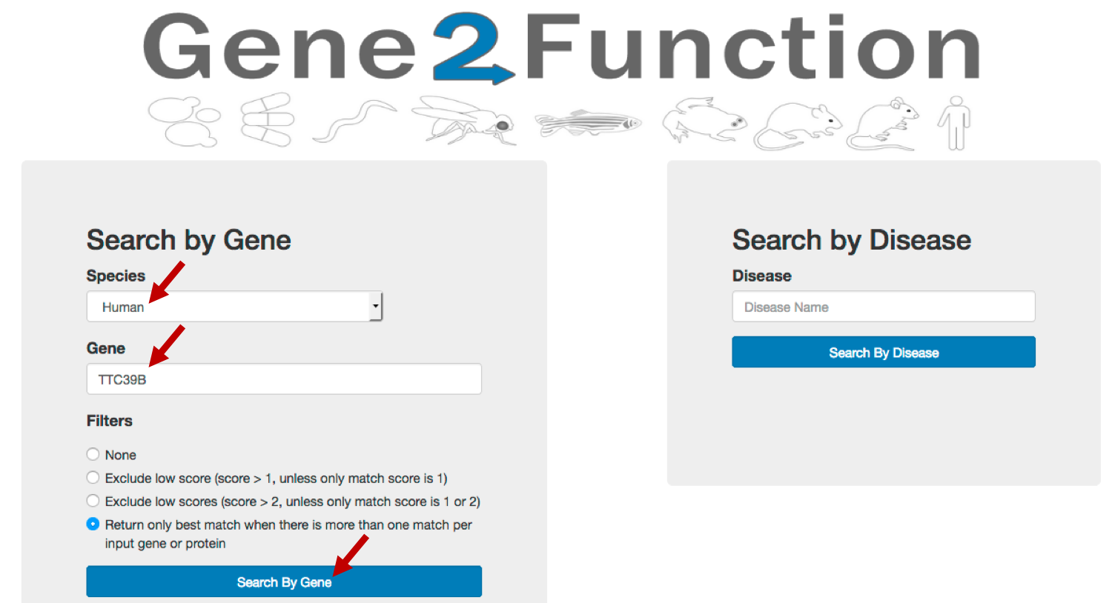
Figure 50. Retrieve the human TTC39B record from the Gene2Function web site.
The “Orthologs Overview” section of the “Gene Search Results” page shows the list of putative orthologs in mouse, rat, western clawed frog, zebrafish, worm, and yeast that were identified by the DRSC integrative ortholog prediction tool (DIOPT) (Hu et al. 2011). The summary table provides links to the NCBI Entrez Gene record (under the “NCBI Gene ID” column), as well as the records in the model organism databases (under the “Species specific gene ID” column). The table also includes links to other resources such as publications, Gene Ontology (GO) terms, known protein and genetic interactions, and RNAi and CRISPR datasets (Figure 51).

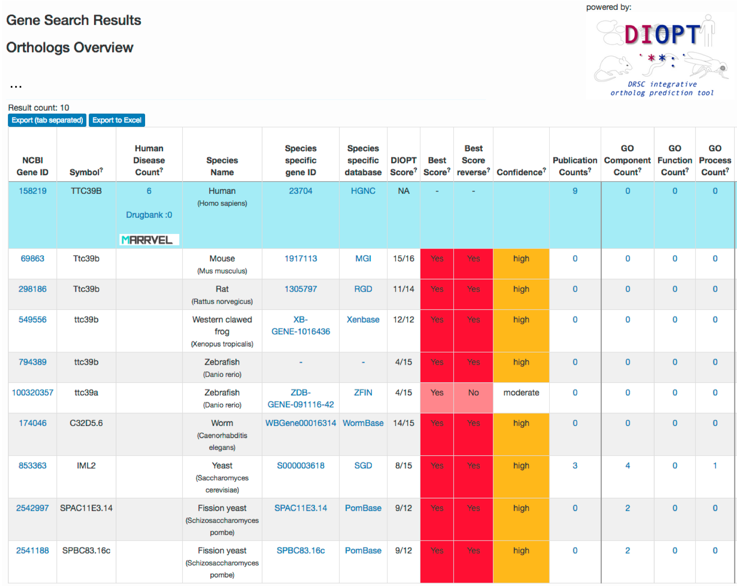
Figure 51. The “Orthologs Overview” section of the Gene Search Results page provides a quick summary of the putative orthologs of the human TTC39B gene.

The “Human Disease Count” column of the summary table indicates that there are six diseases that are associated with the TTC39B gene. Click on the “6” link to navigate to the Disease Annotation page for the TTC39B gene (Figure 52).

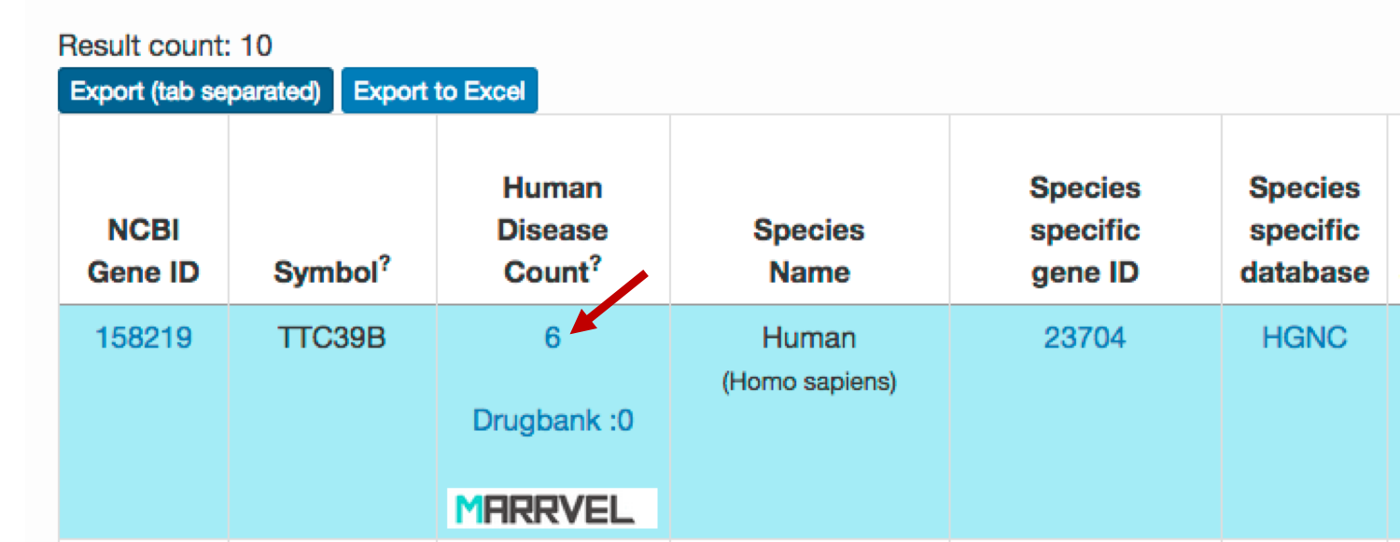
Figure 52. Click on the "6" link under the "Human Disease Count" column (red arrow) to navigate to the six disease terms associated with the TTC39B gene.

The “Disease_Term” column of the Disease Annotation table shows that TTC39B are associated with the disease terms “Coenzyme Q10 levels”, “Bipolar disorder”, “HDL cholesterol”, “Calcium levels”, “Metabolite levels (lipoprotein measures)”, and “Cholesterol, total”. The “Source” column indicates that these disease associations were determined by genome-wide association studies (GWAS). The “Other Values” column include links to the corresponding scientific publications on PubMed (Figure 53).

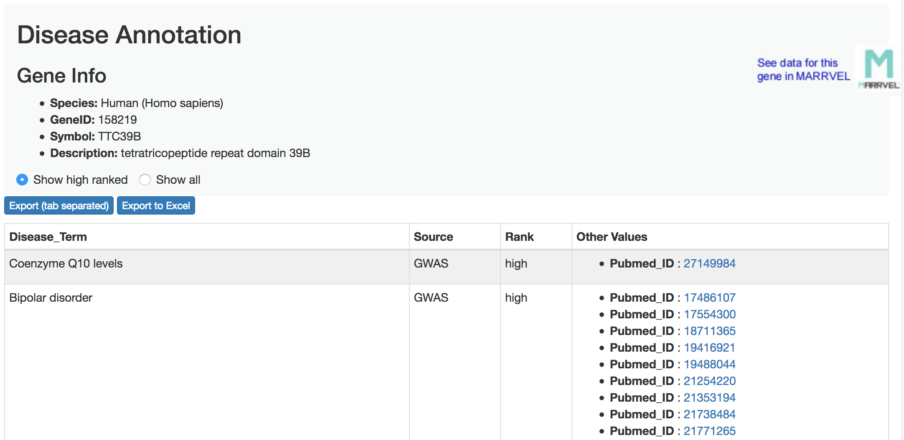
Figure 53. Disease annotations associated with the human TTC39B gene.
The GWAS data on the Gene2Function web site is primarily derived from the NHGRI-EBI GWAS Catalog (https://www.ebi.ac.uk/gwas/home). See Table 1 of the Gene2Function help page (http://www.gene2function.org/search/help) for additional details on the data sources for the Gene2Function web site.

Conclusions
In this tutorial, we used multiple databases and bioinformatics tools to annotate a gene in D. miranda that does not have a corresponding ortholog in the D. melanogaster reference genome. We used Apollo to create an initial gene model based on the Augustus gene prediction scaffold_6.g49.t1. To ascertain whether this feature is similar to any known protein-coding genes, we performed a blastp search against the NCBI refseq_protein database. We used the NCBI Taxonomy reports to investigate the distribution of protein matches among different insects, and to infer the evolutionary history of this gene (based on parsimony).

Comparison of scaffold_6.g49.t1 against the NCBI Conserved Domains Database shows a partial match to the DUF3808 domain, which suggests that the scaffold_6.g49.t1 gene model might be incomplete. We leveraged the RNA-Seq data from whole virgin males (SRR364798) and whole
virgin females (SRR364800), and the StringTie transcript STRG.100_transcript_727319_733139 to revise the gene model using Apollo.

We analyzed this gene model (Dmir_novel_gene1_mRNA1) using SmartBLAST to identify putative orthologs in human and in other model organisms. The SmartBLAST search also shows that the revised gene model is identical to the D. miranda predicted protein XP_017155608.1 in the refseq_protein database. We examined the multiple sequence alignment of the revised D. miranda gene model with the putative orthologs in human, house mouse, zebrafish, and C. elegans using COBALT and the NCBI MSA viewer.

We then investigate the potential function of this D. miranda gene by examining the available information on the putative human ortholog TTC39B using the Entrez Gene record and the Gene2Function web site. We find that there are six disease terms that are associated with the TTC39B gene in human: “Coenzyme Q10 levels”, “Bipolar disorder”, “HDL cholesterol”, “Calcium levels”, “Metabolite levels (lipoprotein measures)”, and “Cholesterol, total”.

Collectively, this walkthrough illustrates how we can utilize comparative genomics (e.g., protein similarity searches, analysis of conserved domains, multiple sequence alignments) to facilitate the annotation and characterization of a novel gene in D. miranda.

Bibliography
Hu, Y., A. Comjean, S. E. Mohr, FlyBase Consortium, and N. Perrimon, 2017 Gene2Function: An Integrated Online Resource for Gene Function Discovery. G3 Bethesda Md 7: 2855–2858.

Hu, Y., I. Flockhart, A. Vinayagam, C. Bergwitz, B. Berger et al., 2011 An integrative approach to ortholog prediction for disease-focused and other functional studies. BMC Bioinformatics 12: 357.

Kuang, W. W., D. A. Thompson, R. V. Hoch, and R. J. Weigel, 1998 Differential screening and suppression subtractive hybridization identified genes differentially expressed in an estrogen receptor-positive breast carcinoma cell line. Nucleic Acids Res. 26: 1116–1123.

Lamb, J. R., S. Tugendreich, and P. Hieter, 1995 Tetratrico peptide repeat interactions: to TPR or not to TPR? Trends Biochem. Sci. 20: 257–259.

Papadopoulos, J. S., and R. Agarwala, 2007 COBALT: constraint-based alignment tool for multiple protein sequences. Bioinforma. Oxf. Engl. 23: 1073–1079.

