Transfer large genomic datasets to G-OnRamp

Wilson Leung
07/2017

1. Introduction
Before we can run the standard G-OnRamp workflow, we must obtain the genome assembly and RNA-Seq reads for the target species of interests, as well as the transcript and protein sequences from an informant species. This walkthrough will explain how you can obtain these genomic datasets from public databases such as NCBI and EMBL-EBI, and then transfer these datasets to G-OnRamp. This walkthrough will use the genomic datasets for Drosophila miranda to demonstrate the key techniques and issues when transferring large datasets to G-OnRamp.
Note that this walkthrough assumes that the reader is already familiar with the basic concepts and objects in Galaxy and G-OnRamp. (See the “Introduction to G-OnRamp Walkthrough” for an overview of G-OnRamp.)

2. Use NCBI BioProject to access datasets associated with a study
The NCBI BioProject database provides an entry point to all the genomic datasets (e.g., genome assembly, transcriptome) associated with a study. The datasets associated with a NCBI BioProject record could range from an individual research project to large research initiatives such as the 1000 Genomes project, ENCODE, and the Human Microbiome Project (HMP).

To identify the genomic resources available for D. miranda, open a web browser window and navigate to the NCBI BioProject web page at https://www.ncbi.nlm.nih.gov/bioproject/. Enter “Drosophila miranda” into the search box and then click on the “Search” button (Figure 1).

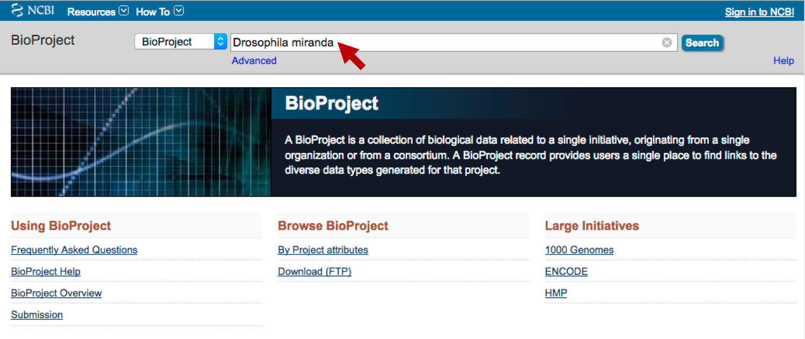
Figure 1. Search for projects in the NCBI BioProject database which contains the term “Drosophila miranda”.
The query syntax “<search term> [search field]” could be used to restrict the search term to a specific field in an NCBI query. For example, the query “Drosophila miranda [Organism]” will only show the records where the “Organism” field has the value “Drosophila miranda”. [See the “Search Field Descriptions for Sequence Database” page for the list of available search fields (https://www.ncbi.nlm.nih.gov/books/NBK49540/)]. The “Advanced Search Builder” could be used to construct more complex queries with multiple search fields (available through the “Advanced” link under the search text box).
The search results page shows 12 records which contain the search term “Drosophila miranda” (Figure 2). The D. miranda datasets available include genome sequencing data, transcriptome data from RNA-Seq, and epigenomics data from ChIP-Seq. Each BioProject has a unique accession number that begins with the prefix “PRJ”.

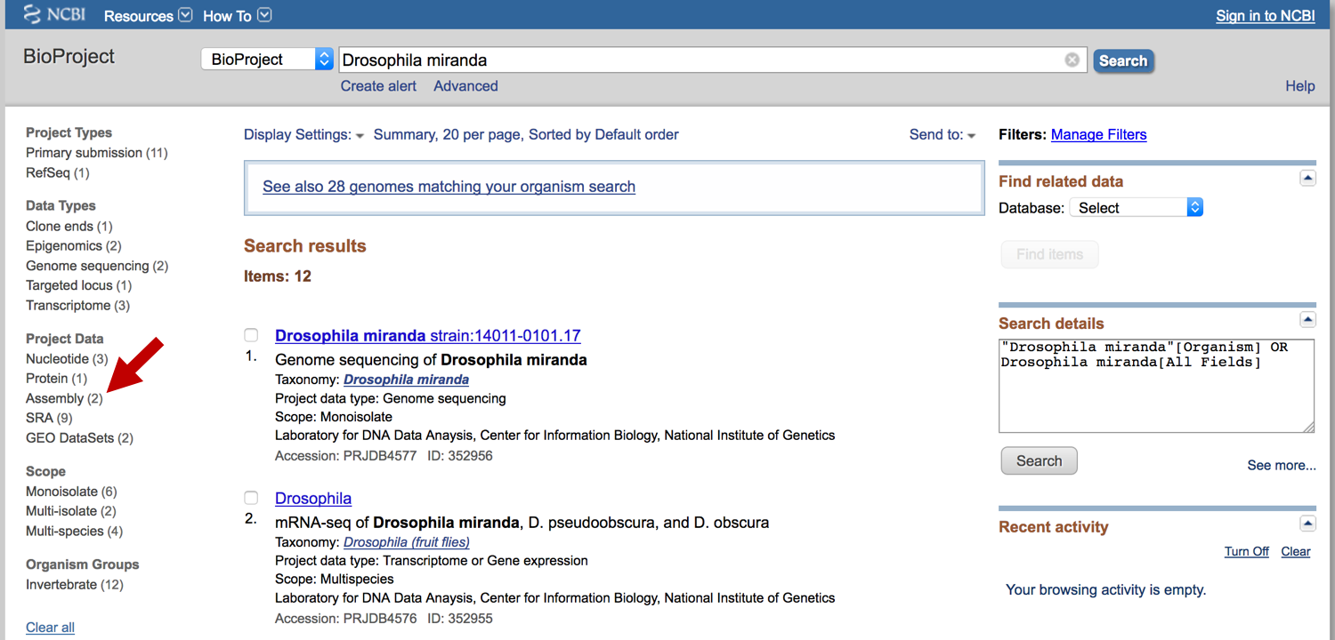
Figure 2. NCBI BioProject search results which shows 12 items that contain the search term “Drosophila miranda”. The categories on the left panel could be used to filter the search results (e.g., by Project Types, Data Types). Click on the “Assembly” link under the “Project Data” section so that only the D. miranda genome assemblies are shown (red arrow).

3. Use the NCBI Assembly database to access genome assemblies
In this walkthrough, we will retrieve a D. miranda genome assembly and upload the assembly to G-OnRamp. Click on the “Assembly” link under “Project Data” section in the left panel so that only the two publicly available D. miranda genome assemblies are shown in the search results (Figure 2, red arrow). The descriptions indicate that both assemblies are for the D. miranda strain MSH22 (Figure 3). The first record (with the accession number PRJNA325520) is from the NCBI Reference Sequence (RefSeq) database, while the second record (with the accession number PRJNA77213) is a primary submission from the University of California, Berkeley.
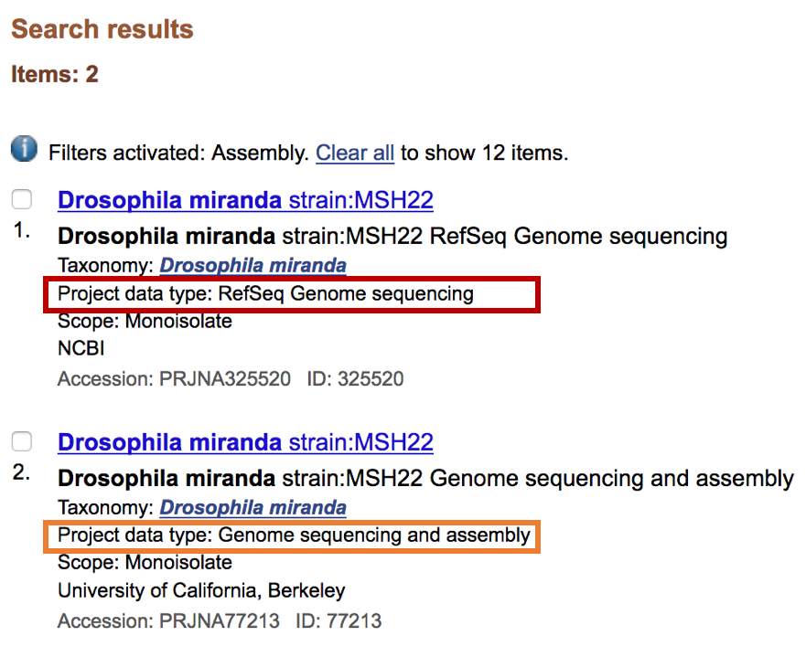
Figure 3. The two D. miranda genome assemblies available through the NCBI BioProject database. The record with the accession number PRJNA325520 has the project data type “RefSeq Genome sequencing” (red box) while the record with the accession number PRJNA77213 (orange box) has the project data type “Genome sequencing and assembly”.
The NCBI Reference Sequence (RefSeq) project provides a high-quality, non-redundant, curated database of genomic, RNA, and protein sequences for multiple organisms. RefSeq records are derived from primary submissions to the other databases at NCBI; see chapter 18 of the NCBI Handbook for details (https://www.ncbi.nlm.nih.gov/books/NBK21091/).
Click on the first “Drosophila miranda strain:MSH22” link (accession number PRJNA325520) to access the RefSeq Genome sequencing record for D. miranda. The BioProject details page shows that this assembly is derived from the GenBank assembly submitted by the Bachtrog lab at University of California, Berkeley (with the BioProject accession number PRJNA77213).
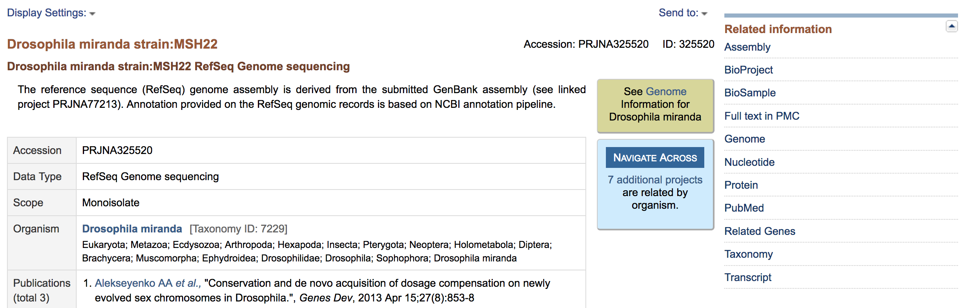
Figure 4. The BioProject details page for the D. miranda RefSeq genome assembly. We can use the links under the “Related information” panel on the right panel to access the datasets associated with this genome assembly in other NCBI databases.
Scroll down to the “Project Data” section of the BioProject details page. We can access the resources associated with this BioProject in other NCBI databases (e.g., transcript and protein sequences, PubMed records) by clicking on the links under the “Number of Links” column. Click on the “1” link in the “Assembly” row to access the D. miranda assembly in the NCBI Assembly database (Figure 5).

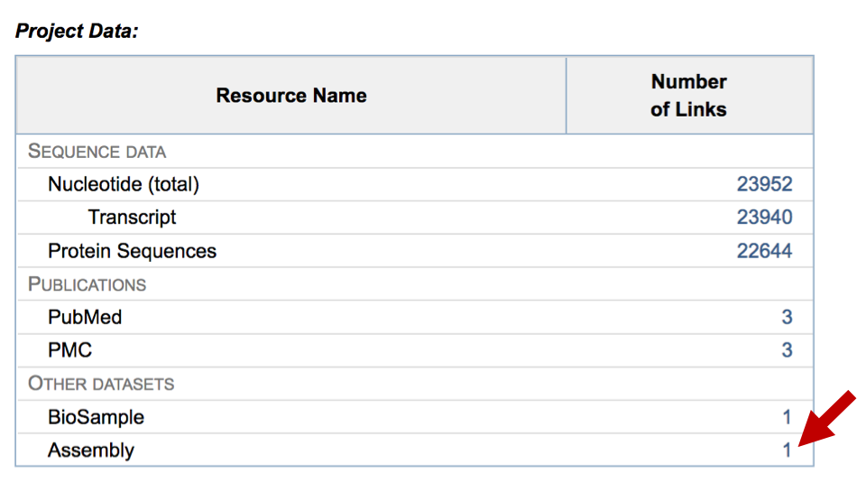
Figure 5. The “Number of Links” column under the “Project Data” section shows there are 23,940 transcripts and 22,644 protein sequences associated with this D. miranda BioProject. Click on the link in the “Assembly” row to navigate to the NCBI Assembly record for this BioProject (red arrow).
The NCBI Assembly search results page shows that the “DroMir_2.2” assembly is the latest RefSeq genome assembly available for D. miranda (accession number = GCF_000269505.1; Figure 6). The “Assembly level” field shows that the assembly is organized into chromosomes, and the “RefSeq category” field shows that this assembly is classified as a “representative genome”. The “GenBank assembly accession” field shows that this RefSeq assembly is derived from the GenBank assembly GCA_000269505.2.

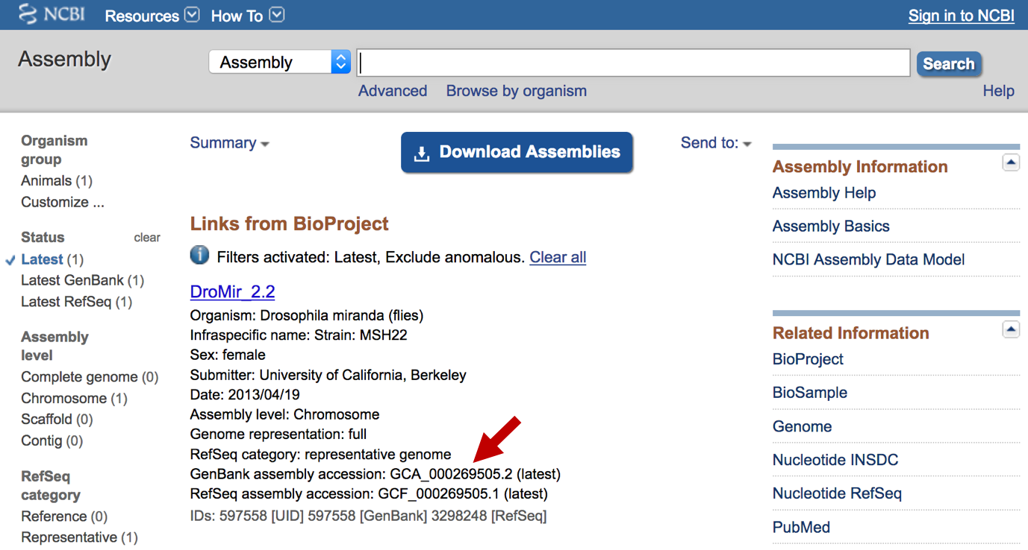
Figure 6. The NCBI Assembly record shows that the DroMir_2.2 RefSeq assembly is derived from the GenBank assembly GCA_000269505.2 (red arrow).
RefSeq Genomes are classified into two major categories: reference genome and representative genome. A reference genome typically corresponds to a model organism with high quality assemblies and gene annotations that is used as the standard for comparative analyses (e.g., human, mouse, D. melanogaster, C. elegans). A representative genome corresponds to a species within a clade that has the highest quality assembly available. (See the NCBI Assembly help page for details https://www.ncbi.nlm.nih.gov/assembly/help/.)

Click on the “DroMir_2.2” link to navigate to the NCBI Assembly report (Figure 7). This
report provides an overview of the assembly, such as the assembly method (i.e., Newbler v 2.6), the sequencing technologies used (i.e., Illumina HiSeq and 454), and the estimated genome coverage (i.e., 95.0x). The “Global statistics” section of the report provides quality metrics such as the total size of the assembly, the total number and size of the gaps, and the scaffold N50 (i.e., scaffolds this size and larger account for half of the total size of the assembly).

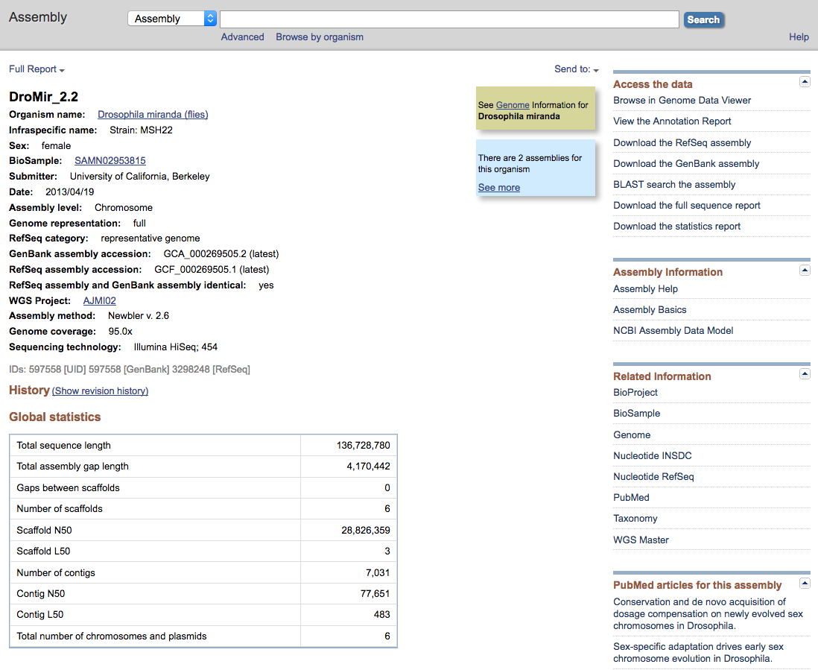
Figure 7. The NCBI Assembly report for the D. miranda DroMir_2.2 assembly. The information in the “Global statistics” section can be used to estimate the quality of the assembly. The genome assembly and assembly reports are available for download under the “Access the data” section on the right panel.

4. Use Cyberduck to access the NCBI Genomes FTP site
In this walkthrough, we will use the Cyberduck program to transfer genomic datasets from the NCBI Genomes FTP site to G-OnRamp. Cyberduck is compatible with MS Windows (Windows 7 or later) and macOS (macOS 10.8 or later). In addition to FTP, Cyberduck can also connect to many other data storage services (e.g., Google Drive, DropBox, OneDrive, Amazon S3) as well as the CyVerse Data Store (i.e., iRods).
The File Explorer in MS Windows and the Finder in macOS have partial support for FTP. There is also a plethora of FTP clients on both platforms (e.g., FileZilla; see https://en.wikipedia.org/wiki/Comparison_of_FTP_client_software). However, some of these FTP clients can only transfer files that are smaller than 2GB, and they might not support data transfer between two remote servers (i.e., FXP). In addition, some FTP clients (e.g., Finder on macOS), do not support usernames that contain an @ character. Because the usernames of most Galaxy accounts are Email addresses, these FTP clients are incompatible with Galaxy (see https://stackoverflow.com/questions/22916990/ for details).

For training purposes, we will use Cyberduck to transfer relatively small files to the G-OnRamp server. If the files you plan to transfer are < 100 MB, then you can upload the file to G-OnRamp directly using the “Upload File” Galaxy tool. See the “Uploading data into Galaxy” tutorial on the Galaxy web site for an overview of the file upload strategies available (https://galaxyproject.org/tutorials/upload/).

4.1 Download and install Cyberduck
Open a new web browser window and navigate to the Cyberduck web site at https://cyberduck.io/?l=en. Click on the “Changelog” link in the top menu bar and then scroll down to the “6.0.0 (May-09-2017)” release (Figure 8). Click on the “Download (Mac)” link for macOS or the “Download Installer (Windows)” link for MS Windows (Figure 9).

Figure 8. Click on the "Changelog" link on the main navigation bar of the Cyberduck web site to access older versions of Cyberduck (red arrow).
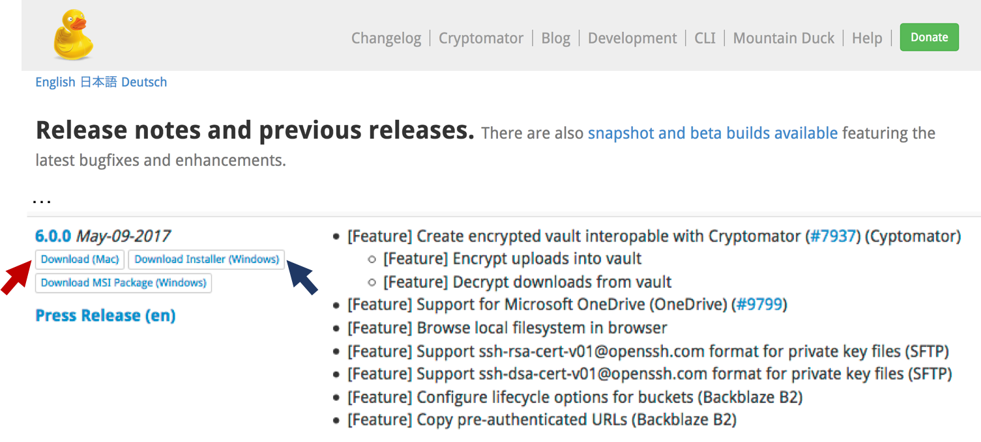
Figure 9. Download version 6.0.0 of Cyberduck from the Changelog page. For macOS, click on the “Download (Mac)” link to download the application (red arrow). For MS Windows, click on the “Download Installer (Windows)” to download the Cyberduck installer (blue arrow).
The more recent versions (6.0.1 or above) of Cyberduck have a bug that prevents the data transfer between two remote FTP servers (i.e., FXP). Consequently, we will use an older version of Cyberduck (6.0.0) in this walkthrough.

Navigate to the directory where you have downloaded the Cyberduck package. For macOS, double click on the zip file (Cyberduck-6.0.0.24625.zip) to expand the package, and then double click on the Cyberduck application to launch the program.

For MS Windows, double click on the Installer (Cyberduck-Installer-6.0.0.24625.exe) to install the program. (See the “Installation” section of the Cyberduck FAQ page for details: https://trac.cyberduck.io/wiki/help/en/faq#Installation). Launch the Cyberduck application once the installation is complete.
A quick reference guide and detailed documentations for Cyberduck are available through the Cyberduck help page at https://trac.cyberduck.io/wiki/help/en.

4.2 Use Cyberduck to connect to the NCBI Genomes FTP site
Go back to the web browser tab with the NCBI Assembly report for the D. miranda DroMir_2.2 assembly (https://www.ncbi.nlm.nih.gov/assembly/GCF_000269505.1; Figure 7). Right click (control click on macOS) on the “Download the RefSeq assembly” link under the “Access the data” section on the right panel. Select the option in the context menu to copy the link to the clipboard (Figure 10). (This option is labeled “Copy Link Location” in Firefox, “Copy Link Address” in Chrome, and “Copy Link” in Safari.)

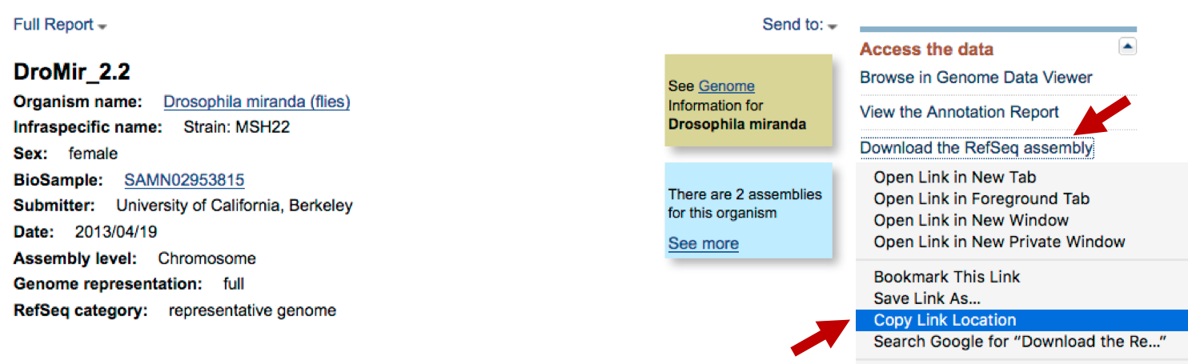
Figure 10. Right click on the "Download the RefSeq assembly” link and then select the “Copy Link Location” option to copy the link. Note that the label for this option is web browser-specific (e.g., “Copy Link Address” in Chrome, “Copy Link” in Safari).

Go to the Cyberduck Browser window. Paste the link into the “Quick Connect” text box (ftp://ftp.ncbi.nlm.nih.gov/genomes/all/GCF/000/269/505/GCF_000269505.1_DroMir_2.2) in the main tool bar. Press “Enter” to connect to the NCBI FTP server (Figure 11).

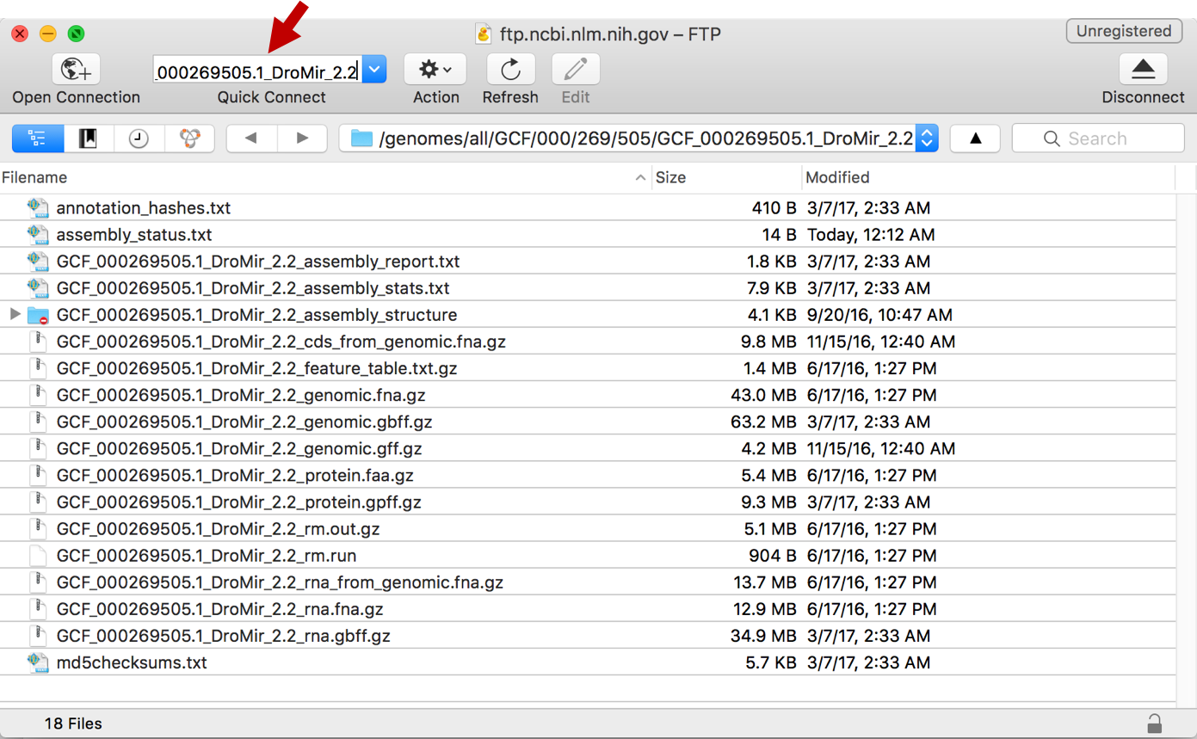
Figure 11. Paste the link to the NCBI Genomes FTP directory for the D. miranda assembly into the “Quick Connect” text box of the Cyberduck Browser window.

4.3 Naming conventions used by the NCBI Genomes FTP site
Files on the NCBI Genomes FTP site are named according to the following convention:

<accession.version>_<assembly name>_<content type>.<format>

There are four major content types that are of interests to genome annotations: “genomic”, “protein”, “rm”, and “rna” (Table 1). Some of these files are produced by the NCBI Eukaryotic Genome Annotation Pipeline, and they are not available for GenBank assemblies (see https://www.ncbi.nlm.nih.gov/genome/annotation_euk/process/ for details).

Table 1. Common content types for NCBI RefSeq Genomes
Content type | Description
genomic | Genome assembly (repeats identified by WindowMasker or RepeatMasker are in lowercase)
protein | Proteins identified by the NCBI Eukaryotic Genome Annotation Pipeline
rm | Transposons identified by RepeatMasker (eukaryotes only)
rna | Transcripts identified by the NCBI Eukaryotic Genome Annotation Pipeline

The data associated with each content type are available in multiple formats (Table 2).

Table 2. Common data formats for NCBI RefSeq Genomes
Format | Description
fna | Nucleotide sequences in FASTA format
faa | Protein sequences in FASTA format
gbff | Nucleotide sequence records in GenBank flat file format
gpff | Protein sequence records in GenBank flat file format
gff | Annotated features in General Feature Format Version 3 (GFF3) format
run | Parameters used in the RepeatMasker analysis
out | The position of each transposon identified by RepeatMasker

See the “README.txt” file in the FTP directory for a more detailed explanation of the data contained in each file on the NCBI Genomes FTP site.
The files with the .gz suffix were compressed using the gzip program. The gzip format is supported by Galaxy, and by macOS and Linux. For MS Windows, you can use the 7-Zip program (http://www.7-zip.org/) to uncompress the gzip files.

Based on the naming conventions described above, there are three files in the NCBI Genomes FTP directory that are often used as input datasets to G-OnRamp:

- GCF_000269505.1_DroMir_2.2_genomic.fna.gz
  - D. miranda genome assembly in FASTA format
  - “Reference genome” input dataset in the G-OnRamp workflow

- GCF_000269505.1_DroMir_2.2_protein.faa.gz
  - D. miranda protein sequences in FASTA format
  - “Protein Query Sequence” input dataset in the G-OnRamp workflow

- GCF_000269505.1_DroMir_2.2_rna.gbff.gz
  - D. miranda transcript sequences in GenBank flat file format
  - “mRNA GenBank records” input dataset in the G-OnRamp workflow

5. Transfer data from the NCBI FTP site to the G-OnRamp server
Once we have identified the datasets of interests, we can use Cyberduck to transfer them to the G-OnRamp server at http://cloud5.galaxyproject.org/. (Note that this instance will only be available during the G-OnRamp workshop.) Before you can upload files to the G-OnRamp server via FTP, you must first create an account on the G-OnRamp server. (See section 2 of the “Introduction to G-OnRamp Walkthrough” for instructions on how to create an account.)

Go back to the Cyberduck application and then select “File” ➜ “New Browser” from the main menu bar to open a new Cyberduck Browser window. Click on the “Open Connection” button on the main tool bar. Select the “FTP (File Transfer Protocol)” option from the drop-down menu, and then change the connection settings to the following:

- Server: cloud5.galaxyproject.org
- Username: <Username for your G-OnRamp account>
- Password: <Password for your G-OnRamp account>

Click on the “Connect” button to establish the connection to the G-OnRamp server (Figure 12). A warning dialog will appear indicating that the connection is unsecured (Figure 13). This is because we are using FTP instead of a secure protocol such as SFTP to connect to the server. Click on the “Continue” button to ignore this warning and to establish the connection.
See the Cyberduck FTP & FTP-TLS help page for details on the available FTP connection settings (https://trac.cyberduck.io/wiki/help/en/howto/ftp).

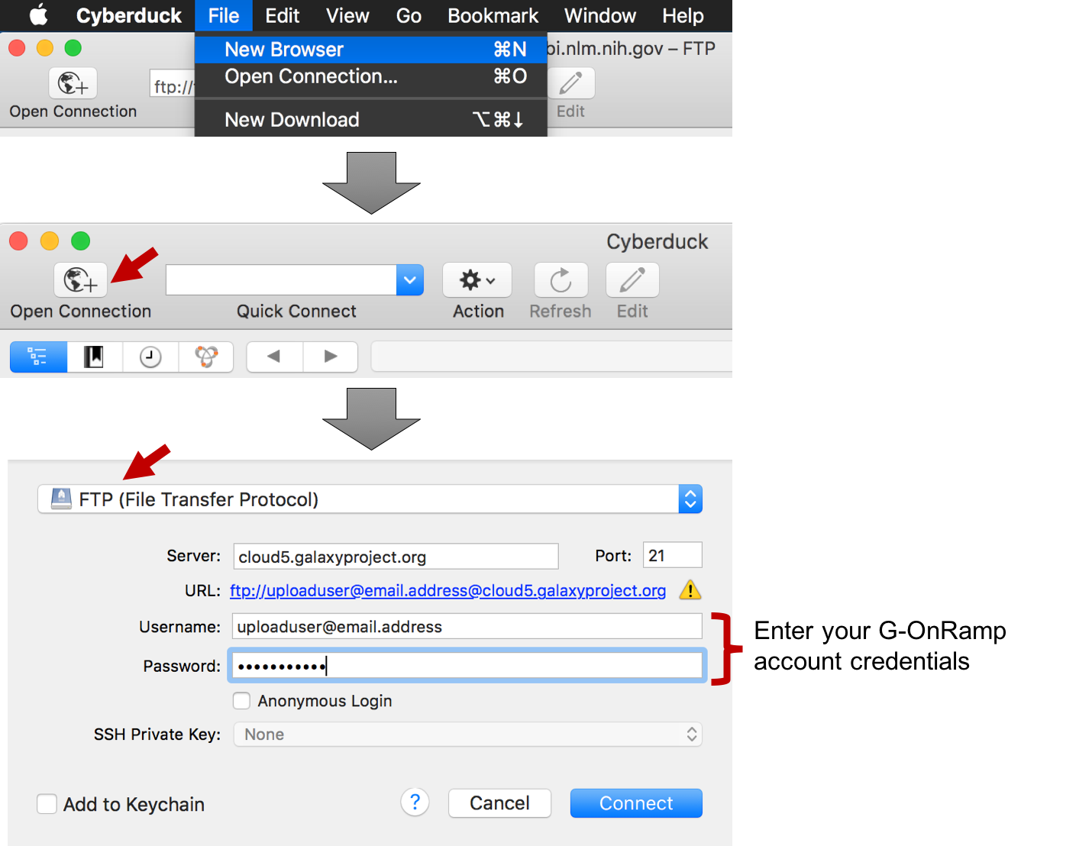
Figure 12. Select the “New Browser” menu item to open a new Cyberduck Browser window. Click on the “Open Connection” button to configure the connection to the G-OnRamp server. (Enter your G-OnRamp account credentials into the “Username” and “Password” fields.)

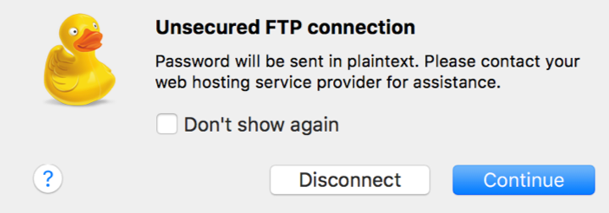
Figure 13. The warning dialog from Cyberduck which indicates that the connections to the FTP server is not secure. Click on the “Continue” button to connect to the G-OnRamp server. Select the “Don’t show again” checkbox so that this dialog will not appear in subsequent connections to the FTP server.

At this point, we should have two Cyberduck Browser windows opened: one window is connected to the NCBI Genomes FTP site and the other window is connected to your account on the G-OnRamp server. To transfer files from the NCBI FTP server to the G-OnRamp server, simply drag and drop the files from one window to the other.
For example, in order to transfer the D. miranda genome assembly to the G-OnRamp server, select the “GCF_000269505.1_DroMir_2.2_genomic.fna.gz” file from the NCBI Genomes FTP site, drag it to the G-OnRamp server window, and then release the mouse button (Figure 14).

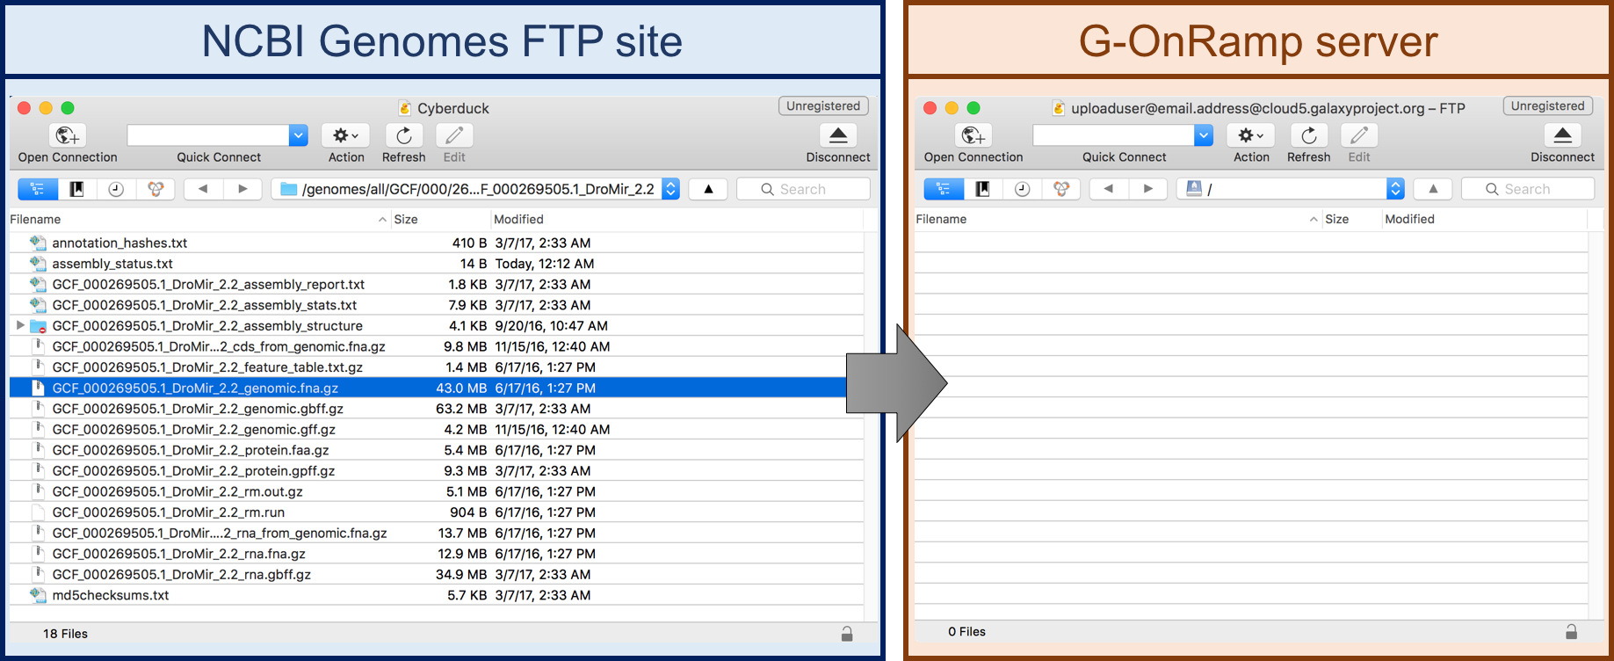
Figure 14. Drag the selected file from the NCBI Genomes FTP site window to the G-OnRamp server window to transfer the file.

A “Transfers” window will appear which shows the progress of the data transfer. Once the data transfer is complete, the file will appear in the Cyberduck Browser window that is connected to your account on the G-OnRamp server (Figure 15).

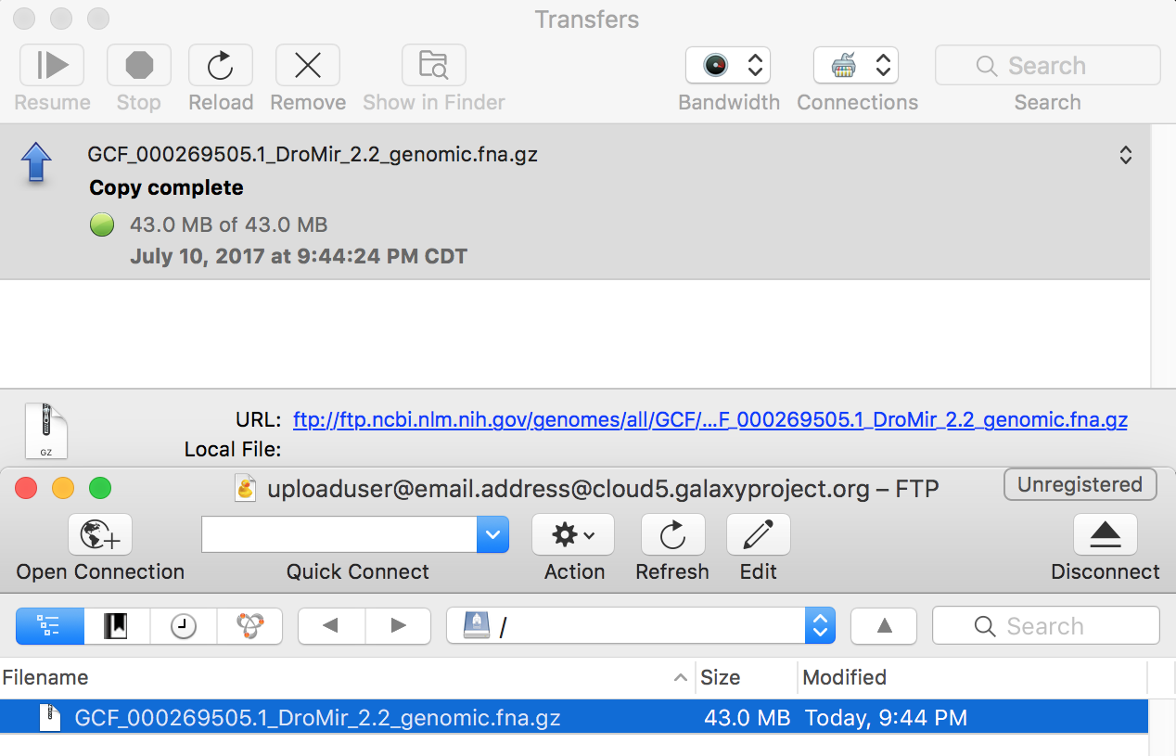
Figure 15. The Transfers window shows that the D. miranda genome assembly was successfully copied from the NCBI Genomes FTP server to the G-OnRamp server.
In order to use the D. miranda genome assembly in our G-OnRamp analyses, we must add the genome assembly to the History. Open a new web browser tab, navigate to the G-OnRamp server (http://cloud5.galaxyproject.org/) and then log into your account.

Click on the “Get Data” link under the “Tools” panel and then select the “Upload File” tool. Click on the “Choose FTP file” button at the bottom of the window (Figure 16, red arrows). A “FTP files” dialog box will appear which shows the file we have just uploaded to the G-OnRamp FTP server. Select the checkbox next to the “GCF_000269505.1_DroMir_2.2_genomic.fna.gz” file to add this file to the upload queue (Figure 16, blue arrow). Click on the blue “Start” button to add this file to the History (Figure 17).

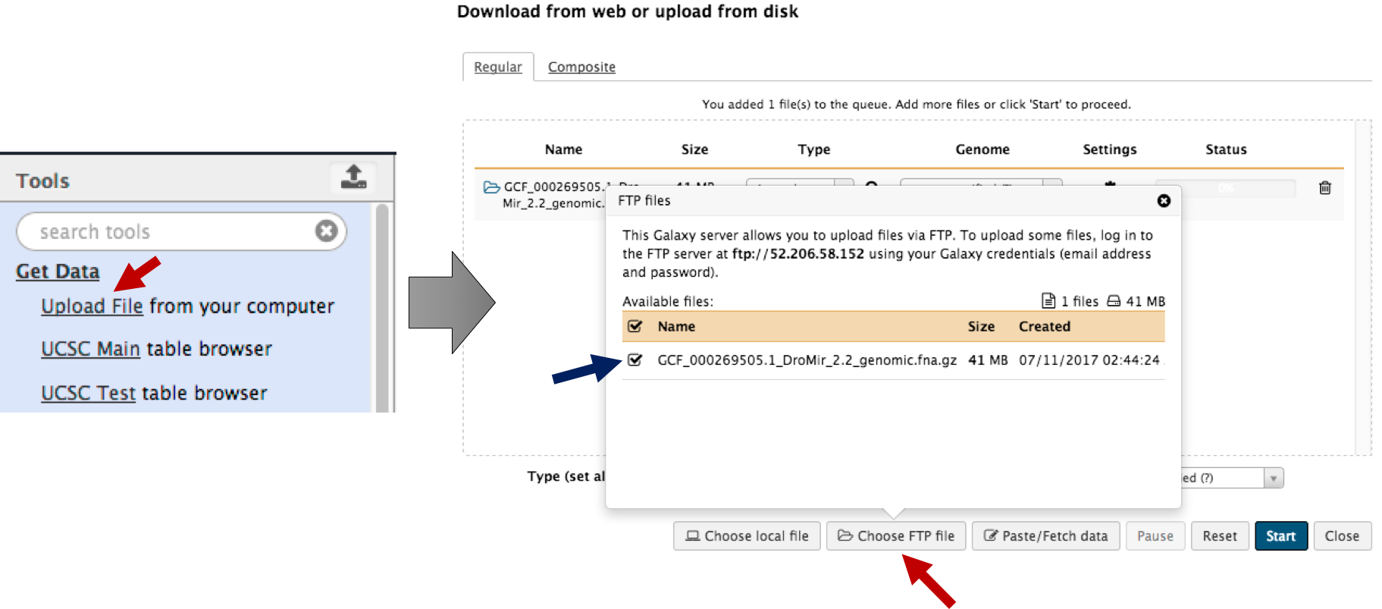
Figure 16. Add FTP files to the G-OnRamp History. Select the “Upload File” tool from the Tools panel and then click on the “Choose FTP file” button (red arrows). Select the checkbox next to the file in the “FTP files” dialog to add it to the queue (blue arrow). Click on the “Start” button to add the file to the current History.

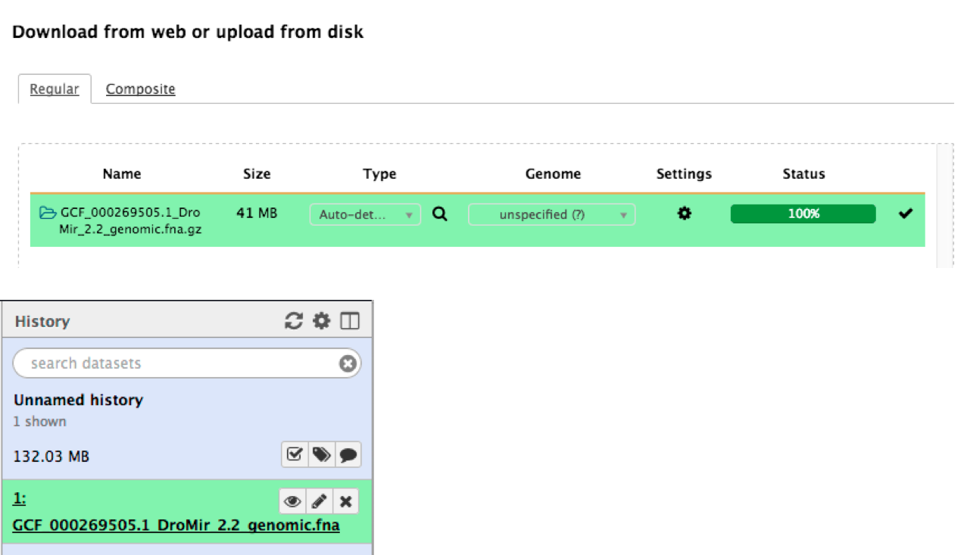
Figure 17. The FASTA file which contains the genome assembly of D. miranda was successfully added to the current History.

5.1: FTP servers with large genomic datasets
In addition to the NCBI FTP server, many other genome databases also provide FTP access to their genomic datasets. Below is a list of FTP servers that might be useful for genome analyses:

Database | Datasets available | Web address
UCSC Genome Browser | Genome assemblies and annotations used to construct the UCSC Genome Browser | ftp://hgdownload.soe.ucsc.edu/goldenPath/
FlyBase | Drosophila genome assemblies and annotations in FASTA, GFF, and GTF formats | ftp://ftp.flybase.net/releases/current/
Ensembl | Genome assemblies and gene annotations for model organisms | ftp://ftp.ensembl.org/pub/
Ensembl Genomes | Genome assemblies and gene annotations for bacteria, protists, fungi, metazoa, and plants | http://ensemblgenomes.org/info/access/ftp
EMBL-EBI | Most of the datasets available through NCBI | http://www.ebi.ac.uk/ena/browse/sequence-download
UniProtKB / Swiss-Prot | Manually curated protein sequences | http://www.uniprot.org/downloads

Exercise: Transfer transcript and protein sequence files to G-OnRamp
As part of the analysis of the D. miranda genome, we would like to identify regions within the D. miranda genome assembly that show sequence similarity to protein-coding genes in Drosophila melanogaster. In order to perform this analysis using G-OnRamp, we need to obtain the D. melanogaster protein sequences in FASTA format (for the tblastn search) and the D. melanogaster transcript records in GenBank format (for the BLAT search), and then transfer these files via FTP to the G-OnRamp server.

In order to complete this exercise, you would need to perform the following tasks:

- Navigate to the D. melanogaster RefSeq genome assembly at NCBI
- Connect to the NCBI Genomes FTP server using Cyberduck
- Connect to the G-OnRamp FTP server using Cyberduck
- Transfer files from the NCBI FTP server to the G-OnRamp FTP server
- Add the transferred datasets to your current G-OnRamp History

6. Search for RNA-Seq data in the NCBI Sequence Read Archive
In addition to the genome assembly, the protein sequences, and the transcript sequences, another input dataset for G-OnRamp is the RNA-Seq reads for the target species of interests. Most of the published second generation (e.g., Illumina, 454) and third generation (e.g., PacBio, Nanopore) sequencing data are available for download through the NCBI Sequence Read Archive (SRA; https://www.ncbi.nlm.nih.gov/sra).

In this walkthrough, we will identify the RNA-Seq datasets for the strain of D. miranda that was used to construct the DroMir_2.2 RefSeq assembly. We will then upload this RNA-Seq dataset to G-OnRamp. Go back to the web browser tab with the NCBI Assembly report for the DroMir_2.2 assembly (https://www.ncbi.nlm.nih.gov/assembly/GCF_000269505.1), and then click on the BioSample link “SAMN02953815” (Figure 18).

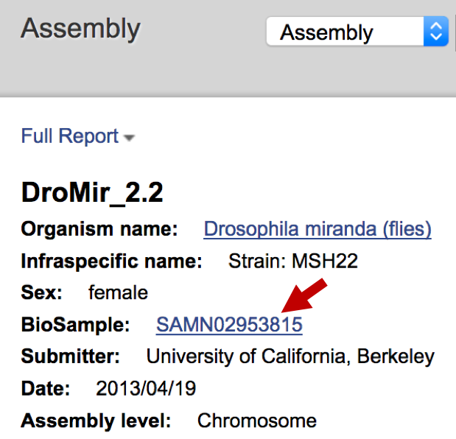
Figure 18. Click on the BioSample link (SAMN02953815; red arrow) to learn more about the strain of D. miranda that was used to construct the DroMir_2.2 assembly.
Each record in the NCBI BioSample database contains a description of the biological source materials (e.g., DNA, cell lines, tissues, developmental stages) used in an experiment. Each genome assembly and sequence record in the SRA are associated with a specific BioSample record. Consequently, we can use the BioSample accession numbers to ensure that results from different experiments are derived from the same biological source material.

The SAMN02953815 BioSample report shows that the DroMir_2.2 assembly is derived from the strain MSH22. The BioProjects section of the BioSample report shows two projects that are associated with this BioSample: PRJNA325520 and PRJNA77213 (Figure 19).

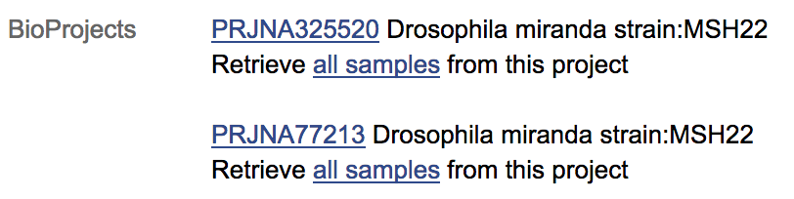
Figure 19. The “BioProjects” section of the BioSample report for SAMN02953815 indicates that this BioSample is associated with the BioProject for the D. miranda RefSeq Genome assembly (PRJNA325520) and the D. miranda GenBank assembly (PRJNA77213).
Click on the “PRJNA77213” link under the “BioProjects” section to navigate to the GenBank assembly record for the D. miranda strain MSH22. Scroll down to the “Project Data” section and then click on the “22” link in the “SRA Experiments” row to access the SRA records associated with this BioProject (Figure 20).

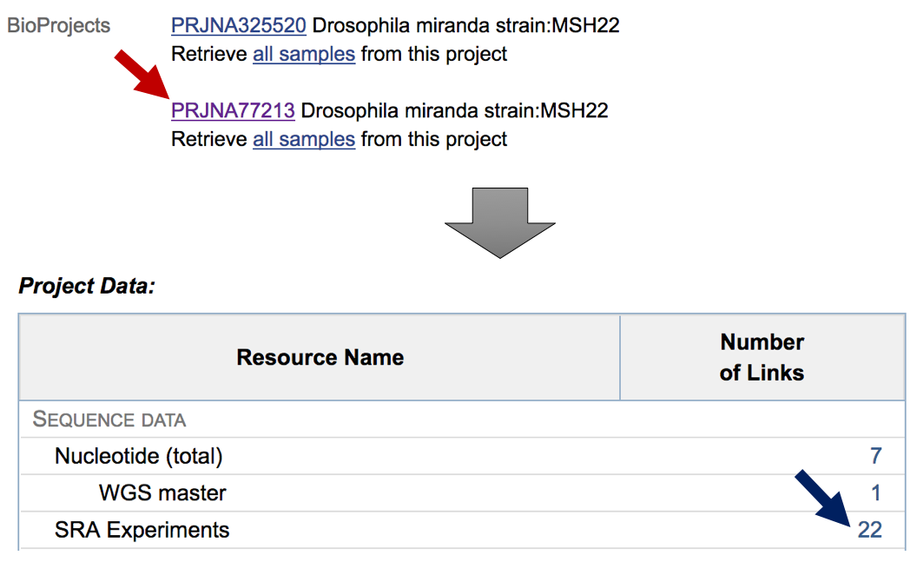
Figure 20. Click on the “PRJNA77213” link on the BioSample page to navigate to the BioProject record for the GenBank assembly of the D. miranda strain MSH22 (red arrow). Click on the “22” link for the “SRA Experiments” row in the “Project Data” table to access the SRA sequencing data associated with this BioProject (blue arrow).
The SRA search results page shows the summary of the 22 SRA records that are associated with this BioProject. In addition to the label that describes each SRA Experiments, the summary also includes metadata such as the sequencing platform, the size of the dataset, and the accession number for the SRA Experiments (Figure 21).

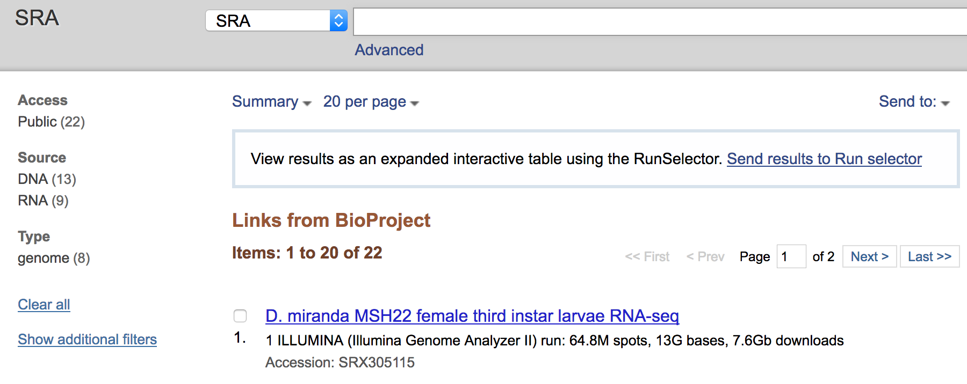
Figure 21. The first record in the SRA search results page corresponds to RNA-Seq data from D. miranda females during the third instar larvae stage of development. This sample was sequenced using the Illumina Genome Analyzer II platform, producing a total of 13G bases.
The 22 SRA Experiments include data produced from whole genome sequencing, ChIP-Seq, and RNA-Seq. To filter the search results so that it only shows the RNA-Seq data, click on the “RNA” link on the left panel of the SRA search results page (Figure 22, red arrow).

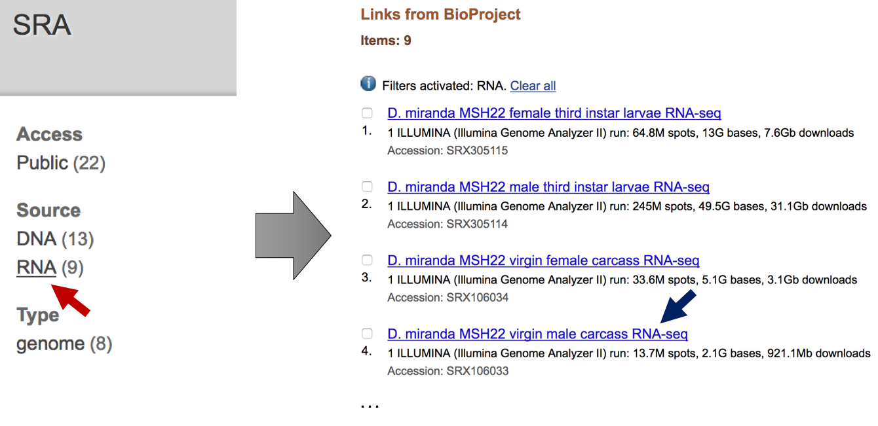
Figure 22. Use the links in the left panel to filter the SRA search results. Select the “RNA” option under the “Source” header to show only the SRA Experiments that sequence RNAs. Click on the link in the search results section to examine the details of the SRA Experiments.

The 9 RNA-Seq samples range from 2.1G bases to 49.5G bases in size. For training purposes, we will examine one of the small RNA-Seq dataset from the virgin male carcass (item #4; Figure 22, blue arrow). Click on the “D. miranda MSH22 virgin male carcass RNA-seq” link in the search results. The SRA record includes a description of the experimental design used to produce the RNA-Seq data, and links to the BioProject and BioSample databases (Figure 23).
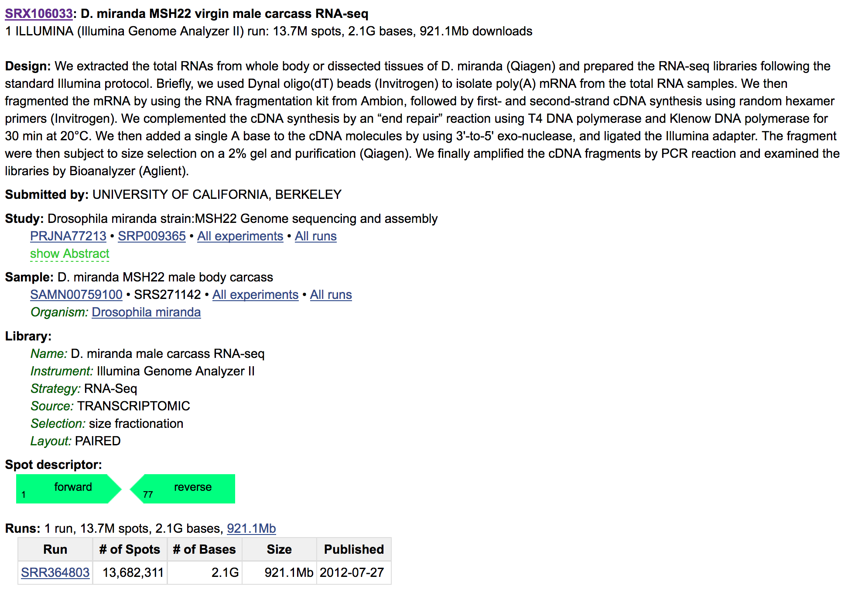
Figure 23. The SRA record for the D. miranda male carcass RNA-Seq experiment.
Based on the description in the “Design” section of the SRA record, we learned that poly(A) mRNAs in the D. miranda male carcass sample were selected using Dynal oligo(dT) beads. The RNA fragmentation technique was used to fragment the mRNAs, random hexamer primers were used for cDNA synthesis, and the RNA-Seq library is not strand-specific. The “Library” section shows that paired-end sequencing was used to produce the RNA-Seq data. The “Spot descriptor” section shows that the length of the paired-end RNA-Seq reads is 76 bp. These details regarding the RNA-Seq experiment could help us assess the quality of the RNA-Seq data, and to optimize the RNA-Seq alignment parameters.

The “Runs” section shows the Illumina sequencing runs that are associated with an SRA Experiments. The accession numbers for SRA Experiments have the prefix “SRX”, while the accession numbers for the individual sequencing runs have the prefix “SRR”. In this case, there is only a single run (SRR364803) associated with this SRA Experiments (SRX106033).
There are usually three sets of accession numbers associated with an SRA submission. An SRA Study (SRP) includes one or more SRA Experiments (SRX), while each SRA Experiments includes one or more SRA Runs (SRR).

The Illumina sequencing data are stored in the SRA Run records. Click on the “SRR364803” link under the “Runs” section to examine this record in the SRA Run Browser (Figure 24). Click on the “Reads” tab to examine the individual Illumina Reads, and the “Download” tab for the instructions on how to download the SRA Runs using the SRA Toolkit.

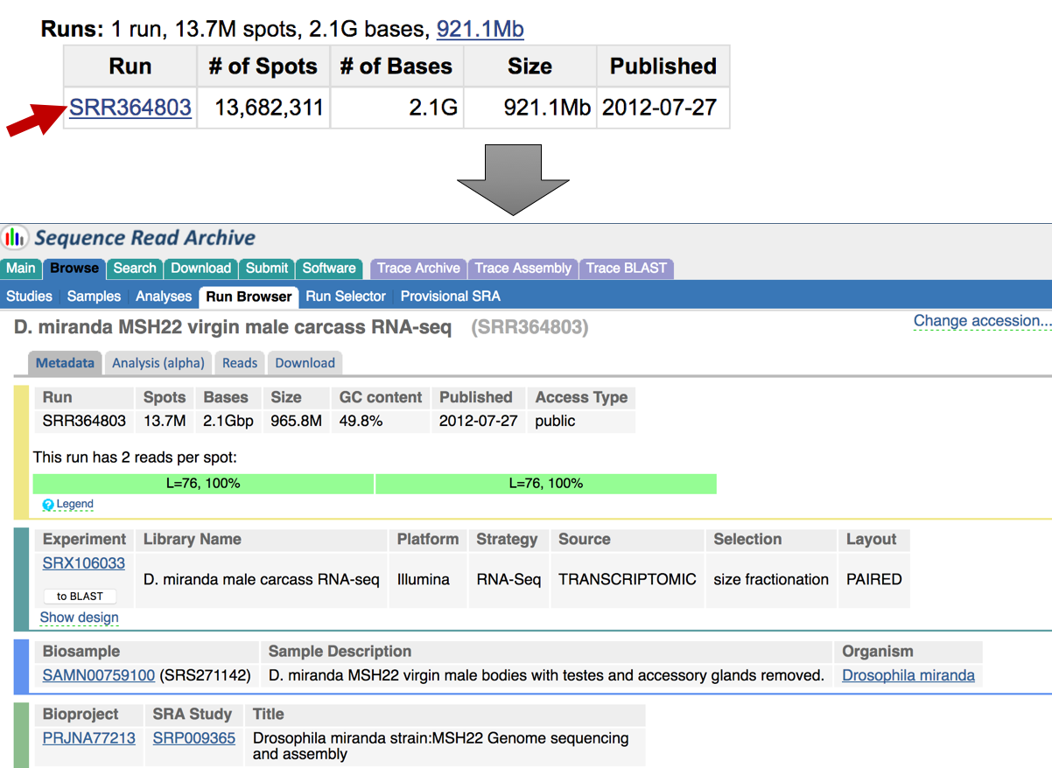
Figure 24. Click on the “SRR364803” link under the "Runs" section of the SRX record to view this SRR record using the SRA Run Browser.

7. Transfer the RNA-Seq reads to G-OnRamp
Sequencing data in the NCBI SRA are stored in the SRA archive format (see https://www.ncbi.nlm.nih.gov/books/NBK242622/ for details). In order to analyze the sequencing data using the Galaxy RNA-Seq tools, one would need to convert the SRA archive file into the original file format. For example, the fastq-dump tool in the NCBI SRA Toolkit can convert SRA archives into FASTQ format.

Instead of converting the SRA archive files, we will retrieve the RNA-Seq data from the European Nucleotide Archive (ENA) at EMBL-EBI. ENA provides the SRR sequencing data in FASTQ format. Galaxy has an “EBI SRA” tool that is designed to import data from the ENA. We will use this tool to upload the RNA-Seq data from the D. miranda male carcass RNA-Seq experiment to the G-OnRamp server.
NCBI, EMBL-EBI, and DDBJ are members of the International Nucleotide Sequence Database Collaboration (INSDC). Sequencing data submitted to one of these databases are synchronized with the other two databases periodically.

Go back to the G-OnRamp web browser tab (http://cloud5.galaxyproject.org/). Under the “Tools” panel, expand the “Get Data” section and then click on the “EBI SRA” link (Figure 25, red arrow). Enter the SRX accession number for the D. miranda RNA-Seq sample (SRX106033) into the text box (Figure 25, brown arrow) and then click on the “Search” button. The search results page shows the links to the SRA Experiment (SRX106033) and the corresponding SRA Run (SRR364803). Click on the “SRX106033” link to view the SRA Experiment record (Figure 25, blue arrow).

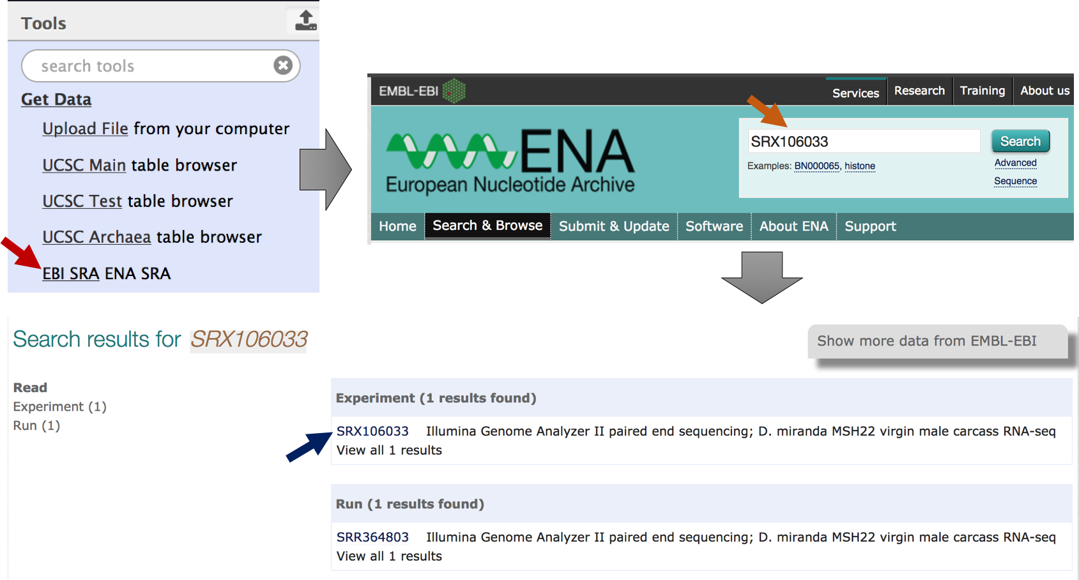
Figure 25. Retrieve the SRA Experiment SRX106033 from the EMBL-EBI ENA.
Scroll down to the “Read Files” section. The sequencing reads in FASTQ format are available under the “FASTQ files (Galaxy)” column. (There are two files because the layout of the RNA-Seq library is paired-end.) Click on the “File 1” link under the FASTQ files (Galaxy) column.

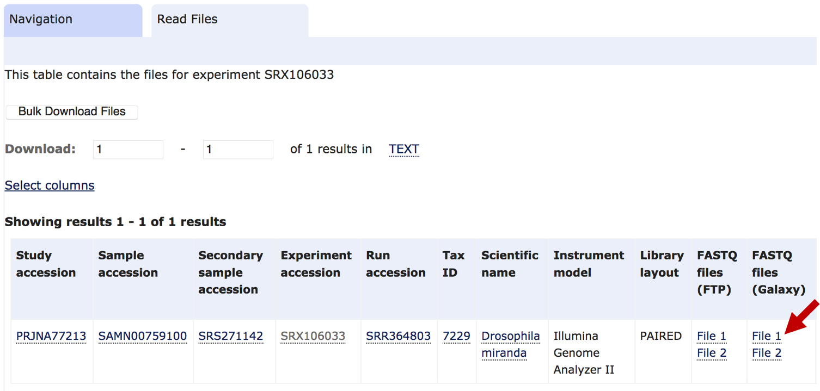
Figure 26. Click on the "File 1" link under the "FASTQ files (Galaxy)" column to transfer the FASTQ file to the G-OnRamp server.
A green message box will appear indicating that a job was added to the History to transfer this file to G-OnRamp. During the data transfer, the background color of the History item will turn yellow. After the data transfer is complete, the background color of the History item will turn green (Figure 27). Repeat the same procedure to transfer File 2 from the EMBL-EBI ENA to G-OnRamp [i.e., navigate to the SRX106033 record and then click on the “File 2” link under the “FASTQ files (Galaxy)” column].

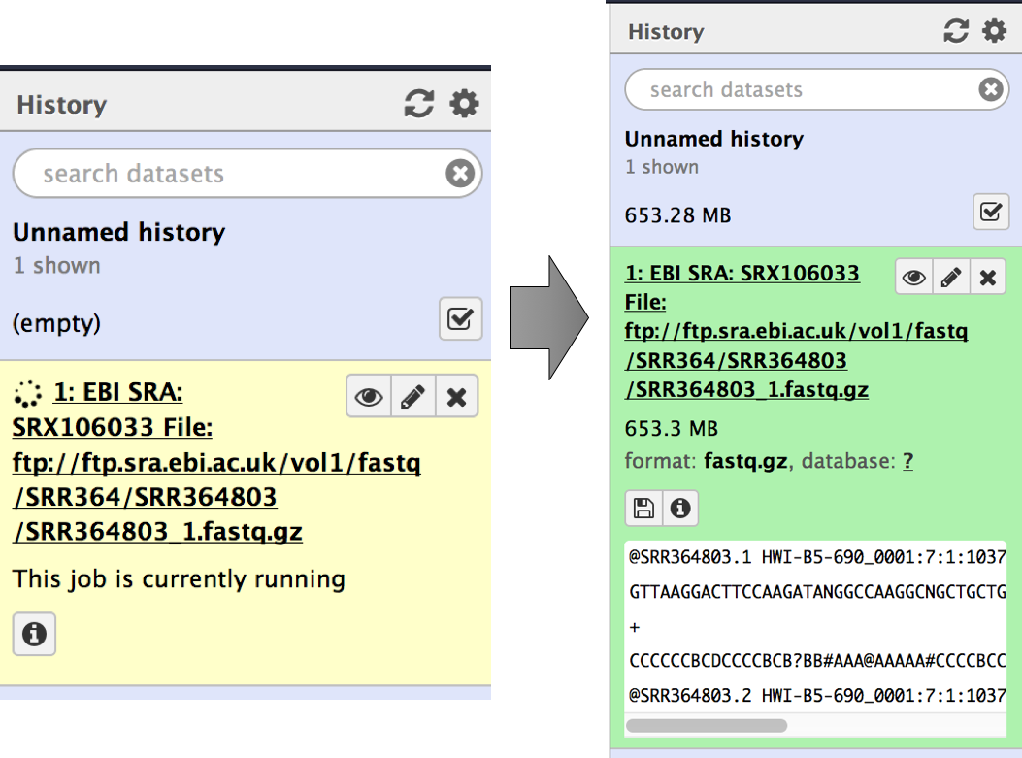
Figure 27. The color of the History item reflects the status of the file transfer from the EMBL-EBI ENA to the G-OnRamp server.
Because the FASTQ files are relatively large (~1Gb), the file transfer will take several minutes to complete.

8. Conclusions
This walkthrough illustrates how we can use FTP and the “EBI SRA” Galaxy tool to transfer large genomic datasets to the G-OnRamp server. First, we used the NCBI BioProject database to identify the D. miranda genome assemblies that are publicly available. We then obtained the RefSeq genome assembly for D. miranda (i.e., DroMir_2.2) from the NCBI Assembly Database. Using Cyberduck and FTP, we transferred the D. miranda genome assembly to the G-OnRamp server. We then queried the NCBI Sequence Read Archive to identify the RNA-Seq datasets for D. miranda, and used the “EBI SRA” tool in Galaxy to transfer the RNA-Seq data to the G-OnRamp server. In conjunction with the local and URL file uploads, the FTP and the “EBI SRA” upload techniques can be used to provide the input datasets to the G-OnRamp workflows.

